INDIVIDUAL PERFORMANCE REPORT
BETHA ODUMO
General Hardware Team
BOMAS Hardware Store
February 1-21, 2026 (18 Working Days)
Generated: 2026-02-27 15:54:28

PERFORMANCE SNAPSHOT
Metric | Value | Team Comparison
Total Sales | KES 9,453,025 | ▲ 33.2% vs team avg
Total Profit | KES 763,498 | 17.6% of team total
Profit Margin | 8.1% | Team avg: 8.7%
Items Sold | 12,927
Daily Avg Sales | KES 525,168
Daily Avg Profit | KES 42,417
Team Share | 19.0% | #2 of 7 reps
Sales Rank | #2
Margin Rank | #6

WEEKLY SALES BREAKDOWN
Week | Sales | Profit | Margin | Daily Avg | Change
Week 1 (Feb 1-7) | KES 2,284,170 | KES 213,772 | 9.4% | KES 380,695 | —
Week 2 (Feb 9-14) | KES 3,520,025 | KES 266,403 | 7.6% | KES 586,671 | +54.1%
Week 3 (Feb 16-21) | KES 3,648,830 | KES 283,323 | 7.8% | KES 608,138 | +3.7%
TOTAL | KES 9,453,025 | KES 763,498 | 8.1% | KES 525,168 | +59.7%

Weekly Progress
▲ W1→W2: Sales increased by 54.1% (KES 2,284K → 3,520K)
▲ W2→W3: Sales increased by 3.7% (KES 3,520K → 3,649K)
📈 Consistent upward trend over 3 weeks (+59.7% overall)

CATEGORY PERFORMANCE
Category | Sales | Profit | Margin % | Qty | % of Total
GENERAL HARDWARE | KES 8,967,025 | KES 664,794 | 7.4% | 12,044 | 94.9%
PAINTS | KES 395,960 | KES 72,158 | 18.2% | 452 | 4.2%
PLUMBING | KES 73,580 | KES 21,366 | 29.0% | 279 | 0.8%
ELECTRICALS | KES 16,460 | KES 5,180 | 31.5% | 152 | 0.2%
TOTAL | KES 9,453,025 | KES 763,498 | 8.1% | 12,927 | 100.0%

Category Weekly Trends
GENERAL HARDWARE: W1: KES 2,163,840 → W2: KES 3,332,785 → W3: KES 3,470,400 → Overall: ▲60%
PAINTS: W1: KES 109,900 → W2: KES 134,210 → W3: KES 151,850 → Overall: ▲38%
PLUMBING: W1: KES 5,790 → W2: KES 42,460 → W3: KES 25,330 → Overall: ▲337%
ELECTRICALS: W1: KES 4,640 → W2: KES 10,570 → W3: KES 1,250 → Overall: ▼73%

VISUAL ANALYSIS

Sales Distribution by Category
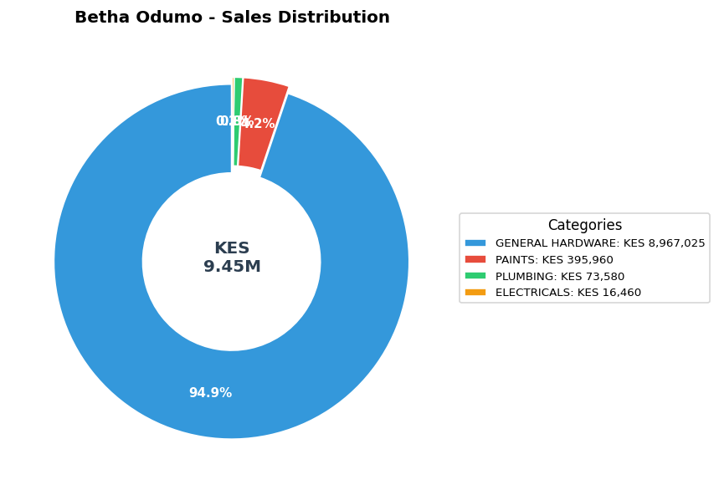

Sales vs Profit by Category
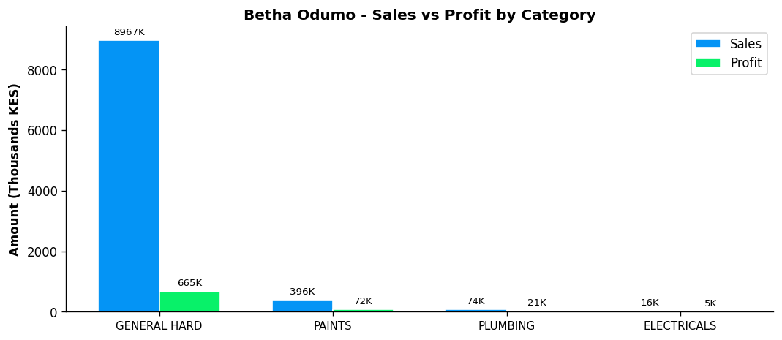

Profit Margin Gauge
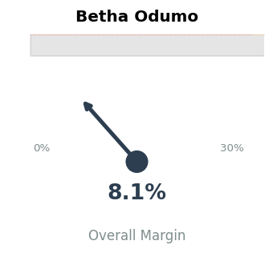

TEAM CONTEXT
How Betha Odumo compares to the rest of the team:

Rank | Rep | Total Sales | Margin % | Team Share
#1 | Gladys | KES 19,339,020 | 5.9% | 38.9%
#2 | Betha Odumo | KES 9,453,025 | 8.1% | 19.0%
#3 | Eliza | KES 8,456,260 | 10.0% | 17.0%
#4 | Stephen | KES 4,067,316 | 10.2% | 8.2%
#5 | Bonface Muriu | KES 3,948,909 | 13.9% | 8.0%
#6 | Lewis | KES 2,614,482 | 14.3% | 5.3%
#7 | Bonface Kitheka | KES 1,790,725 | 14.1% | 3.6%

Team Week-over-Week Comparison
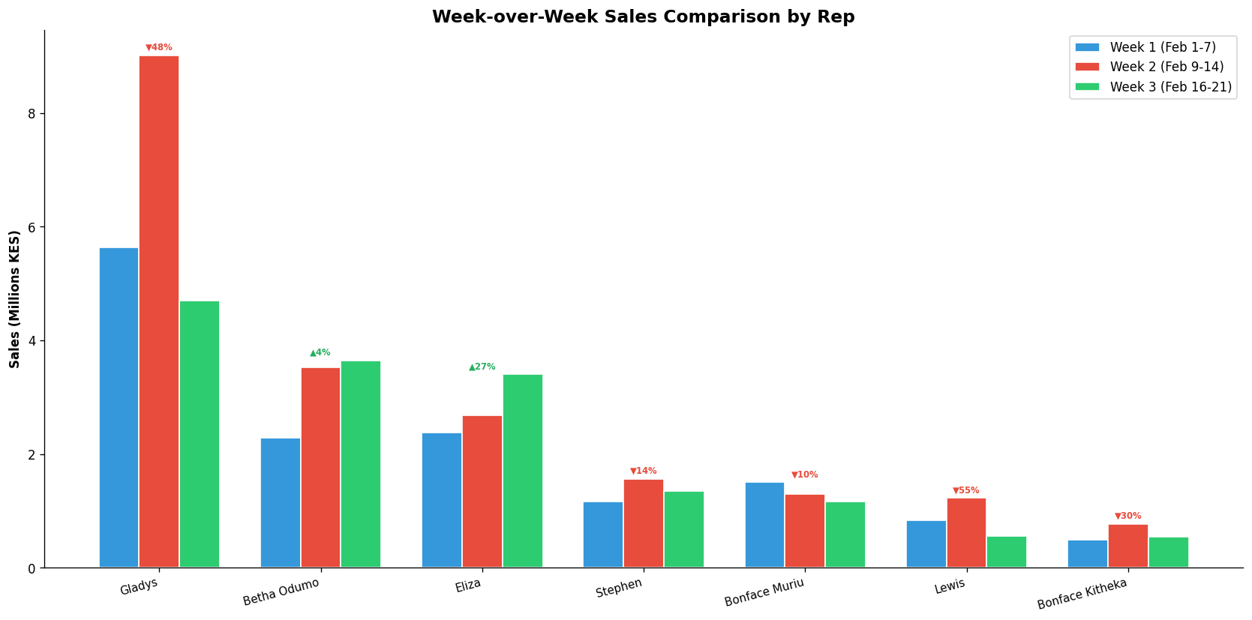

PERFORMANCE NOTES
- Sales 33% above team average - solid performance
- W1→W2: Strong growth +54.1% (KES 2,284K → 3,520K)
- W2→W3: Steady +3.7% (KES 3,520K → 3,649K)
- 📈 Consistent upward trend over 3 weeks (+59.7% overall)
- General Hardware: 20.6% of dept, 7.4% margin
- ✓ Selling across all 4 categories - excellent product range
- Best margin in ELECTRICALS: 31.5%

RECOMMENDATIONS
- Focus on higher-margin products to improve margin from 8.1% toward the team average of 8.7%.
- Selling across all 4 categories — excellent product range coverage.

--- End of Individual Report ---

