INDIVIDUAL PERFORMANCE REPORT
BONFACE KITHEKA
Department Head - Electricals
BOMAS Hardware Store
February 1-21, 2026 (18 Working Days)
Generated: 2026-02-27 15:54:33

PERFORMANCE SNAPSHOT
Metric | Value | Team Comparison
Total Sales | KES 1,790,725 | ▼ 74.8% vs team avg
Total Profit | KES 252,676 | 5.8% of team total
Profit Margin | 14.1% | Team avg: 8.7%
Items Sold | 4,982
Daily Avg Sales | KES 99,485
Daily Avg Profit | KES 14,038
Team Share | 3.6% | #7 of 7 reps
Sales Rank | #7
Margin Rank | #2

WEEKLY SALES BREAKDOWN
Week | Sales | Profit | Margin | Daily Avg | Change
Week 1 (Feb 1-7) | KES 486,660 | KES 79,296 | 16.3% | KES 81,110 | —
Week 2 (Feb 9-14) | KES 768,140 | KES 105,675 | 13.8% | KES 128,023 | +57.8%
Week 3 (Feb 16-21) | KES 535,925 | KES 67,705 | 12.6% | KES 89,321 | -30.2%
TOTAL | KES 1,790,725 | KES 252,676 | 14.1% | KES 99,485 | +10.1%

Weekly Progress
▲ W1→W2: Sales increased by 57.8% (KES 487K → 768K)
▼ W2→W3: Sales decreased by 30.2% (KES 768K → 536K)
⚠️ Week 3 reversal after Week 2 growth — monitor closely

CATEGORY PERFORMANCE
Category | Sales | Profit | Margin % | Qty | % of Total
GENERAL HARDWARE | KES 1,163,052 | KES 119,199 | 10.2% | 1,762 | 64.9%
PAINTS | KES 297,736 | KES 48,962 | 16.4% | 388 | 16.6%
PLUMBING | KES 143,176 | KES 35,799 | 25.0% | 472 | 8.0%
ELECTRICALS | KES 186,761 | KES 48,716 | 26.1% | 2,360 | 10.4%
TOTAL | KES 1,790,725 | KES 252,676 | 14.1% | 4,982 | 100.0%

Category Weekly Trends
GENERAL HARDWARE: W1: KES 232,485 → W2: KES 538,787 → W3: KES 391,780 → Overall: ▲69%
PAINTS: W1: KES 142,420 → W2: KES 105,136 → W3: KES 50,180 → Overall: ▼65%
PLUMBING: W1: KES 74,120 → W2: KES 29,431 → W3: KES 39,625 → Overall: ▼47%
ELECTRICALS: W1: KES 37,635 → W2: KES 94,786 → W3: KES 54,340 → Overall: ▲44%

VISUAL ANALYSIS

Sales Distribution by Category
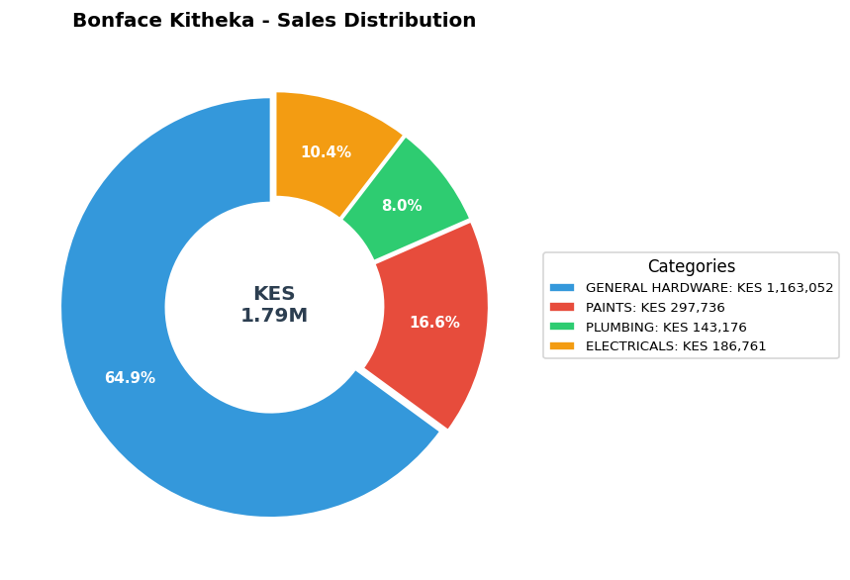

Sales vs Profit by Category
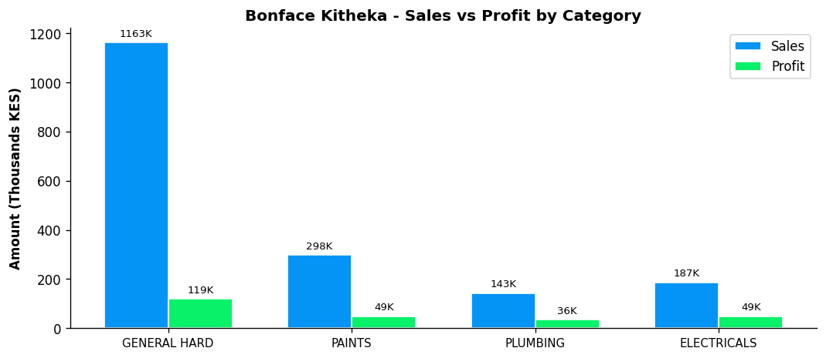

Profit Margin Gauge
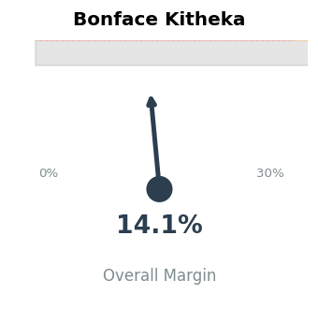

TEAM CONTEXT
How Bonface Kitheka compares to the rest of the team:

Rank | Rep | Total Sales | Margin % | Team Share
#1 | Gladys | KES 19,339,020 | 5.9% | 38.9%
#2 | Betha Odumo | KES 9,453,025 | 8.1% | 19.0%
#3 | Eliza | KES 8,456,260 | 10.0% | 17.0%
#4 | Stephen | KES 4,067,316 | 10.2% | 8.2%
#5 | Bonface Muriu | KES 3,948,909 | 13.9% | 8.0%
#6 | Lewis | KES 2,614,482 | 14.3% | 5.3%
#7 | Bonface Kitheka | KES 1,790,725 | 14.1% | 3.6%

Team Week-over-Week Comparison
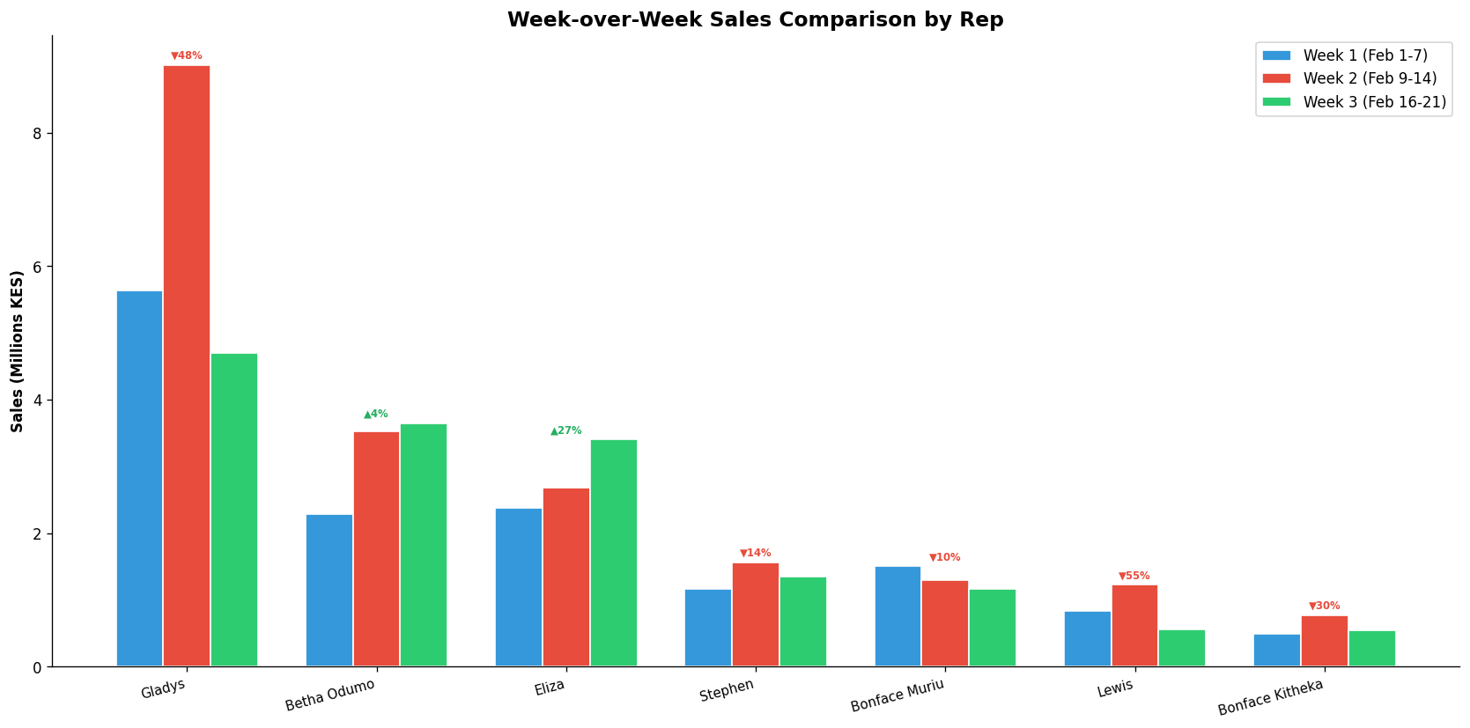

DEPARTMENT LEADERSHIP: ELECTRICALS
Rep | Dept Sales | Dept Profit | Margin | Dept Share
Bonface Kitheka | KES 186,761 | KES 48,716 | 26.1% | 57.6%
Eliza | KES 50,050 | KES 11,493 | 23.0% | 15.4%
Lewis | KES 42,885 | KES 8,224 | 19.2% | 13.2%
Bonface Muriu | KES 27,190 | KES 12,443 | 45.8% | 8.4%
Betha Odumo | KES 16,460 | KES 5,180 | 31.5% | 5.1%
Gladys | KES 790 | KES 317 | 40.1% | 0.2%

✓ Strong department leadership — Bonface Kitheka controls 57.6% of ELECTRICALS sales

PERFORMANCE NOTES
- Sales 75% below team average - needs improvement
- Excellent margin at 14.1% (Team avg: 8.7%)
- W1→W2: Strong growth +57.8% (KES 487K → 768K)
- W2→W3: Declined -30.2% (KES 768K → 536K)
- ⚠️ Week 3 reversal after Week 2 growth - monitor closely
- Electricals Dept Head: 57.6% of dept sales, 26.1% margin
- ✓ Strong leadership - controls 57.6% of department sales
- ✓ Selling across all 4 categories - excellent product range
- Best margin in ELECTRICALS: 26.1%

RECOMMENDATIONS
- Maintain excellent margin discipline at 14.1% (above team avg of 8.7%).
- Week 3 showed a 30.2% decline. Review customer activity and pipeline for Week 4.
- Selling across all 4 categories — excellent product range coverage.
- Sales are significantly below team average. Consider additional training or customer assignment review.
- As ELECTRICALS Department Head, only 10.4% of your sales are in your department. Consider refocusing.

--- End of Individual Report ---

