INDIVIDUAL PERFORMANCE REPORT
BONFACE MURIU
Department Head - Paints
BOMAS Hardware Store
February 1-21, 2026 (18 Working Days)
Generated: 2026-02-27 15:54:31

PERFORMANCE SNAPSHOT
Metric | Value | Team Comparison
Total Sales | KES 3,948,909 | ▼ 44.3% vs team avg
Total Profit | KES 550,482 | 12.7% of team total
Profit Margin | 13.9% | Team avg: 8.7%
Items Sold | 4,888
Daily Avg Sales | KES 219,384
Daily Avg Profit | KES 30,582
Team Share | 8.0% | #5 of 7 reps
Sales Rank | #5
Margin Rank | #3

WEEKLY SALES BREAKDOWN
Week | Sales | Profit | Margin | Daily Avg | Change
Week 1 (Feb 1-7) | KES 1,499,769 | KES 199,397 | 13.3% | KES 249,962 | —
Week 2 (Feb 9-14) | KES 1,291,500 | KES 180,128 | 13.9% | KES 215,250 | -13.9%
Week 3 (Feb 16-21) | KES 1,157,640 | KES 170,956 | 14.8% | KES 192,940 | -10.4%
TOTAL | KES 3,948,909 | KES 550,482 | 13.9% | KES 219,384 | -22.8%

Weekly Progress
▼ W1→W2: Sales decreased by 13.9% (KES 1,500K → 1,292K)
▼ W2→W3: Sales decreased by 10.4% (KES 1,292K → 1,158K)
📉 Declining trend over 3 weeks (-22.8% overall) — needs urgent attention

CATEGORY PERFORMANCE
Category | Sales | Profit | Margin % | Qty | % of Total
GENERAL HARDWARE | KES 2,295,609 | KES 246,116 | 10.7% | 3,273 | 58.1%
PAINTS | KES 1,535,360 | KES 268,264 | 17.5% | 1,291 | 38.9%
PLUMBING | KES 90,750 | KES 23,658 | 26.1% | 218 | 2.3%
ELECTRICALS | KES 27,190 | KES 12,443 | 45.8% | 106 | 0.7%
TOTAL | KES 3,948,909 | KES 550,482 | 13.9% | 4,888 | 100.0%

Category Weekly Trends
GENERAL HARDWARE: W1: KES 1,128,619 → W2: KES 753,970 → W3: KES 413,020 → Overall: ▼63%
PAINTS: W1: KES 323,270 → W2: KES 477,620 → W3: KES 734,470 → Overall: ▲127%
PLUMBING: W1: KES 21,120 → W2: KES 59,480 → W3: KES 10,150 → Overall: ▼52%
ELECTRICALS: W1: KES 26,760 → W2: KES 430 → W3: KES 0 → Overall: ▼100%

VISUAL ANALYSIS

Sales Distribution by Category
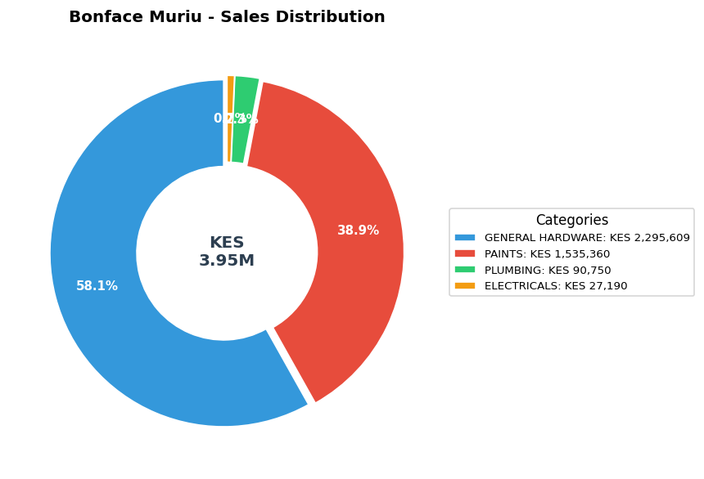

Sales vs Profit by Category
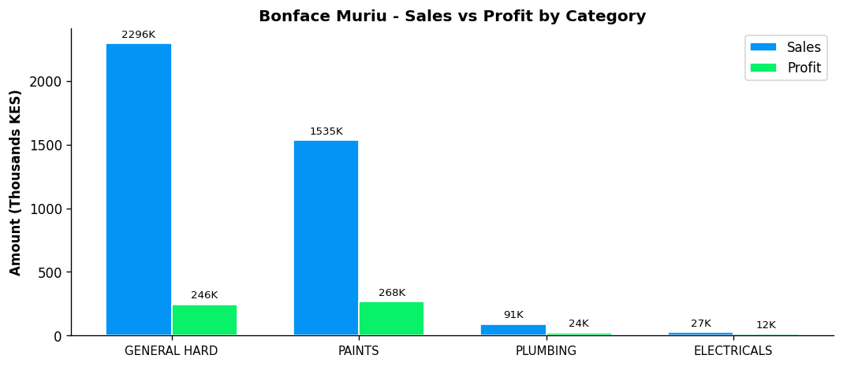

Profit Margin Gauge
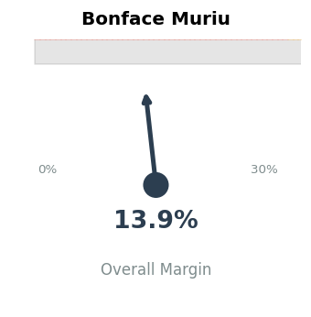

TEAM CONTEXT
How Bonface Muriu compares to the rest of the team:

Rank | Rep | Total Sales | Margin % | Team Share
#1 | Gladys | KES 19,339,020 | 5.9% | 38.9%
#2 | Betha Odumo | KES 9,453,025 | 8.1% | 19.0%
#3 | Eliza | KES 8,456,260 | 10.0% | 17.0%
#4 | Stephen | KES 4,067,316 | 10.2% | 8.2%
#5 | Bonface Muriu | KES 3,948,909 | 13.9% | 8.0%
#6 | Lewis | KES 2,614,482 | 14.3% | 5.3%
#7 | Bonface Kitheka | KES 1,790,725 | 14.1% | 3.6%

Team Week-over-Week Comparison
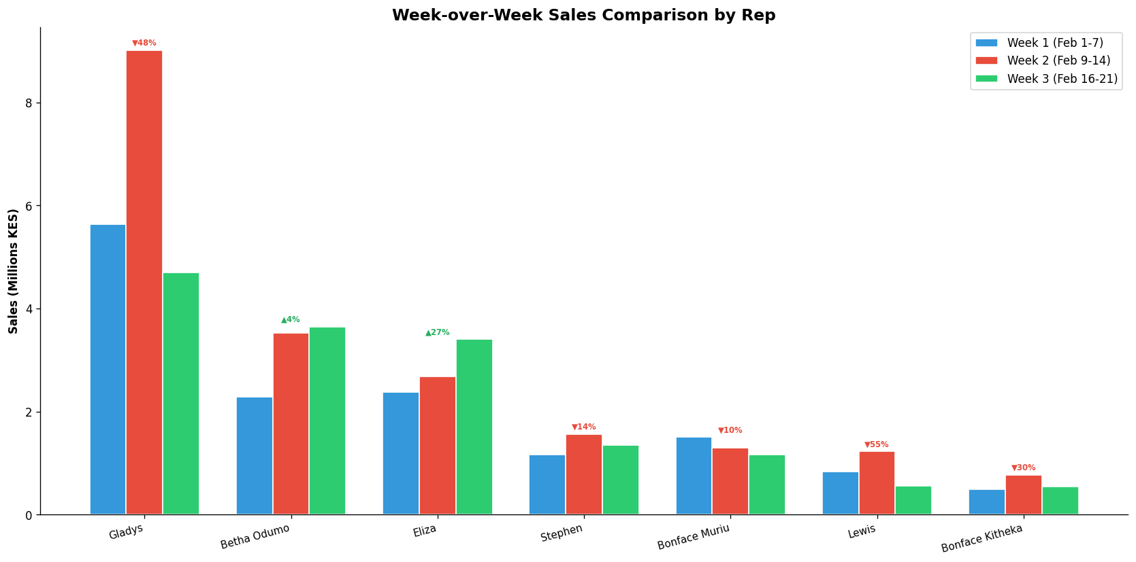

DEPARTMENT LEADERSHIP: PAINTS
Rep | Dept Sales | Dept Profit | Margin | Dept Share
Bonface Muriu | KES 1,535,360 | KES 268,264 | 17.5% | 35.8%
Eliza | KES 1,483,420 | KES 222,538 | 15.0% | 34.6%
Betha Odumo | KES 395,960 | KES 72,158 | 18.2% | 9.2%
Bonface Kitheka | KES 297,736 | KES 48,962 | 16.4% | 6.9%
Stephen | KES 266,000 | KES 48,733 | 18.3% | 6.2%
Gladys | KES 155,440 | KES 24,733 | 15.9% | 3.6%
Lewis | KES 155,000 | KES 35,624 | 23.0% | 3.6%

⚠️ As Department Head, Bonface Muriu contributes 35.8% of PAINTS sales — consider increasing dept focus

PERFORMANCE NOTES
- Sales 44% below team average - needs improvement
- Excellent margin at 13.9% (Team avg: 8.7%)
- W1→W2: Declined -13.9% (KES 1,500K → 1,292K)
- W2→W3: Declined -10.4% (KES 1,292K → 1,158K)
- 📉 Declining trend over 3 weeks (-22.8% overall) - urgent review
- Paints Dept Head: 35.8% of dept sales, 17.5% margin
- ✓ Good paints leadership with 35.8% of dept sales
- ✓ Selling across all 4 categories - excellent product range
- Best margin in ELECTRICALS: 45.8%

RECOMMENDATIONS
- Maintain excellent margin discipline at 13.9% (above team avg of 8.7%).
- Week 3 showed a 10.4% decline. Review customer activity and pipeline for Week 4.
- Selling across all 4 categories — excellent product range coverage.

--- End of Individual Report ---

