INDIVIDUAL PERFORMANCE REPORT
ELIZA
General Hardware Team
📈 MOST IMPROVED
BOMAS Hardware Store
February 1-21, 2026 (18 Working Days)
Generated: 2026-02-27 15:54:29

PERFORMANCE SNAPSHOT
Metric | Value | Team Comparison
Total Sales | KES 8,456,260 | ▲ 19.2% vs team avg
Total Profit | KES 842,095 | 19.4% of team total
Profit Margin | 10.0% | Team avg: 8.7%
Items Sold | 10,636
Daily Avg Sales | KES 469,792
Daily Avg Profit | KES 46,783
Team Share | 17.0% | #3 of 7 reps
Sales Rank | #3
Margin Rank | #5

WEEKLY SALES BREAKDOWN
Week | Sales | Profit | Margin | Daily Avg | Change
Week 1 (Feb 1-7) | KES 2,370,660 | KES 282,809 | 11.9% | KES 395,110 | —
Week 2 (Feb 9-14) | KES 2,682,395 | KES 260,188 | 9.7% | KES 447,066 | +13.1%
Week 3 (Feb 16-21) | KES 3,403,205 | KES 299,098 | 8.8% | KES 567,201 | +26.9%
TOTAL | KES 8,456,260 | KES 842,095 | 10.0% | KES 469,792 | +43.6%

Weekly Progress
▲ W1→W2: Sales increased by 13.1% (KES 2,371K → 2,682K)
▲ W2→W3: Sales increased by 26.9% (KES 2,682K → 3,403K)
📈 Consistent upward trend over 3 weeks (+43.6% overall)

CATEGORY PERFORMANCE
Category | Sales | Profit | Margin % | Qty | % of Total
GENERAL HARDWARE | KES 6,742,565 | KES 549,398 | 8.1% | 8,376 | 79.7%
PAINTS | KES 1,483,420 | KES 222,538 | 15.0% | 1,236 | 17.5%
PLUMBING | KES 180,225 | KES 58,666 | 32.6% | 624 | 2.1%
ELECTRICALS | KES 50,050 | KES 11,493 | 23.0% | 400 | 0.6%
TOTAL | KES 8,456,260 | KES 842,095 | 10.0% | 10,636 | 100.0%

Category Weekly Trends
GENERAL HARDWARE: W1: KES 1,636,135 → W2: KES 2,232,275 → W3: KES 2,874,155 → Overall: ▲76%
PAINTS: W1: KES 595,550 → W2: KES 432,050 → W3: KES 455,820 → Overall: ▼23%
PLUMBING: W1: KES 100,035 → W2: KES 16,110 → W3: KES 64,080 → Overall: ▼36%
ELECTRICALS: W1: KES 38,940 → W2: KES 1,960 → W3: KES 9,150 → Overall: ▼77%

VISUAL ANALYSIS

Sales Distribution by Category
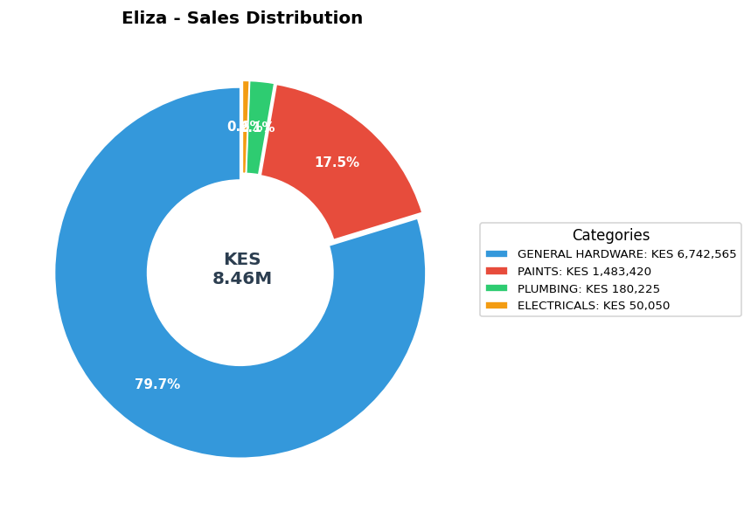

Sales vs Profit by Category
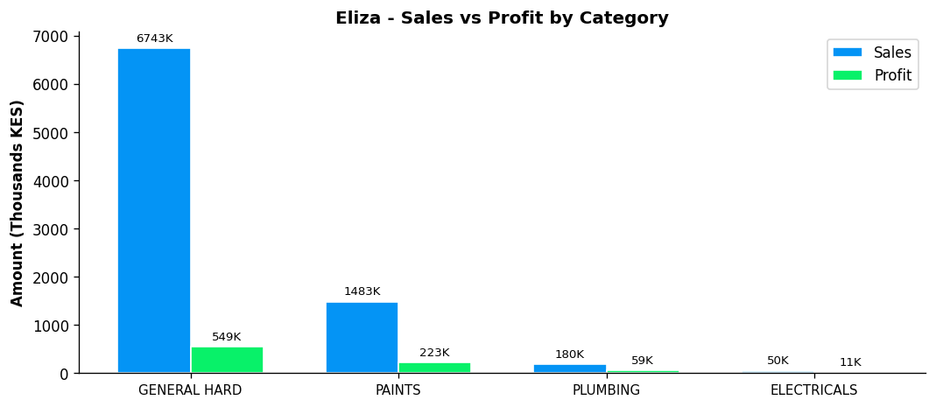

Profit Margin Gauge
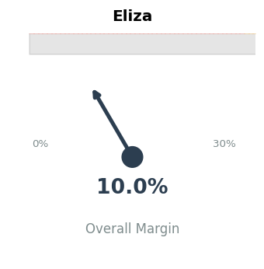

TEAM CONTEXT
How Eliza compares to the rest of the team:

Rank | Rep | Total Sales | Margin % | Team Share
#1 | Gladys | KES 19,339,020 | 5.9% | 38.9%
#2 | Betha Odumo | KES 9,453,025 | 8.1% | 19.0%
#3 | Eliza | KES 8,456,260 | 10.0% | 17.0%
#4 | Stephen | KES 4,067,316 | 10.2% | 8.2%
#5 | Bonface Muriu | KES 3,948,909 | 13.9% | 8.0%
#6 | Lewis | KES 2,614,482 | 14.3% | 5.3%
#7 | Bonface Kitheka | KES 1,790,725 | 14.1% | 3.6%

Team Week-over-Week Comparison
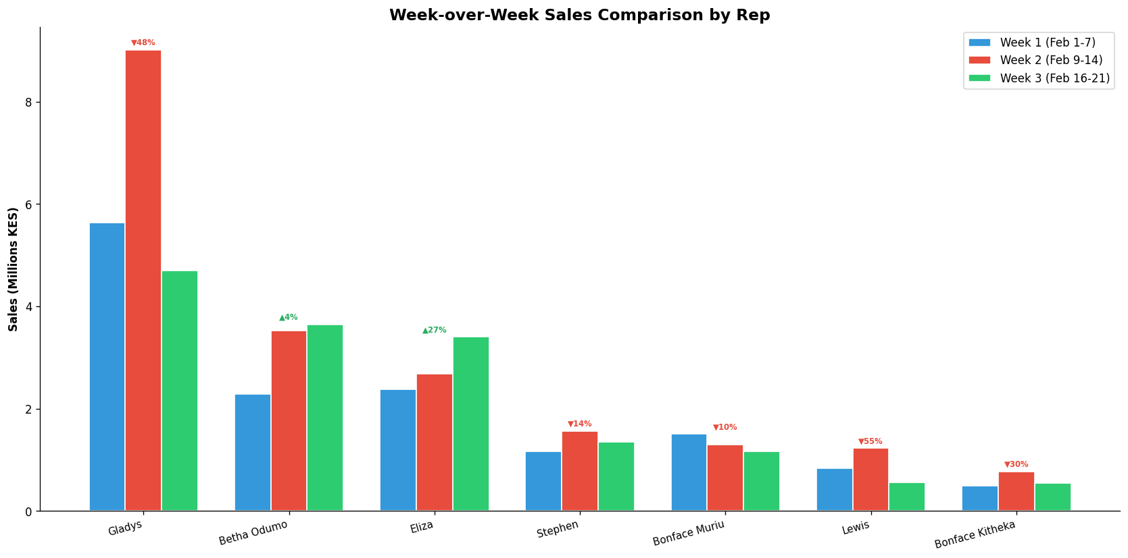

PERFORMANCE NOTES
- Sales 19% above team average - solid performance
- W1→W2: Steady +13.1% (KES 2,371K → 2,682K)
- W2→W3: Steady +26.9% (KES 2,682K → 3,403K)
- 📈 Consistent upward trend over 3 weeks (+43.6% overall)
- General Hardware: 15.5% of dept, 8.1% margin
- ✓ Selling across all 4 categories - excellent product range
- Best margin in PLUMBING: 32.6%

RECOMMENDATIONS
- Maintain excellent margin discipline at 10.0% (above team avg of 8.7%).
- Outstanding Week 3 growth of +26.9%. Maintain this momentum into Week 4.
- Selling across all 4 categories — excellent product range coverage.

--- End of Individual Report ---

