INDIVIDUAL PERFORMANCE REPORT
GLADYS
General Hardware Team
🏆 TOP SELLER 💰 TOP PROFIT
BOMAS Hardware Store
February 1-21, 2026 (18 Working Days)
Generated: 2026-02-27 15:54:28

PERFORMANCE SNAPSHOT
Metric | Value | Team Comparison
Total Sales | KES 19,339,020 | ▲ 172.5% vs team avg
Total Profit | KES 1,149,099 | 26.4% of team total
Profit Margin | 5.9% | Team avg: 8.7%
Items Sold | 22,606
Daily Avg Sales | KES 1,074,390
Daily Avg Profit | KES 63,839
Team Share | 38.9% | #1 of 7 reps
Sales Rank | #1
Margin Rank | #7

WEEKLY SALES BREAKDOWN
Week | Sales | Profit | Margin | Daily Avg | Change
Week 1 (Feb 1-7) | KES 5,631,385 | KES 325,749 | 5.8% | KES 938,564 | —
Week 2 (Feb 9-14) | KES 9,016,020 | KES 533,008 | 5.9% | KES 1,502,670 | +60.1%
Week 3 (Feb 16-21) | KES 4,691,615 | KES 290,341 | 6.2% | KES 781,936 | -48.0%
TOTAL | KES 19,339,020 | KES 1,149,099 | 5.9% | KES 1,074,390 | -16.7%

Weekly Progress
▲ W1→W2: Sales increased by 60.1% (KES 5,631K → 9,016K)
▼ W2→W3: Sales decreased by 48.0% (KES 9,016K → 4,692K)
⚠️ Week 3 reversal after Week 2 growth — monitor closely

CATEGORY PERFORMANCE
Category | Sales | Profit | Margin % | Qty | % of Total
GENERAL HARDWARE | KES 19,080,190 | KES 1,096,127 | 5.7% | 22,251 | 98.7%
PAINTS | KES 155,440 | KES 24,733 | 15.9% | 114 | 0.8%
PLUMBING | KES 102,600 | KES 27,921 | 27.2% | 234 | 0.5%
ELECTRICALS | KES 790 | KES 317 | 40.1% | 7 | 0.0%
TOTAL | KES 19,339,020 | KES 1,149,099 | 5.9% | 22,606 | 100.0%

Category Weekly Trends
GENERAL HARDWARE: W1: KES 5,538,955 → W2: KES 8,927,070 → W3: KES 4,614,165 → Overall: ▼17%
PAINTS: W1: KES 33,800 → W2: KES 61,410 → W3: KES 60,230 → Overall: ▲78%
PLUMBING: W1: KES 58,630 → W2: KES 26,890 → W3: KES 17,080 → Overall: ▼71%
ELECTRICALS: W1: KES 0 → W2: KES 650 → W3: KES 140

VISUAL ANALYSIS

Sales Distribution by Category
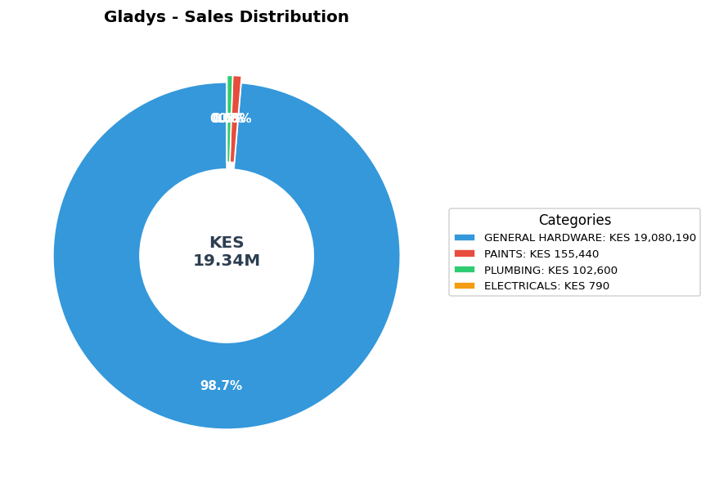

Sales vs Profit by Category
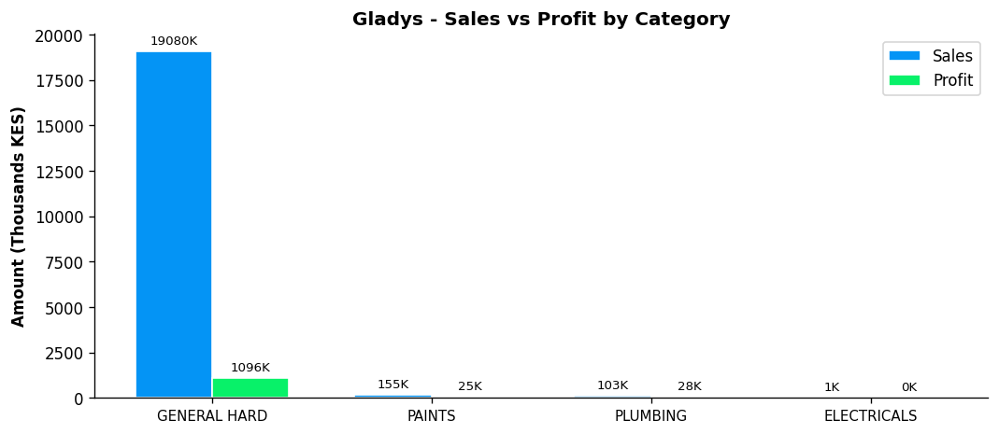

Profit Margin Gauge
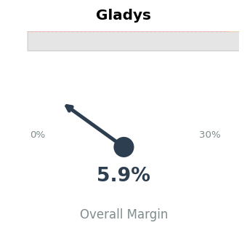

TEAM CONTEXT
How Gladys compares to the rest of the team:

Rank | Rep | Total Sales | Margin % | Team Share
#1 | Gladys | KES 19,339,020 | 5.9% | 38.9%
#2 | Betha Odumo | KES 9,453,025 | 8.1% | 19.0%
#3 | Eliza | KES 8,456,260 | 10.0% | 17.0%
#4 | Stephen | KES 4,067,316 | 10.2% | 8.2%
#5 | Bonface Muriu | KES 3,948,909 | 13.9% | 8.0%
#6 | Lewis | KES 2,614,482 | 14.3% | 5.3%
#7 | Bonface Kitheka | KES 1,790,725 | 14.1% | 3.6%

Team Week-over-Week Comparison
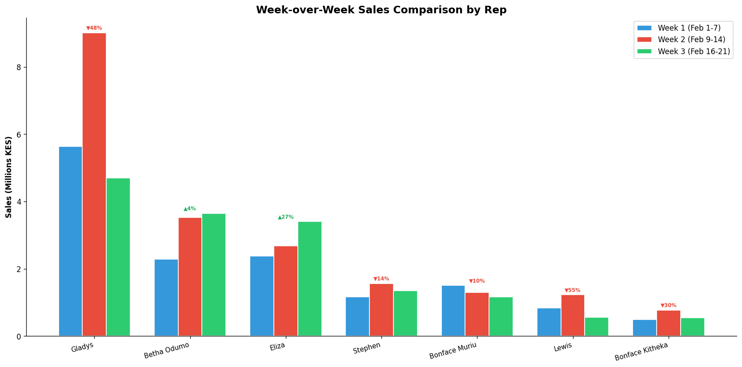

PERFORMANCE NOTES
- Outstanding! Sales 173% above team average
- Margin at 5.9% below team average of 8.7%
- W1→W2: Strong growth +60.1% (KES 5,631K → 9,016K)
- W2→W3: Declined -48.0% (KES 9,016K → 4,692K)
- ⚠️ Week 3 reversal after Week 2 growth - monitor closely
- General Hardware: 43.7% of dept, 5.7% margin
- ✓ Selling across all 4 categories - excellent product range
- Best margin in ELECTRICALS: 40.1%

RECOMMENDATIONS
- Focus on higher-margin products to improve margin from 5.9% toward the team average of 8.7%.
- Week 3 showed a 48.0% decline. Review customer activity and pipeline for Week 4.
- Selling across all 4 categories — excellent product range coverage.

--- End of Individual Report ---

