INDIVIDUAL PERFORMANCE REPORT
LEWIS
Department Head - Plumbing
💎 BEST MARGIN
BOMAS Hardware Store
February 1-21, 2026 (18 Working Days)
Generated: 2026-02-27 15:54:32

PERFORMANCE SNAPSHOT
Metric | Value | Team Comparison
Total Sales | KES 2,614,482 | ▼ 63.2% vs team avg
Total Profit | KES 373,746 | 8.6% of team total
Profit Margin | 14.3% | Team avg: 8.7%
Items Sold | 4,791
Daily Avg Sales | KES 145,249
Daily Avg Profit | KES 20,764
Team Share | 5.3% | #6 of 7 reps
Sales Rank | #6
Margin Rank | #1

WEEKLY SALES BREAKDOWN
Week | Sales | Profit | Margin | Daily Avg | Change
Week 1 (Feb 1-7) | KES 837,537 | KES 130,077 | 15.5% | KES 139,590 | —
Week 2 (Feb 9-14) | KES 1,225,705 | KES 129,693 | 10.6% | KES 204,284 | +46.3%
Week 3 (Feb 16-21) | KES 551,240 | KES 113,976 | 20.7% | KES 91,873 | -55.0%
TOTAL | KES 2,614,482 | KES 373,746 | 14.3% | KES 145,249 | -34.2%

Weekly Progress
▲ W1→W2: Sales increased by 46.3% (KES 838K → 1,226K)
▼ W2→W3: Sales decreased by 55.0% (KES 1,226K → 551K)
⚠️ Week 3 reversal after Week 2 growth — monitor closely

CATEGORY PERFORMANCE
Category | Sales | Profit | Margin % | Qty | % of Total
GENERAL HARDWARE | KES 1,796,987 | KES 171,440 | 9.5% | 2,485 | 68.7%
PAINTS | KES 155,000 | KES 35,624 | 23.0% | 230 | 5.9%
PLUMBING | KES 619,610 | KES 158,458 | 25.6% | 1,902 | 23.7%
ELECTRICALS | KES 42,885 | KES 8,224 | 19.2% | 174 | 1.6%
TOTAL | KES 2,614,482 | KES 373,746 | 14.3% | 4,791 | 100.0%

Category Weekly Trends
GENERAL HARDWARE: W1: KES 552,707 → W2: KES 1,002,130 → W3: KES 242,150 → Overall: ▼56%
PAINTS: W1: KES 71,660 → W2: KES 47,540 → W3: KES 35,800 → Overall: ▼50%
PLUMBING: W1: KES 208,330 → W2: KES 157,320 → W3: KES 253,960 → Overall: ▲22%
ELECTRICALS: W1: KES 4,840 → W2: KES 18,715 → W3: KES 19,330 → Overall: ▲299%

VISUAL ANALYSIS

Sales Distribution by Category
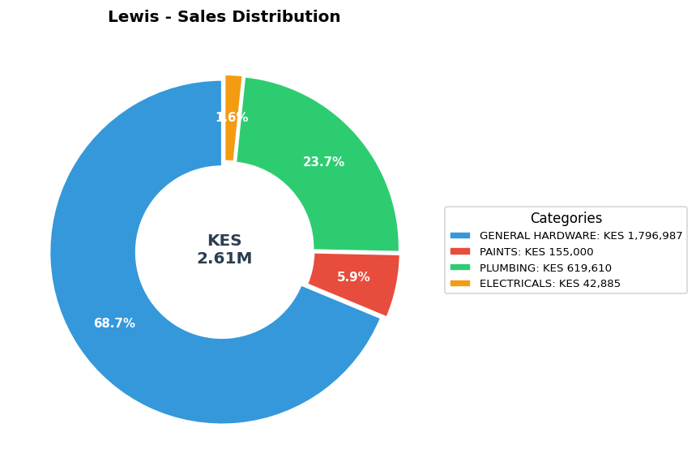

Sales vs Profit by Category
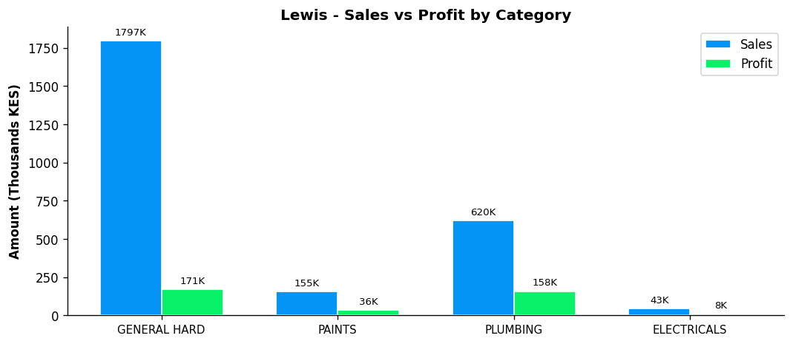

Profit Margin Gauge
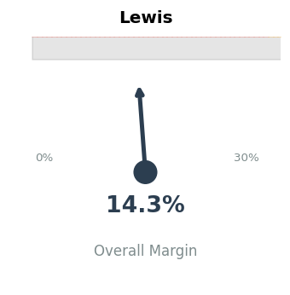

TEAM CONTEXT
How Lewis compares to the rest of the team:

Rank | Rep | Total Sales | Margin % | Team Share
#1 | Gladys | KES 19,339,020 | 5.9% | 38.9%
#2 | Betha Odumo | KES 9,453,025 | 8.1% | 19.0%
#3 | Eliza | KES 8,456,260 | 10.0% | 17.0%
#4 | Stephen | KES 4,067,316 | 10.2% | 8.2%
#5 | Bonface Muriu | KES 3,948,909 | 13.9% | 8.0%
#6 | Lewis | KES 2,614,482 | 14.3% | 5.3%
#7 | Bonface Kitheka | KES 1,790,725 | 14.1% | 3.6%

Team Week-over-Week Comparison
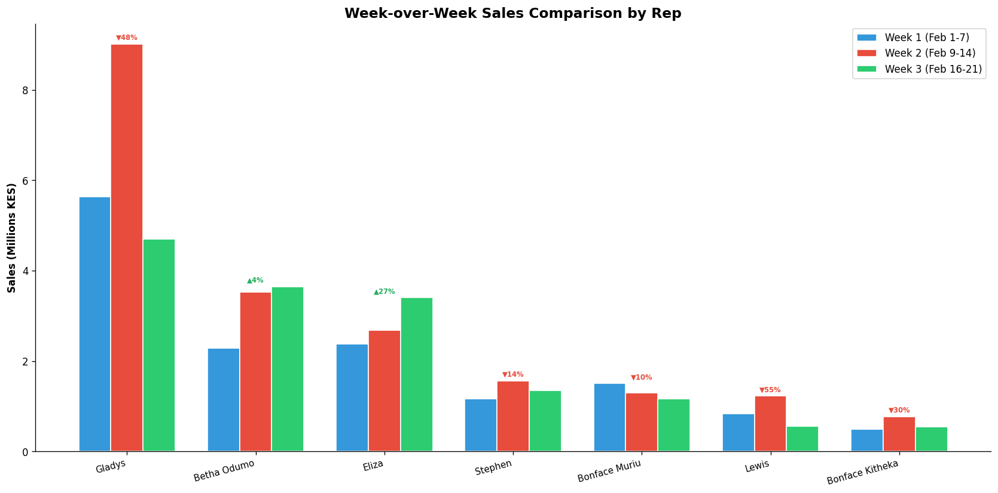

DEPARTMENT LEADERSHIP: PLUMBING
Rep | Dept Sales | Dept Profit | Margin | Dept Share
Lewis | KES 619,610 | KES 158,458 | 25.6% | 43.6%
Stephen | KES 211,720 | KES 34,434 | 16.3% | 14.9%
Eliza | KES 180,225 | KES 58,666 | 32.6% | 12.7%
Bonface Kitheka | KES 143,176 | KES 35,799 | 25.0% | 10.1%
Gladys | KES 102,600 | KES 27,921 | 27.2% | 7.2%
Bonface Muriu | KES 90,750 | KES 23,658 | 26.1% | 6.4%
Betha Odumo | KES 73,580 | KES 21,366 | 29.0% | 5.2%

✓ Strong department leadership — Lewis controls 43.6% of PLUMBING sales

PERFORMANCE NOTES
- Sales 63% below team average - needs improvement
- Excellent margin at 14.3% (Team avg: 8.7%)
- W1→W2: Strong growth +46.3% (KES 838K → 1,226K)
- W2→W3: Declined -55.0% (KES 1,226K → 551K)
- ⚠️ Week 3 reversal after Week 2 growth - monitor closely
- Plumbing Dept Head: 43.6% of dept sales, 25.6% margin
- ✓ Strong plumbing leadership with 43.6% of dept sales
- ✓ Selling across all 4 categories - excellent product range
- Best margin in PLUMBING: 25.6%

RECOMMENDATIONS
- Maintain excellent margin discipline at 14.3% (above team avg of 8.7%).
- Week 3 showed a 55.0% decline. Review customer activity and pipeline for Week 4.
- Selling across all 4 categories — excellent product range coverage.
- Sales are significantly below team average. Consider additional training or customer assignment review.
- As PLUMBING Department Head, only 23.7% of your sales are in your department. Consider refocusing.

--- End of Individual Report ---

