INDIVIDUAL PERFORMANCE REPORT
STEPHEN
General Hardware Team
BOMAS Hardware Store
February 1-21, 2026 (18 Working Days)
Generated: 2026-02-27 15:54:30

PERFORMANCE SNAPSHOT
Metric | Value | Team Comparison
Total Sales | KES 4,067,316 | ▼ 42.7% vs team avg
Total Profit | KES 414,349 | 9.5% of team total
Profit Margin | 10.2% | Team avg: 8.7%
Items Sold | 5,683
Daily Avg Sales | KES 225,962
Daily Avg Profit | KES 23,019
Team Share | 8.2% | #4 of 7 reps
Sales Rank | #4
Margin Rank | #4

WEEKLY SALES BREAKDOWN
Week | Sales | Profit | Margin | Daily Avg | Change
Week 1 (Feb 1-7) | KES 1,156,911 | KES 121,671 | 10.5% | KES 192,818 | —
Week 2 (Feb 9-14) | KES 1,561,475 | KES 162,823 | 10.4% | KES 260,246 | +35.0%
Week 3 (Feb 16-21) | KES 1,348,930 | KES 129,855 | 9.6% | KES 224,822 | -13.6%
TOTAL | KES 4,067,316 | KES 414,349 | 10.2% | KES 225,962 | +16.6%

Weekly Progress
▲ W1→W2: Sales increased by 35.0% (KES 1,157K → 1,561K)
▼ W2→W3: Sales decreased by 13.6% (KES 1,561K → 1,349K)
⚠️ Week 3 reversal after Week 2 growth — monitor closely

CATEGORY PERFORMANCE
Category | Sales | Profit | Margin % | Qty | % of Total
GENERAL HARDWARE | KES 3,589,596 | KES 331,182 | 9.2% | 5,318 | 88.3%
PAINTS | KES 266,000 | KES 48,733 | 18.3% | 265 | 6.5%
PLUMBING | KES 211,720 | KES 34,434 | 16.3% | 100 | 5.2%
TOTAL | KES 4,067,316 | KES 414,349 | 10.2% | 5,683 | 100.0%

Category Weekly Trends
GENERAL HARDWARE: W1: KES 925,821 → W2: KES 1,423,935 → W3: KES 1,239,840 → Overall: ▲34%
PAINTS: W1: KES 74,360 → W2: KES 117,500 → W3: KES 74,140 → Overall: ▼0%
PLUMBING: W1: KES 156,730 → W2: KES 20,040 → W3: KES 34,950 → Overall: ▼78%

VISUAL ANALYSIS

Sales Distribution by Category
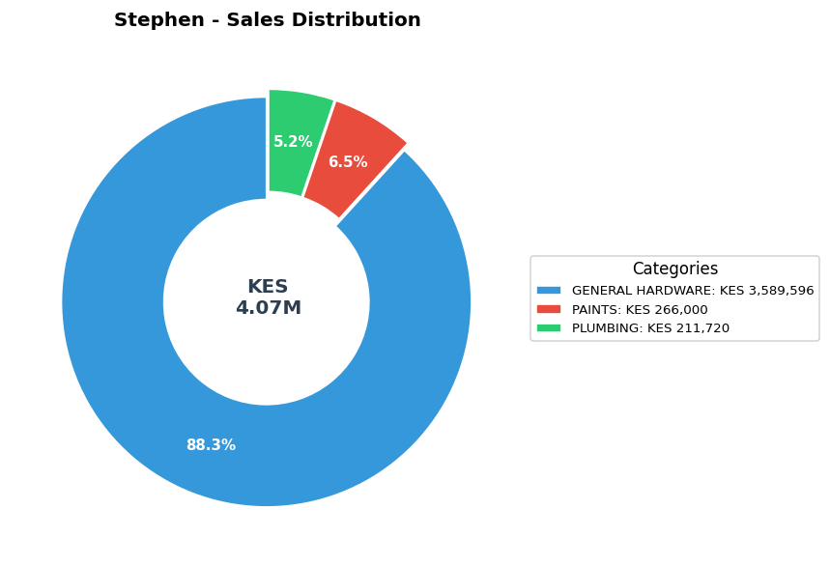

Sales vs Profit by Category
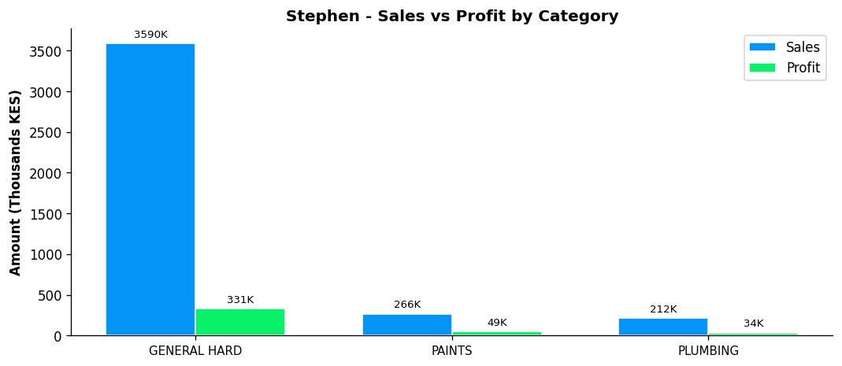

Profit Margin Gauge
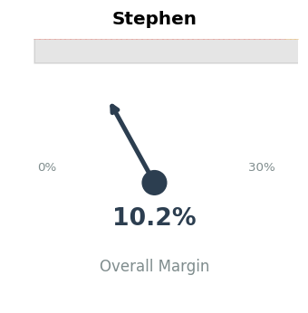

TEAM CONTEXT
How Stephen compares to the rest of the team:

Rank | Rep | Total Sales | Margin % | Team Share
#1 | Gladys | KES 19,339,020 | 5.9% | 38.9%
#2 | Betha Odumo | KES 9,453,025 | 8.1% | 19.0%
#3 | Eliza | KES 8,456,260 | 10.0% | 17.0%
#4 | Stephen | KES 4,067,316 | 10.2% | 8.2%
#5 | Bonface Muriu | KES 3,948,909 | 13.9% | 8.0%
#6 | Lewis | KES 2,614,482 | 14.3% | 5.3%
#7 | Bonface Kitheka | KES 1,790,725 | 14.1% | 3.6%

Team Week-over-Week Comparison
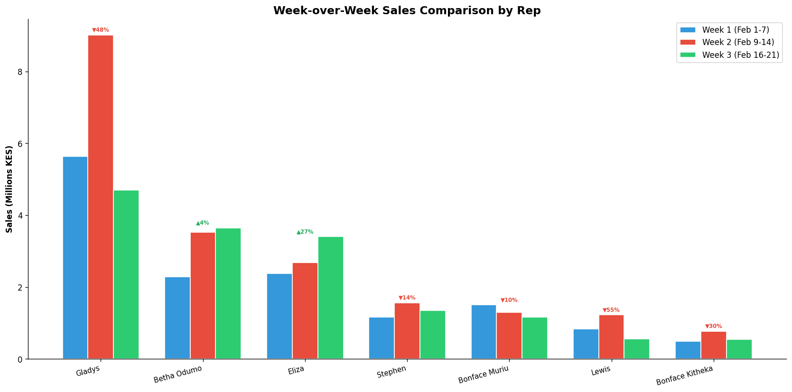

PERFORMANCE NOTES
- Sales 43% below team average - needs improvement
- W1→W2: Strong growth +35.0% (KES 1,157K → 1,561K)
- W2→W3: Declined -13.6% (KES 1,561K → 1,349K)
- ⚠️ Week 3 reversal after Week 2 growth - monitor closely
- General Hardware: 8.2% of dept, 9.2% margin
- Consider expanding into ELECTRICALS
- Best margin in PAINTS: 18.3%

RECOMMENDATIONS
- Maintain excellent margin discipline at 10.2% (above team avg of 8.7%).
- Week 3 showed a 13.6% decline. Review customer activity and pipeline for Week 4.
- Expand into ELECTRICALS to increase cross-selling coverage (currently 3/4 categories).

--- End of Individual Report ---

