SALES PERFORMANCE ANALYSIS
BOMAS - March 2026, Week 1

EXECUTIVE SUMMARY
Total Sales (Incl. VAT) | KES 12,288,061
Total Profit (Incl. VAT) | KES 1,116,848
Overall Margin | 9.1%
Daily Average Sales | KES 2,048,010
Daily Average Profit | KES 186,141
Active Sales Reps | 7

MONTHLY TARGET PROGRESS
After Week 1, the branch has achieved 20.5% of the monthly target (KES 60M). This puts us BEHIND the expected 25% pace.
Category | Monthly Target | Week 1 Actual | % Achieved | Pace
GENERAL HARDWARE | KES 48,500,000 | KES 10,447,608 | 21.5% | Behind
PAINTS | KES 7,000,000 | KES 869,815 | 12.4% | Behind
PLUMBING | KES 3,000,000 | KES 627,548 | 20.9% | Behind
ELECTRICALS | KES 1,500,000 | KES 343,090 | 22.9% | Behind
OVERALL | KES 60,000,000 | KES 12,288,061 | 20.5% | Behind

SALES REP PERFORMANCE
Rank | Sales Rep | Sales (KES) | Profit (KES) | Margin | Contribution
1 | Gladys | 4,753,480 | 275,217 | 5.8% | 38.7%
2 | Betha Odumo | 2,645,238 | 204,956 | 7.7% | 21.5%
3 | Eliza | 2,286,730 | 235,347 | 10.3% | 18.6%
4 | Stephen | 971,120 | 82,594 | 8.5% | 7.9%
5 | Bonface Muriu | 707,920 | 102,855 | 14.5% | 5.8%
6 | Lewis | 477,193 | 122,005 | 25.6% | 3.9%
7 | Bonface Kitheka | 446,380 | 93,873 | 21.0% | 3.6%

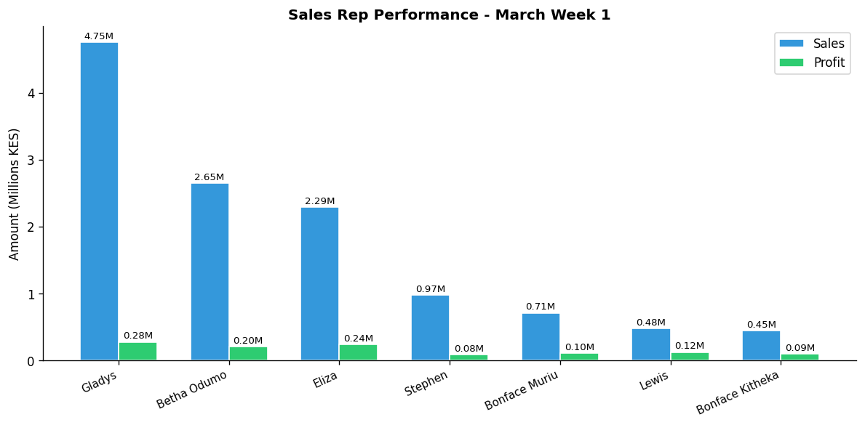

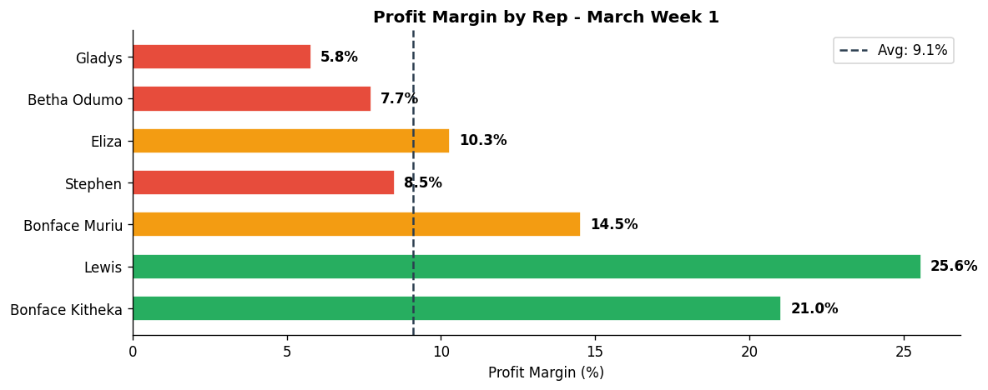

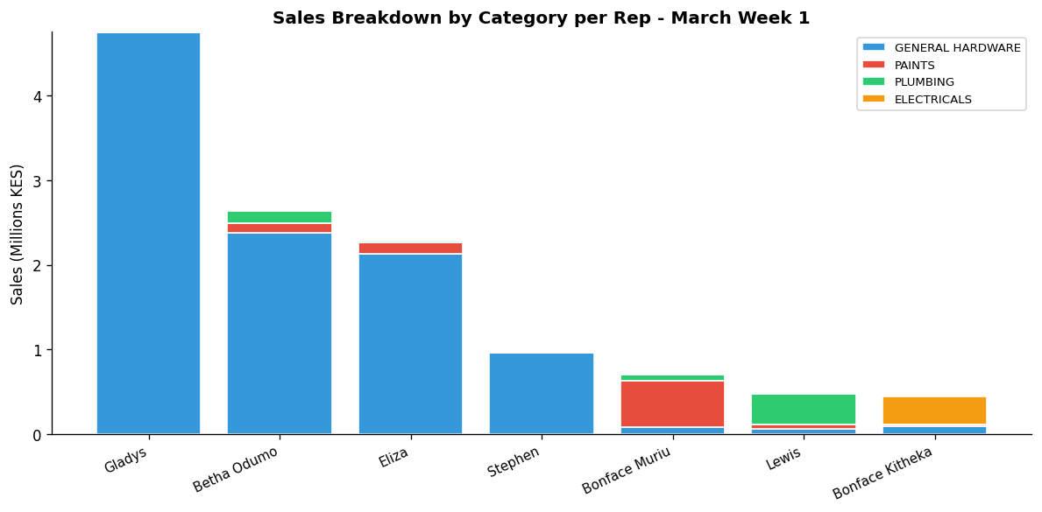

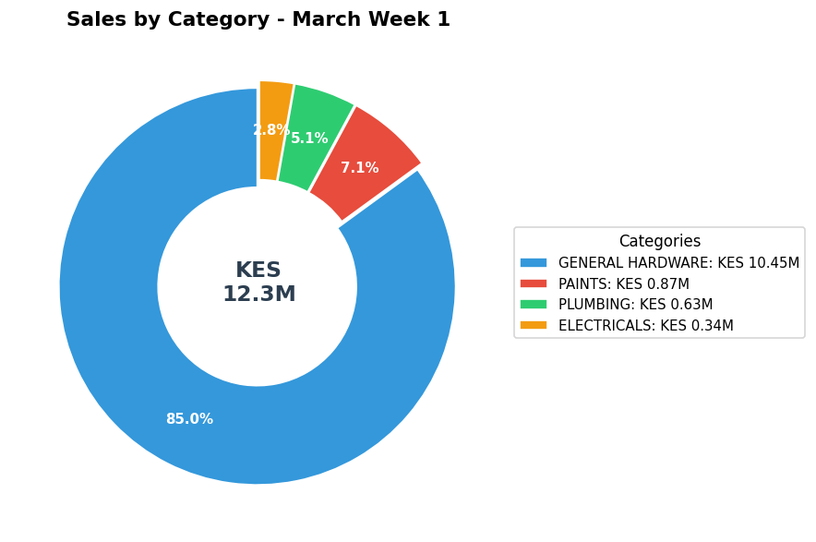

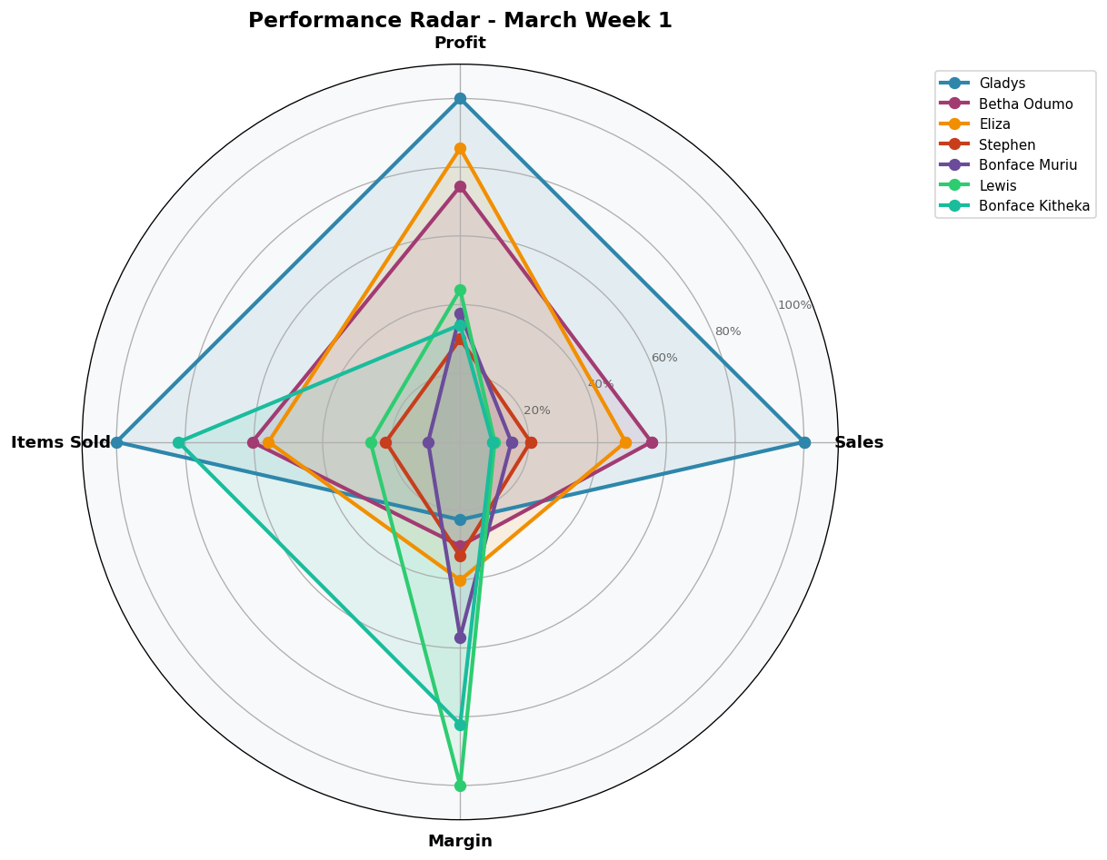

DEPARTMENT DETAILS
GENERAL HARDWARE
Department Head(s): Gladys, Betha Odumo, Eliza, Stephen
Sales: KES 10,447,608 | Profit: KES 762,789 | Margin: 7.3%
Rep | Sales | Profit | Margin | Share
Gladys | KES 4,741,090 | KES 271,575 | 5.7% | 45.4%
Betha Odumo | KES 2,382,408 | KES 163,347 | 6.9% | 22.8%
Eliza | KES 2,125,320 | KES 198,362 | 9.3% | 20.3%
Stephen | KES 959,990 | KES 79,803 | 8.3% | 9.2%
Bonface Kitheka | KES 96,560 | KES 20,892 | 21.6% | 0.9%
Bonface Muriu | KES 76,695 | KES 11,638 | 15.2% | 0.7%
Lewis | KES 65,545 | KES 17,171 | 26.2% | 0.6%

PAINTS
Department Head(s): Bonface Muriu
Sales: KES 869,815 | Profit: KES 147,212 | Margin: 16.9%
Rep | Sales | Profit | Margin | Share
Bonface Muriu | KES 549,715 | KES 81,145 | 14.8% | 63.2%
Eliza | KES 134,900 | KES 28,648 | 21.2% | 15.5%
Betha Odumo | KES 112,650 | KES 20,190 | 17.9% | 13.0%
Lewis | KES 46,510 | KES 11,413 | 24.5% | 5.3%
Bonface Kitheka | KES 15,800 | KES 3,523 | 22.3% | 1.8%
Stephen | KES 6,250 | KES 1,450 | 23.2% | 0.7%
Gladys | KES 3,990 | KES 843 | 21.1% | 0.5%

PLUMBING
Department Head(s): Lewis
Sales: KES 627,548 | Profit: KES 134,365 | Margin: 21.4%
Rep | Sales | Profit | Margin | Share
Lewis | KES 361,968 | KES 92,837 | 25.6% | 57.7%
Betha Odumo | KES 140,760 | KES 17,559 | 12.5% | 22.4%
Bonface Muriu | KES 81,060 | KES 9,893 | 12.2% | 12.9%
Eliza | KES 26,510 | KES 8,338 | 31.5% | 4.2%
Gladys | KES 8,400 | KES 2,800 | 33.3% | 1.3%
Stephen | KES 4,880 | KES 1,341 | 27.5% | 0.8%
Bonface Kitheka | KES 3,970 | KES 1,597 | 40.2% | 0.6%

ELECTRICALS
Department Head(s): Bonface Kitheka
Sales: KES 343,090 | Profit: KES 72,484 | Margin: 21.1%
Rep | Sales | Profit | Margin | Share
Bonface Kitheka | KES 330,050 | KES 67,861 | 20.6% | 96.2%
Betha Odumo | KES 9,420 | KES 3,860 | 41.0% | 2.7%
Lewis | KES 3,170 | KES 584 | 18.4% | 0.9%
Bonface Muriu | KES 450 | KES 179 | 39.8% | 0.1%

INDIVIDUAL REP PERFORMANCE
GLADYS - General Hardware Team
TOP SELLER TOP PROFIT
Total Sales | Total Profit | Margin | Items Sold | Rank
KES 4,753,480 | KES 275,217 | 5.8% | 6,082 | #1

Category | Sales | Profit | Margin | Qty
GENERAL HARDWARE | KES 4,741,090 | KES 271,575 | 5.7% | 6,073
PAINTS | KES 3,990 | KES 843 | 21.1% | 7
PLUMBING | KES 8,400 | KES 2,800 | 33.3% | 2

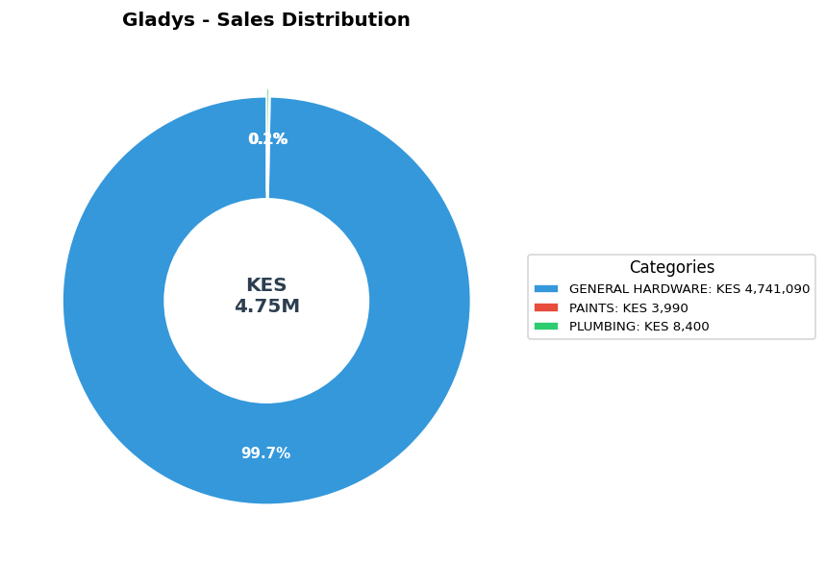

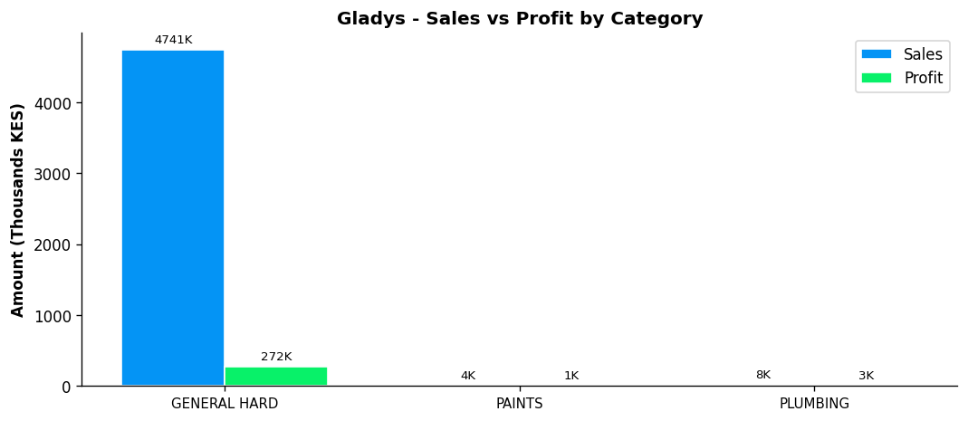

BETHA ODUMO - General Hardware Team
Total Sales | Total Profit | Margin | Items Sold | Rank
KES 2,645,238 | KES 204,956 | 7.7% | 3,679 | #2

Category | Sales | Profit | Margin | Qty
GENERAL HARDWARE | KES 2,382,408 | KES 163,347 | 6.9% | 3,332
PAINTS | KES 112,650 | KES 20,190 | 17.9% | 239
PLUMBING | KES 140,760 | KES 17,559 | 12.5% | 51
ELECTRICALS | KES 9,420 | KES 3,860 | 41.0% | 57

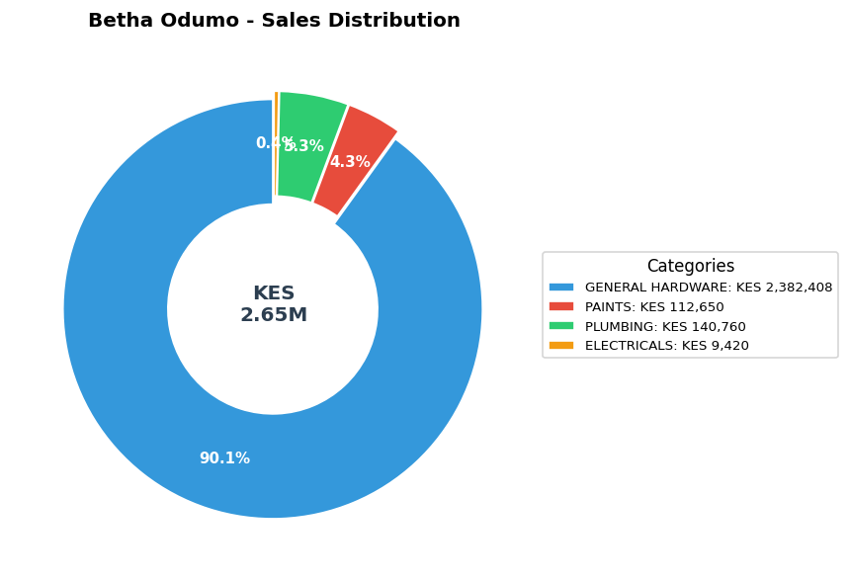

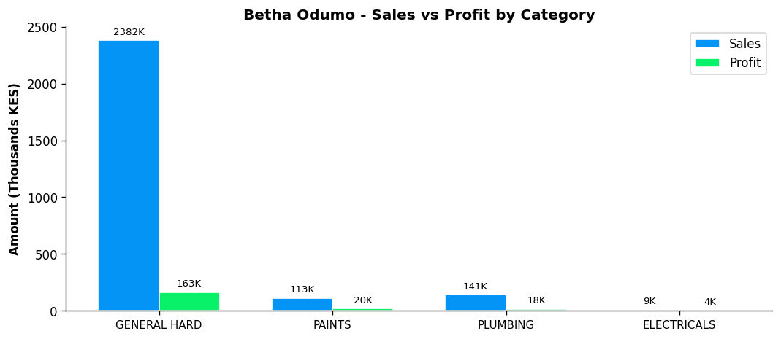

ELIZA - General Hardware Team
Total Sales | Total Profit | Margin | Items Sold | Rank
KES 2,286,730 | KES 235,347 | 10.3% | 3,392 | #3

Category | Sales | Profit | Margin | Qty
GENERAL HARDWARE | KES 2,125,320 | KES 198,362 | 9.3% | 3,078
PAINTS | KES 134,900 | KES 28,648 | 21.2% | 240
PLUMBING | KES 26,510 | KES 8,338 | 31.5% | 74

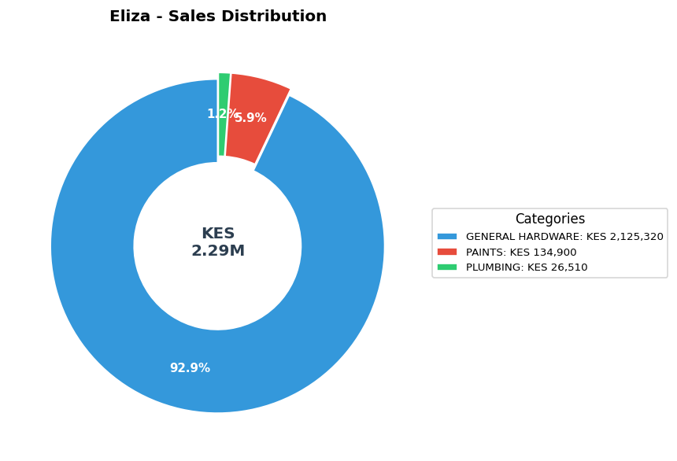

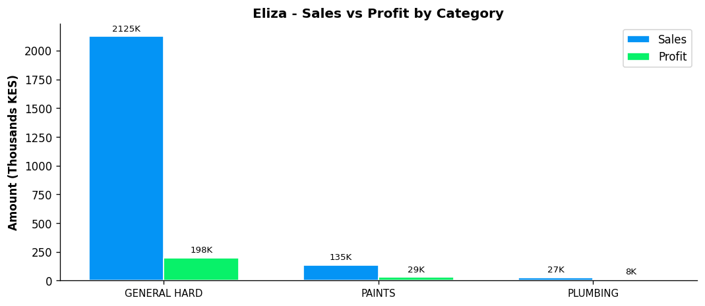

STEPHEN - General Hardware Team
Total Sales | Total Profit | Margin | Items Sold | Rank
KES 971,120 | KES 82,594 | 8.5% | 1,319 | #4

Category | Sales | Profit | Margin | Qty
GENERAL HARDWARE | KES 959,990 | KES 79,803 | 8.3% | 1,294
PAINTS | KES 6,250 | KES 1,450 | 23.2% | 21
PLUMBING | KES 4,880 | KES 1,341 | 27.5% | 4

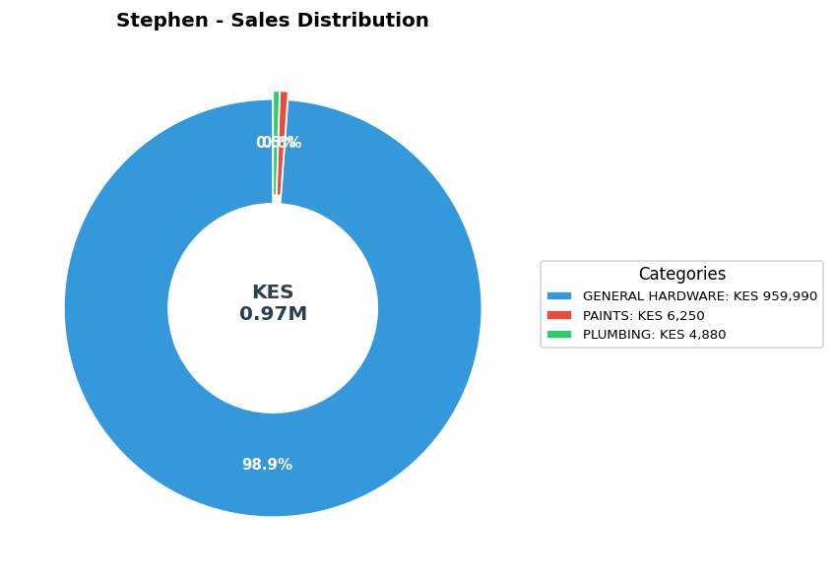

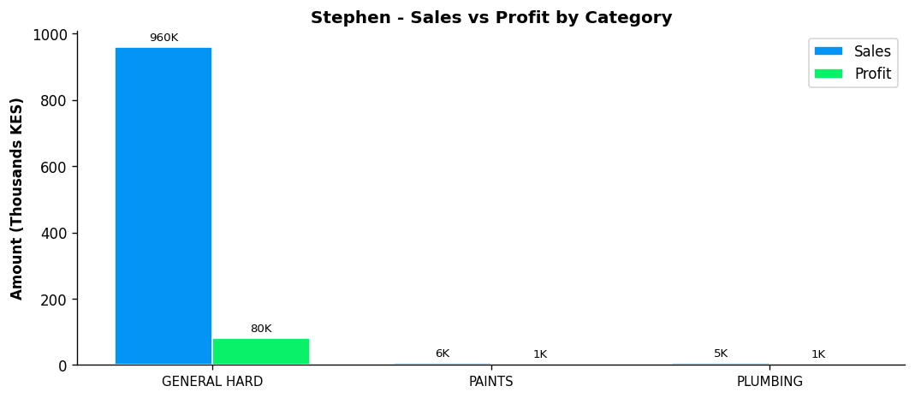

BONFACE MURIU - Department Head - Paints
Total Sales | Total Profit | Margin | Items Sold | Rank
KES 707,920 | KES 102,855 | 14.5% | 568 | #5

Category | Sales | Profit | Margin | Qty
GENERAL HARDWARE | KES 76,695 | KES 11,638 | 15.2% | 74
PAINTS | KES 549,715 | KES 81,145 | 14.8% | 473
PLUMBING | KES 81,060 | KES 9,893 | 12.2% | 18
ELECTRICALS | KES 450 | KES 179 | 39.8% | 3

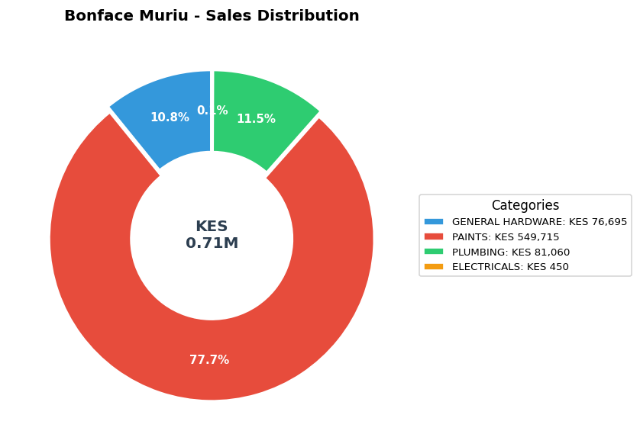

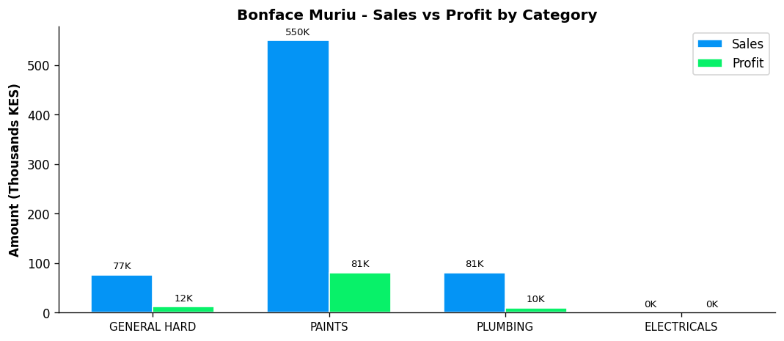

LEWIS - Department Head - Plumbing
BEST MARGIN
Total Sales | Total Profit | Margin | Items Sold | Rank
KES 477,193 | KES 122,005 | 25.6% | 1,588 | #6

Category | Sales | Profit | Margin | Qty
GENERAL HARDWARE | KES 65,545 | KES 17,171 | 26.2% | 167
PAINTS | KES 46,510 | KES 11,413 | 24.5% | 130
PLUMBING | KES 361,968 | KES 92,837 | 25.6% | 1,286
ELECTRICALS | KES 3,170 | KES 584 | 18.4% | 5

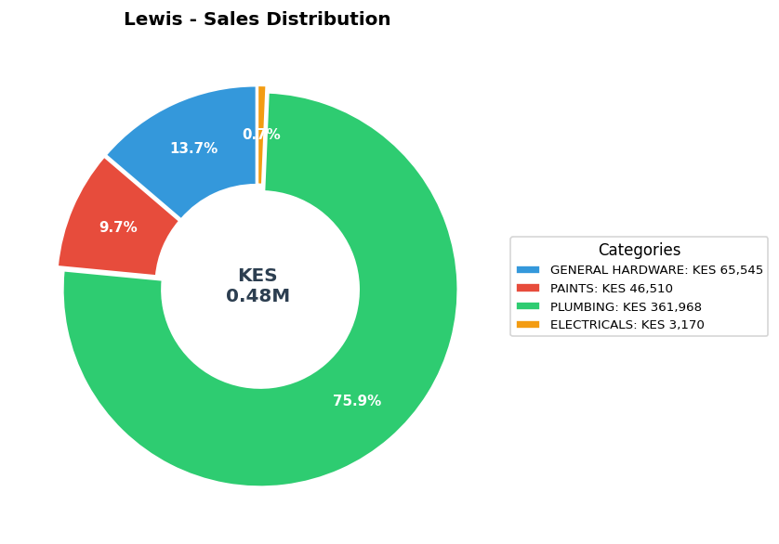

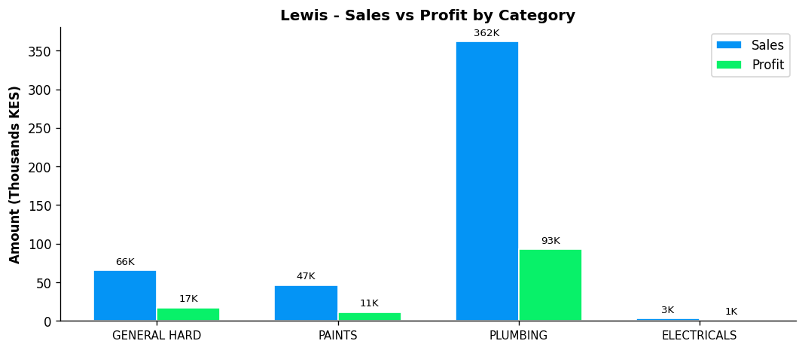

BONFACE KITHEKA - Department Head - Electricals
Total Sales | Total Profit | Margin | Items Sold | Rank
KES 446,380 | KES 93,873 | 21.0% | 4,985 | #7

Category | Sales | Profit | Margin | Qty
GENERAL HARDWARE | KES 96,560 | KES 20,892 | 21.6% | 541
PAINTS | KES 15,800 | KES 3,523 | 22.3% | 35
PLUMBING | KES 3,970 | KES 1,597 | 40.2% | 11
ELECTRICALS | KES 330,050 | KES 67,861 | 20.6% | 4,398

