KAREN BRANCH - CUSTOMER SALES PERFORMANCE REPORT
Period: January - April 2026

1. Executive Overview
This report consolidates customer sales performance for the Karen Branch from January to April 2026. The total sales generated across all tracked customers was KES 196,466,791.72, delivering a gross profit of KES 14,973,898.98 (Overall Margin: 7.62%).
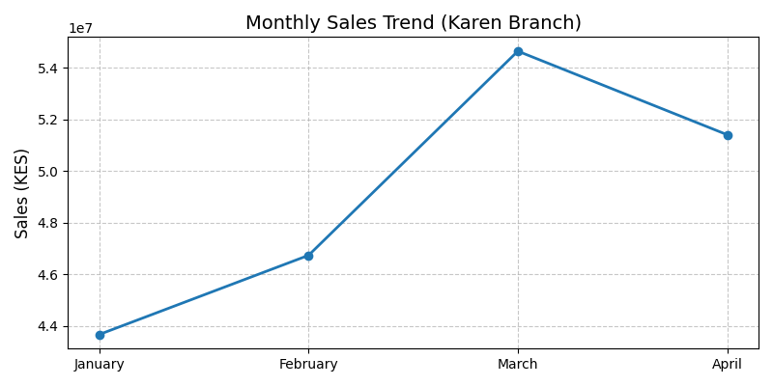

2. Top 10 Customers by YTD Volume
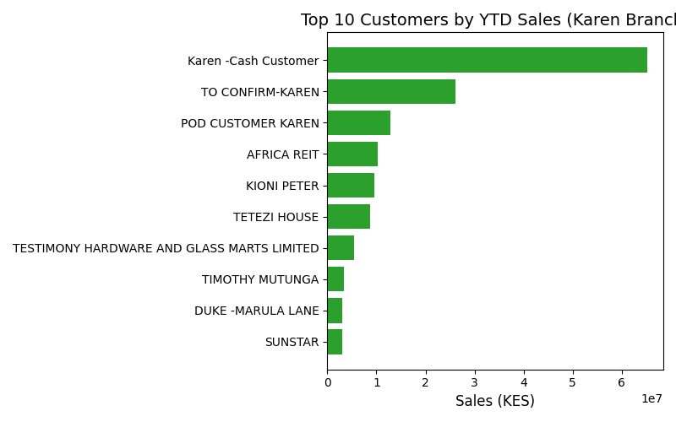
Customer Name | Sales (KES) | Profit (KES) | Margin (%)
Karen -Cash Customer | 65,257,798.23 | 5,854,783.96 | 9.0%
TO CONFIRM-KAREN | 26,081,040.90 | 2,053,499.93 | 7.9%
POD CUSTOMER KAREN | 12,799,768.04 | 826,399.97 | 6.5%
AFRICA REIT | 10,328,301.71 | 667,983.82 | 6.5%
KIONI PETER | 9,583,999.91 | 804,982.49 | 8.4%
TETEZI HOUSE | 8,685,107.70 | 668,058.74 | 7.7%
TESTIMONY HARDWARE AND GLASS MARTS LIMITED | 5,420,137.93 | 207,237.91 | 3.8%
TIMOTHY MUTUNGA | 3,325,068.96 | 187,938.63 | 5.7%
DUKE -MARULA LANE | 3,000,155.26 | 278,453.32 | 9.3%
SUNSTAR | 2,940,775.83 | 135,372.43 | 4.6%

3. Monthly Performance Breakdown
- January: KES 43,665,604.46
- February: KES 46,735,712.99
- March: KES 54,652,442.28
- April: KES 51,413,031.99

