SALES PERFORMANCE ANALYSIS
BOMAS Hardware Store - April 2026, Week All
Period: April 1 - April 30, 2026 (26 working days)
Generated: May 12, 2026

EXECUTIVE SUMMARY
Total Sales (Incl. VAT) | KES 69,864,836
Total Profit (Incl. VAT) | KES 6,160,115
Overall Margin | 8.8%
Daily Average Sales | KES 2,687,109
Daily Average Profit | KES 236,928
Active Sales Reps | 7

MONTHLY TARGET PROGRESS
After Week 1, the branch has achieved 116.4% of the monthly target (KES 60M). This puts us AHEAD of the expected 25% pace.
Category | Monthly Target | Week 1 Actual | % Achieved | Pace
GENERAL HARDWARE | KES 48,500,000 | KES 61,301,331 | 126.4% | Ahead
PAINTS | KES 7,000,000 | KES 5,920,540 | 84.6% | Ahead
PLUMBING | KES 3,000,000 | KES 1,834,255 | 61.1% | Ahead
ELECTRICALS | KES 1,500,000 | KES 808,710 | 53.9% | Ahead
OVERALL | KES 60,000,000 | KES 69,864,836 | 116.4% | Ahead

SALES REP PERFORMANCE
Rank | Sales Rep | Sales (KES) | Profit (KES) | Margin | Contribution
1 | Gladys | 29,407,278 | 1,959,212 | 6.7% | 42.1%
2 | Betha Odumo | 16,509,420 | 1,192,440 | 7.2% | 23.6%
3 | Eliza | 14,180,203 | 1,128,771 | 8.0% | 20.3%
4 | Bonface Muriu | 5,578,445 | 1,065,150 | 19.1% | 8.0%
5 | Lewis | 2,002,130 | 468,827 | 23.4% | 2.9%
6 | Bonface Kitheka | 1,154,035 | 264,750 | 22.9% | 1.7%
7 | Stephen | 1,033,325 | 80,964 | 7.8% | 1.5%

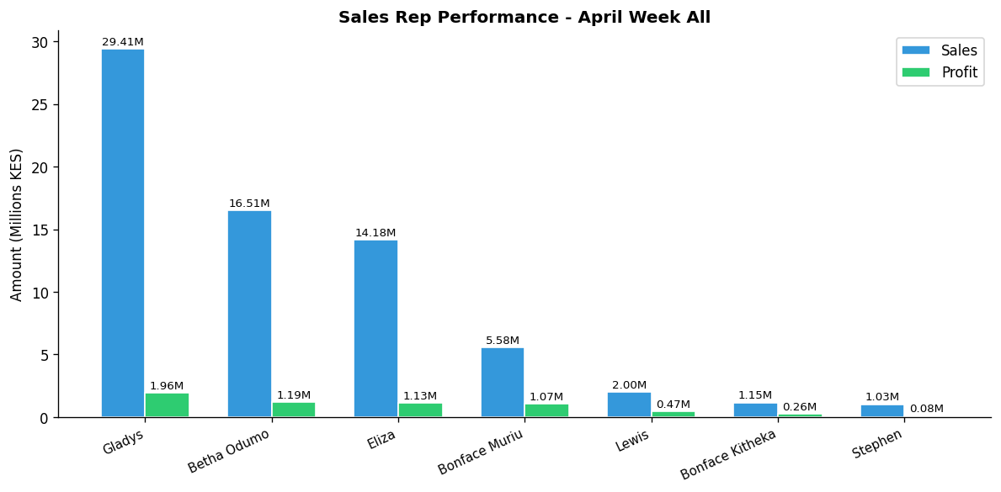

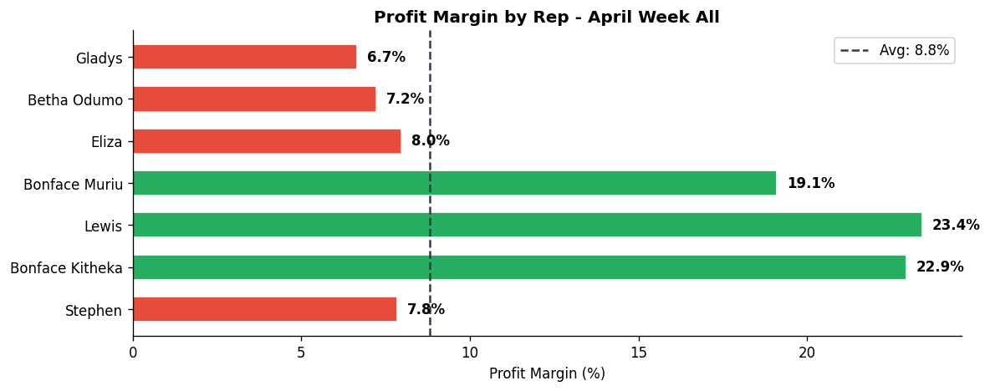

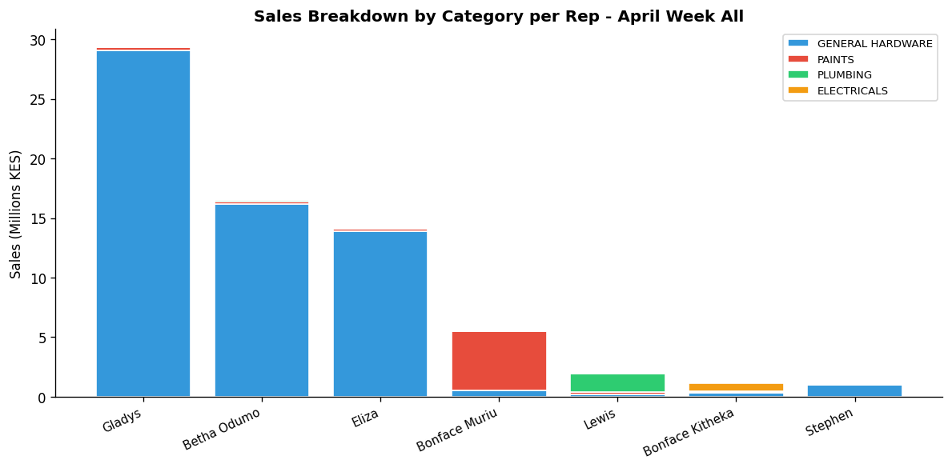

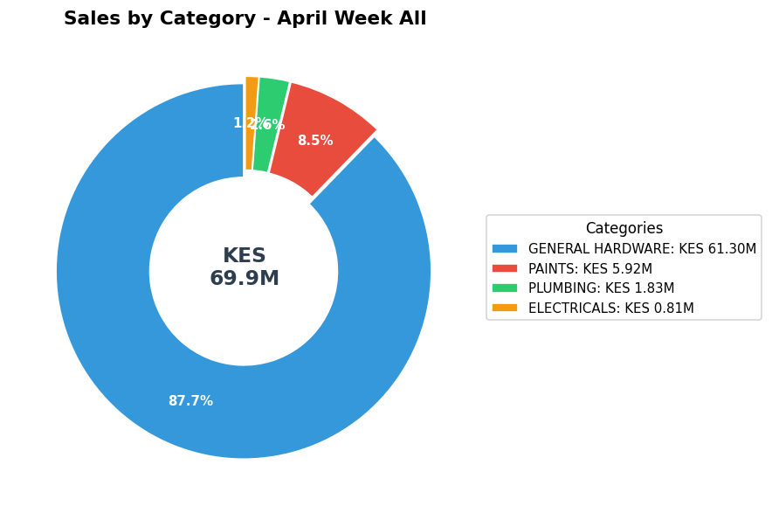

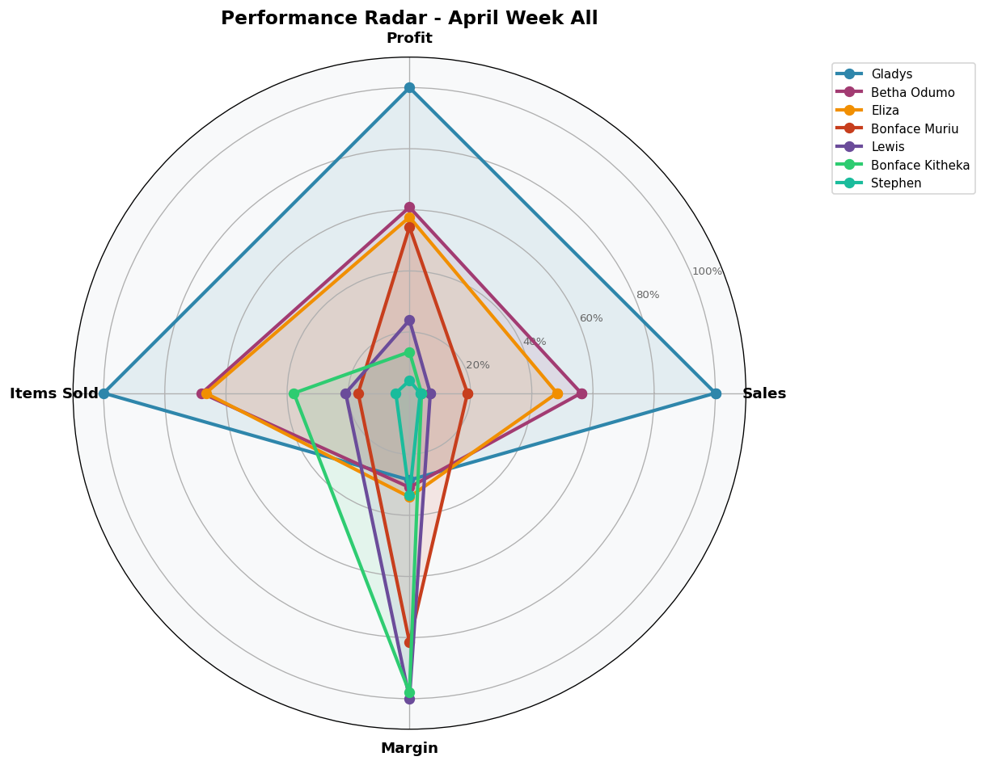

DEPARTMENT DETAILS
GENERAL HARDWARE
Department Head(s): Gladys, Betha Odumo, Eliza, Stephen
Sales: KES 61,301,331 | Profit: KES 4,334,537 | Margin: 7.1%
Rep | Sales | Profit | Margin | Share
Gladys | KES 29,109,268 | KES 1,879,711 | 6.5% | 47.5%
Betha Odumo | KES 16,185,695 | KES 1,119,441 | 6.9% | 26.4%
Eliza | KES 13,915,603 | KES 1,058,524 | 7.6% | 22.7%
Stephen | KES 1,005,625 | KES 74,721 | 7.4% | 1.6%
Bonface Muriu | KES 562,385 | KES 101,905 | 18.1% | 0.9%
Bonface Kitheka | KES 297,885 | KES 55,471 | 18.6% | 0.5%
Lewis | KES 224,870 | KES 44,764 | 19.9% | 0.4%

PAINTS
Department Head(s): Bonface Muriu
Sales: KES 5,920,540 | Profit: KES 1,163,213 | Margin: 19.6%
Rep | Sales | Profit | Margin | Share
Bonface Muriu | KES 4,972,845 | KES 951,182 | 19.1% | 84.0%
Betha Odumo | KES 214,890 | KES 43,742 | 20.4% | 3.6%
Gladys | KES 212,650 | KES 53,648 | 25.2% | 3.6%
Lewis | KES 199,495 | KES 36,295 | 18.2% | 3.4%
Eliza | KES 182,740 | KES 47,507 | 26.0% | 3.1%
Bonface Kitheka | KES 111,520 | KES 25,184 | 22.6% | 1.9%
Stephen | KES 26,400 | KES 5,655 | 21.4% | 0.4%

PLUMBING
Department Head(s): Lewis
Sales: KES 1,834,255 | Profit: KES 466,409 | Margin: 25.4%
Rep | Sales | Profit | Margin | Share
Lewis | KES 1,522,920 | KES 376,835 | 24.7% | 83.0%
Betha Odumo | KES 105,685 | KES 27,726 | 26.2% | 5.8%
Eliza | KES 80,770 | KES 22,450 | 27.8% | 4.4%
Gladys | KES 57,080 | KES 18,285 | 32.0% | 3.1%
Bonface Muriu | KES 34,645 | KES 10,475 | 30.2% | 1.9%
Bonface Kitheka | KES 31,855 | KES 10,049 | 31.5% | 1.7%
Stephen | KES 1,300 | KES 588 | 45.3% | 0.1%

ELECTRICALS
Department Head(s): Bonface Kitheka
Sales: KES 808,710 | Profit: KES 195,957 | Margin: 24.2%
Rep | Sales | Profit | Margin | Share
Bonface Kitheka | KES 712,775 | KES 174,046 | 24.4% | 88.1%
Lewis | KES 54,845 | KES 10,933 | 19.9% | 6.8%
Gladys | KES 28,280 | KES 7,569 | 26.8% | 3.5%
Bonface Muriu | KES 8,570 | KES 1,589 | 18.5% | 1.1%
Betha Odumo | KES 3,150 | KES 1,530 | 48.6% | 0.4%
Eliza | KES 1,090 | KES 291 | 26.7% | 0.1%

INDIVIDUAL REP PERFORMANCE

GLADYS - General Hardware Team
TOP SELLER TOP PROFIT
Total Sales | Total Profit | Margin | Items Sold | Rank
KES 29,407,278 | KES 1,959,212 | 6.7% | 30,267 | #1

Category | Sales | Profit | Margin | Qty
GENERAL HARDWARE | KES 29,109,268 | KES 1,879,711 | 6.5% | 29,416
PAINTS | KES 212,650 | KES 53,648 | 25.2% | 385
PLUMBING | KES 57,080 | KES 18,285 | 32.0% | 113
ELECTRICALS | KES 28,280 | KES 7,569 | 26.8% | 353

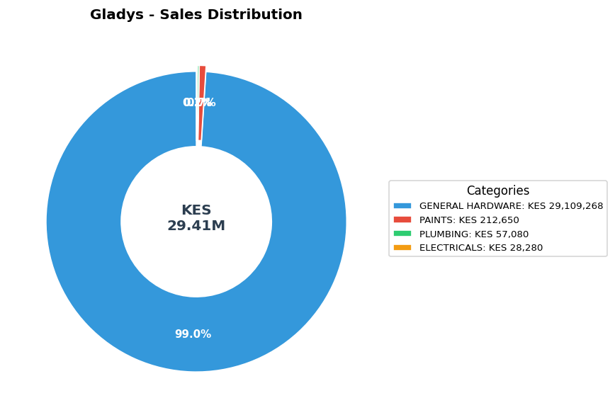

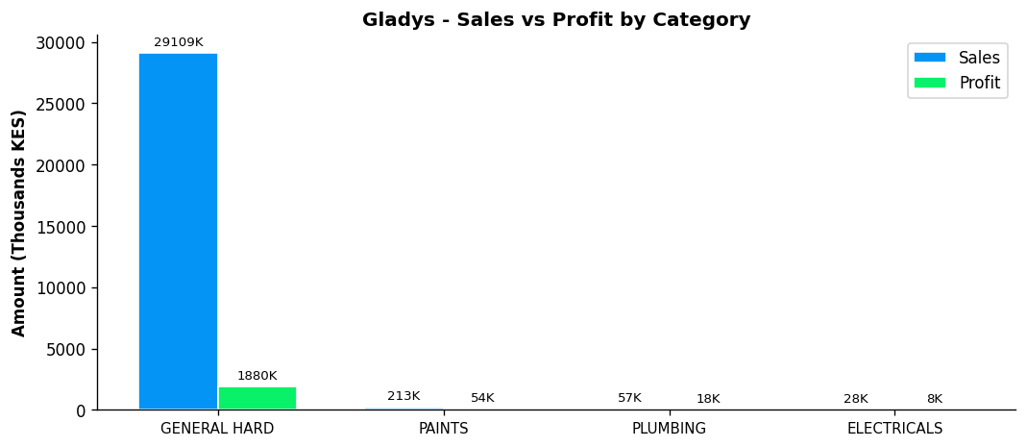
Performance Notes:
- Outstanding! Sales 195% above team average
- Margin at 6.7% below team average of 13.6%
- General Hardware: 47.5% of dept, 6.5% margin
- Selling across all 4 categories - excellent product range
- Best margin in PLUMBING: 32.0%

BETHA ODUMO - General Hardware Team
Total Sales | Total Profit | Margin | Items Sold | Rank
KES 16,509,420 | KES 1,192,440 | 7.2% | 20,558 | #2

Category | Sales | Profit | Margin | Qty
GENERAL HARDWARE | KES 16,185,695 | KES 1,119,441 | 6.9% | 20,041
PAINTS | KES 214,890 | KES 43,742 | 20.4% | 331
PLUMBING | KES 105,685 | KES 27,726 | 26.2% | 137
ELECTRICALS | KES 3,150 | KES 1,530 | 48.6% | 49

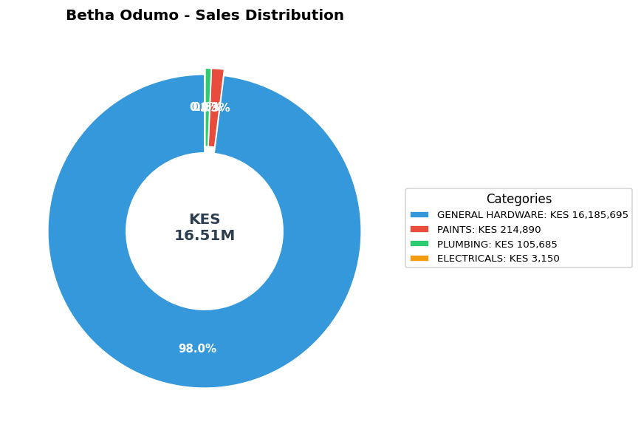

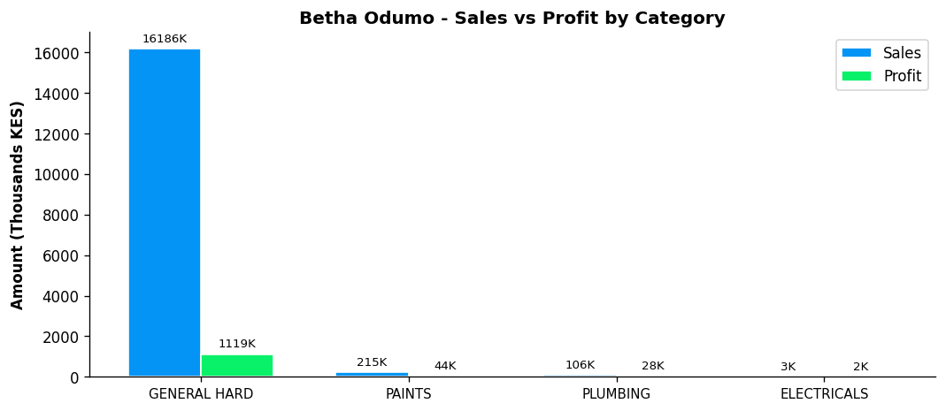
Performance Notes:
- Outstanding! Sales 65% above team average
- Margin at 7.2% below team average of 13.6%
- General Hardware: 26.4% of dept, 6.9% margin
- Selling across all 4 categories - excellent product range
- Best margin in ELECTRICALS: 48.6%

ELIZA - General Hardware Team
Total Sales | Total Profit | Margin | Items Sold | Rank
KES 14,180,203 | KES 1,128,771 | 8.0% | 20,153 | #3

Category | Sales | Profit | Margin | Qty
GENERAL HARDWARE | KES 13,915,603 | KES 1,058,524 | 7.6% | 19,583
PAINTS | KES 182,740 | KES 47,507 | 26.0% | 404
PLUMBING | KES 80,770 | KES 22,450 | 27.8% | 156
ELECTRICALS | KES 1,090 | KES 291 | 26.7% | 10

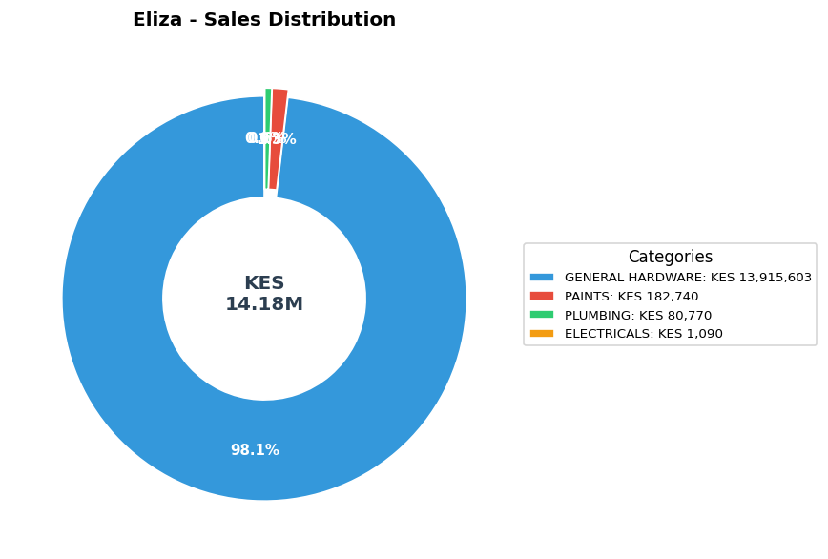

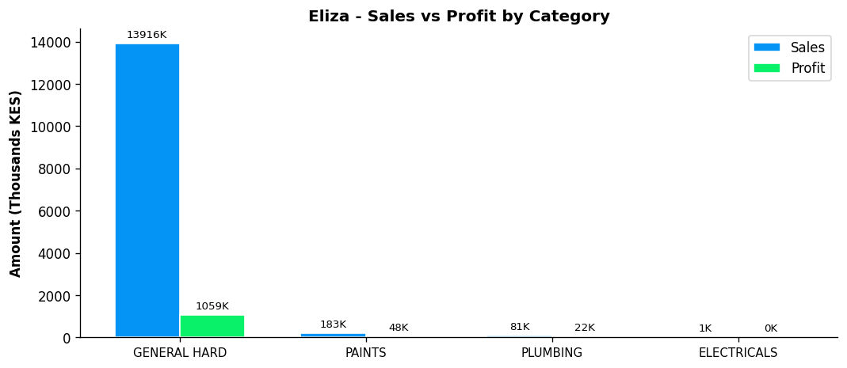
Performance Notes:
- Sales 42% above team average - solid performance
- Margin at 8.0% below team average of 13.6%
- General Hardware: 22.7% of dept, 7.6% margin
- Selling across all 4 categories - excellent product range
- Best margin in PLUMBING: 27.8%

BONFACE MURIU - Department Head - Paints
Total Sales | Total Profit | Margin | Items Sold | Rank
KES 5,578,445 | KES 1,065,150 | 19.1% | 5,079 | #4

Category | Sales | Profit | Margin | Qty
GENERAL HARDWARE | KES 562,385 | KES 101,905 | 18.1% | 1,198
PAINTS | KES 4,972,845 | KES 951,182 | 19.1% | 3,742
PLUMBING | KES 34,645 | KES 10,475 | 30.2% | 116
ELECTRICALS | KES 8,570 | KES 1,589 | 18.5% | 24

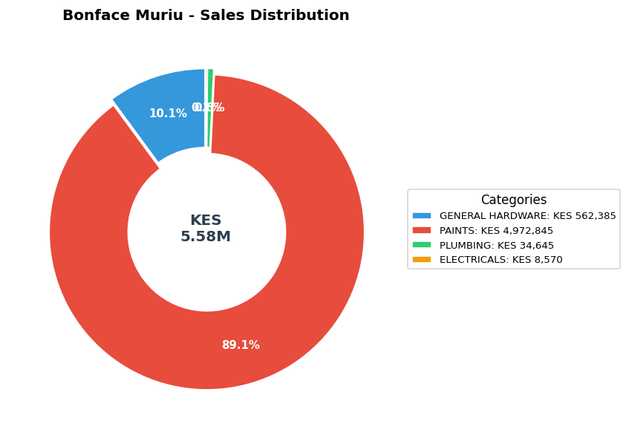

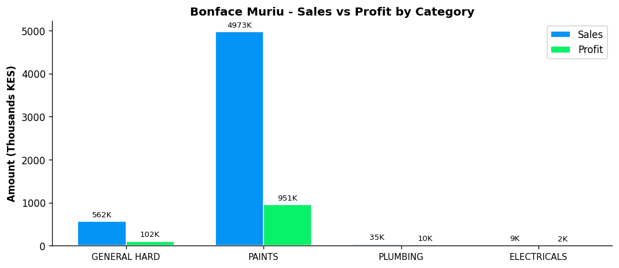
Performance Notes:
- Sales 44% below team average - needs improvement
- Excellent margin at 19.1% (Team avg: 13.6%)
- Paints Dept Head: 84.0% of dept sales, 19.1% margin
- Good paints leadership with 84.0% of dept sales
- Selling across all 4 categories - excellent product range

LEWIS - Department Head - Plumbing
BEST MARGIN
Total Sales | Total Profit | Margin | Items Sold | Rank
KES 2,002,130 | KES 468,827 | 23.4% | 6,317 | #5

Category | Sales | Profit | Margin | Qty
GENERAL HARDWARE | KES 224,870 | KES 44,764 | 19.9% | 430
PAINTS | KES 199,495 | KES 36,295 | 18.2% | 250
PLUMBING | KES 1,522,920 | KES 376,835 | 24.7% | 5,414
ELECTRICALS | KES 54,845 | KES 10,933 | 19.9% | 223

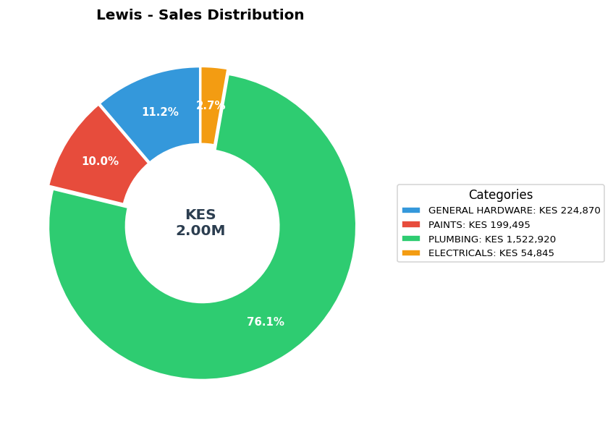

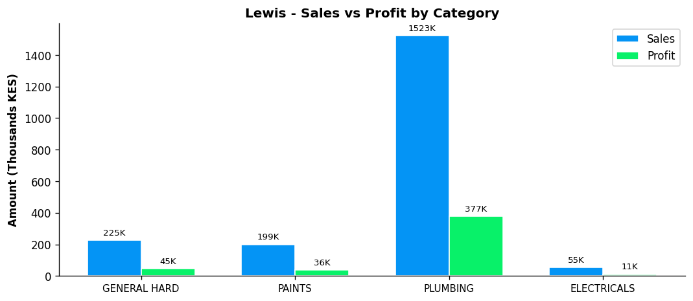
Performance Notes:
- Sales 80% below team average - needs improvement
- Excellent margin at 23.4% (Team avg: 13.6%)
- Plumbing Dept Head: 83.0% of dept sales, 24.7% margin
- Strong plumbing leadership with 83.0% of dept sales
- Selling across all 4 categories - excellent product range

BONFACE KITHEKA - Department Head - Electricals
Total Sales | Total Profit | Margin | Items Sold | Rank
KES 1,154,035 | KES 264,750 | 22.9% | 11,440 | #6

Category | Sales | Profit | Margin | Qty
GENERAL HARDWARE | KES 297,885 | KES 55,471 | 18.6% | 713
PAINTS | KES 111,520 | KES 25,184 | 22.6% | 196
PLUMBING | KES 31,855 | KES 10,049 | 31.5% | 131
ELECTRICALS | KES 712,775 | KES 174,046 | 24.4% | 10,400

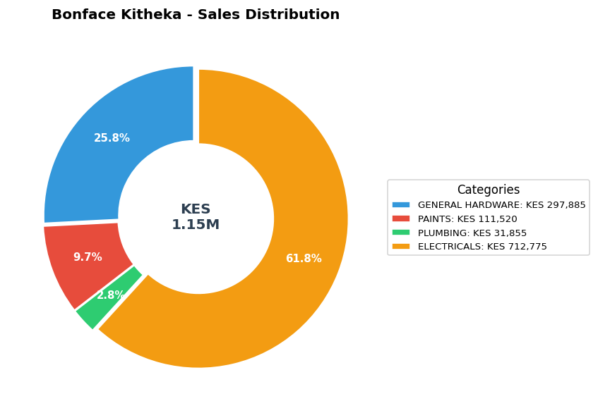

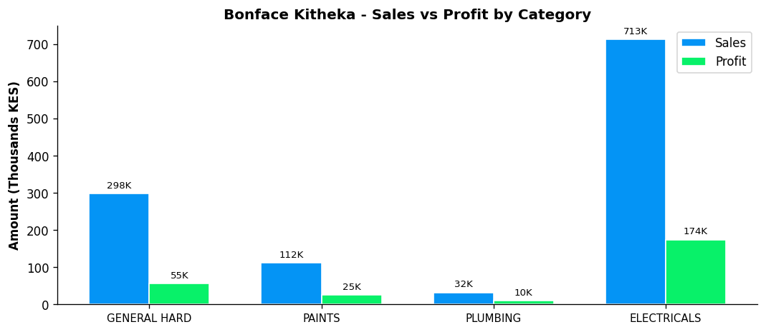
Performance Notes:
- Sales 88% below team average - needs improvement
- Excellent margin at 22.9% (Team avg: 13.6%)
- Electricals Dept Head: 88.1% of dept sales, 24.4% margin
- Strong leadership - controls 88.1% of department sales
- Selling across all 4 categories - excellent product range

STEPHEN - General Hardware Team
Total Sales | Total Profit | Margin | Items Sold | Rank
KES 1,033,325 | KES 80,964 | 7.8% | 1,354 | #7

Category | Sales | Profit | Margin | Qty
GENERAL HARDWARE | KES 1,005,625 | KES 74,721 | 7.4% | 1,303
PAINTS | KES 26,400 | KES 5,655 | 21.4% | 47
PLUMBING | KES 1,300 | KES 588 | 45.3% | 4

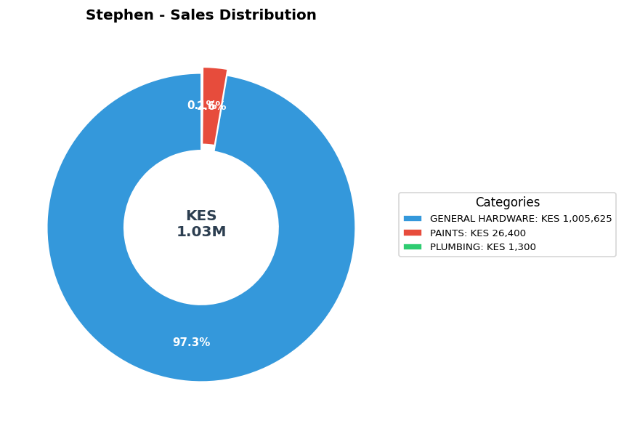

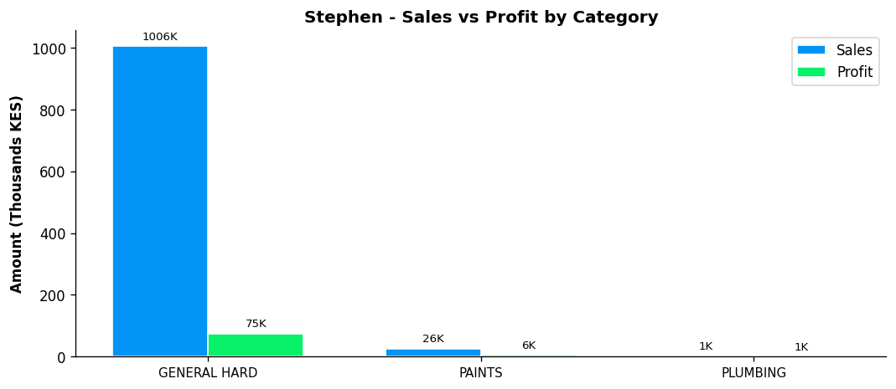
Performance Notes:
- Sales 90% below team average - needs improvement
- Margin at 7.8% below team average of 13.6%
- General Hardware: 1.6% of dept, 7.4% margin
- Consider expanding into ELECTRICALS
- Best margin in PLUMBING: 45.3%

April 2026 STRATEGIC BUSINESS INSIGHTS
1. Overall Monthly Performance
BOMAS Hardware Store generated KES 69,864,836 in revenue and KES 6,160,115 in gross profit during the first 26 working days of April 2026. This translates to an average daily revenue of KES 2,687,109 and an average daily profit of KES 236,928. The overall profit margin stabilized at 8.8%.
2. Departmental Contribution & Margin Analysis
The GENERAL HARDWARE department remains the dominant revenue driver, accounting for 87.7% of total April sales (KES 61,301,331). However, margin analysis reveals that PLUMBING operates at the highest profitability rate (25.4%). Strategic focus should be placed on pushing higher-margin PLUMBING items in May to lift the overall 8.8% store margin.
3. Sales Team Productivity
Sales concentration is notably high among the top performers. Gladys led the month with KES 29,407,278 in sales, followed closely by Betha Odumo (KES 16,509,420). Combined, these top two representatives accounted for 65.7% of the store's total April volume. To mitigate key-person dependency risks, training and mentorship programs should be implemented for the remaining 5 active representatives.
4. May Operational Recommendations
- Balance cross-selling between volume leader (General Hardware) and margin leaders (Plumbing/Electricals).
- Conduct sales training focused on improving the conversion rates and average order values of bottom-quartile representatives.
- Align Minimum Order Quantities (MOQs) with April daily consumption averages to ensure optimal working capital allocation.

