SALES PERFORMANCE ANALYSIS
BOMAS Hardware Store - March 2026, Week 3
Period: March 16-21, 2026 (6 working days)
Generated: March 25, 2026

EXECUTIVE SUMMARY
Total Sales (Incl. VAT) | KES 12,788,645
Total Profit (Incl. VAT) | KES 1,096,521
Overall Margin | 8.6%
Daily Average Sales | KES 2,131,441
Daily Average Profit | KES 182,753
Active Sales Reps | 7

MONTHLY TARGET PROGRESS
After Week 3, the branch has achieved 67.8% of the monthly target (KES 60M). This puts us BEHIND the expected 75% pace.
Category | Monthly Target | Week 3 Actual | % Achieved | Pace
GENERAL HARDWARE | KES 48,500,000 | KES 35,412,619 | 73.0% | Behind
PAINTS | KES 7,000,000 | KES 3,258,343 | 46.5% | Behind
PLUMBING | KES 3,000,000 | KES 1,392,314 | 46.4% | Behind
ELECTRICALS | KES 1,500,000 | KES 589,235 | 39.3% | Behind
OVERALL | KES 60,000,000 | KES 40,652,511 | 67.8% | Behind

SALES REP PERFORMANCE
Rank | Sales Rep | Sales (KES) | Profit (KES) | Margin | Contribution
1 | Gladys | 4,855,140 | 279,952 | 5.8% | 38.0%
2 | Betha Odumo | 3,356,785 | 257,313 | 7.7% | 26.2%
3 | Eliza | 2,036,750 | 155,529 | 7.6% | 15.9%
4 | Stephen | 1,080,965 | 116,901 | 10.8% | 8.5%
5 | Bonface Muriu | 902,470 | 165,252 | 18.3% | 7.1%
6 | Lewis | 381,330 | 85,293 | 22.4% | 3.0%
7 | Bonface Kitheka | 175,205 | 36,281 | 20.7% | 1.4%

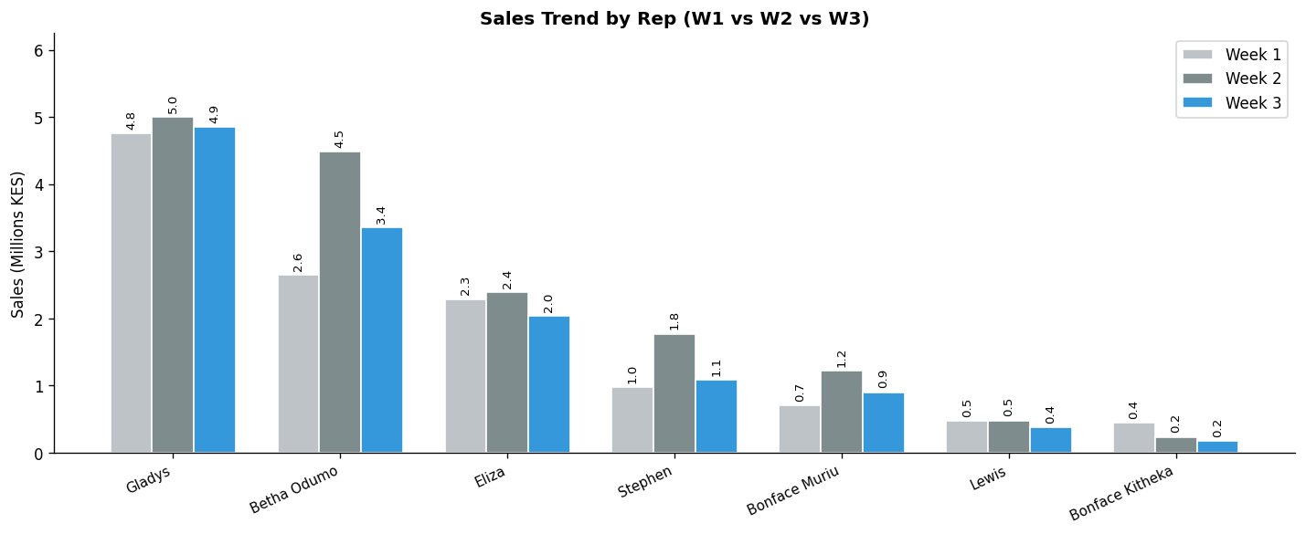

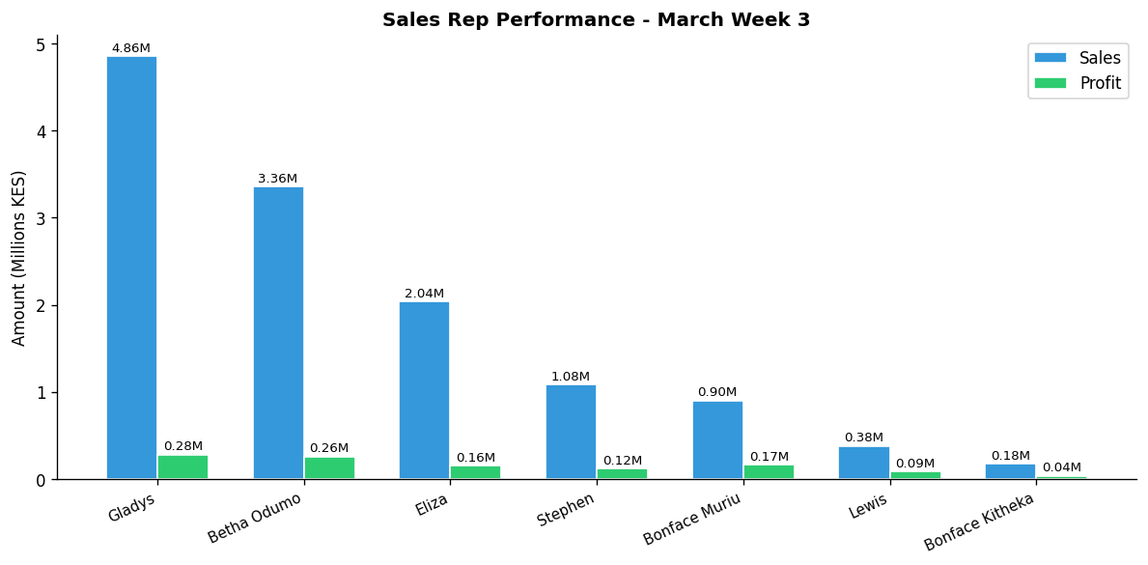

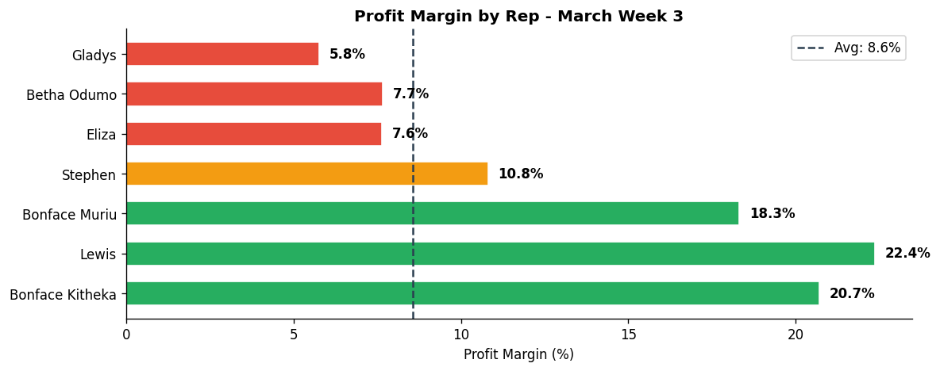

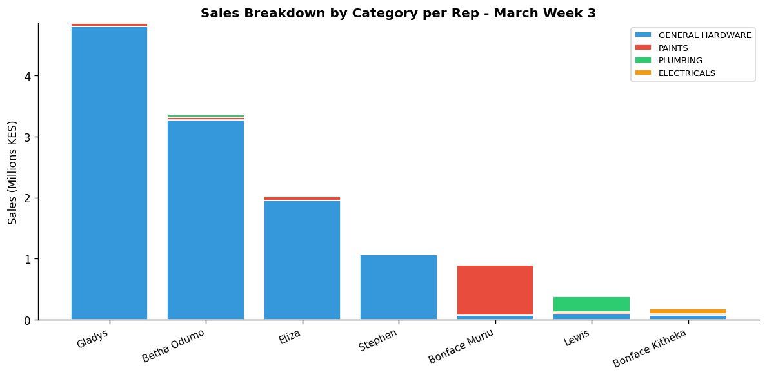

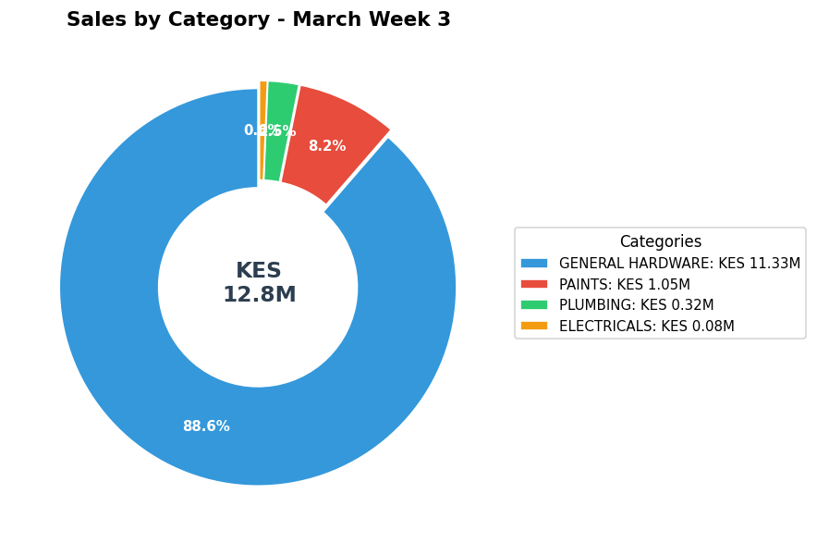

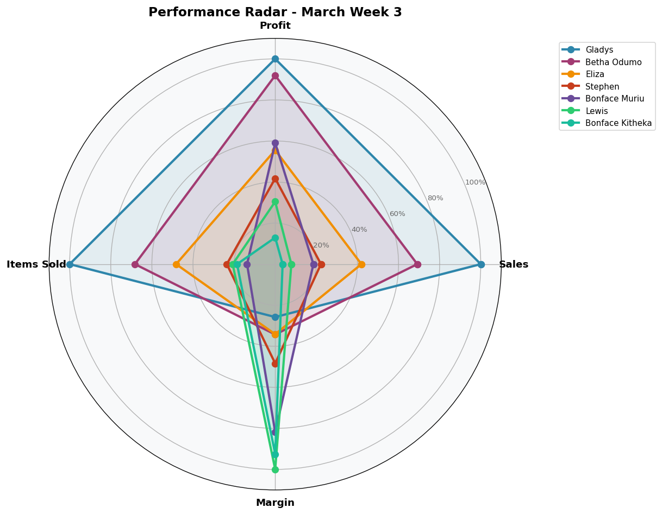

DEPARTMENT DETAILS
GENERAL HARDWARE
Department Head(s): Gladys, Betha Odumo, Eliza, Stephen
Sales: KES 11,334,521 | Profit: KES 805,714 | Margin: 7.1%
Rep | Sales | Profit | Margin | Share
Gladys | KES 4,805,140 | KES 270,204 | 5.6% | 42.4%
Betha Odumo | KES 3,275,991 | KES 244,980 | 7.5% | 28.9%
Eliza | KES 1,955,050 | KES 136,799 | 7.0% | 17.2%
Stephen | KES 1,060,615 | KES 112,736 | 10.6% | 9.4%
Lewis | KES 92,065 | KES 15,606 | 17.0% | 0.8%
Bonface Kitheka | KES 74,260 | KES 11,773 | 15.9% | 0.7%
Bonface Muriu | KES 71,400 | KES 13,616 | 19.1% | 0.6%

PAINTS
Department Head(s): Bonface Muriu
Sales: KES 1,049,188 | Profit: KES 191,062 | Margin: 18.2%
Rep | Sales | Profit | Margin | Share
Bonface Muriu | KES 824,375 | KES 149,071 | 18.1% | 78.6%
Eliza | KES 60,500 | KES 11,248 | 18.6% | 5.8%
Gladys | KES 49,880 | KES 9,669 | 19.4% | 4.8%
Betha Odumo | KES 42,268 | KES 6,239 | 14.8% | 4.0%
Lewis | KES 33,325 | KES 6,501 | 19.5% | 3.2%
Bonface Kitheka | KES 19,890 | KES 4,594 | 23.1% | 1.9%
Stephen | KES 18,950 | KES 3,741 | 19.7% | 1.8%

PLUMBING
Department Head(s): Lewis
Sales: KES 322,591 | Profit: KES 79,203 | Margin: 24.6%
Rep | Sales | Profit | Margin | Share
Lewis | KES 255,940 | KES 63,186 | 24.7% | 79.3%
Betha Odumo | KES 36,606 | KES 5,565 | 15.2% | 11.3%
Eliza | KES 21,050 | KES 7,428 | 35.3% | 6.5%
Bonface Muriu | KES 5,880 | KES 2,111 | 35.9% | 1.8%
Bonface Kitheka | KES 1,835 | KES 479 | 26.1% | 0.6%
Stephen | KES 1,200 | KES 380 | 31.7% | 0.4%
Gladys | KES 80 | KES 54 | 67.5% | 0.0%

ELECTRICALS
Department Head(s): Bonface Kitheka
Sales: KES 82,345 | Profit: KES 20,541 | Margin: 24.9%
Rep | Sales | Profit | Margin | Share
Bonface Kitheka | KES 79,220 | KES 19,434 | 24.5% | 96.2%
Betha Odumo | KES 1,920 | KES 529 | 27.5% | 2.3%
Bonface Muriu | KES 815 | KES 454 | 55.7% | 1.0%
Stephen | KES 200 | KES 44 | 22.2% | 0.2%
Eliza | KES 150 | KES 55 | 36.6% | 0.2%
Gladys | KES 40 | KES 25 | 62.5% | 0.0%

INDIVIDUAL REP PERFORMANCE

GLADYS - General Hardware Team
TOP SELLER TOP PROFIT
Total Sales | Total Profit | Margin | Items Sold | Rank
KES 4,855,140 | KES 279,952 | 5.8% | 5,974 | #1

Category | Sales | Profit | Margin | Qty
GENERAL HARDWARE | KES 4,805,140 | KES 270,204 | 5.6% | 5,864
PAINTS | KES 49,880 | KES 9,669 | 19.4% | 107
PLUMBING | KES 80 | KES 54 | 67.5% | 2
ELECTRICALS | KES 40 | KES 25 | 62.5% | 1

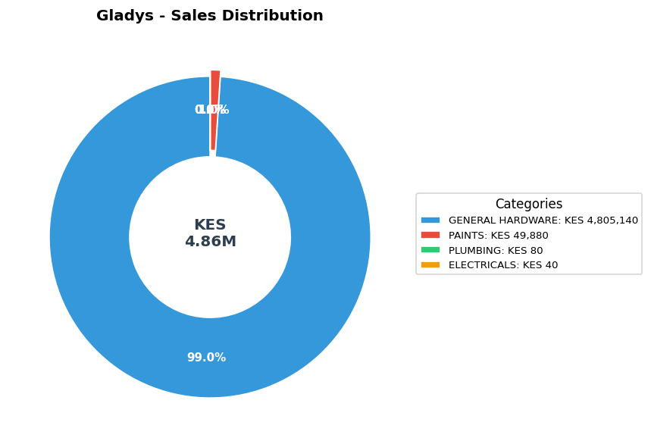

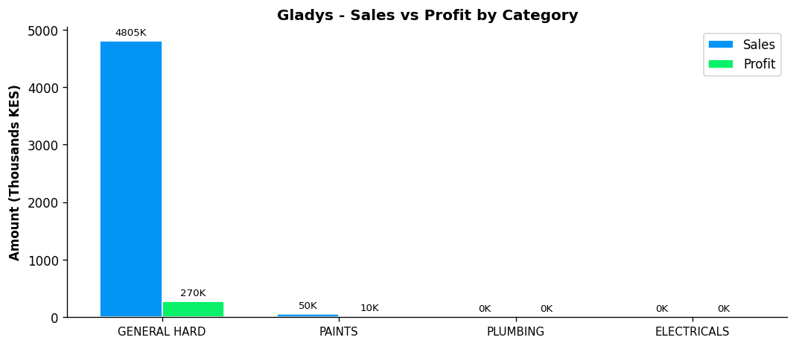
Performance Notes:
- Outstanding! Sales 166% above team average
- Margin at 5.8% below team average of 13.3%
- General Hardware: 42.4% of dept, 5.6% margin
- Selling across all 4 categories - excellent product range
- Best margin in PLUMBING: 67.5%

BETHA ODUMO - General Hardware Team
Total Sales | Total Profit | Margin | Items Sold | Rank
KES 3,356,785 | KES 257,313 | 7.7% | 4,077 | #2

Category | Sales | Profit | Margin | Qty
GENERAL HARDWARE | KES 3,275,991 | KES 244,980 | 7.5% | 3,970
PAINTS | KES 42,268 | KES 6,239 | 14.8% | 44
PLUMBING | KES 36,606 | KES 5,565 | 15.2% | 40
ELECTRICALS | KES 1,920 | KES 529 | 27.5% | 23

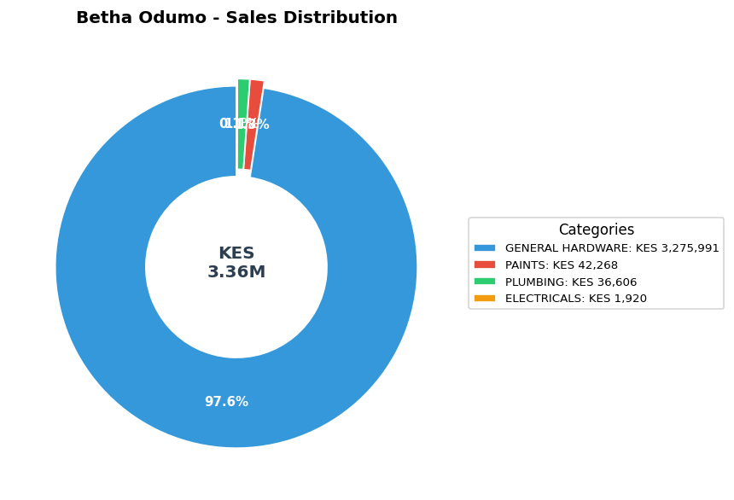

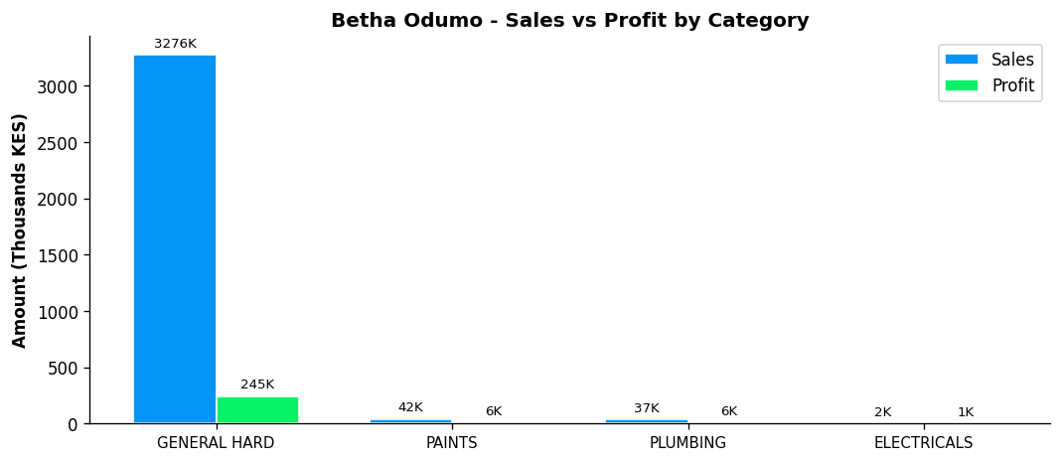
Performance Notes:
- Outstanding! Sales 84% above team average
- Margin at 7.7% below team average of 13.3%
- General Hardware: 28.9% of dept, 7.5% margin
- Selling across all 4 categories - excellent product range
- Best margin in ELECTRICALS: 27.5%

ELIZA - General Hardware Team
Total Sales | Total Profit | Margin | Items Sold | Rank
KES 2,036,750 | KES 155,529 | 7.6% | 2,880 | #3

Category | Sales | Profit | Margin | Qty
GENERAL HARDWARE | KES 1,955,050 | KES 136,799 | 7.0% | 2,682
PAINTS | KES 60,500 | KES 11,248 | 18.6% | 103
PLUMBING | KES 21,050 | KES 7,428 | 35.3% | 95
ELECTRICALS | KES 150 | KES 55 | 36.6% | 1

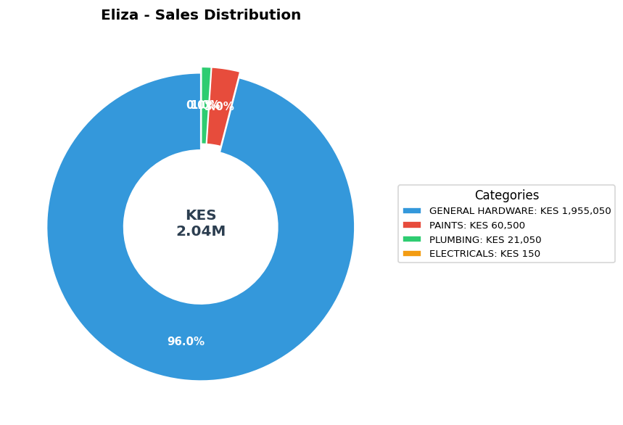

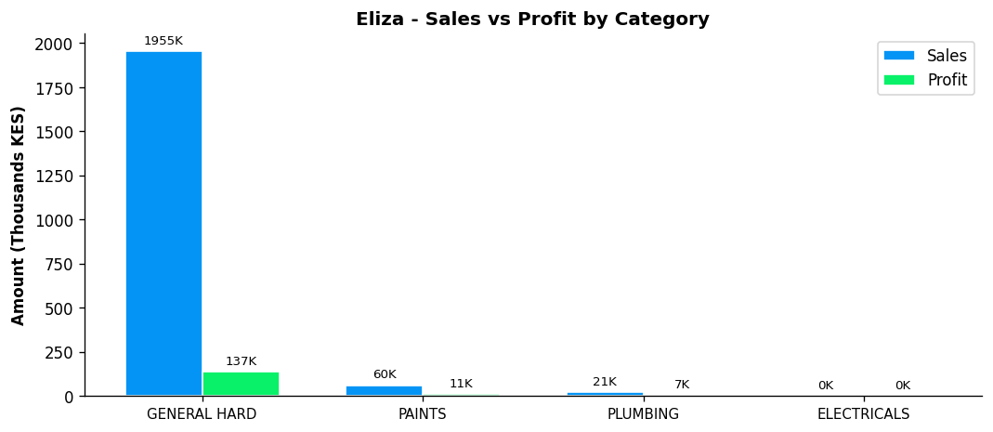
Performance Notes:
- Sales 11% above team average - solid performance
- Margin at 7.6% below team average of 13.3%
- General Hardware: 17.2% of dept, 7.0% margin
- Selling across all 4 categories - excellent product range
- Best margin in ELECTRICALS: 36.6%

STEPHEN - General Hardware Team
Total Sales | Total Profit | Margin | Items Sold | Rank
KES 1,080,965 | KES 116,901 | 10.8% | 1,406 | #4

Category | Sales | Profit | Margin | Qty
GENERAL HARDWARE | KES 1,060,615 | KES 112,736 | 10.6% | 1,376
PAINTS | KES 18,950 | KES 3,741 | 19.7% | 28
PLUMBING | KES 1,200 | KES 380 | 31.7% | 1
ELECTRICALS | KES 200 | KES 44 | 22.2% | 1

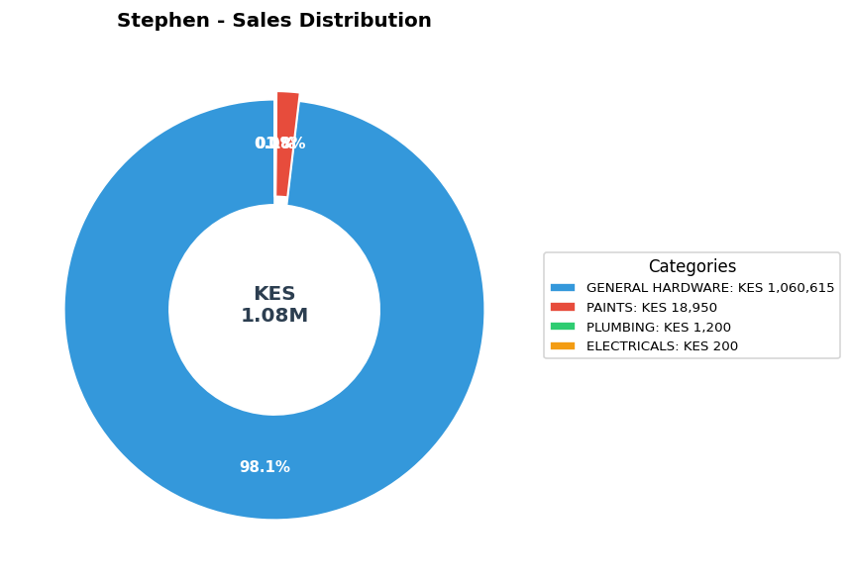

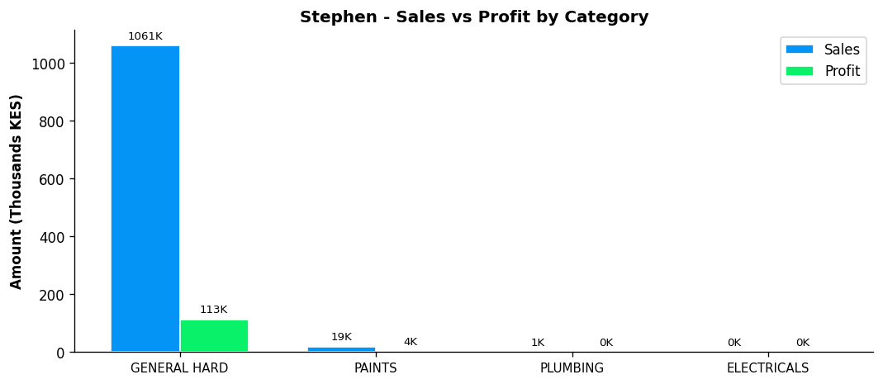
Performance Notes:
- Sales 41% below team average - needs improvement
- Margin at 10.8% below team average of 13.3%
- General Hardware: 9.4% of dept, 10.6% margin
- Selling across all 4 categories - excellent product range
- Best margin in PLUMBING: 31.7%

BONFACE MURIU - Department Head - Paints
Total Sales | Total Profit | Margin | Items Sold | Rank
KES 902,470 | KES 165,252 | 18.3% | 819 | #5

Category | Sales | Profit | Margin | Qty
GENERAL HARDWARE | KES 71,400 | KES 13,616 | 19.1% | 154
PAINTS | KES 824,375 | KES 149,071 | 18.1% | 645
PLUMBING | KES 5,880 | KES 2,111 | 35.9% | 14
ELECTRICALS | KES 815 | KES 454 | 55.7% | 6

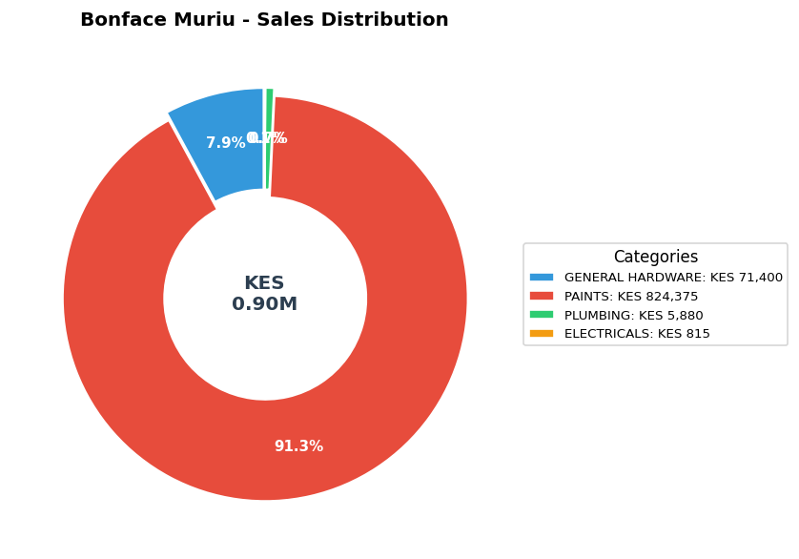

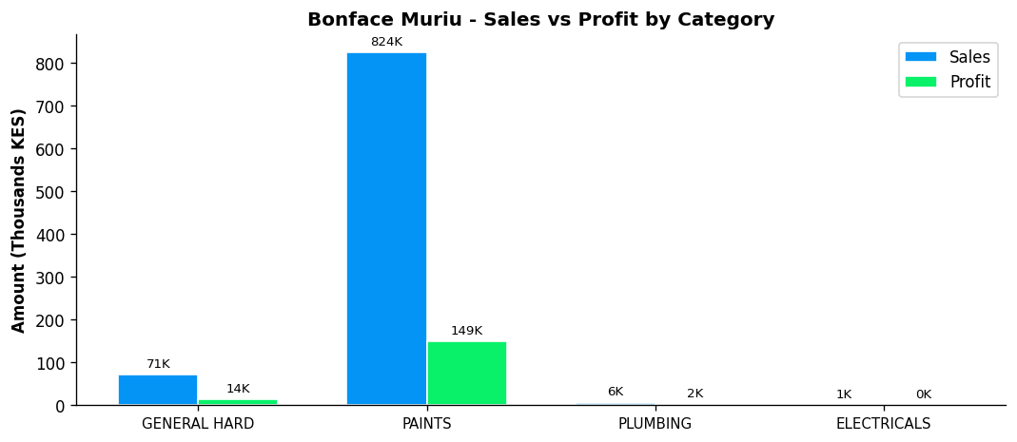
Performance Notes:
- Sales 51% below team average - needs improvement
- Excellent margin at 18.3% (Team avg: 13.3%)
- Paints Dept Head: 78.6% of dept sales, 18.1% margin
- Good paints leadership with 78.6% of dept sales
- Selling across all 4 categories - excellent product range

LEWIS - Department Head - Plumbing
BEST MARGIN
Total Sales | Total Profit | Margin | Items Sold | Rank
KES 381,330 | KES 85,293 | 22.4% | 1,236 | #6

Category | Sales | Profit | Margin | Qty
GENERAL HARDWARE | KES 92,065 | KES 15,606 | 17.0% | 174
PAINTS | KES 33,325 | KES 6,501 | 19.5% | 46
PLUMBING | KES 255,940 | KES 63,186 | 24.7% | 1,016

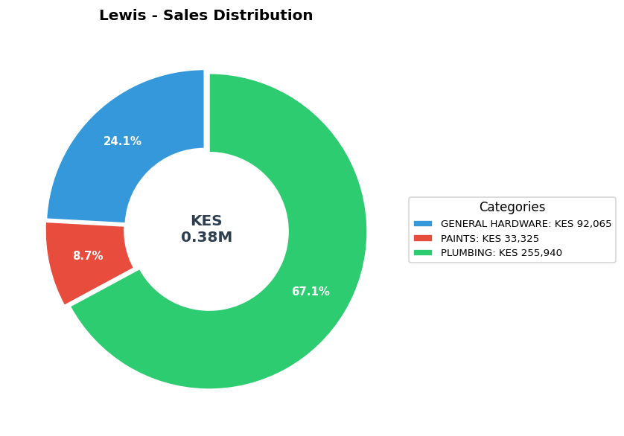

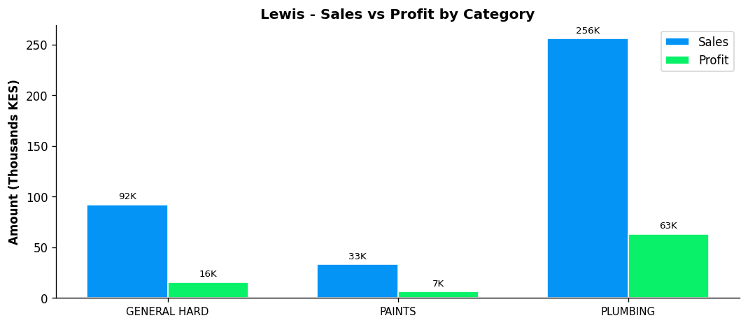
Performance Notes:
- Sales 79% below team average - needs improvement
- Excellent margin at 22.4% (Team avg: 13.3%)
- Plumbing Dept Head: 79.3% of dept sales, 24.7% margin
- Strong plumbing leadership with 79.3% of dept sales
- Consider expanding into ELECTRICALS

BONFACE KITHEKA - Department Head - Electricals
Total Sales | Total Profit | Margin | Items Sold | Rank
KES 175,205 | KES 36,281 | 20.7% | 1,109 | #7

Category | Sales | Profit | Margin | Qty
GENERAL HARDWARE | KES 74,260 | KES 11,773 | 15.9% | 153
PAINTS | KES 19,890 | KES 4,594 | 23.1% | 40
PLUMBING | KES 1,835 | KES 479 | 26.1% | 11
ELECTRICALS | KES 79,220 | KES 19,434 | 24.5% | 905

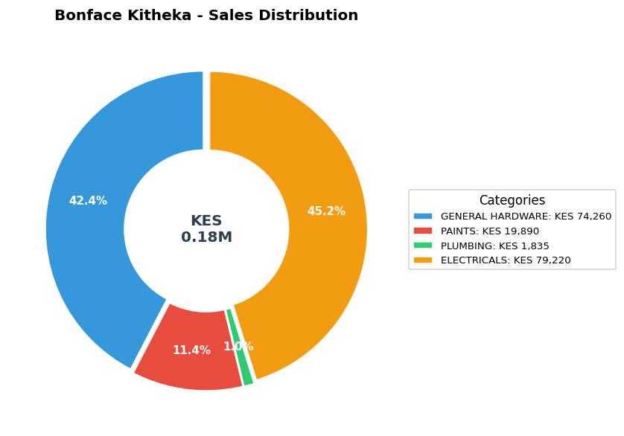

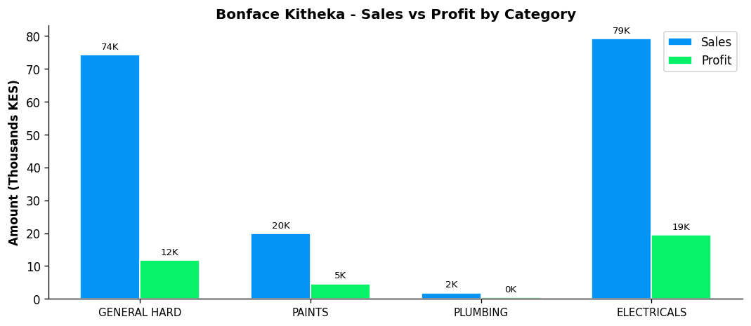
Performance Notes:
- Sales 90% below team average - needs improvement
- Excellent margin at 20.7% (Team avg: 13.3%)
- Electricals Dept Head: 96.2% of dept sales, 24.5% margin
- Strong leadership - controls 96.2% of department sales
- Selling across all 4 categories - excellent product range

