SALES PERFORMANCE ANALYSIS
BOMAS Hardware Store - Q1 2026, Week Q1
Period: January 5 - March 31, 2026 (74 working days)
Generated: April 06, 2026

EXECUTIVE SUMMARY
Total Sales (Incl. VAT) | KES 183,444,382
Total Profit (Incl. VAT) | KES 16,495,301
Overall Margin | 9.0%
Daily Average Sales | KES 2,478,978
Daily Average Profit | KES 222,909
Active Sales Reps | 10

MONTHLY TARGET PROGRESS
After Week 1, the branch has achieved 101.9% of the monthly target (KES 180M). This puts us AHEAD of the expected 25% pace.
Category | Monthly Target | Week 1 Actual | % Achieved | Pace
GENERAL HARDWARE | KES 145,500,000 | KES 159,936,565 | 109.9% | Ahead
PAINTS | KES 21,000,000 | KES 15,769,084 | 75.1% | Ahead
PLUMBING | KES 9,000,000 | KES 5,635,949 | 62.6% | Ahead
ELECTRICALS | KES 4,500,000 | KES 2,102,784 | 46.7% | Ahead
OVERALL | KES 180,000,000 | KES 183,444,382 | 101.9% | Ahead

SALES REP PERFORMANCE
Rank | Sales Rep | Sales (KES) | Profit (KES) | Margin | Contribution
1 | Gladys | 74,132,410 | 4,546,677 | 6.1% | 40.4%
2 | Betha Odumo | 38,903,951 | 3,347,052 | 8.6% | 21.2%
3 | Eliza | 30,855,552 | 2,915,704 | 9.4% | 16.8%
4 | Bonface Muriu | 13,330,942 | 2,015,440 | 15.1% | 7.3%
5 | Stephen | 13,208,958 | 1,421,789 | 10.8% | 7.2%
6 | Lewis | 6,302,141 | 1,146,652 | 18.2% | 3.4%
7 | Bonface Kitheka | 5,406,468 | 879,548 | 16.3% | 2.9%
8 | Dennis Rudiga | 1,230,195 | 214,859 | 17.5% | 0.7%
9 | WALK IN-BOMAS | 76,485 | 8,119 | 10.6% | 0.0%
10 | Unknown | -2,720 | -540 | 0.0% | -0.0%

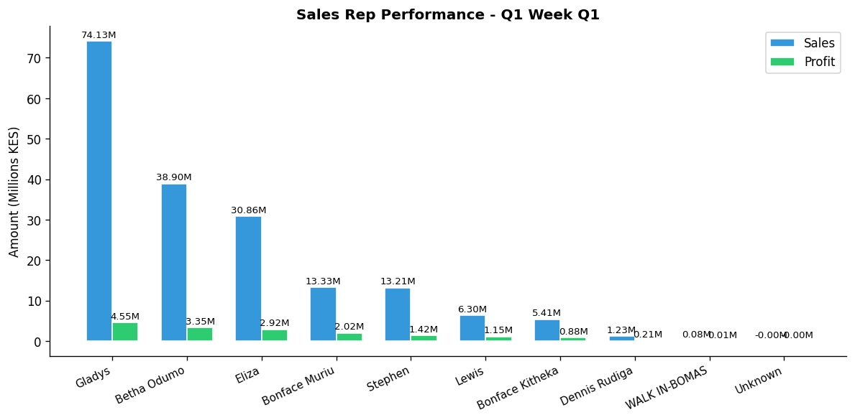

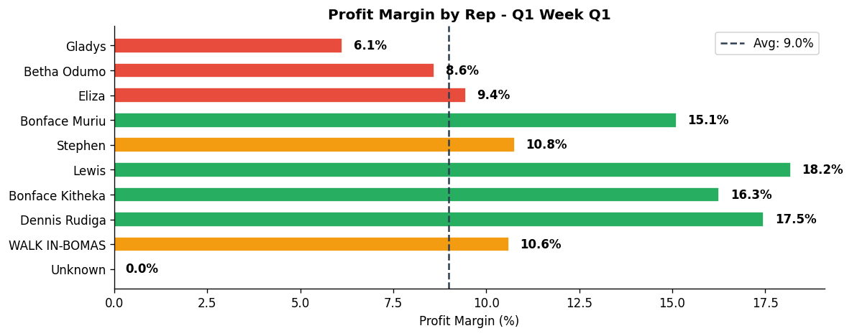

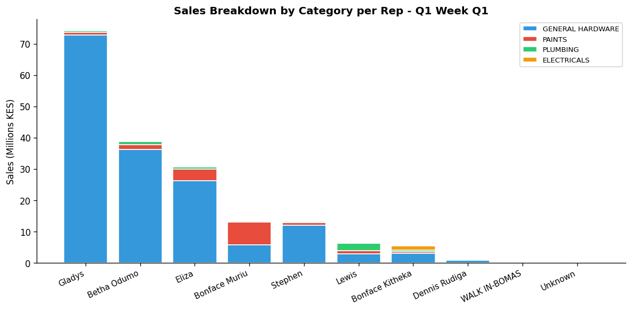

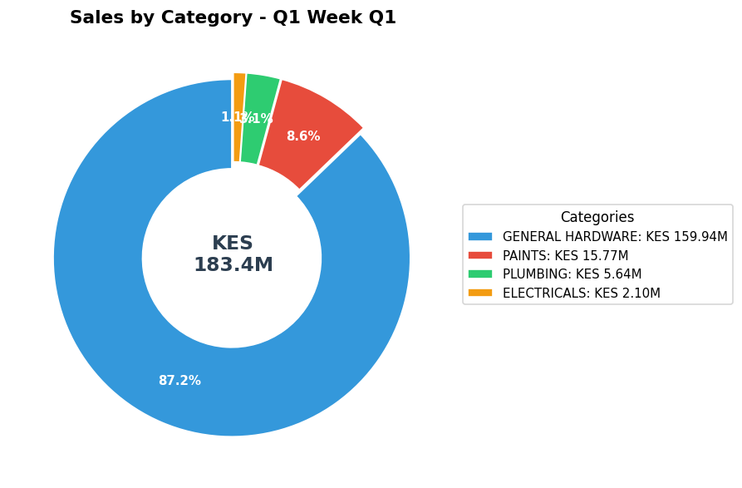

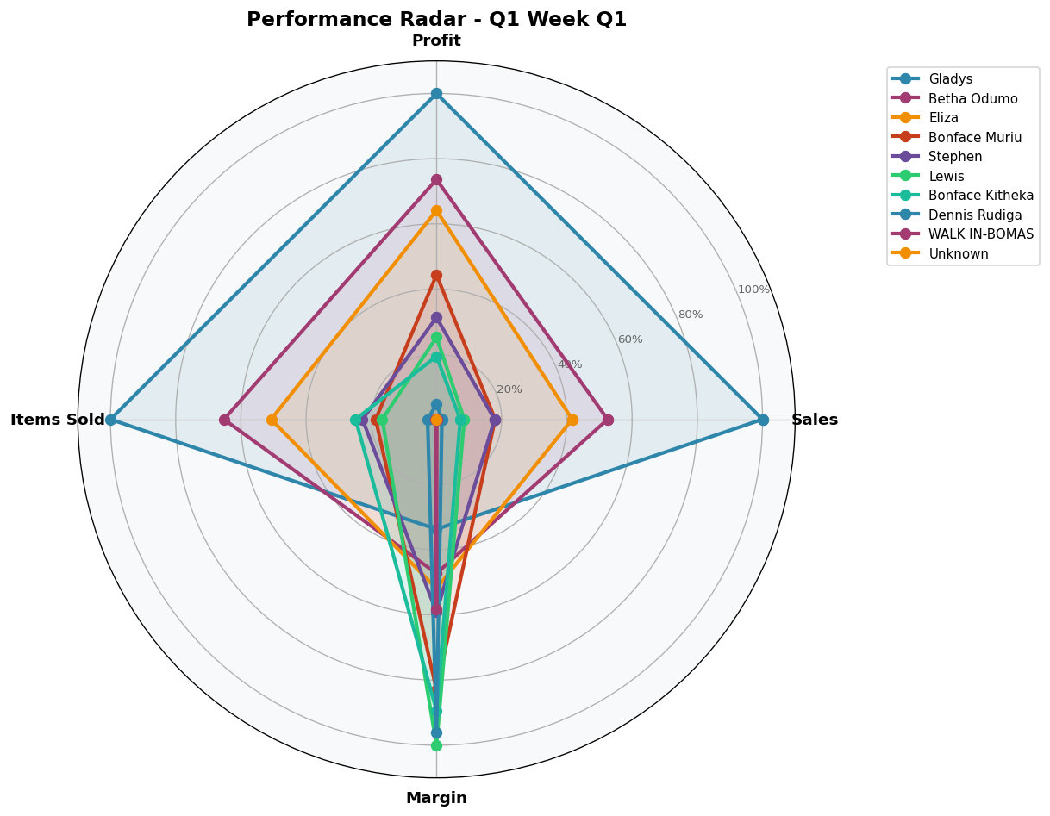

DEPARTMENT DETAILS
GENERAL HARDWARE
Department Head(s): Gladys, Betha Odumo, Eliza, Stephen
Sales: KES 159,936,565 | Profit: KES 11,856,014 | Margin: 7.4%
Rep | Sales | Profit | Margin | Share
Gladys | KES 72,833,280 | KES 4,297,008 | 5.9% | 45.5%
Betha Odumo | KES 36,260,606 | KES 2,791,223 | 7.7% | 22.7%
Eliza | KES 26,296,242 | KES 2,099,885 | 8.0% | 16.4%
Stephen | KES 12,086,148 | KES 1,189,143 | 9.8% | 7.6%
Bonface Muriu | KES 5,664,637 | KES 649,106 | 11.5% | 3.5%
Bonface Kitheka | KES 3,044,170 | KES 343,055 | 11.3% | 1.9%
Lewis | KES 2,946,129 | KES 361,537 | 12.3% | 1.8%
Dennis Rudiga | KES 757,350 | KES 118,019 | 15.6% | 0.5%
WALK IN-BOMAS | KES 48,823 | KES 7,281 | 14.9% | 0.0%
Unknown | KES -820 | KES -244 | 0.0% | -0.0%

PAINTS
Department Head(s): Bonface Muriu
Sales: KES 15,769,084 | Profit: KES 2,725,590 | Margin: 17.3%
Rep | Sales | Profit | Margin | Share
Bonface Muriu | KES 7,313,530 | KES 1,277,469 | 17.5% | 46.4%
Eliza | KES 3,708,040 | KES 556,373 | 15.0% | 23.5%
Betha Odumo | KES 1,539,245 | KES 287,309 | 18.7% | 9.8%
Lewis | KES 890,445 | KES 168,121 | 18.9% | 5.6%
Gladys | KES 877,290 | KES 143,858 | 16.4% | 5.6%
Stephen | KES 710,600 | KES 141,576 | 19.9% | 4.5%
Bonface Kitheka | KES 528,580 | KES 108,509 | 20.5% | 3.4%
Dennis Rudiga | KES 190,560 | KES 42,250 | 22.2% | 1.2%
WALK IN-BOMAS | KES 12,694 | KES 420 | 3.3% | 0.1%
Unknown | KES -1,900 | KES -296 | 0.0% | -0.0%

PLUMBING
Department Head(s): Lewis
Sales: KES 5,635,949 | Profit: KES 1,419,225 | Margin: 25.2%
Rep | Sales | Profit | Margin | Share
Lewis | KES 2,376,352 | KES 595,832 | 25.1% | 42.2%
Betha Odumo | KES 884,570 | KES 210,606 | 23.8% | 15.7%
Eliza | KES 664,770 | KES 211,973 | 31.9% | 11.8%
Bonface Kitheka | KES 396,185 | KES 110,551 | 27.9% | 7.0%
Gladys | KES 385,110 | KES 95,033 | 24.7% | 6.8%
Stephen | KES 383,470 | KES 84,292 | 22.0% | 6.8%
Bonface Muriu | KES 299,885 | KES 70,074 | 23.4% | 5.3%
Dennis Rudiga | KES 233,540 | KES 40,878 | 17.5% | 4.1%
WALK IN-BOMAS | KES 12,067 | KES -14 | -0.1% | 0.2%

ELECTRICALS
Department Head(s): Bonface Kitheka
Sales: KES 2,102,784 | Profit: KES 494,471 | Margin: 23.5%
Rep | Sales | Profit | Margin | Share
Bonface Kitheka | KES 1,437,533 | KES 317,433 | 22.1% | 68.4%
Betha Odumo | KES 219,530 | KES 57,913 | 26.4% | 10.4%
Eliza | KES 186,500 | KES 47,473 | 25.5% | 8.9%
Lewis | KES 89,215 | KES 21,162 | 23.7% | 4.2%
Bonface Muriu | KES 52,890 | KES 18,791 | 35.5% | 2.5%
Dennis Rudiga | KES 48,745 | KES 13,712 | 28.1% | 2.3%
Gladys | KES 36,730 | KES 10,777 | 29.3% | 1.7%
Stephen | KES 28,740 | KES 6,779 | 23.6% | 1.4%
WALK IN-BOMAS | KES 2,901 | KES 432 | 14.9% | 0.1%

INDIVIDUAL REP PERFORMANCE

GLADYS - General Hardware Team
TOP SELLER TOP PROFIT
Total Sales | Total Profit | Margin | Items Sold | Rank
KES 74,132,410 | KES 4,546,677 | 6.1% | 85,597 | #1

Category | Sales | Profit | Margin | Qty
GENERAL HARDWARE | KES 72,833,280 | KES 4,297,008 | 5.9% | 83,531
PAINTS | KES 877,290 | KES 143,858 | 16.4% | 741
PLUMBING | KES 385,110 | KES 95,033 | 24.7% | 914
ELECTRICALS | KES 36,730 | KES 10,777 | 29.3% | 411

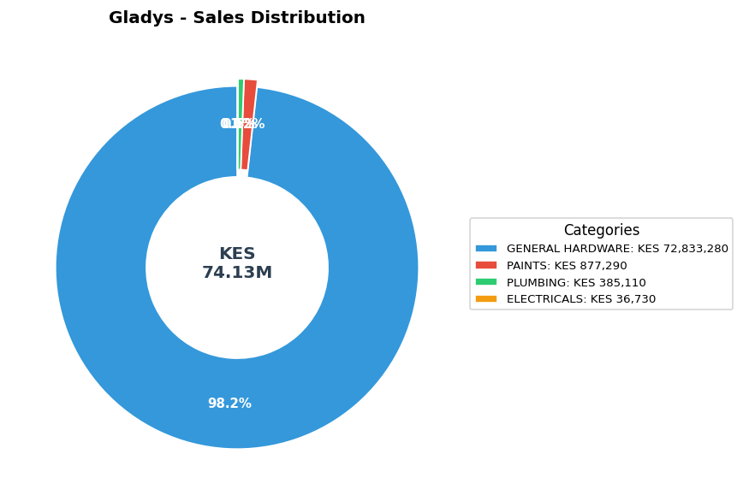

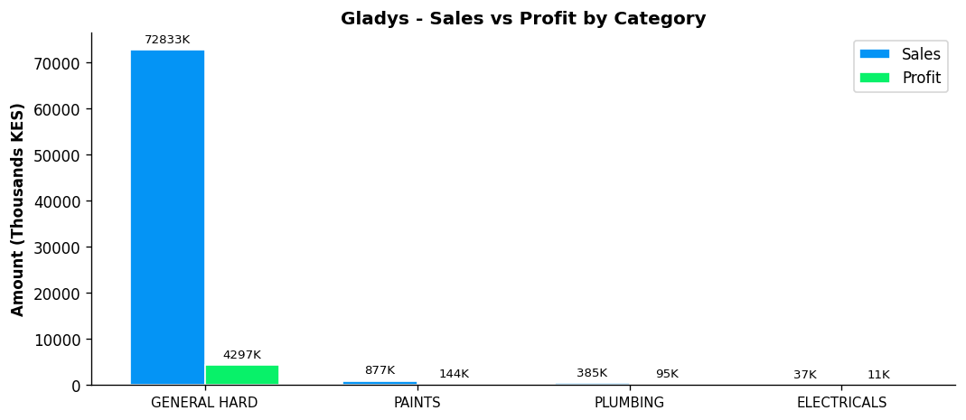
Performance Notes:
- Outstanding! Sales 304% above team average
- Margin at 6.1% below team average of 11.3%
- General Hardware: 45.5% of dept, 5.9% margin
- Selling across all 4 categories - excellent product range
- Best margin in ELECTRICALS: 29.3%

BETHA ODUMO - General Hardware Team
Total Sales | Total Profit | Margin | Items Sold | Rank
KES 38,903,951 | KES 3,347,052 | 8.6% | 55,812 | #2

Category | Sales | Profit | Margin | Qty
GENERAL HARDWARE | KES 36,260,606 | KES 2,791,223 | 7.7% | 48,282
PAINTS | KES 1,539,245 | KES 287,309 | 18.7% | 1,913
PLUMBING | KES 884,570 | KES 210,606 | 23.8% | 2,663
ELECTRICALS | KES 219,530 | KES 57,913 | 26.4% | 2,954

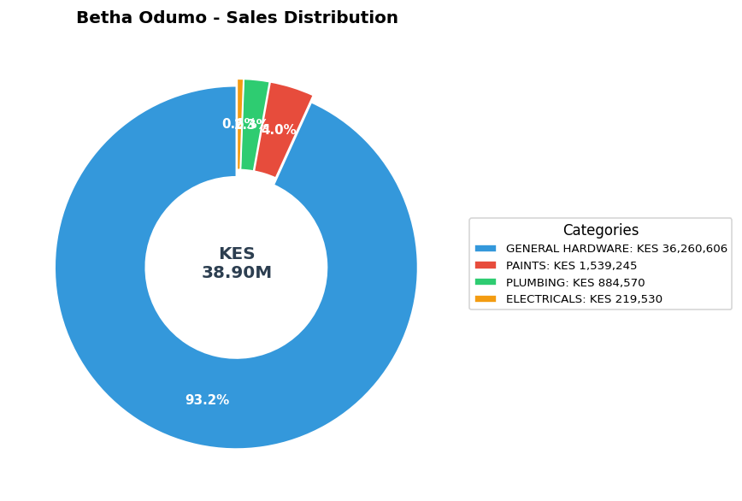

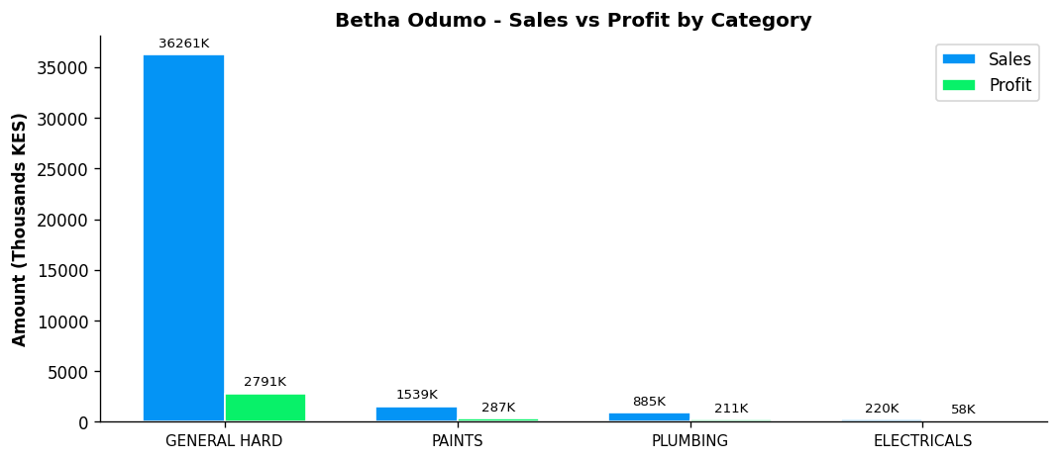
Performance Notes:
- Outstanding! Sales 112% above team average
- Margin at 8.6% below team average of 11.3%
- General Hardware: 22.7% of dept, 7.7% margin
- Selling across all 4 categories - excellent product range
- Best margin in ELECTRICALS: 26.4%

ELIZA - General Hardware Team
Total Sales | Total Profit | Margin | Items Sold | Rank
KES 30,855,552 | KES 2,915,704 | 9.4% | 43,418 | #3

Category | Sales | Profit | Margin | Qty
GENERAL HARDWARE | KES 26,296,242 | KES 2,099,885 | 8.0% | 35,510
PAINTS | KES 3,708,040 | KES 556,373 | 15.0% | 3,329
PLUMBING | KES 664,770 | KES 211,973 | 31.9% | 2,453
ELECTRICALS | KES 186,500 | KES 47,473 | 25.5% | 2,125

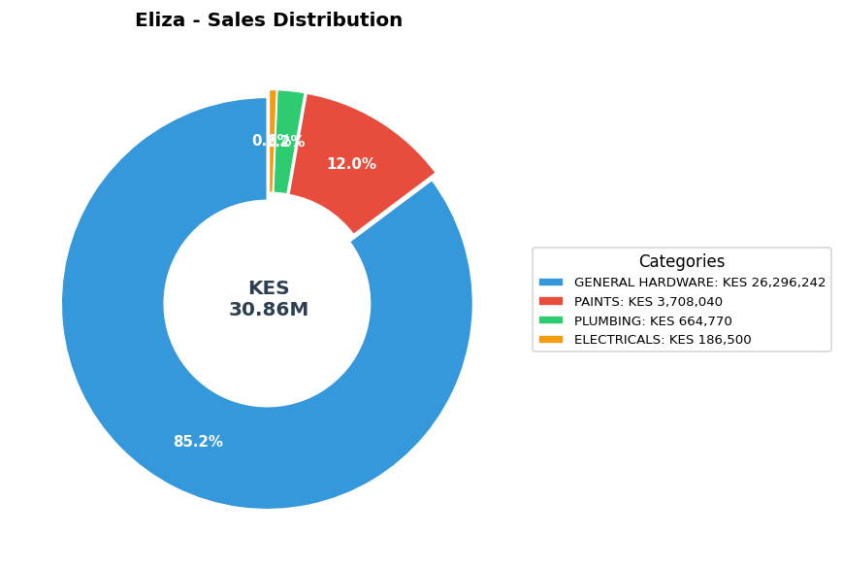

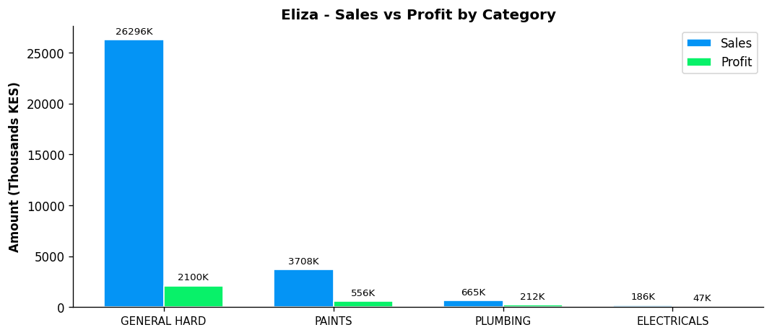
Performance Notes:
- Outstanding! Sales 68% above team average
- General Hardware: 16.4% of dept, 8.0% margin
- Selling across all 4 categories - excellent product range
- Best margin in PLUMBING: 31.9%

BONFACE MURIU - Department Head - Paints
Total Sales | Total Profit | Margin | Items Sold | Rank
KES 13,330,942 | KES 2,015,440 | 15.1% | 15,973 | #4

Category | Sales | Profit | Margin | Qty
GENERAL HARDWARE | KES 5,664,637 | KES 649,106 | 11.5% | 8,970
PAINTS | KES 7,313,530 | KES 1,277,469 | 17.5% | 6,014
PLUMBING | KES 299,885 | KES 70,074 | 23.4% | 698
ELECTRICALS | KES 52,890 | KES 18,791 | 35.5% | 292

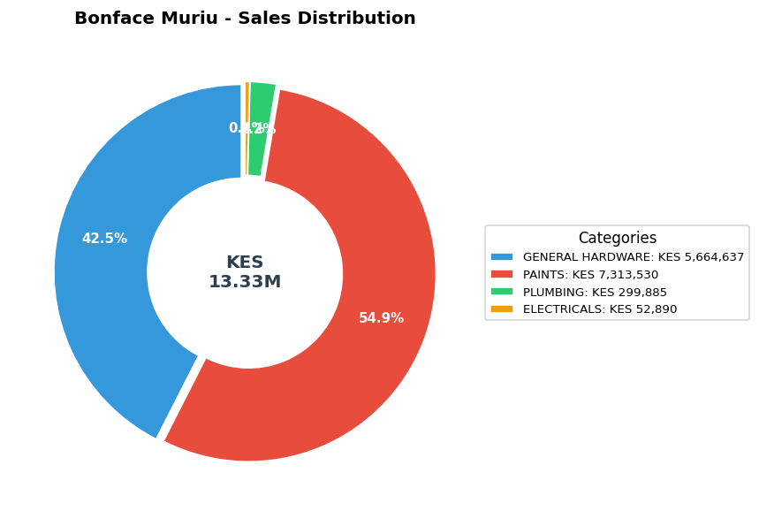

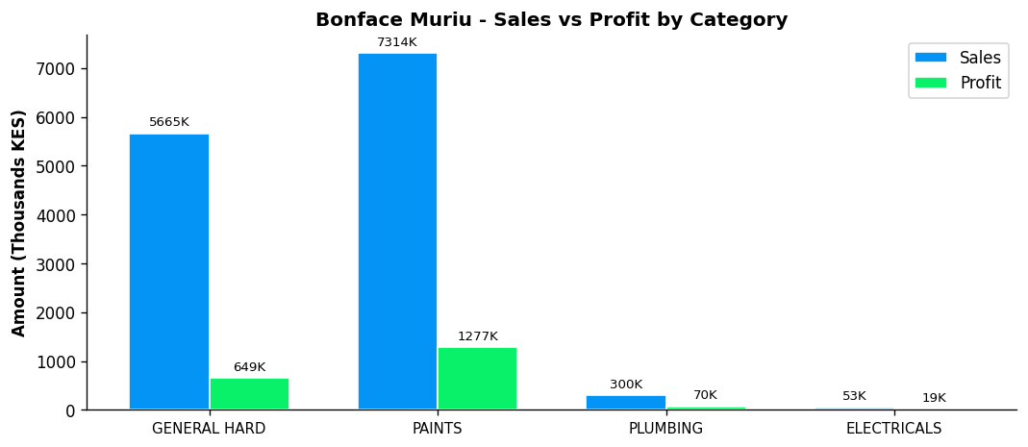
Performance Notes:
- Sales 27% below team average - needs improvement
- Excellent margin at 15.1% (Team avg: 11.3%)
- Paints Dept Head: 46.4% of dept sales, 17.5% margin
- Good paints leadership with 46.4% of dept sales
- Selling across all 4 categories - excellent product range

STEPHEN - General Hardware Team
Total Sales | Total Profit | Margin | Items Sold | Rank
KES 13,208,958 | KES 1,421,789 | 10.8% | 19,440 | #5

Category | Sales | Profit | Margin | Qty
GENERAL HARDWARE | KES 12,086,148 | KES 1,189,143 | 9.8% | 17,965
PAINTS | KES 710,600 | KES 141,576 | 19.9% | 760
PLUMBING | KES 383,470 | KES 84,292 | 22.0% | 503
ELECTRICALS | KES 28,740 | KES 6,779 | 23.6% | 212

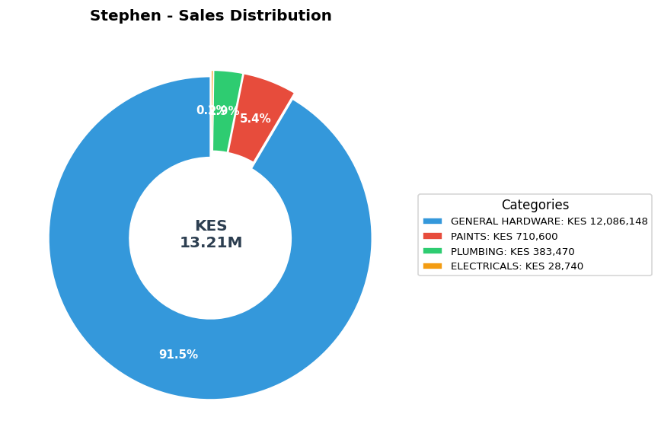

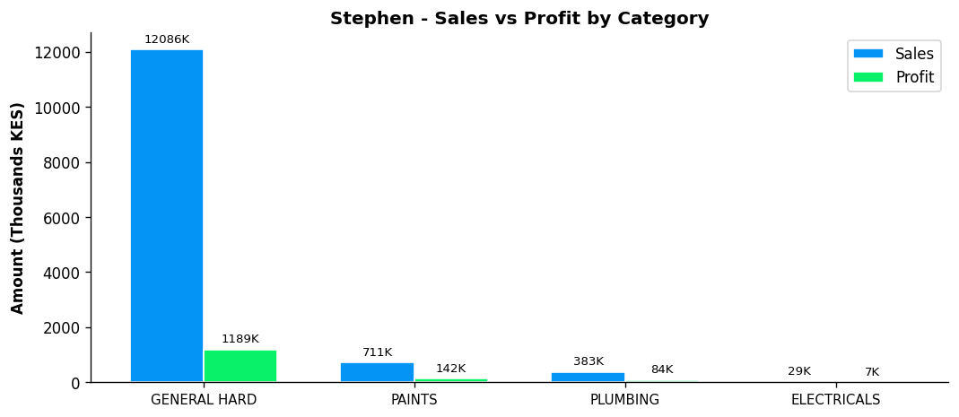
Performance Notes:
- Sales 28% below team average - needs improvement
- General Hardware: 7.6% of dept, 9.8% margin
- Selling across all 4 categories - excellent product range
- Best margin in ELECTRICALS: 23.6%

LEWIS - Department Head - Plumbing
BEST MARGIN
Total Sales | Total Profit | Margin | Items Sold | Rank
KES 6,302,141 | KES 1,146,652 | 18.2% | 14,235 | #6

Category | Sales | Profit | Margin | Qty
GENERAL HARDWARE | KES 2,946,129 | KES 361,537 | 12.3% | 4,722
PAINTS | KES 890,445 | KES 168,121 | 18.9% | 970
PLUMBING | KES 2,376,352 | KES 595,832 | 25.1% | 8,142
ELECTRICALS | KES 89,215 | KES 21,162 | 23.7% | 401

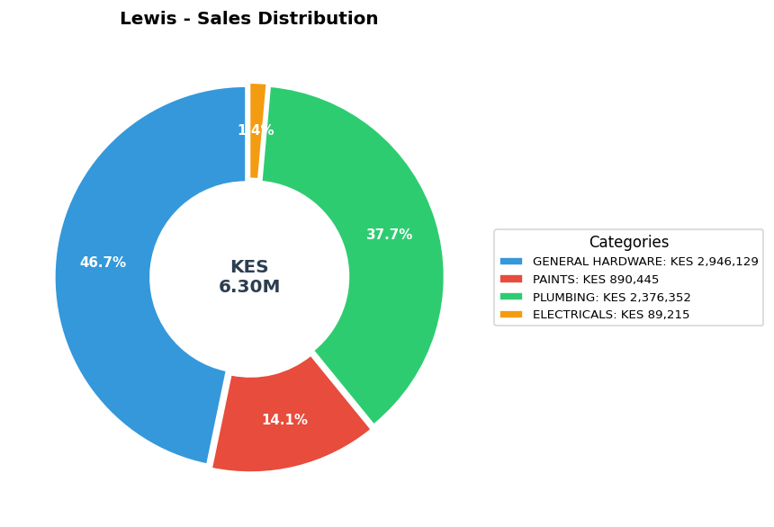

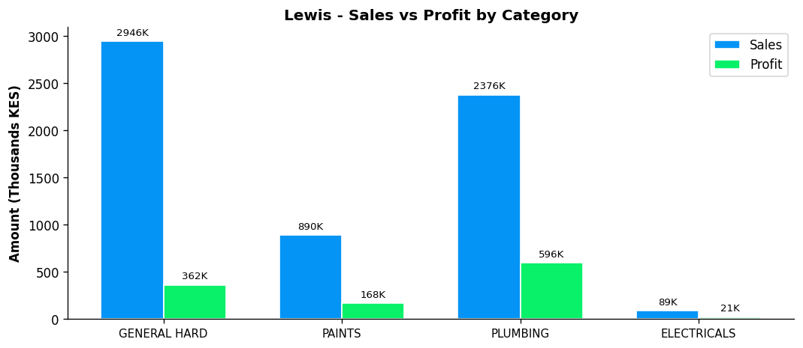
Performance Notes:
- Sales 66% below team average - needs improvement
- Excellent margin at 18.2% (Team avg: 11.3%)
- Plumbing Dept Head: 42.2% of dept sales, 25.1% margin
- Strong plumbing leadership with 42.2% of dept sales
- Selling across all 4 categories - excellent product range

BONFACE KITHEKA - Department Head - Electricals
Total Sales | Total Profit | Margin | Items Sold | Rank
KES 5,406,468 | KES 879,548 | 16.3% | 21,242 | #7

Category | Sales | Profit | Margin | Qty
GENERAL HARDWARE | KES 3,044,170 | KES 343,055 | 11.3% | 5,304
PAINTS | KES 528,580 | KES 108,509 | 20.5% | 904
PLUMBING | KES 396,185 | KES 110,551 | 27.9% | 1,583
ELECTRICALS | KES 1,437,533 | KES 317,433 | 22.1% | 13,452

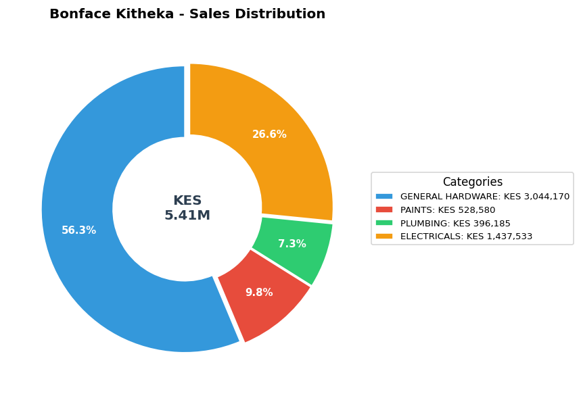

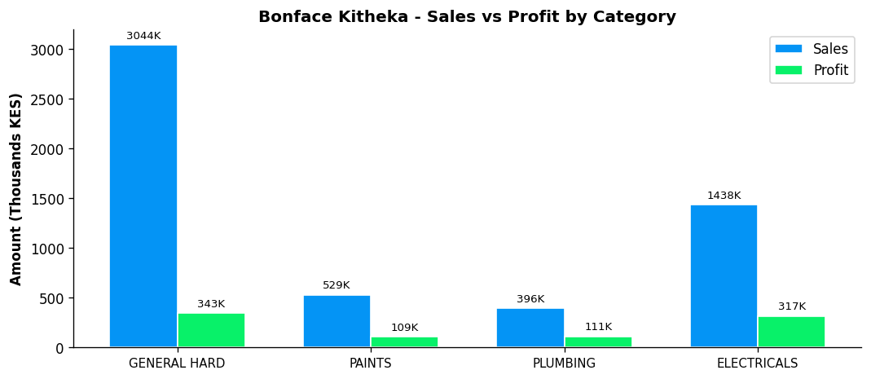
Performance Notes:
- Sales 71% below team average - needs improvement
- Excellent margin at 16.3% (Team avg: 11.3%)
- Electricals Dept Head: 68.4% of dept sales, 22.1% margin
- Strong leadership - controls 68.4% of department sales
- Selling across all 4 categories - excellent product range

DENNIS RUDIGA - General Hardware Team
Total Sales | Total Profit | Margin | Items Sold | Rank
KES 1,230,195 | KES 214,859 | 17.5% | 2,332 | #8

Category | Sales | Profit | Margin | Qty
GENERAL HARDWARE | KES 757,350 | KES 118,019 | 15.6% | 1,320
PAINTS | KES 190,560 | KES 42,250 | 22.2% | 247
PLUMBING | KES 233,540 | KES 40,878 | 17.5% | 351
ELECTRICALS | KES 48,745 | KES 13,712 | 28.1% | 414

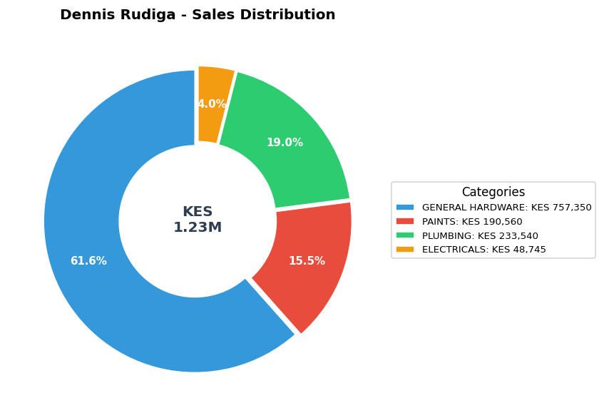

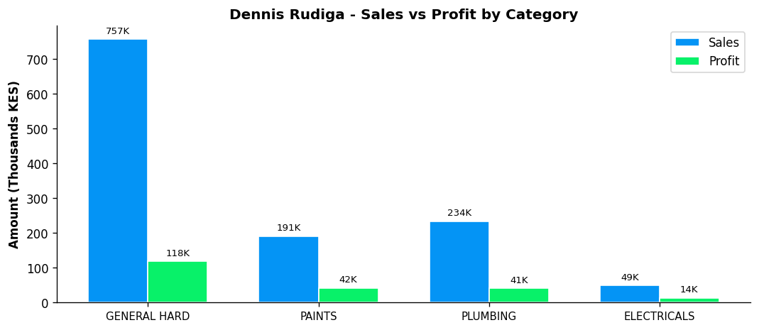
Performance Notes:
- Sales 93% below team average - needs improvement
- Excellent margin at 17.5% (Team avg: 11.3%)
- General Hardware: 0.5% of dept, 15.6% margin
- Selling across all 4 categories - excellent product range
- Best margin in ELECTRICALS: 28.1%

WALK IN-BOMAS - General Hardware Team
Total Sales | Total Profit | Margin | Items Sold | Rank
KES 76,485 | KES 8,119 | 10.6% | 229 | #9

Category | Sales | Profit | Margin | Qty
GENERAL HARDWARE | KES 48,823 | KES 7,281 | 14.9% | 133
PAINTS | KES 12,694 | KES 420 | 3.3% | 5
PLUMBING | KES 12,067 | KES -14 | -0.1% | 46
ELECTRICALS | KES 2,901 | KES 432 | 14.9% | 45

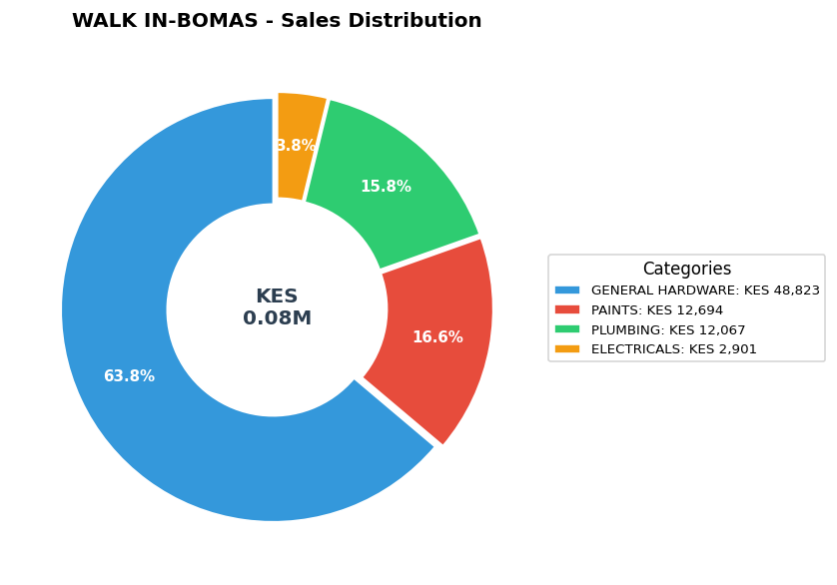

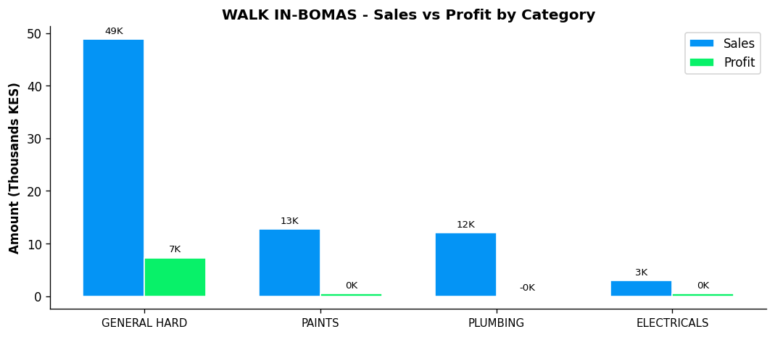
Performance Notes:
- Sales 100% below team average - needs improvement
- General Hardware: 0.0% of dept, 14.9% margin
- Selling across all 4 categories - excellent product range
- Best margin in GENERAL HARDWARE: 14.9%
- Low contribution at 0.0% of total branch sales - growth opportunity

UNKNOWN - General Hardware Team
Total Sales | Total Profit | Margin | Items Sold | Rank
KES -2,720 | KES -540 | 0.0% | -5 | #10

Category | Sales | Profit | Margin | Qty
GENERAL HARDWARE | KES -820 | KES -244 | 0.0% | -4
PAINTS | KES -1,900 | KES -296 | 0.0% | -1
Performance Notes:
- Sales 100% below team average - needs improvement
- Margin at 0.0% below team average of 11.3%
- General Hardware: -0.0% of dept, 0.0% margin
- Limited to 2 categories - expand into PLUMBING, ELECTRICALS
- Best margin in GENERAL HARDWARE: 0.0%

