BOMAS HARDWARE - Q1 STOCK MOVEMENT REPORT
Period: January 5 - March 31, 2026 | Includes Jan, Feb, Mar Comparison
Total SKUs Monitored: 2,032 | Total Units Moved: 276,299 (Jan: 81,506 - Feb: 95,047 - Mar: 99,746)

INFORMED RECOMMENDATIONS & INSIGHTS
- Prioritize restocking investments on 'Consistent' top-moving SKUs (e.g. Simba Cement, D10) which reliably drive volume across all months.
- Conduct an immediate audit on the Dead Stock SKUs (recorded zero movement across Jan, Feb, and March). Consider promotions or liquidation to free up space.
- Investigate 'Declining' SKUs which moved well early in the quarter but recorded 0 sales in March. Verify if this drop is due to demand falloff or simply stockouts.
- Implement monthly MOQ re-calculations that adjust thresholds organically. Items tagged 'Emerging' that picked up pace late in Q1 require updated stock buffers.

VISUALIZED DATA SUMMARY
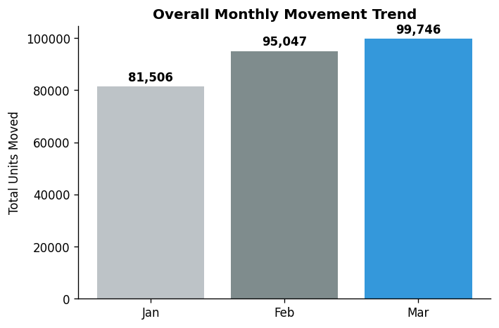
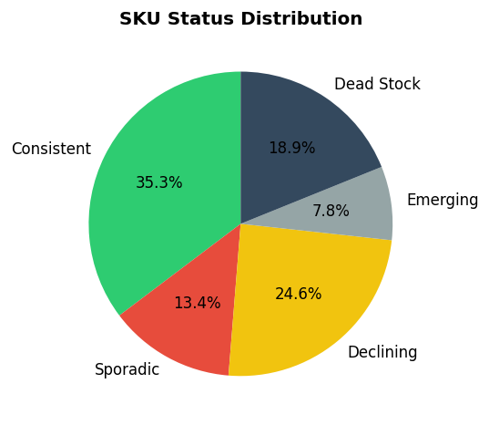
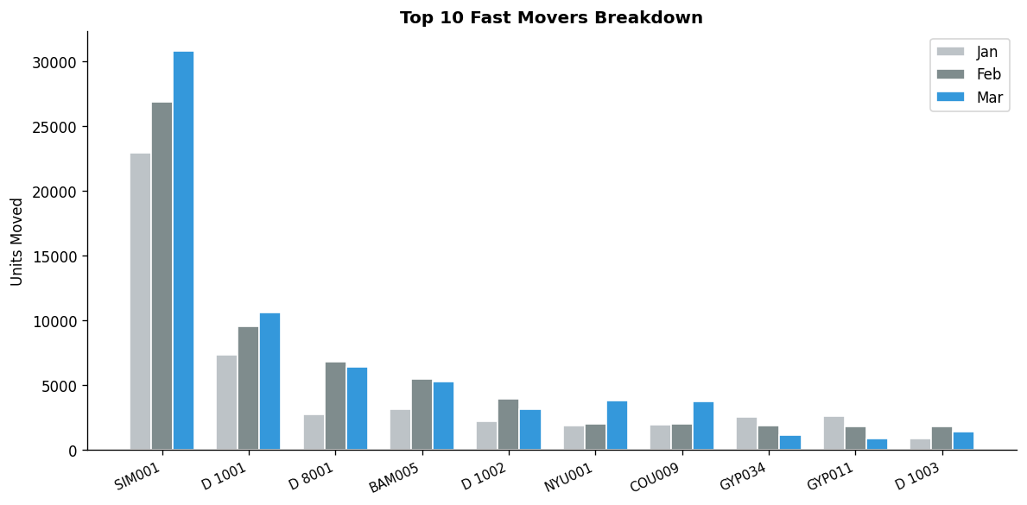

Q1 KEY ITEMS: TOP MOVERS (CONSISTENT DEMAND)
Code | Description | Jan Qty | Feb Qty | Mar Qty | Q1 Total | Status
SIM001 | Simba Cement | 22,922 | 26,881 | 30,767 | 80,570 | Consistent
D 1001 | D 10 | 7,367 | 9,568 | 10,644 | 27,579 | Consistent
D 8001 | D 8 | 2,786 | 6,807 | 6,413 | 16,006 | Consistent
BAM005 | Bamburi Tembo | 3,154 | 5,467 | 5,311 | 13,932 | Consistent
D 1002 | D 12 | 2,216 | 3,994 | 3,159 | 9,369 | Consistent
NYU001 | Nyumba Cement | 1,900 | 2,060 | 3,820 | 7,780 | Consistent
COU009 | Couplers 20mm | 1,958 | 2,010 | 3,752 | 7,720 | Consistent
GYP034 | Gypsum Stud | 2,543 | 1,879 | 1,169 | 5,591 | Consistent
GYP011 | Gypsum Channel | 2,608 | 1,855 | 923 | 5,386 | Consistent
D 1003 | D 16 | 897 | 1,841 | 1,463 | 4,201 | Consistent
MAR001 | Marine Board- Tywood | 861 | 1,605 | 1,008 | 3,474 | Consistent
CON006 | Conduit Metro 20mm | 762 | 824 | 1,744 | 3,330 | Consistent
GYP006 | Gypsum Board Hada | 759 | 920 | 743 | 2,422 | Consistent
PPR016 | Ppr Elbow 25mm | 932 | 213 | 475 | 1,620 | Consistent
COU010 | Couplers 25mm | 438 | 370 | 810 | 1,618 | Consistent
MAR002 | Marine Board-Zurkit 16mm | 746 | 785 | 82 | 1,613 | Consistent
HAC001 | Hacksaw Blade | 326 | 634 | 642 | 1,602 | Consistent
D 2001 | D 20 | 343 | 545 | 607 | 1,495 | Consistent
GYP012 | Gypsum Cornice-Plain | 593 | 521 | 252 | 1,366 | Consistent
PPR126 | Ppr Socket 25mm | 688 | 363 | 275 | 1,326 | Consistent
NAI006 | Nails 4'- Kgs | 316 | 570 | 366 | 1,252 | Consistent
CIR009 | Circular Box 4way 20mm | 333 | 190 | 613 | 1,136 | Consistent
DR 011 | Dr Fixit Modern Tile Adhesive 25kg | 244 | 424 | 422 | 1,090 | Consistent
NAI005 | Nails 3'- Kgs | 324 | 480 | 243 | 1,047 | Consistent
CON007 | Conduit Metro 25mm | 306 | 179 | 558 | 1,043 | Consistent
TRA009 | Transport | 0 | 474 | 493 | 967 | Sporadic
WEL009 | Welding Rods Simba | 308 | 264 | 274 | 846 | Consistent
SAN019 | Sand Paper P120 Ft | 228 | 355 | 238 | 821 | Consistent
PPR085 | Ppr Pipe Danco 25mm | 419 | 246 | 148 | 813 | Consistent
FLA007 | Flusher Plugs pcs | 800 | 0 | 0 | 800 | Declining
CUT013 | Cutting Disk Slim 9 | 247 | 255 | 295 | 797 | Consistent
HOO003 | Hoop Iron Roll | 242 | 224 | 313 | 779 | Consistent
WOO008 | Wood Screw Assorted | 478 | 55 | 211 | 744 | Consistent
DR 012 | Dr Fixit Waterproof Powder | 158 | 342 | 231 | 731 | Consistent
CRO024 | Crown Wallputty 25kg | 215 | 202 | 286 | 703 | Consistent
R 6001 | R 6 | 621 | 59 | 14 | 694 | Consistent
SWI006 | Switch Box Single | 303 | 126 | 263 | 692 | Consistent
SAN018 | Sand Paper P100 Ft | 203 | 212 | 216 | 631 | Consistent
PPR018 | Ppr Elbow 32mm | 296 | 166 | 163 | 625 | Consistent
SWI005 | Switch Box Double | 225 | 214 | 148 | 587 | Consistent

DECLINING ITEMS (ZERO MOVEMENT IN MARCH)
Code | Description | Jan Qty | Feb Qty | Mar Qty | Q1 Total | Status
FLA007 | Flusher Plugs pcs | 800 | 0 | 0 | 800 | Declining
GYP036 | Gypsum Board Thumb 9mm | 372 | 1 | 0 | 373 | Declining
GYP039 | Gypsum Stud 75mm | 120 | 209 | 0 | 329 | Declining
RHI001 | Rhino Cement | 220 | 0 | 0 | 220 | Declining
STO003 | Stone 9x9 | 51 | 150 | 0 | 201 | Declining
GYP040 | Gypsum Channel 75mm | 65 | 105 | 0 | 170 | Declining
BIN002 | Binding Wire 17kg | 94 | 64 | 0 | 158 | Declining
TUB013 | Tube 2x1x14g | 150 | 0 | 0 | 150 | Declining
D8A001 | D 8 Accurate | 0 | 150 | 0 | 150 | Declining
D10004 | D 10 Accurate | 0 | 140 | 0 | 140 | Declining
GYP003 | Gypsum Board 12mm | 95 | 0 | 0 | 95 | Declining
WAL006 | Wall Pass | 12 | 80 | 0 | 92 | Declining
BUS002 | Bush JK 1/2" | 84 | 0 | 0 | 84 | Declining
DOW001 | Down Stoppers | 22 | 62 | 0 | 84 | Declining
D12004 | D 12 Accurate | 0 | 80 | 0 | 80 | Declining
GYP037 | Gypsum Screws 1 *1000pcs | 71 | 6 | 0 | 77 | Declining
USP001 | Uspro Foam Premium 750ml | 50 | 21 | 0 | 71 | Declining
BAL015 | Ballast Dust Tonnes | 66 | 0 | 0 | 66 | Declining
SOC005 | Socket Double Black | 0 | 64 | 0 | 64 | Declining
CEN001 | Center Stopper | 8 | 52 | 0 | 60 | Declining
COM001 | Complete Hinges 1 | 7 | 50 | 0 | 57 | Declining
STO001 | Stone 4x9 | 54 | 0 | 0 | 54 | Declining
RIV003 | Rivet Pcs | 20 | 30 | 0 | 50 | Declining
DRA008 | Drawer Handles Brass 9 | 47 | 0 | 0 | 47 | Declining
MAS002 | Masking Tape Welfast 1.5" | 19 | 27 | 0 | 46 | Declining
CYP005 | Cypress 2x1 | 45 | 0 | 0 | 45 | Declining
BOS007 | Bosch Cutting Slim 9 | 21 | 24 | 0 | 45 | Declining
COR008 | Corner Strip Plastic White | 44 | 0 | 0 | 44 | Declining
ANG001 | Angle Brackets | 40 | 2 | 0 | 42 | Declining
SAF001 | Safety Gloves | 23 | 18 | 0 | 41 | Declining

DEAD STOCK SAMPLES (ZERO MOVEMENT ENTIRE Q1)
Code | Description | Jan Qty | Feb Qty | Mar Qty | Q1 Total
COL006 | Colorant Fast Green | 0 | 0 | 0 | 0
DES003 | D/E Sf Soft White 1tr | 0 | 0 | 0 | 0
NEM051 | Nemsi Black $ Chrome Kitchen Pillar BTOapM-AP | 0 | 0 | 0 | 0
R P012 | R Pipe 3x16g | 0 | 0 | 0 | 0
CUR013 | Curtain Caps White | 0 | 0 | 0 | 0
NAI017 | Nails Bag Ceiling 1 | 0 | 0 | 0 | 0
CAL001 | Caliper | 0 | 0 | 0 | 0
RSR001 | R/S ROMAN TILE 2.5X30G | 0 | 0 | 0 | 0
P003 | R Pipe 11/4x16g | 0 | 0 | 0 | 0
COL001 | Colorant Ext Orange | 0 | 0 | 0 | 0
CUR009 | Curtain Caps Black | 0 | 0 | 0 | 0
COL009 | Colorant Fast Violet | 0 | 0 | 0 | 0
C/S022 | C/S/G Eggshell Black 1l | 0 | 0 | 0 | 0
ALL003 | Stanley-Alluminium Level12'(300mm)BAOntMicAhS | 0 | 0 | 0 | 0
C/E041 | C/E Silk Accent Base 20l | 0 | 0 | 0 | 0
GI 047 | Gi Red Bush 11/2x3/4 | 0 | 0 | 0 | 0
AQU001 | C/S/G Aqua Gloss Deep 4l | 0 | 0 | 0 | 0
LED011 | LED Flood Light 30w(Sensor) | 0 | 0 | 0 | 0
CON014 | Consumer Unit 14way | 0 | 0 | 0 | 0
URI001 | Urinal Bowl | 0 | 0 | 0 | 0
WAT027 | Water Heater 45aGrey | 0 | 0 | 0 | 0
COL005 | Colorant Fast Blue | 0 | 0 | 0 | 0
BAS010 | Basco Silver Almn 4l | 0 | 0 | 0 | 0
DEW007 | Dewalt std HeatGun 1800w | 0 | 0 | 0 | 0
PIN005 | Pine 8x1 | 0 | 0 | 0 | 0
DAT001 | Data Socket Grey | 0 | 0 | 0 | 0
LED012 | LED Flood Light 20w | 0 | 0 | 0 | 0
MOP004 | Mop Bucket J/K | 0 | 0 | 0 | 0
GRE003 | Green Oxide 1kg | 0 | 0 | 0 | 0
PPR112 | Ppr Red/Socket 50x20 | 0 | 0 | 0 | 0
HDP004 | Hdpe Pipe roll 40mm | 0 | 0 | 0 | 0
GLA023 | Glass Tint Grey 4mm | 0 | 0 | 0 | 0
DEC003 | Decra Valleys | 0 | 0 | 0 | 0
BAS013 | Base Aquagloss 2 4l | 0 | 0 | 0 | 0
R/S003 | R/S Box Clear 2.5m | 0 | 0 | 0 | 0
BAS036 | Base Silicon Ext 2 1l | 0 | 0 | 0 | 0
PPR063 | Ppr M/Elbow 32x3/4 | 0 | 0 | 0 | 0
COO007 | Cooker Socket Gold | 0 | 0 | 0 | 0
GIR001 | Gi Red Bush 11/2x1/2 | 0 | 0 | 0 | 0
CYP011 | Cypress 6x2 | 0 | 0 | 0 | 0
NEM044 | Nemsi Premium Gun Grey Towel BaBr-ON3M0A6S | 0 | 0 | 0 | 0
STY002 | Styro Foam 1/2 | 0 | 0 | 0 | 0
BOT002 | Bottle Trap 11/4 Malpine | 0 | 0 | 0 | 0
BAL013 | Ball Valve 11/2 pegler | 0 | 0 | 0 | 0
COU008 | Coupler Threaded 25mm | 0 | 0 | 0 | 0
PPR124 | Ppr Red/Tee 40x32 | 0 | 0 | 0 | 0
PLI004 | Stanley-Pliers Combination7'' dyna grBipO MAS | 0 | 0 | 0 | 0
PPR071 | Ppr M/Tee 40x11/4 | 0 | 0 | 0 | 0
BAL005 | Ball Cork 1/2 | 0 | 0 | 0 | 0
BAS047 | Base Vm3 1l | 0 | 0 | 0 | 0

