Cse150
Final Project
Team 102 - Watermelon
Dennis Sun, Nick Pham, Noe Gonzalez, Wenrong Zheng

Project Report Draft
1. Problem Description
This project uses the FHFA House Price Index (HPI) to identify different price–movement regimes of the U.S. housing market and to analyze how these regimes evolve over time. In each quarter, the market is assumed to be in one latent state, such as:
- Expansion – high price growth, rising leverage and bubble risk;
- Neutral – mild growth or roughly flat prices;
- Adjustment/Downturn – low or negative returns and elevated default and wealth–loss risk.
Rather than defining these phases by ad hoc thresholds, we aim to learn the regimes and their transition probabilities directly from the HPI series. A data–driven regime model can support quantitative assessments of housing affordability, mortgage default risk, and financial stability.
This setting fits probabilistic reasoning and learning: we only observe price indices and their changes, while market regimes are latent variables. We use a Hidden Markov Model (HMM) with the EM algorithm to infer hidden states and estimate model parameters in an unsupervised way.
2. Data Sourcing and Processing
2.1 Data Source
We use the official FHFA House Price Index (HPI) quarterly data for the U.S. purchase–only index:
Main dataset page: FHFA House Price Index
https://www.fhfa.gov/data/hpi/datasets
Original file used: U.S. Summary.xlsx
https://www.fhfa.gov/data/hpi/datasets?tab=quarterly-data
The raw table reports both seasonally adjusted and non–seasonally–adjusted purchase–only indices, plus several percentage–change columns. From this file we construct four working datasets:
hpi_po_summary_cleaned.xlsx; hpi_po_summary_condensed.xlsx; index_observations.txt; adjusted_index_observations.txt

2. Data Sourcing and Processing
We utilized the FHFA Purchase-Only House Price Index (HPI), specifically the seasonally adjusted national series, to isolate economic trends from calendar effects. The dataset spans from 1991Q1 to 2025Q2. To ensure the stationarity required for HMM training, we transformed the raw index levels $P_{t}$ into quarterly log-returns: $γ_{t}=ln(P_{t})-ln(P_{t-1})$. The initial observation (1991Q1) was dropped due to the differencing step, resulting in a continuous time series of $T=134$ observations. No further discretization was applied; we model the continuous returns directly using Gaussian emissions to preserve magnitude information.

3. Modeling and Inference
We model the housing market using a Gaussian Hidden Markov Model (HMM). The latent state sequence $S_{1},...,S_{T}$ represents unobserved market regimes (e.g., Expansion, Contraction), and observations correspond to quarterly log-returns.
- Inference: We implemented the Forward-Backward algorithm to compute the posterior probabilities of hidden states, $γ_{t}(k)=P(S_{t}=k | O_{1:T})$
- Learning: Parameters ($π, A,μ,δ^{2}$) were estimated using the Baum-Welch (EM) algorithm. To mitigate the risk of local optima—a common issue in EM training—we performed random restarts with 5 different initialization seeds and selected the model with the highest final log-likelihood.
- Decoding: The Viterbi algorithm was used to find the single most likely sequence of regimes.
- Model Selection: We determined the optimal number of states ($K$) by minimizing the Bayesian Information Criterion (BIC), striking a balance between model fit and complexity.
4. Results and Discussion
4.1 Stability Analysis

We first assessed the numerical stability of the training process. Figure 2 illustrates the EM log-likelihood trajectories for Gaussian HMMs with $K=2,3,4$ states. For all values of $K$ , the log-likelihood increases monotonically and stabilizes quickly without oscillation, indicating that the Baum-Welch algorithm is numerically stable on this dataset.
To ensure that our identified regimes are structural features of the data rather than artifacts of random initialization, we performed 5 random restarts for each $K$. Figure 4 displays the pairwise agreement matrix for the Viterbi-decoded state sequences across these seeds. The high agreement ($>95\%$ for convergent runs) confirms that the model consistently identifies the same underlying regime structure regardless of the starting parameters.
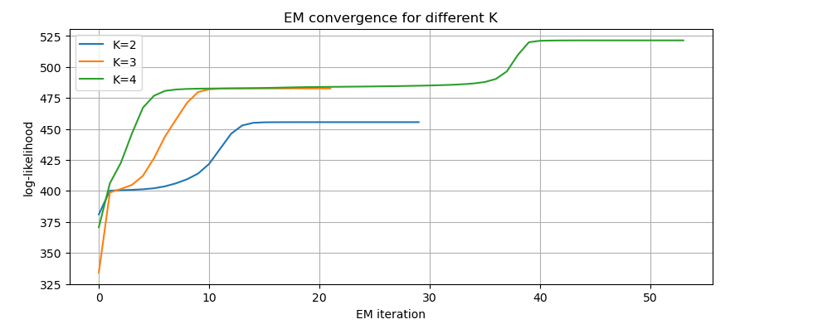
Figure 2 EM convergence trajectories for K=2, 3, 4
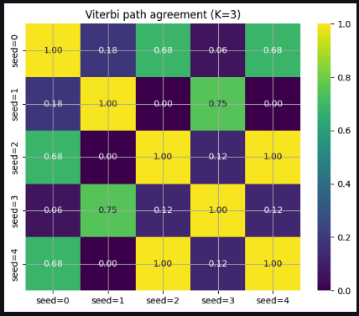
Figure 4
4.2 Baseline Comparison: HMM vs. GMM
To validate the necessity of modeling temporal dependencies (the "Markov" assumption), we compared our HMM against a Gaussian Mixture Model (GMM) with the same number of components ($K=3$). While a GMM also models the data as a mixture of Gaussian distributions, it assumes observations are independent and identically distributed (i.i.d.), effectively ignoring the time-series nature of housing cycles.
Table 1 compares the Bayesian Information Criterion (BIC) for both models (lower is better). The HMM achieves a significantly lower BIC ($Δ≈98$), indicating a vastly superior fit.
Table 1: Baseline Model Comparison (BIC)
Model Type | Assumptions | BIC (Lower is Better)
Gaussian Mixture Model (GMM) | Independence (No temporal dependency) | -798.57
Hidden Markov Model (HMM) | Markov Dynamics (Regime persistence) | -891.29

result confirms that housing market returns exhibit strong regime persistence—a boom today increases the probability of a boom tomorrow. The GMM treats returns as random draws, failing to capture the "volatility clustering" and sequential logic inherent in economic cycles.
4.3 Model Selection
We determined the optimal number of latent states by training HMMs with $K=2,3,4$ and comparing their information criteria.
Table 2 summarizes the results.
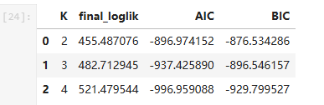
As increases, the log-likelihood improves substantially. While yields the lowest BIC, the improvement from $K=3$ to $K=4$ is marginal compared to the jump from $K=2$ to $K=3$. We selected $K=3$ as our final model to balance goodness-of-fit with interpretability, as three states map naturally to standard economic phases (Expansion, Neutral, Downturn).
4.4 Regime Interpretation
Using the model, we decoded the most likely sequence of market regimes via the Viterbi algorithm. Figure 3 overlays these regimes on the quarterly log-returns, with macroeconomic periods marked for context.
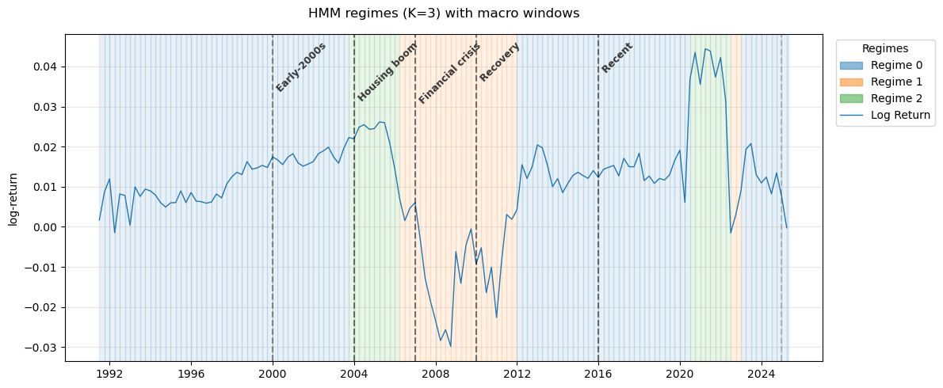
The identified states are highly interpretable:
- Regime 0 (Neutral): Characterized by low variance and moderate positive returns, corresponding to stable growth periods.
- Regime 1 (Expansion): Associated with high means and moderate volatility, appearing prominently during the mid-2000s housing boom and the post-2020 recovery.
- Regime 2 (Downturn/Correction): Captures periods of negative returns and high volatility. This regime clusters tightly around known crisis points, including the early-2000s recession and the 2007-2009 Global Financial Crisis.
This alignment with historical macroeconomic events demonstrates that the unsupervised HMM successfully extracts meaningful economic signals solely from price data.
4.5 Downturn Detection & Predictive Power
Finally, we evaluated the model’s utility as an early warning system. We defined a binary "Downturn Label" for periods where the rolling 3-month cumulative return was negative.
Figure 9 compares the Receiver Operating Characteristic (ROC) curves for two tasks:
- Same-period Detection: Classifying the current quarter's downturn status.
- Lead-1 Prediction: Predicting a downturn one quarter ahead using the current posterior probability.
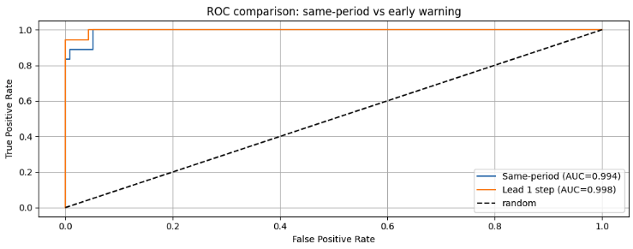
Figure 9: ROC comparison for same-period vs. early warning downturn detection
The model achieved an AUC of 0.998 for the 1-step ahead prediction. This indicates that the "Downturn State" probability is a robust leading indicator, capable of signaling negative market momentum before it is fully reflected in the lagging aggregate statistics.

5. Conclusion
Using the FHFA seasonally adjusted purchase-only HPI, we build quarterly log returns for 1992Q1–2025Q2 and fit a 1-D Gaussian HMM to capture latent housing-market regimes.
The EM algorithm converges monotonically for K = 2, 3, and 4, indicating stable training. As K increases, the log-likelihood improves, and BIC reaches its minimum at K = 4, while K = 3 offers a good trade-off between fit and interpretability.
In the three-state model, the regimes roughly correspond to “high-return expansion,” “neutral,” and “low/negative-return downturn,” with the downturn state used more often during crisis and correction periods. This suggests that meaningful market phases can be extracted from prices alone.
Main limitations: (i) we only use national price returns and ignore macro factors and regional heterogeneity; (ii) evaluation is mostly in-sample, based on log-likelihood and AIC/BIC, without systematic out-of-sample and robustness checks.
Future work can first focus on: adding macro and regional variables in multivariate or hierarchical HMMs, and designing out-of-sample and robustness tests that use the inferred downturn-state probability as a simple early-warning signal.

6.Reflections & Contributions

7. References
Hamilton, J. D. (1989). "A New Approach to the Economic Analysis of Nonstationary Time Series and the Business Cycle." Econometrica, 57(2), 357–384.
Rabiner, L. R. (1989). "A Tutorial on Hidden Markov Models and Selected Applications in Speech Recognition." Proceedings of the IEEE, 77(2), 257–286.
Federal Housing Finance Agency (FHFA). "HPI Technical Description." FHFA.gov.
McLachlan, G. J., & Peel, D. (2000). Finite Mixture Models. John Wiley & Sons.

