Computer Analysis of Models

Part I

1. Introduction

This course aims to bring together modelling and statistical methodology in the way that it is actually used in practice. The course provides the student with the information and viewpoint that I have found most useful in tackling a modelling problem - the sort of things that in retrospect I wished had been pointed out to me when I first encountered problems of this sort.

Those near the end of an MSc programme in either Statistics or OR will already have encountered most of the methods used in this course. However these will usually have been taught somewhat in isolation, each within a formal, even disembodied, setting in which there is not enough scope, or time, to emphasize the overall way that these methods invariably come together when studying a modelling problem. There is a natural order in which the methods are used, giving them a power and unity that is often not well appreciated by a student.

This course aims to revisit statistical and modelling methodology in a way that emphasises how they are used in practice. It emphasises what should be going through the mind of the investigator at each stage, namely that an overall problem can be broken down into a standard set of subproblems all of which will invariably occur. The subproblems will be reviewed and discussed, in a unified way in this course.

By the end of the course the student should be much more assured in the way that she/he confronts and tackles such a modelling exercise. There will be a much better awareness of the steps needed to carry out an exercise successfully, and of the problems and issues that occur at each step.

A very good book that has a similar philosophy to this course is An Introduction to Statistical Modelling by W.J. Krzanowski, (1998) Arnold, London. However this reference has a stronger statistical emphasis than we adopt and gives rather less attention to the resampling methods that we shall be using in the analysis.

Resampling is quite well covered in the book Computer Intensive Statistical Methods by J.S.U. Hjorth (1994) Chapman & Hall, London. One problem with this reference is the order in which material is presented. The initial chapters deal with arguably somewhat advanced topics. A good starting point for the book is Chapter 5.

2. Statistical MetaModels.

This course emphasizes the importance of statistical metamodels for analysing data. We need therefore to be clear what is meant by a metamodel and this is discussed first.

Figure 1 illustrates the situation where we have data, Y (here and throughout this text, a quantity is written in bold to indicate that it is a vector quantity), available concerning the behaviour.of a system under study. The system itself, represented by the box in the middle, might be simple but it will typically be complicated or even unknown. We call Y the output and this is what we wish to analyse, to learn about the behaviour of the system.

We also have input quantities, whose values are expected to influence the output. The inputs are divided into two types. The input X = (X₁, X₂, … , X_{k}) is a vector of k explanatory variables. These are known quantities and indeed may possibly be under the control of the investigator. The input θ = (θ₁, θ₂, …, θ_{p}) is a vector of parameters which influence the output but whose values are not controllable. Often they will be unknown. Their values would therefore have to be estimated.

In addition the output Y may contain a random component, typically referred to as ‘noise’ or ‘error’. This is denoted by ε.

Figure 1: Schematic of the System

Input
X
1: Real System

2: Simulation model

3: Statistical metamodel

Y
Input

Output
Data

Noise

As well as depicting the situation where the output data has been obtained from a real system Figure 1 also illustrates the situation where we have constructed a simulation model and have made simulation runs with it to obtain simulated output data. This is indicated in Figure 1 by replacing the real system in the central block by a simulation model. All other blocks remain the same.

In this course the focus is on how to analyse Y and in particular to identify how the inputs X and influence Y in the presence of the random effects . We use a statistical model for doing this. We shall make precise later what is meant by a statistical model. However we observe here that the structure of the process is unchanged, and this is emphasized by using Figure 1 yet again, only with the central block now representing the statistical model.

The term statistical model is conventionally used when we are analysing data obtained from a real system. In the case of data obtained from a simulation model, then the statistical model is a model of a model, so to speak – and this is when the term metamodel is used. It will be clear that whatever statistical model is deemed appropriate in a given situation is determined purely by the structure of the data and not by its origin. Thus the model would apply whether the output came from a real system or a simulation model.

Example 1: Consider the operation of a queue where we are interested in estimating, the average queue length, over a given period of time, T say. Here Y might be the sampled mean queue length over a period of length T. Input quantities are λ the arrival rate, and μ, the service rate, and C might be the number of servers available.

This is a situation that has been well analysed theoretically and where the relationship between Y and the quantities λ, μ and C is known precisely in certain situations. However we might be uncertain about the precise form of inter-arrival and service time distributions. We can assume that the results of n simulation runs take the form

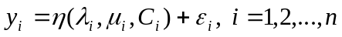 (1)

where 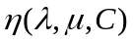 is some suitably selected function characterising the likely behaviour of Y. The quantity is a random variable. A common assumption is that the errors have a normal distribution:

~ 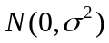. (2)

This assumption is questionable in the present context as the variability of Y will depend critically on the traffic intensity 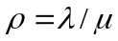, so the assumption of constant variance  for the observations Y is dubious. □

Example 2: The National Health Service has data for, Y, the number of newly registered diabetics in each year for a given number of years. It also has data on a selection of factors that might influence the onset of diabetes such as, X₁ amount of alcohol consumed; X₂ the number of cigarettes smoked, per day; X₃; previous illnesses contracted, age, sex of each case. The problem here is to those identify factors that have a significant influence on the onset of diabetes. A typical model is

. (3)

where y_{i} is the observed number of registered diabetics in year i and x_{ij} is the observed value of the jth factor in year i; and we have n years of observations. Again we might assume normal errors ~ . □

The scenario of Figure 1 can be varied or extended in many different ways. We illustrate this with two commonly occurring situations.

The first is illustrated in Figure 2. This is the situation where the input θ parameters can be estimated using data or past information, w, containing information about θ. Sometimes this information is not explicit but is derived from expert opinion. The estimation in this latter case is then possibly subjective. We write these estimates as 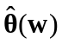, or simply as depending on whether past data w is involved or not, using the circumflex to indicate an estimated quantity.

Figure 2: Input Parameters Estimated from Data

Input
X
System/
Model
Output

Input

Data
w
Noise
ε
Example 1 (continued): It may be that λ, the arrival rate, is not known. However we have a sample of interarrival times from which λ can be estimated. □

Another important variation is when a dynamic system or simulation is being examined. Here time - which we denote by t - enters into the picture. It is usually best to treat t as being a continuously varying input variable that is part of the input X, but which then results in the output Y being time-dependent. Figure 3 represents this time dependent situation.

Figure 3: Schematic of a Dynamic System/Model
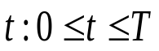
Input
X
System/
Model
Output

Input

Data
w
Noise
ε

Example 3: In the study of an epidemic let η(t, θ) represent the prevalence of a certain disease at time t. (Prevalence means the proportion of the population who has the given disease.) Several scenarios are possible. Firstly, it may be that there is no information on θ, but there are observations y_{i} of the prevalence at given time points t_{i} i =1, 2, ..., n. These are subject to error, thus

y_{i} = η(t_{i}, θ) + ε_{i}, i =1, 2, ..., n. (4)

Then the problem would be to fit θ to the observations {y_{i}}. Secondly we might have past information w on which θ depends and the task is then to estimate θ from the information w. The third possibility is when we have both observations {y_{i}} of the epidemic and there is past information w on the parameters θ. In this case we should use both the {y_{i}} and w to estimate θ.

The following is a set of data giving the number of notifications of pulmonary TB (per 100,000) in Morocco in four selected years 1980, 1983, 1990, 2000, grouped by age. What form should η(t, θ) take? Moroccan TB Data □

In dynamic problems the regression formulation (4) is typical. The regression function η(t, θ) has to be selected so that its behaviour resembles the output of the system or mathematical/simulation model that it represents. In some situations, as might occur in the dynamic case just considered, the physical process of the actual system may be sufficiently known to suggest a natural form for η(t, θ).

Example 4: The logistical curve

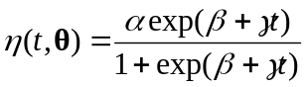 (5)

is commonly used to represent population growth when this takes a sigmoidal form. □

Exercise 1: Plot the logistic curve on a spreadsheet for different combinations of α, β, γ. □

If little is known about the real system, the form assumed for η(t, θ) does not have to be complicated. When there is a single explanatory variable X then a low polynomial function of X is a typically used model:

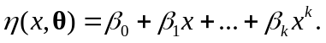 (6)

When there are a large number of factors, and especially when the errors ε are not small then a multivariate linear form is often used:

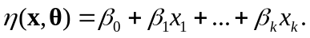 (3 bis)

Here the x_{i} are the values of the different factors, and the model only considers the inclusion of a linear term for each factor. Example 2 is an illustration of a situation where this multivariate form is appropriate.

Sometimes the output Y takes a binary form, indicating success (Y = 1) or failure (Y = 0). Representing Y in terms of a continuous function is not then very sensible. The usual ploy is to model the probability π that Y = 1 and then to ensure that π lies between 0 and 1 by using a transformation such as the logistic transformation. This is usually written as

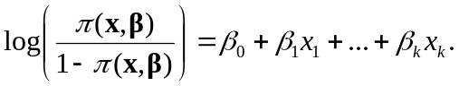 (7)

but the more correct version is

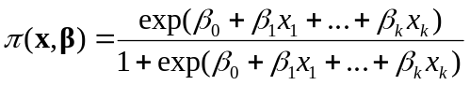 (7a)

as (in the one x variable case) it is actually

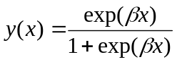 (7b)

that is the logistic transform.

This binary model is best not thought of in regression terms. Instead we regard each observation as a Bernoulli variable

Y_{i} ~ Bernoulli(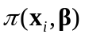) (8)

As far as this course is concerned we will be focusing on the third representation of Figure 1 where we use a statistical model to describe the output. The first step in model formulation is therefore to write down the distributional form of the output and in particular to make explicit how the distribution is expected to depend on the input quantities. It should be stressed that the statistical model does not have to precisely copy the characteristics of the underlying true model, which anyway may be too complicated to be sensibly reproducible. Rather the statistical model has to be capable of modelling the essential features of the system it represents, but that is all that is needed. Figure 4 illustrates this key requirement, in the dynamic case, by including boxes to represent both the unknown system and the statistical model representing it. The parameters of the statistical model do not have to correspond in any explicit way to the parameters θ of the system, and this is indicated in Figure 4

Figure 4: Statistical Model of a System/Metamodel of a Simulation Model
Input
X
System/
Model
Output

Input

Data
w
Noise
U
Statistical Model..
Output

Often the regression format is a convenient one to use. However, as the last example shows, the regression approach is not completely general. In fact the procedure used in the last example of treating Y as a random variable and writing down its distribution by name, is a very good one to follow. The distribution will depend on parameters. It is also necessary therefore to write down how these parameters of the distribution depend on the input variables and on the input parameters of the process model.

This first step of treating the output Y as a random variable and of identifying its distribution is essential in determining the most appropriate subsequent analysis. We discuss the main characteristics of random variables in the next Section.

3. Random Variables

The key concept of all statistics is the random variable. A formal definition of a random variable requires a mathematical foundation (and elaboration) that takes us away from the main focus of this course. We shall therefore not attempt a formal definition but instead adopt a simpler practical viewpoint. We therefore define a random variable simply as a quantity that one can observe many times but that takes different values each time it is observed in an unpredictable, random way. These values however will follow a probability distribution. The probability distribution is thus the defining property of a random variable. Thus, given a random variable, the immediate and only question one can, and should always ask is: What is its distribution?

We denote a random variable by an upper case letter X (Y, Z etc.). An observed value of such a random variable will be denoted by a lower case letter x (y, z etc).

In view of the above discussion, given a random variable, one should immediately think of the range of possible values that it can take and its probability distribution over this range.

The definition of most statistical probability distributions involves parameters. Such a probability distribution is completely fixed once the parameter values are known. Well known parametric probability distributions are the normal, exponential, gamma, binomial and Poisson.

A probability distribution is usually either discrete or continuous. A discrete distribution takes a specific set of values, typically the integers 0, 1, 2,…. Each value i has a given probability p_{i} of occurring. This set of probabilities is called its probability mass function.

Example 5/Exercise 2: Plot the probability mass function of
- the binomial distribution, B(n, p)
- the Poisson distribution, P(λ)
Write down what you know of each distribution. □

A continuous random variable, as its name implies, takes a continuous range of values for example all y ≥ 0. One way of defining its distribution is to give its probability density function (pdf), typically written as f(y). The pdf is not a probability, however it can be used to form a probability increment. 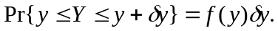 This is a good way to view the pdf.

Example 6/Exercise 3: Write down the pdf of
(i) the normal distribution, 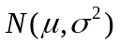. Normal Distribution
(ii) the gamma distribution, 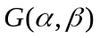. Gamma Distribution

Plot the density functions. Write down what you know about each distribution. □

Exercise 4: Suppose that X is a continuous random variable with density f(x). Let Y be a function of X, say Y = h(X). What is the pdf, g(y) of Y, in terms of f(x)? Give the pdf of Y = X ² when X is a standard normal random variable. What is the name of this random variable and what is the form of its pdf? □

An alternative way of defining a probability distribution, which applies to either a discrete or continuous distribution, is to give its cumulative distribution function (cdf).

Exercise 5: Write down the main properties of a cdf. □

Exercise 6: Plot the cdf’s of each of the examples in the previous examples. □

Exercise 7: What is the relation between the pdf and the cdf for a continuous random variable? How is one obtained from the other? □

Exercise 8: Define the expected value of a random variable X in terms of its pdf f(x). Define the expected value of Y = h(X) in terms of the pdf of X. □

4. Fitting Parametric Distributions to Random Samples; Input Modelling

Random samples are the simplest data sets that are encountered. A random sample is just a set of n independent and identically distributed observations (of a random variable). We write it as Y = {Y₁, Y₂, … Y_{n},} where each Y_{i} represents one of the observations.

Exercise 9: Generate random samples from
- the normal distribution . Normal Var Generator
- the gamma distribution . Gamma Var Generator

A basic problem is when we wish to fit a parametric distribution to a random sample. This problem is an elementary form of modelling called input modelling.

Example 1 (continued): Suppose we are modelling a queueing system where service times are expected to have a gamma distribution and we have some actual data of the service times of a number of customers from which we wish to estimate the parameters of the distribution. This is an example of the input modelling problem. If we can estimate the parameters of the distribution, we will have identified the distribution completely and can then use it to study the characteristics of the system employing either queueing theory or simulation. □

To fit a distribution, a method of estimating the parameters is needed. The best method by far is the method of maximum likelihood (ML). The resulting estimates of parameters, which as we shall see shortly possess a number of very desirable properties, are called maximum likelihood estimates (MLEs). ML estimation is a completely general method that applies not only to input modelling problems but to all parametric estimation problems. We describe the method next.

5. Maximum Likelihood Estimation

Suppose Y = {Y₁, Y₂, …, Y_{n}} is a set of observations where the ith observation, Y_{i}, is a random variable drawn from the continuous distribution with pdf f_{i}(y, θ) (i = 1, 2, …, n). The subscript i indicates that the distributions of the y_{i} can all be different.

Example 7: Suppose Y_{i} ~ N(μ, σ ²) all i. In this case
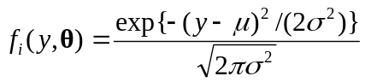 (9)
so that the observations are identically distributed. The set of observations is therefore a random sample in this case. □

Example 8: Suppose Y_{i} ~ 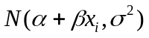, i = 1, 2, ..., n. In this case one often writes

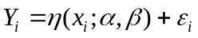 (10)
where

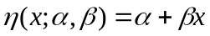 (11)

is called the regression function, and

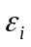~ N(0, σ ²) (2 bis)

can be thought of as an error term, or a perturbation affecting proper observation of the regression function. □

In the example, the regression function is linear in both the parameters 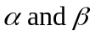, and in the explanatory variable x. In general the regression function can be highly nonlinear in both the parameters and in the explanatory variables. Study of nonlinear regression models forms a major part of this course.

In the example, the pdf of Y_{i} is

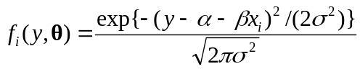. (12)

Thus Y is not a random sample in this case, because the observations are not all identically distributed. However ML estimation still works in this case.

We now describe the method. Suppose that y = {y₁, y₂, …, y_{n}} is a sampled value of Y = {Y₁, Y₂, …, Y_{n}}. Then we write down the joint distribution of Y evaluated at the sampled value y as:

. (13)

This expression, treated as a function of θ, is called the called the likelihood (of the sampled value y). The logarithm:

(14)

is called the loglikelihood.

The ML estimate, , is that value of which maximizes the loglikelihood.

The MLE is illustrated in Figure 5 in the one parameter case. In some many cases the maximum can be obtained explicitly as the solution of the vector equation

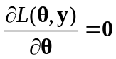 (15)

which identifies the stationary points of the likelihood. The maximum is often obtained at such a stationary point. This equation is called the likelihood equation. The MLE illustrated in Figure 5 corresponds to a stationary point.

In certain situations, and this includes some well known standard ones, the likelihood equations can be solved to give the ML estimators explicitly. This is preferable when it can be done. However in general the likelihood equations are not very tractable. Then a much more practical approach is to obtain the maximum using a numerical search method.

Figure 5. The Maximum Likelihood Estimator
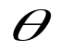
Loglikelihood

There are two immediate and important points to realise in using the ML method.

(i) An expression for the likelihood needs to be written down using (13) or (14).
(ii) A method has to be available for carrying out the optimization.

We illustrate (i) with some examples.

Example 9: Write down the likelihood and loglikelihood for
(i) The sample of Example 7
(ii) The sample of Example 8
(iii) A sample of observations with the Bernoulli distributions (8).
(iv) The sample of Example 3 □

We now consider the second point, which concerns how to find the maximum of the likelihood. There exists a number of powerful numerical optimizing methods but these can be laborious to set up. An exception is the readily accessible numerical optimizer Solver which can be called from an Excel spreadsheet. This can handle problems that are not too large. A more flexible alternative is to use a direct search method like the Nelder-Mead method. This is discussed in more detail here: Nelder Mead Method.

Exercise 10: NelderMeadDemo This is a VBA implementation of the Nelder-Mead Algorithm. Insert a function of your own to be optimized and see if it finds the optimum correctly.

Watchpoint: Check whether an optimizer minimizes or maximizes the objective. Nelder Mead usually does function minimization. □

Exercise 11: The following is a (random) sample of 47 observed times (in seconds) for vehicles to pay the toll at a booth when crossing the Severn River Bridge. Use the Nelder-Mead method to fit the gamma distribution G(α, β) to this data using the method of maximum likelihood. Gamma MLE

Watchpoints: Write down the loglikelihood for this example yourself, and check that you know how it is incorporated in the spreadsheet. □

6. Accuracy of ML Estimators

A natural question to ask of an MLE is: How accurate is it? Now an MLE, being just a function of the sample, is a statistic, and so is a random variable. Thus the question is answered once we know its distribution.

An important property of the MLE, , is that its asymptotic probability distribution is known to be normal, that is, as the sample size n → ∞,

~ 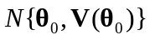 (16)

where 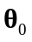is the unknown true parameter value and the variance has the form

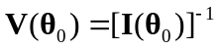, (17)
where
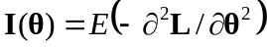 (18)
is called the information matrix. Thus the asymptotic variance of is the inverse of the information matrix evaluated at 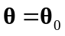. Its value cannot be computed precisely as it depends on the unknown , but it can be approximated by

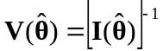. (19)

The expectation in the definition of 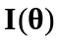 is with respect to the joint distribution of Y and this expectation can be hard to evaluate. In practice the approximation

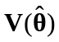 '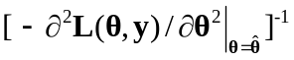 (20)

where we replace the information matrix by its sample analogue, called the observed information, is quite adequate. Practical experience indicates that it tends to give a better indication of the actual variability of the MLE. Thus the working version of (16) is

~ 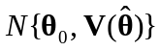 (21)

The second derivative of the loglikelihood, 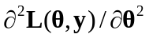, that appears in the expression for is called the Hessian (of L). It measures the rate of change of the derivative of the loglikelihood. This is essentially the curvature of the loglikelihood. Thus it will be seen that the variance is simply the inverse of the magnitude of this curvature at the stationary point.

Though easier to calculate than the expectation, the expression 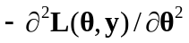 can still be very messy to evaluate analytically. Again it is usually much easier to calculate this numerically using a finite-difference formula for the second derivatives. The expression is a matrix of course, and the variance-covariance matrix of the MLE is the negative of its inverse. A numerical procedure is needed for this inversion.

The way that (21) is typically used is to provide confidence intervals. For example an (1-α)100% confidence interval for the coefficient θ₁ is

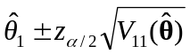 (22)

where 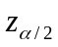is the upper 100α/2 percentage point of the standard normal distribution.

Often we are interested not in θ directly, but some arbitrary, but given function of θ, g(θ) say. ML estimation has the attractive general invariant property that the MLE of
g(θ) is
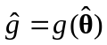. (23)

An approximate (1-α)100% confidence interval for g(θ) is then

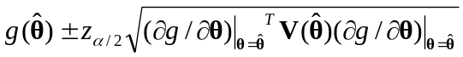 (24)

In this formula the first derivative of g(θ) is required. If this is not tractable to obtain analytically then, as with the evaluation of the information matrix, it should be obtained numerically using a finite-difference calculation.

Summarising it will be seen that we need to
(i) Formulate a statistical model of the data to be examined. (The data may or may not have been already collected. The data might arise from observation of a real situation, but it might just as well have been obtained from a simulation.)
(ii) Write down an expression for the loglikelihood of the data, identifying the parameters to be estimated.
(iii) Use this in a (Nelder-Mead say) numerical optimization of the loglikelihood..
(iv) Use the optimal parameter values to obtain estimates for the quantities of interest.
(v) Calculate confidence intervals for these quantities.

Example 10: Suppose that the gamma distribution 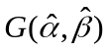 fitted to the toll booth data of Exercise 11 is used as the service distribution in the design of an M/G/1 queue. The interarrival time distribution is known to be exponential with pdf

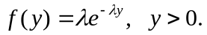 (25)

but a range of possible values for the arrival rate, λ, needs to be considered.

The steady state mean waiting time in the queue is known to be

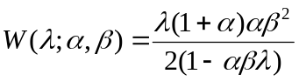. (26)

Plot a graph of the mean waiting time 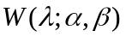 for the queue for 0 < λ < 0.1 (per second), assuming that the service time distribution is gamma: . Add 95% confidence intervals to this graph to take into account the uncertainty concerning because estimated values 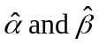 have been used. Gamma MLE □

The previous example contains all the key steps in the fitting of a statistical model to data.

There are usually additional analyses that are then subsequently required such as model validation and selection and sensitivity analyses. We will be discussing these in Part II. Before turning to these we shall introduce a method of sensitivity analysis using what are sometimes referred to as computer intensive methods.

Our discussion so far has relied heavily on the classic asymptotic theory of MLE’s. The formulas based on this classical approach are useful to calculate, but only become accurate with increasing sample size. With existing computing power computer intensive methods can often be used instead to assess the variability of estimators. Experience has shown these to give better results in general for small sample sizes. Moreover this alternative approach is usually much easier to implement than the classical methodology. The method is called bootstrap resampling, or simply resampling. Resampling hinges on the properties of the empirical distribution function (EDF) which we need to discuss first, and this is what we shall start with in Part II.

