Computer Analysis of Models

Contents
1. Introduction
I Classical Methods
2. Random Variables
3. Fitting Parametric Distributions to Random Samples; Input Modelling
4. Maximum Likelihood Estimation
5. Accuracy of MLEs
II Computer Intensive Methods
6. Empirical Distribution Functions
7. Basic Bootstrap Method
8. Bootstrapping the Distribution of a Statistic
9. The Parametric Bootstrap; Validation
10. Comparing Models; Model Selection
III Models
11 Statistical MetaModels; Output Analysis
12 Regression and ANOVA
13 Dynamic models
14 Performance Analysis

1. Introduction

This course aims to bring together modelling and statistical methodology in the way that it is actually used in practice. The course provides the student with the information and viewpoint that I have found most useful in tackling a modelling problem - the sort of things that in retrospect I wished had been pointed out to me when I first started tackling problems of this sort.

Those near the end of an MSc programme in either Statistics or OR will already have encountered most of the methods used in this course. However these will usually have been taught somewhat in isolation, each within a formal, even disembodied, setting in which there is not enough scope, or time, to emphasize the overall way that these methods invariably come together when studying a modelling problem. There is a natural order in which the methods are used, giving them a power and unity that is often not well appreciated by a student.

This course aims to revisit statistical and modelling methodology in a way that emphasises how they are used in practice. It emphasises what should be going through the mind of the investigator at each stage. The overall problem can be broken down into a standard set of subproblems all of which will invariably occur. Each subproblem will be reviewed and discussed, not in an isolated way, but in the context of the overall problem.

By the end of the course the student should be much more assured in the way that she/he confronts and tackles such a modelling exercise. There will be a much better awareness of the steps needed to carry out an exercise successfully, and of the problems and issues that occur at each step.

A very good book that has a similar philosophy to this course is An Introduction to Statistical Modelling by W.J. Krzanowski (1998) Arnold, London

2. Random Variables

The key concept of all statistics is the random variable. A formal definition of a random variable requires a mathematical foundation (and elaboration) that takes us away from the main focus of this course. We shall therefore not attempt a formal definition but instead adopt a simpler practical viewpoint. We therefore define a random variable simply as a quantity that one can observe many times but that takes different values each time it is observed in an unpredictable, random way. These values however will follow a probability distribution. The probability distribution is thus the defining property of a random variable. Thus, given a random variable, the immediate and only question one can, and should always ask is: What is its distribution?

We denote a random variable by an upper case letter X (Y, Z etc.). An observed value of such a random variable will be denoted by a lower case letter x (y, z etc).

In view of the above discussion, given a random variable, one should immediately think of the range of possible values that it can take and its probability distribution over this range.

The definition of most statistical probability distributions involves parameters. Such a probability distribution is completely fixed once the parameter values are known. Well known parametric probability distributions are the normal, exponential, gamma, binomial and Poisson.

A probability distribution is usually either discrete or continuous. A discrete distribution takes a specific set of values, typically the integers 0, 1, 2,…. Each value i has a given probability p_{i} of occurring. This set of probabilities is called its probability mass function.

Exercise: Plot the probability mass function of
- the binomial distribution, B(n, p)
- the Poisson distribution, P(λ)
Write down what you know of each distribution.

A continuous random variable, as its name implies, takes a continuous range of values for example all y ≥ 0. One way of defining its distribution is to give its probability density function (pdf), typically written as f(y). The pdf is not a probability, however it can be used to form a probability increment. 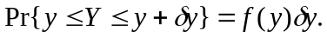 This is a good way to view the pdf.

Exercise: Write down the pdf of
(i) the normal distribution, 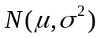. Normal Distribution
(ii) the gamma distribution, 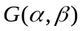. Gamma Distribution

Plot the density functions. Write down what you know about each distribution.

Exercise: Suppose that X is a continuous random variable with density f(x). Let Y be a function of X, say Y = h(X). What is the pdf, g(y) of Y, in terms of f(x)? Give the pdf of Y = X ² when X is a standard normal random variable. What is the name of this random variable and what is the form of its pdf?

An alternative way of defining a probability distribution, which applies to either a discrete or continuous distribution, is to give its cumulative distribution function (cdf).

Exercise: Write down the main properties of a cdf.

Exercise: Plot the cdf’s of each of the examples in the previous examples.

Exercise: What is the relation between the pdf and the cdf for a continuous random variable? How is one obtained from the other?

Exercise: Define the expected value of a random variable X in terms of its pdf f(x). Define the expected value of Y = h(X) in terms of the pdf of X.

3. Fitting Parametric Distributions to Random Samples; Input Modelling

Random samples are the simplest data sets that are encountered. A random sample is just a set of n independent and identically distributed observations (of a random variable). We write it as Y = {Y₁, Y₂, … Y_{n},} where each Y_{i} represents one of the observations.

Exercise: Generate random samples from
- the normal distribution . Normal Var Generator
- the gamma distribution . Gamma Var Generator

A basic problem is when we wish to fit a parametric distribution to a random sample. This problem is an elementary form of modelling called input modelling.

Example: Suppose we are modelling a queueing system where service times are expected to have a gamma distribution and we have some actual data of the service times of a number of customers from which we wish to estimate the parameters of the distribution. This is an example of the input modelling problem. If we can estimate the parameters of the distribution, we will have identified the distribution completely and can then use it to study the characteristics of the system employing either queueing theory or simulation.

To fit a distribution, a method of estimating the parameters is needed. The best method by far is the method of maximum likelihood (ML). The resulting estimates of parameters, which as we shall see shortly possess a number of very desirable properties, are called maximum likelihood estimates (MLEs). ML estimation is a completely general method that applies not only to input modelling problems but to all parametric estimation problems. We describe the method next.

4. Maximum Likelihood Estimation

Suppose Y = {Y₁, Y₂, …, Y_{n}} is a set of observations where the ith observation, Y_{i}, is a random variable drawn from the continuous distribution with pdf f_{i}(y, θ) (i = 1, 2, …, n). The subscript i indicates that the distributions of the y_{i} can all be different.

Example: Suppose Y_{i} ~ N(μ, σ ²) all i. In this case
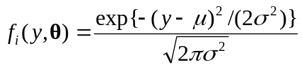
so that the observations are identically distributed. The set of observations is therefore a random sample in this case.

Example: Suppose Y_{i} ~ 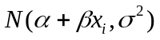, i = 1, 2, ..., n. In this case one often writes

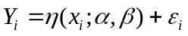
where

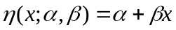

is called the regression function, and

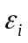~ N(0, σ ²)

can be thought of as an error term, or a perturbation affecting proper observation of the regression function.

In the example, the regression function is linear in both the parameters 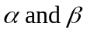, and in the explanatory variable x. In general the regression function can be highly nonlinear in both the parameters and in the explanatory variables. Study of nonlinear regression models forms a major part of this course.

In the example, the pdf of Y_{i} is

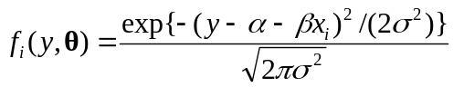.

Thus Y is not a random sample in this case, because the observations are not all identically distributed. However ML estimation still works in this case.

We now describe the method. Suppose that y = {y₁, y₂, …, y_{n}} is a sampled value of Y = {Y₁, Y₂, …, Y_{n}}. Then we write down the joint distribution of Y evaluated at the sampled value y as:

.

This expression, treated as a function of θ, is called the called the likelihood (of the sampled value y). The logarithm:

is called the loglikelihood.

The ML estimate, , is that value of which maximizes the loglikelihood.

The MLE is illustrated in Figure 1 in the one parameter case. In some many cases the maximum can be obtained explicitly as the solution of the vector equation
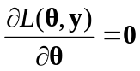

which identifies the stationary points of the likelihood. The maximum is often obtained at such a stationary point. This equation is called the likelihood equation. The MLE illustrated in Figure 1 corresponds to a stationary point.

Figure 1. The Maximum Likelihood Estimator

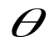
Loglikelihood

In certain situations, and this includes some well known standard situations, the liekelihood equations can be solved to give the ML estimators explicitly. This is preferable when it can be done. However in general the likelihood equations are not very tractable. Then a much more practical approach is to obtain the maximum using a numerical search method.

There exists a number of powerful numerical optimizing methods but these can be laborious to set up. An exception is the readily accessible numerical optimizer Solver which can be called from an Excel spreadsheet. This can handle problems that are not too large. A more flexible alternative is to use a direct search method like the Nelder-Mead method. This is discussed in more detail here: Nelder Mead Method.

Exercise: NelderMeadDemo This is a VBA implementation of the Nelder-Mead Algorithm. Insert a function of your own to be optimized and see if it finds the optimum correctly. Watchpoint: Check whether an optimizer minimizes or maximizes the objective. Nelder Mead usually does function minimization.

Exercise: The following is a (random) sample of 47 observed times (in seconds) for vehicles to pay the toll at a booth when crossing the Severn River Bridge. Use the Nelder-Mead method to fit the gamma distribution G(α, β) to this data using the method of maximum likelihood. Gamma MLE

5. Accuracy of ML Estimators

A natural question to ask of an MLE is: How accurate is it? Now an MLE, being just a function of the sample, is a statistic, and so is a random variable. Thus the question is answered once we know its distribution.

An important property of the MLE, , is that its asymptotic probability distribution is known to be normal, that is, as the sample size n → ∞,

~ 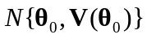

where 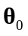is the unknown true parameter value and the variance has the form

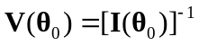,
where
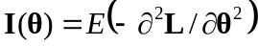
is called the information matrix. Thus the asymptotic variance of is the inverse of the information matrix evaluated at 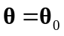. Its value cannot be computed precisely as it depends on the unknown , but it can be approximated by

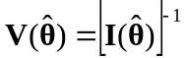.

The expectation in the definition of 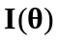 is with respect to the joint distribution of Y and this expectation can be hard to evaluate. In practice the approximation

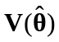 '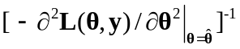

where we replace the information matrix by its sample analogue, called the observed information, is quite adequate. Practical experience indicates that it tends to give a better indication of the actual variability of the MLE. Thus the working version of (???) is

~ 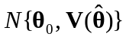

The second derivative of the loglikelihood, 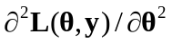, that appears in the expression for is called the Hessian (of L). It measures the rate of change of the derivative of the loglikelihood. This is essentially the curvature of the loglikelihood. Thus it will be seen that the variance is simply the inverse of the magnitude of this curvature at the stationary point.

Though easier to calculate than the expectation, the expression 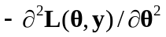 can still be very messy to evaluate analytically. Again it is usually much easier to calculate this numerically using a finite-difference formula for the second derivatives. The expression is a matrix of course, and the variance-covariance matrix of the MLE is the negative of its inverse. A numerical procedure is needed for this inversion.

The way that (???) is typically used is to provide confidence intervals. For example an (1-α)100% confidence interval for the coefficient θ₁ is

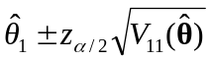

where 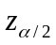is the upper 100α/2 percentage point of the standard normal distribution.

Often we are interested not in θ directly, but some arbitrary, but given function of θ, g(θ) say. ML estimation has the attractive general invariant property that the MLE of
g(θ) is
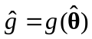.

An approximate (1-α)100% confidence interval for g(θ) is then

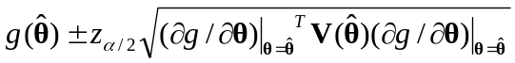

In this formula the first derivative of g(θ) is required. If this is not tractable to obtain analytically then, as with the evaluation of the information matrix, it should be obtained numerically using a finite-difference calculation.

Summarising it will be seen that we need to
(i) Formulate a statistical model of the data to be examined. (The data may or may not have been already collected. The data might arise from observation of a real situation, but it might just as well have been obtained from a simulation.)
(ii) Write down an expression for the loglikelihood of the data, identifying the parameters to be estimated.
(iii) Use this in a (Nelder-Mead say) numerical optimization of the loglikelihood..
(iv) Use the optimal parameter values to obtain estimates for the quantities of interest.
(v) Calculate confidence intervals for these quantities.

Example: Suppose that the gamma distribution 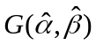 fitted to the toll booth data of example (???) is used as the service distribution in the design of an M/G/1 queue. The interarrival time distribution is known to be exponential with pdf

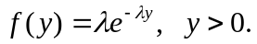

but a range of possible values for the arrival rate, λ, needs to be considered.

The steady state mean waiting time in the queue is known to be

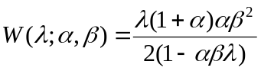.

Plot a graph of the mean waiting time 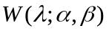 for the queue for 0 < λ < 0.1 (per second), assuming that the service time distribution is gamma: . Add 95% confidence intervals to this graph to take into account the uncertainty concerning because estimated values 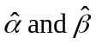 have been used. Gamma MLE

The previous example contains all the key steps in fitting a statistical model to data. There are several additional aspects that we

The above formulas are useful to calculate, but only become accurate with increasing sample size. There is a rather different approach to assessing the variability of estimators which experience has shown to give better results in general for small sample sizes. Moreover this alternative approach is usually much easier to implement. The method is called bootstrap resampling, or simply resampling. Resampling hinges on the properties of the empirical distribution function (EDF) which we need to discuss first.

6. Empirical Distribution Functions

Consider first a single random sample of observations , for i = 1, 2, ..., n. The empirical distribution function (EDF) is defined as:

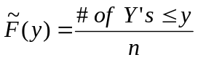. (1)

The EDF is illustrated in Figure 2. It is usually simplest to think of the observations as being ordered:

Y₍₁₎ < Y₍₂₎ < … < Y_{(n)} . (2)

Figure 2: EDF of the Y_{i} , 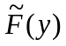

Y₍₁₎
Y_{(j)}
Y_{(n)}

These are what are depicted in Figure 2. Note that the subscript are placed in brackets to indicate that this is an ordered sample.

The key point is that the EDF estimates the (unknown) cumulative distribution function (CDF) of Y. We shall make repeated use of the following:

Fundamental Theorem of Sampling: As the size of a random sample tends to infinity then the EDF constructed from the sample will tend, with probability one, to the underlying cumulative distribution function (CDF) of the distribution from which the sample is drawn.

(This result when stated in full mathematical rigour, is known as the Glivenko-Cantelli Lemma, and it underpins all of statistical methodology. It guarantees that study of increasingly large samples is ultimately equivalent to studying the underlying population.)
In the previous section we studied the CDF of the Y_{i} ‘s of a random sample by fitting a parametric distribution and then studying the fitted parameters and the fitted parametric CDF. Using the EDF, we can do one of two things:

(i) We can study the properties of the Y_{i} directly using the EDF, without bothering to fit a parametric model at all.

(ii) We can use the EDF to study properties of the fitted parameters and fitted parametric distribution.

We shall discuss both approaches. We shall focus first on (ii) as we wish to utilise bootstrapping to give us an alternative way of studying the properties of MLE’s, to that provided by asymptotic normality theory which was discussed in Section ???.

We postpone discussion of (i) until later. We simply note at this juncture that the attraction of using the EDF directly, rather than a fitted parametric CDF, is that we make no assumption about the underlying distributional properties of Y. Thus Y can be either a continuous or a discrete random variable. Nor is it assumed to come from any particular family of distributions like the normal or Weibull. This flexibility is particularly important when studying or comparing the output from complex simulations where it is possible that the distribution of the output may be unusual. For example it may well be skew, or possibly even multimodal.

7. Basic Bootstrap Method

The basic process of constructing a given statistic of interest is illustrated in Figure 3. This depicts the steps of drawing a sample Y = (Y₁, Y₁, ..., Y_{n}) of size n from a distribution F₀(y), and then the calculating the statistic of interest T from Y. The problem is then to find the distribution of T.

Bootstrapping is a very general method for numerically estimating the distribution of a statistic. It is a resampling method that operates by sampling from the data used to calculate the original statistic.

Bootstrapping is based on the following idea. Suppose we could repeat the basic process, as depicted in Figure 3, a large number of times, B say. This would give a large sample {T₁, T₂,..., T_{B}} of test statistics, and, by the Fundamental Theorem of Section 3, the EDF of the T_{i} will tend to the CDF of T as B tends to infinity. Thus, not simply does the EDF estimate the CDF, it can be made accurate to arbitrary accuracy at least in principle, simply by making B sufficiently large.

Figure 3: Basic Sampling Process
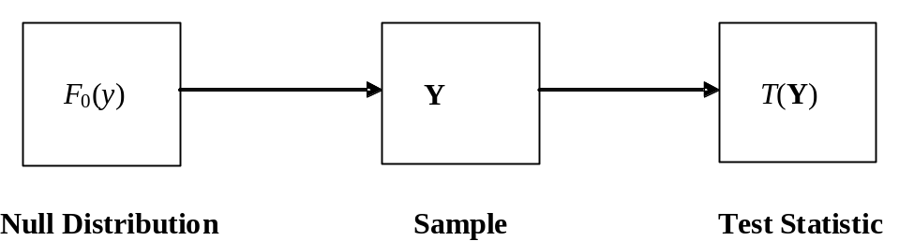

Unfortunately to apply this result requires repeating the basic process many times. In the present context this means having to repeat the simulation trials many times - something that is certainly too expensive and impractical to do.

The bootstrap method is based on the idea of replacing F₀(y) by the best estimate we have for it. The best available estimate is the EDF constructed from the sample Y. Thus we mimic the basic process depicted in Figure 3 but instead of sampling from F₀(y) we sample from the EDF of Y. This is exactly the same as sampling with replacement from Y. We carry out this process B times to get B bootstrap samples Y₁*, Y₂*, ..., Y_{B}*. (We have adopted the standard convention of adding an asterisk to indicate that a sample is a bootstrap sample.) From each of these bootstrap samples we calculate a corresponding bootstrap statistic value T_{i}* = T(Y_{i}*), i = 1, 2, ..., B. The process is depicted in Figure 4.

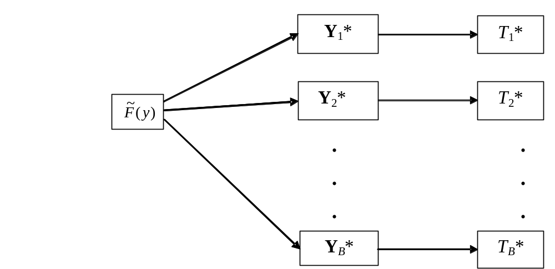Figure 4: Bootstrap Process

The EDF of the bootstrap sample, which without loss of generality we can assume to be reordered, so that T₁* < T₂* < ... < T_{B}*, now estimates the distribution of T. This is depicted in Figure 5. Figure 5 also includes the original statistic value, T₀. Its p-value, as estimated from the EDF, can be read off as

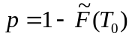. (11)

If the p-value is small then this is an indication that T is in some sense unusual. We shall see how this idea can be developed into a full methodology for making differnet kinds of comparisons.

In practice typical values of B used for bootstrapping are 500 or 1000, and such a value is generally large enough. With current computing power resampling 1000 values (which is the default value used in the our spreadsheet demonstrations) is, to all intents and purposes, instantaneous. A good reference for bootstrap methods is Davison and Hinkley (1997).

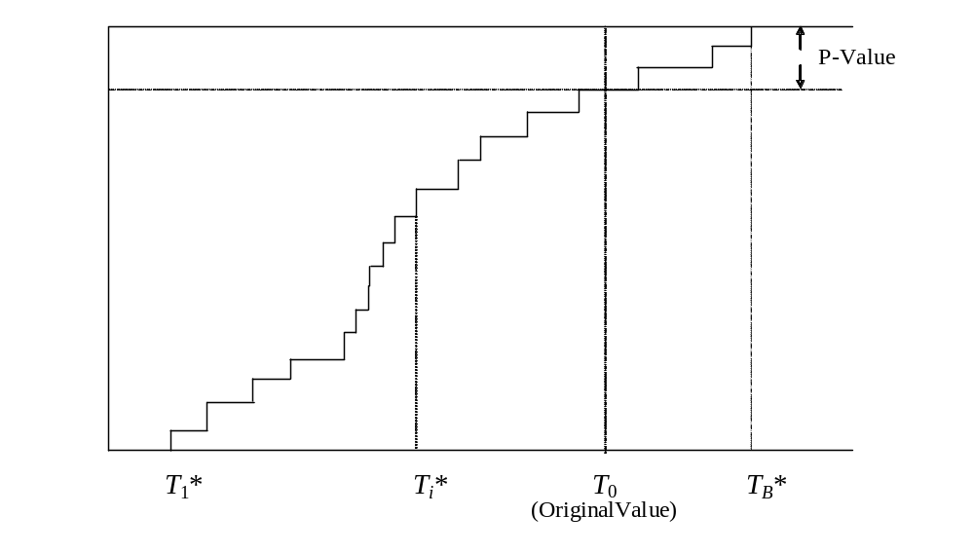Figure 5: Empirical Distribution Function of the T^{(i)}

8. Evaluating the Distribution of MLEs by Bootstrapping

Let us apply the bootstrapping idea to the evaluation of the distribution of MLE’s. All that is required is to simply treat the MLE, as being the statistic T of interest!

All we need to do is to follow the scheme depicted in Figure 4. We generate bootstrap samples by resampling with replacement from the original sample. Then we use the code to produce the bootstrap T from this sample. The pseudocode for the entire bootstrap process is as follows:

// y = (y(1), y(2), ..., y(n)) is the original sample.
// T=T(y) is the calculation that produced T from y.
For k = 1 to B
{
For i = 1 to n
{
j = 1 + n × Unif() // Unif() returns a uniformly distributed
// U(0,1) variate each time it is called.
y*(i) = y(j)
}
T*(k) = T(y*)
}

The beautiful simplicity of bootstrapping is now apparent. The resampling is trivially easy. The step that produces T*(k) invokes the procedure that produced T from y, only y is replaced by y*. The key point here is that no matter how elaborate the original procedure was to produce T, we will already have it available, as we must have set it up in order to calculate T = T(y) in the first place. The bootstrap procedure simply calls it a further B times.

Example: Use bootstrapping to produce 100 bootstrap versions of of Example ???. Compare these with the confidence intervals produced for 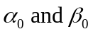 using the asymptotic normality theory. Gamma Bootstrap

Produce confidence intervals for the waiting time in the queue using bootstrapping. Again compare these results with those produced by asymptotic theory.

The above discussion has considered the use of the basic bootstrap. There is a second method of bootstrapping which is unfairly sometimes considered to be less effective. This view arises probably because it has overlapping uses to the basic bootstrap, but where it might be less accurate. However this difference can be advantageous in certain specific situations when we are comparing models. We will discuss these problems in Section ???. but before doing so we describe need to describe how the parametric bootstrap works. We do this in the next Section.

9. The Parametric Bootstrap

Suppose we have fitted a parametric model to data. If the parametric model is the correct one and describes the form of the data accurately, then the fitted parametric model will be a close representation of the unknown true parametric model. We can therefore generate bootstrap samples not by resampling from the original data, but by sampling from the fitted parametric model. This is called the parametric bootstrap.

Figure 6: Parametric Bootstrap Process
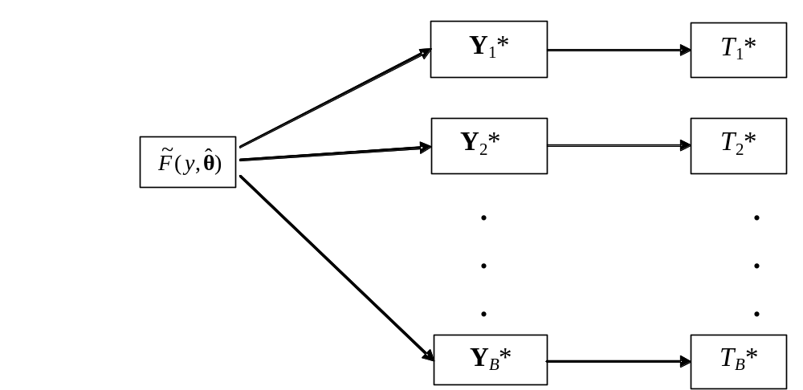

The basic process is depicted in Figure ???. It will be seen that the method is similar to the basic bootstrap. (Compare Figure ??? with Figure ???) The difference is that in the parametric version one has to generate samples from a given distribution, like the gamma say. A method has to be available to enable this to be done.

Example Consider the queueing example where we have already used asymptotic theory and the basic bootstrap to analyse the effect of estimated parameter uncertainty. Repeat the exercise but now use the parametric bootstrap instead of the basic bootstrap. ParametricBS-GammaEG

At first sight the parametric bootstrap does not seem to be a particularly good idea because it adds an extra layer of uncertainty into the process, requiring selection of a model that may or may not be right.

However there are uses and we discuss these in the next sections.

10 Goodness of Fit Testing

We consider the natural question: Does the model that we have fitted actually fit the data very well? For instance in Example ??? we fitted a gamma distribution to toll booth service time data, but does the fitted gamma distribution capture the characteristics of the data properly?

The classical way to answer this question is to use a goodness of fit test (GOF test). A very popular test is the chi-squared goodness of fit test. The main reason for its popularity is that it is relatively easy to implement. The test statistic is easy to calculate and moreover it has a known chi-squared distribution, under the null, which makes critical values easy to obtain.

However the chi-squared test has two obvious weaknesses. It is actually not all that powerful, and it has a certain subjective element because the user has to divide the data into groups of her/his own choosing.

The best general GOF tests directly compare the EDF with the fitted CDF. Such tests are called EDF goodness of fit tests. In the past the Kolmogorov-Smirnov test has been the most popular, but the Cramér – von Mises test and the Anderson Darling test, defined below, are generally more powerful and should be used in preference. The trouble with these tests is that, because of their sensitivity, their critical values are very dependent on the model being tested, and on whether the model has been fitted (with parameters having to be estimated in consequence). This means that different tables of test values are required for different models (see d’Agostino and Stephens, 1986).

We shall show how to calculate the distributions of test statistics using resampling methods here and in the following section.

First we describe EDF tests in more detail. Applying the Fundamental Theorem of Section ???, we see that a natural way to test if a sample has been drawn from the distribution with CDF F₀(y), is to compare with F₀(y) by looking at some quantity involving the difference – F₀(y). Such an EDF test statistic typically has the form

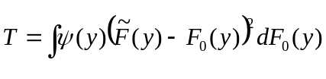.

Here ψ(y) is a weighting function. Special cases are the Cramér-von Mises test statistic:
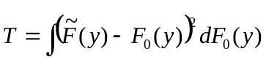
where ψ(y) = 1, and the Anderson-Darling test statistic:

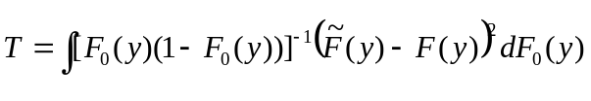
where ψ(y) = [F₀(y)(1 – F₀ (x))]⁻¹ .

The basic idea in using a goodness of fit test statistic is as follows. When the sample has really been drawn from F₀(y) then the value of the test statistic will be small. This follows from the Fundamental Theorem of Section ??? which guarantees that 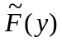 will be close in value to F₀(y) across the range of possible y values. Thus T will be small. Nevertheless because the test statistic is a random quantity, it will have some variability according to a null distribution depending on the sample size n. If the null distribution is known then we can assess an observed value of T against this distribution. If the sample is drawn from a distribution different from F₀(y) then the T will be large. Statistically, what is conventionally called its p - value will then be small, indicating that the distribution has not been drawn from the supposed null distribution.

Figure 7: Process Underlying the Calculation of a GOF Test, T

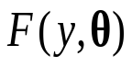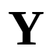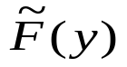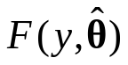
T

Figure 7 illustrates the process involved in calculating a GOF test statistic for the parametric case. The random sample Y is assumed to have been drawn from the parametric family , but with the added complication that is unknown. We therefore calculate the ML estimate of to obtained the fitted distribution . We can test the assumption that Y has been drawn from the family by constructing the GOF statistic T to compare with .

The further complication arises because the difference between and is smaller than the difference between and the unknown true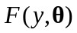. This is because the fitted distribution will follow the sample more closely than because it has been fitted to the sample. This has to be allowed for in calculating the null distribution of the test statistic.

It will be seen that the GOF test hinges on being able to calculate the null distribution. This is a big issue and has meant that many potentially powerful test statistics, like the Cramér - von Mises, have not been fully utilized in practice because the null distribution is difficult to obtain.

In the next Section we show how resampling provides a simple and accurate way of resolving this problem.

11. Bootstrapping a GOF statistic

The principle of the method is exactly as before. The process of Figure 7 is identical to that of Figure 3. Thus if we could obtain many values of T using this process then the EDF of the T_{i} will converge to the CDF of T. This is almost certainly too expensive or impractical to do. However we can get a close approximation by simply replacing the unknown by its MLE . This is precisely the parametric bootstrap process as given in Figure 6. All being well this will be close in value to . Thus the distributional properties of the 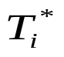 will be close to a set of 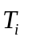obtained under the unknown true process of Figure 7.

The method is illustrated in more detail in Figure 8. In the Figure, 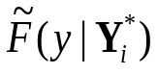 is the EDF of the bootstrap sample 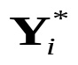, while 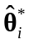 is the bootstrap MLE of obtained from the bootstrap sample

Figure 8: Bootstrap Process to Calculation the Distribution of a GOF Test, T
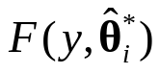
i = 1,2, ..., B

Example Examine whether the gamma model is a good fit to the toll booth data. Examine also whether the normal model is a good fit to the toll booth data.

12 Comparison of Different Models

We consider a problem closely related to that of the previous section. Suppose we have two samples of observations Y and Z and we wish to know if they have been drawn from the same or different distributions.

12.1 Basic Bootstrap Comparison

We can now consider how bootstrapping is done for the two sample comparison problem. We shall consider the version (10) of the test statistic T where ranks are used to make the comparison.

The procedure for producing a bootstrap version of T under the (null) assumption that the two samples are drawn from the same distribution is trivial. We do not have to produce a bootstrap Y* or bootstrap Z* sample at all! Under the null, the ranks of the Y* sample are simply a random sample of m rank values drawn from the set of rank values of the combined sample. This latter comprises simply the set of integers I = {1, 2, …, n + m}. Thus we only have to select at random m integers from the set I and these are then the ranks of the bootstrap Y*. The remaining n values in the set I form the set of ranks of the bootstrap Z* sample. We can thus easily produce B such bootstrap T*’s.

There are two ways we can answer this question:

(i)
(ii) If we fit different models which is the best fit?

We can exploit this uncertainty to construct a way of checking the quality of fit of the model. We use the fitted parametric model to produce a bootstrap sample, and then compare the original Y and bootstrap Y* samples to see how similar they are. It will be seen we need two things. We need

(i) a measure D(Y, Y*) of the difference between two samples,

and

(ii) the distribution of D assuming the two samples have been drawn from the same statistical model F₀(y).

Suppose a large number of original samples are available. We write these samples in pairs: Y₁, Z₁, Y₂, Z₂, Y₃, Z₃, (the Z_{i} therefore are assumed drawn from the same distribution F₀(y) as the Y_{i}), and form a large sample of D’s: D_{i} = D(Y_{i}, Z_{i}). The EDF of the D_{i} thus estimates the distribution of D. If therefore the original Y and the bootstrap Y* come from the same distribution then D(Y, Y*) would be a typical value. If therefore its p-value is small this would indicate that D(Y, Y*) is atypical and we would conclude that Y and the bootstrap Y* come from different distributions. We therefore conclude that the fitted parametric model is not a good model of the original data.

A supply of samples from the original distribution will almost certainly not be available. However this was simply because we were attempting to compare D(Y, Y*) with the distribution of D(Y, Z). . The comparison will be equally effective if we reverse the roles of Y and Y* and compare D(Y, Y*) with the distribution of D(Y*, Z*) generated from pairs of samples drawn from the fitted parametric model. Bootstrap samples are easy to obtain, so this is the version of the problem that we adopt. Figure ??? illustrates the procedure.

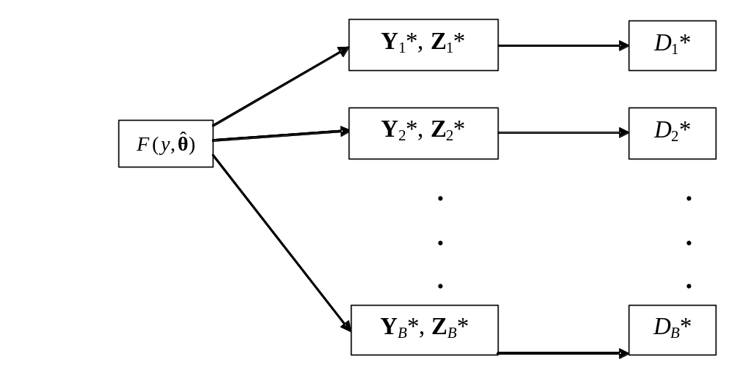Figure ???: A Parametric Bootstrap Process

Actually this method is not quite as sensitive as it can be. In the evaluation of D(Y, Y*), Y* is generated from 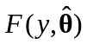. Now this distribution has been fitted to Y, and so is therefore more closely matched to Y than if Y had simply been generated from . Thus Y* and Y are more closely matched than if both samples had been generated from . A more sensitive version is therefore not simply to generate D(Y*, Z*) but to use a double bootstrap process. We generate Y* from , then fit the distribution to Y* to get 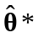, then generate Y** from 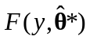 and finally calculate 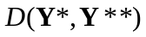.

Figure ???: A Refined Parametric Bootstrap Process
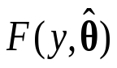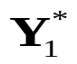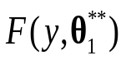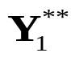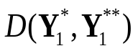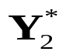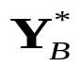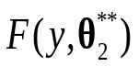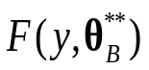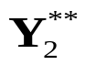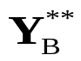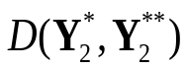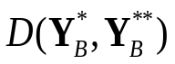
Y

10. Comparing models; Model Selection

11. Statistical MetaModels

The final example of the previous section captures the key features of a statistical analysis.

We will need to review the tools and techniques at our disposal, however we follow the precepts set out in the introduction and get to grips with a typical modelling problem immediately. This is how it is in practice. Imagine we are a consultant with our customer standing in front of us. She/he will not be interested in our inspecting and reviewing the tools at our disposal. Our first step is to look at the system that is the object of our attention. Some examples are
1. An epidemic
2. A queuing system
3. A production process
4. A supply chain
5. A project and its management
6. An environmental system
7. A battle
7. A mechanical/engineering system

The main purpose of a typical OR study might very well be to construct a mathematical or a simulation model of such a system in order to study its behaviour. However in this course, this is not the issue of interest. We shall not be discussing the construction of such a model, but will regard such a model as a ‘black-box’. Our view of the system is as given in Figure 1

Figure 1: Schematic of the System/Model
Input
X

System/
Model
Output
Y
Input

Data
w
Noise
U

The inputs are divided into two types. The input X = (X₁, X₂, … , X_{k}) is a vector of k explanatory variables. These are known quantities and indeed may possibly be selectable by the investigator. The input θ = (θ₁, θ₂, …, θ_{p}) is a vector of unknown parameters. These will therefore have to be estimated. This is done using separate data or past information, w, containing information about θ. Alternatively the estimation might be subjective, and be derived from expert opinion. We write these estimates as 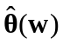, or simply as depending on whether past data w is involved or not, using the circumflex to indicate an estimated quantity. In addition there may be a random component, typically referred to as ‘noise’ or ‘error’ which affects sytem performance. This has been denoted by U to indicate that in a simulation model this error is introduced by transforming uniform random variables.

Example:

The schematic of Figure 1 can be used to represent the system in two distinct ways. It can represent:
(i) The actual system itself
or
(ii) A mathematical or simulation model of the system

Figure 1 is a generic model only, and there are variations. One important variation, when a dynamic system or simulation is being examined, is the way time - which we denote by t - enters into the picture. It is usually best to treat t as being a continuously varying input variable that is part of the input X, but which then results in the output Y being time-dependent. Figure 2 represents this time dependent situation.

Figure 1 is a generic model only, and there are many variations. One important variation, when a dynamic system or simulation is being examined, when we introduce time, which we denote by t, explicitly into the scheme. It is usually best to treat t as being a continuously varying input variable that is part of the input X, but which then results in the output Y being time-dependent. Figure 2 represents this time dependent situation.

Figure 2: Schematic of a Dynamic System/Model
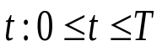
Input
X
System/
Model
Output

Input

Data
w
Noise
U

There is a third way of representing the system. This uses a statistical model. This can represent either (i) the actual system or (ii) the mathematical or simulation model. In case (ii) it is then called a metamodel because it is a model of a model!

As far as this course is concerned we will be focusing on this third representation. We shall not slavishly call it a metamodel, but simply call it a statistical model for short with the understanding that it is always a metamodel.

Whether it is a statistical model of the actual system or of a mathematical/simulation model of the system will depend on the context. The important thing is that the statistical model will need to contain the right structure to explain the relationship between the inputs X and and the output Y. But this structure needs to be developed at the metalevel and not involve detailed causal relationships of the actual system.

The statistical model needs to be set up so that its output resembles the output of the system or mathematical/simulation model that it represents. This is done by fitting it to given input data X and and output data Y, this latter either being real output or output obtained from a mathematical or simulation model. The situation corresponding to Figure 2 is depicted in Figure 3. There will usually be uncertainty as the form of the statistical model. This is handled by including some adjustable parameters or coefficients, β, in the statistical model. Fitting the model therefore requires estimating the β. The estimates, , are found by ensuring that the output of the statistical model closely resembles the output of the system or model.

Figure 3: Fitting a Statistical Metamodel to Data from a Dynamic System/Model

Input
X
System/
Model
Output

Input

Data
w
Noise
U
Statistical Model..
Output

We shall use the regression approach to analysis of simulation output. [Use quadratic regression example, and PAD example. Mention basic estimation formulas.]

