PROOF OF CONCEPT · MALL SECURITY CAMERAS · OPUS 5.5 VISION · 21 OCTOBER 2026

Spill detection on the mall's own cameras
The mall already has fixed cameras over every corridor and atrium. This proof of concept uses them to spot a liquid spill within seconds of it happening and to send the cleaning robot only to confirmed spills, so the robot does not patrol. No training data was collected and no model was trained: a general vision model judges what changed on the floor against a written description of a spill, and every answer is kept as a label for a smaller on-site model later.
98%  accurate on mounted cameras  305 before-and-after checks, 4 cameras | 96%  of spills found  131 of 136 rendered spills on real floors | 0  false alarms  in 169 real frames of people and trolleys | $0.05  per checked frame  frames with nothing persistent cost nothing

HOW IT WORKS

Reference, persistent change, verdict
Because the cameras never move, the server keeps a reference picture of each empty floor and only asks the model about patches that changed and stayed changed: a spill persists, a person walks on. Each such patch is cut out of the frames at full size and sent with the reference and a frame two seconds later. A frame with no persistent change costs nothing. The robot is dispatched only to a confirmed spill.
1 · Reference. Remember the empty floor. A median over a few seconds of footage removes passers-by and leaves the clean floor, per camera. Refreshed slowly so lighting changes do not pile up.
2 · Persistent change. Find what appeared and stayed. Difference against the reference, kept only where the change is still there two seconds later. People, trolleys and their shadows drop out; spills, dropped bags and signs remain.
3 · Ask about the patch. Three frames, one crop. Claude sees the same crop from the reference, the current frame and a frame two seconds later, and answers "has a liquid spill appeared on the floor?" with a fixed JSON shape. The third frame is how it tells a spill, which stays, from a shadow, which walks away.
RESULTS
Across all 458 pairs from 5 cameras: 97% accuracy, 205 of 213 spills found, 8 false alarms in 245 real frames, and 200 of 205 found spills placed at the right spot. On the four mounted cameras alone (305 pairs): 98% accuracy, 131 of 136 spills found, 0 false alarms in 169 real frames. The handheld walkway clip accounts for every false alarm.
WHAT THE MODEL SAW
Each example is exactly what the model saw: the same crop from the reference, the current frame and two seconds later. The amber box is the model's answer, the thin green box is the true spill.
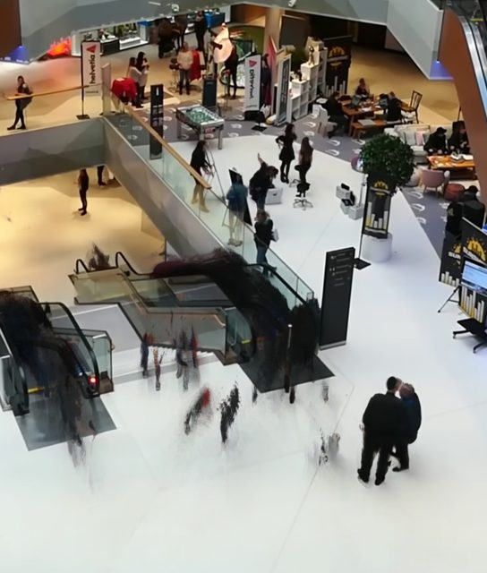 | 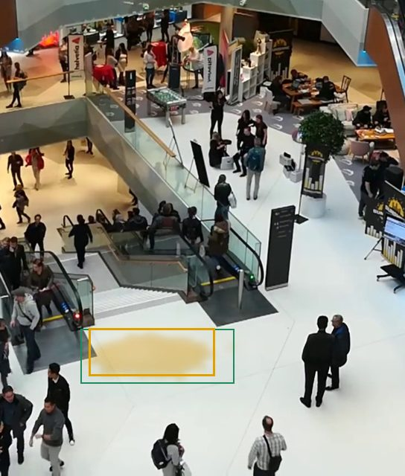 | 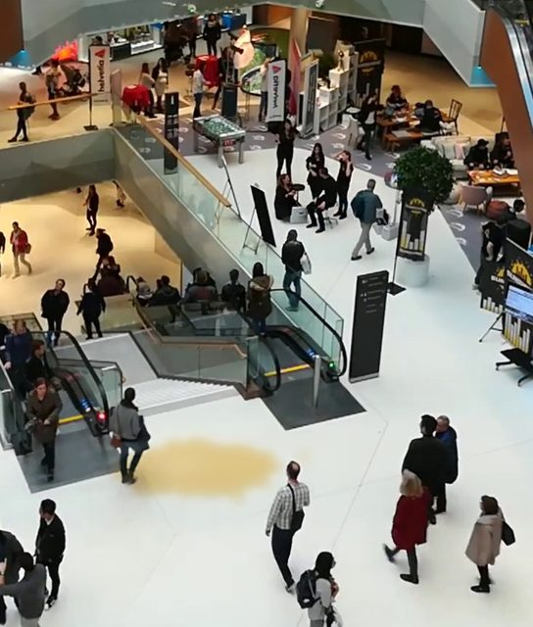
REFERENCE | CURRENT | 2 S LATER
SPILL confidence 0.93 Found
A large tan/brown puddle with an irregular outline has appeared on open floor below the escalator. It is absent from the reference and unchanged in the later frame, and no person touches it, so it is not a shadow.
atrium_escalators camera · truth: rendered juice spill, 11% of frame width
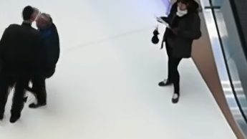 | 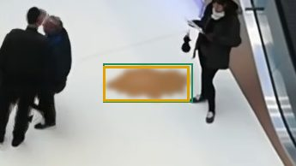
REFERENCE | CURRENT
SPILL confidence 0.93 Found
A brownish irregular puddle has appeared on open floor between the people. It is absent in the reference, unchanged in the later frame, and does not touch anyone's feet, so it is not a shadow.
atrium_escalators camera · truth: rendered coffee spill, 5% of frame width
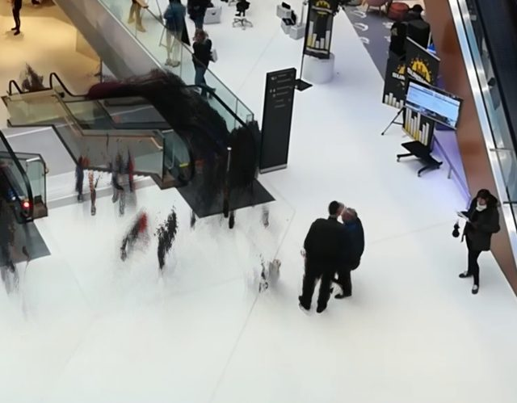 | 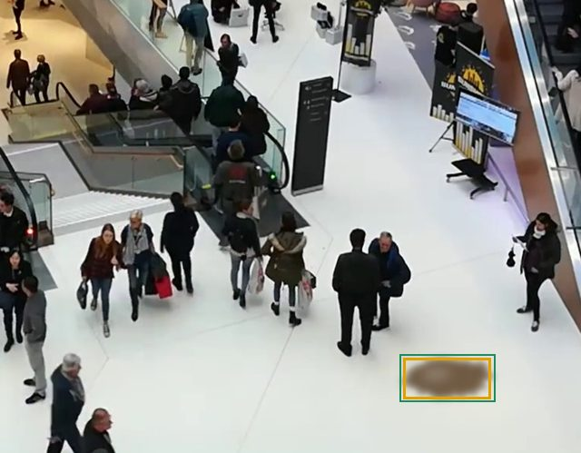 | 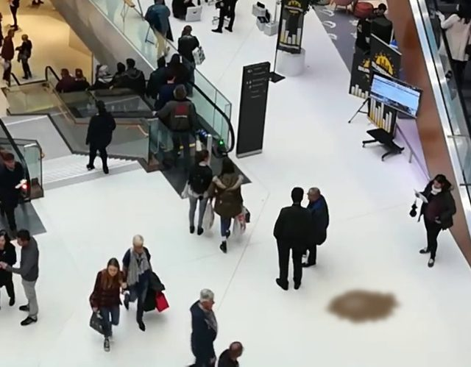
REFERENCE | CURRENT | 2 S LATER
SPILL confidence 0.90 Found
A brown, irregular puddle-shaped patch is on open floor at the lower right in the current frame. It is absent from the reference, unchanged in the later frame, and not attached to any person, which fits a spilled drink such as coffee.
atrium_escalators camera · truth: rendered cola spill, 6% of frame width
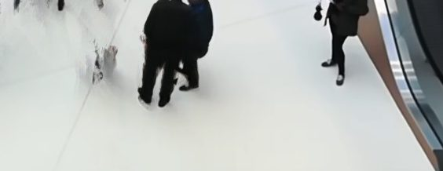 | 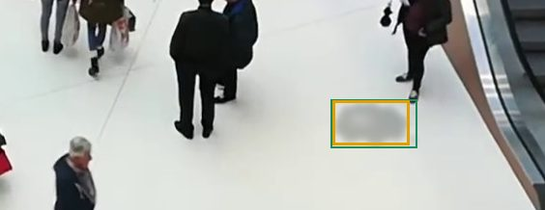 | 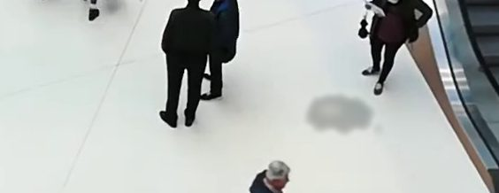
REFERENCE | CURRENT | 2 S LATER
SPILL confidence 0.88 Found
A grey, irregular, puddle-shaped dark patch has appeared on open floor right of centre. It is absent in the reference, is not attached to any person, and stays unchanged in the later frame, which is consistent with a liquid spill.
atrium_escalators camera · truth: rendered water spill, 4% of frame width
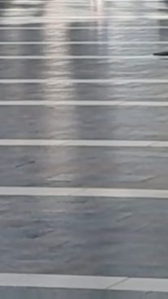 | 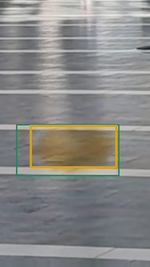
REFERENCE | CURRENT
SPILL confidence 0.90 Found
A new yellowish-brown patch with an irregular rounded outline appears on open floor in the current frame and is unchanged in the later frame. No person is nearby to cast it, so it looks like a spilled drink such as juice or tea.
corridor_vert camera · truth: rendered juice spill, 9% of frame width
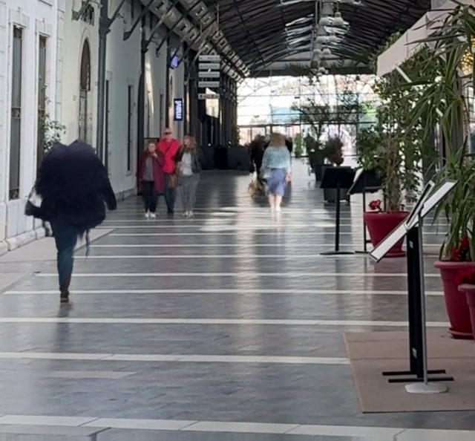 | 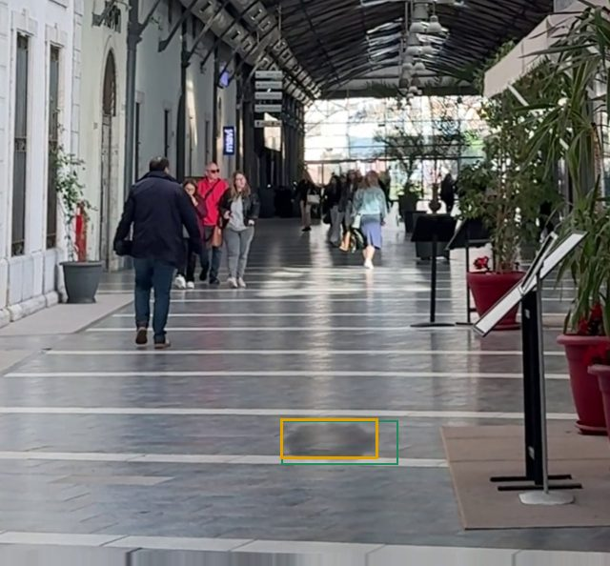 | 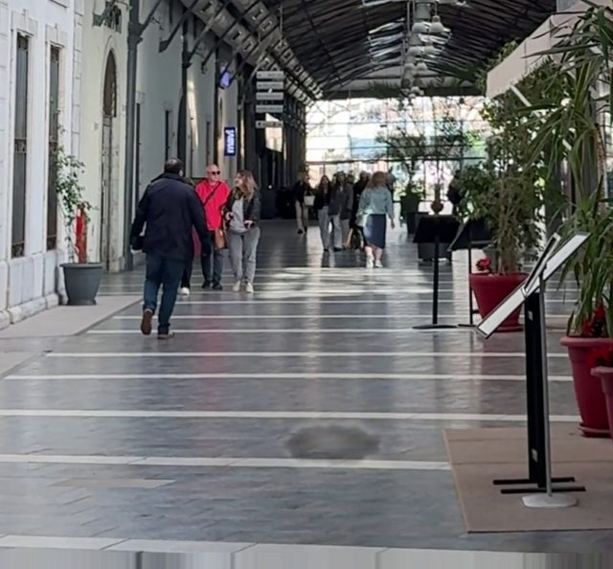
REFERENCE | CURRENT | 2 S LATER
SPILL confidence 0.85 Found
A new dark, irregular, wet-looking patch has appeared on open floor near center-bottom that is absent in the reference. It persists unchanged in the later frame and is not attached to any person, so it is not a moving shadow.
corridor_vert camera · truth: rendered water spill, 10% of frame width
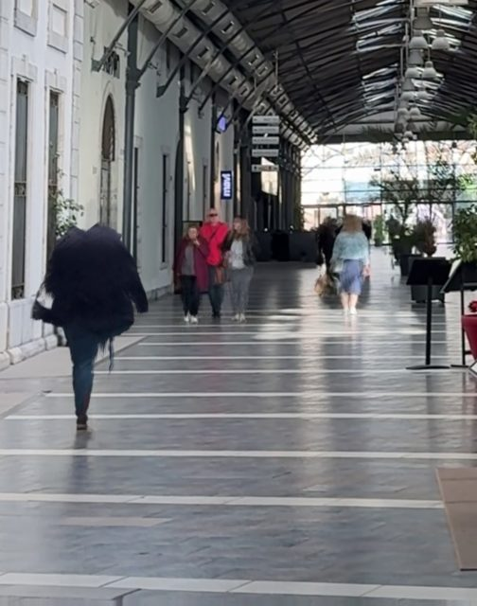 | 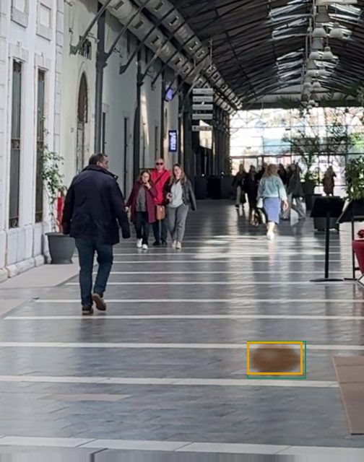 | 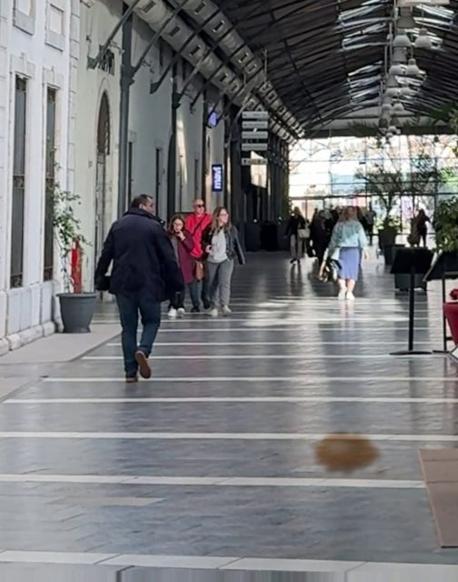
REFERENCE | CURRENT | 2 S LATER
SPILL confidence 0.85 Found
A brown, irregular patch with a liquid-like outline has appeared on open floor at the lower right. It is absent from the reference and unchanged in the later frame, and no person is near it, so it is not a shadow.
corridor_vert camera · truth: rendered coffee spill, 8% of frame width
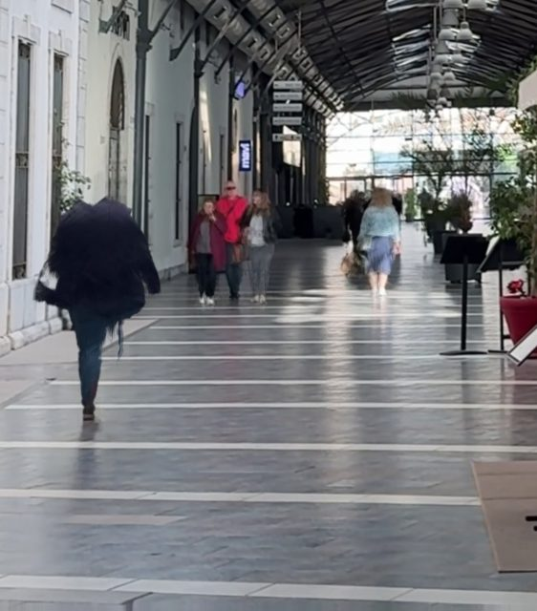 | 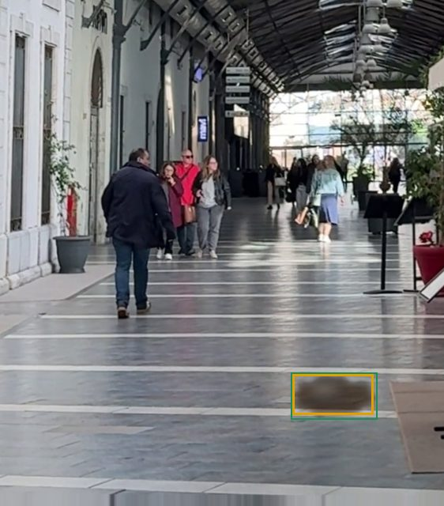 | 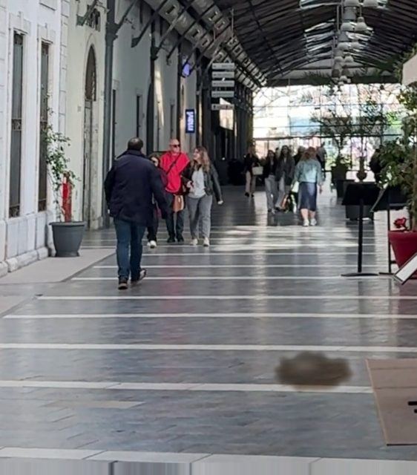
REFERENCE | CURRENT | 2 S LATER
SPILL confidence 0.85 Found
A new brownish patch on open floor near the right mat is absent in the reference and unchanged in the later frame, with no person touching it. Its dark, wet-looking outline suggests a liquid or semi-liquid spill.
corridor_vert camera · truth: rendered cola spill, 10% of frame width
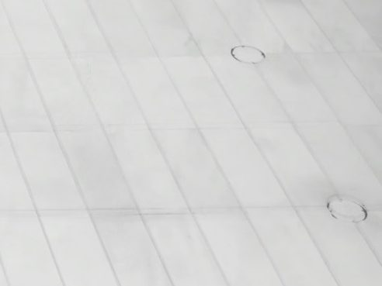 | 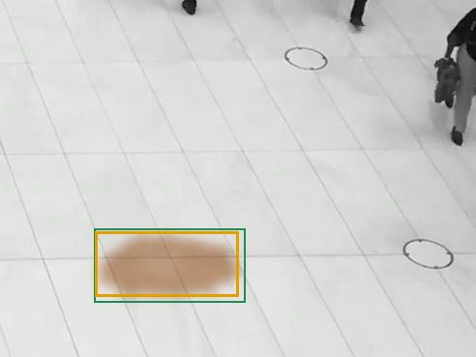 | 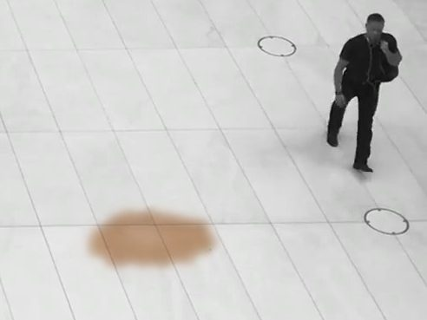
REFERENCE | CURRENT | 2 S LATER
SPILL confidence 0.93 Found
A brownish, irregular puddle has appeared on open floor in the lower left that is absent from the reference. It stays unchanged in the later frame and is not attached to any person, which fits a spilled drink such as coffee or juice.
plaza_overhead camera · truth: rendered coffee spill, 7% of frame width
 | 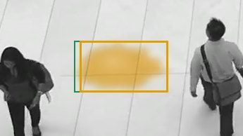 | 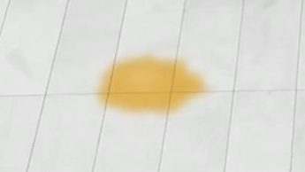
REFERENCE | CURRENT | 2 S LATER
SPILL confidence 0.93 Found
A yellow-orange irregular patch with a splash-like outline is on open floor in the current frame. It is absent from the clean reference, does not touch either person, and is still present unchanged after both people have left, so it is a liquid spill such as juice.
plaza_overhead camera · truth: rendered juice spill, 6% of frame width
 | 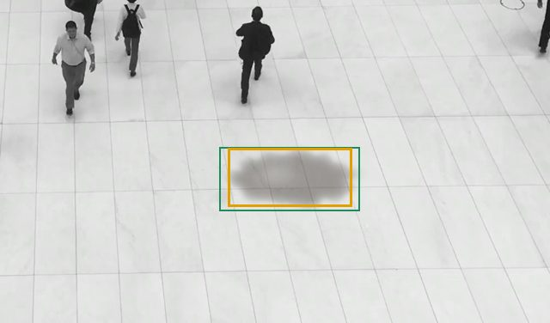 | 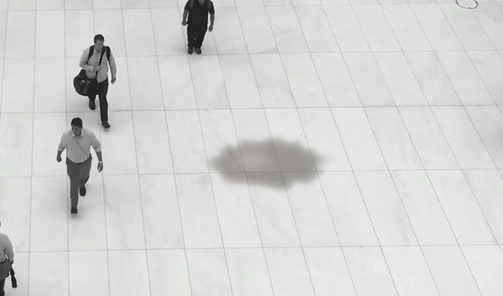
REFERENCE | CURRENT | 2 S LATER
SPILL confidence 0.90 Found
A dark, irregular puddle-shaped patch on open floor is absent from the reference and appears unchanged in both later frames, with no person touching it. That rules out a shadow or a moving object.
plaza_overhead camera · truth: rendered oil spill, 11% of frame width
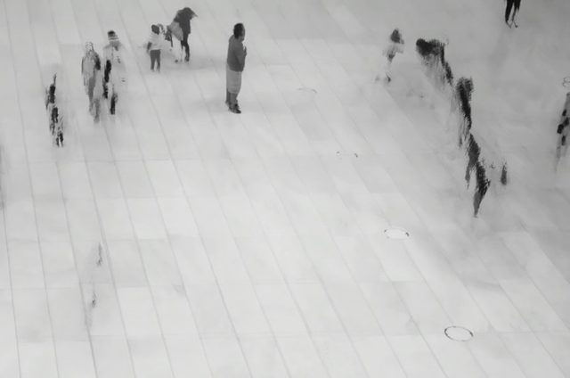 | 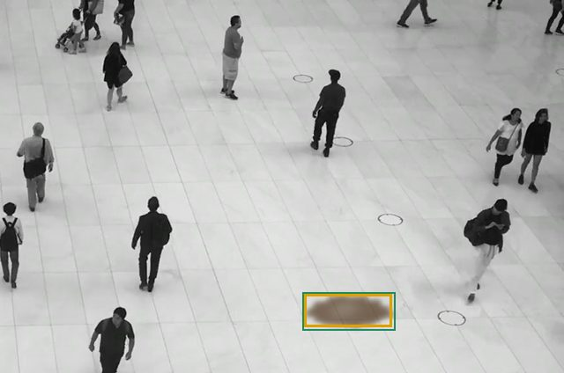 | 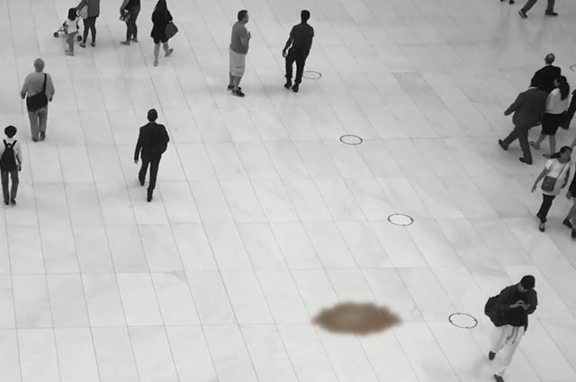
REFERENCE | CURRENT | 2 S LATER
SPILL confidence 0.90 Found
A brown, irregular puddle-shaped patch on open floor near the bottom centre is absent in the reference but present and unchanged in both the current and later frames, and it does not touch any person. Its brown colour suggests coffee or a similar drink.
plaza_overhead camera · truth: rendered cola spill, 7% of frame width
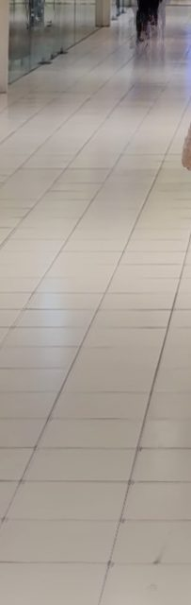 | 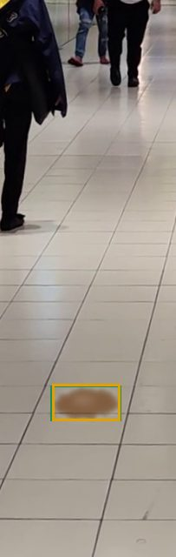 | 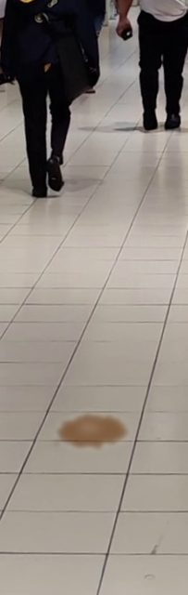
REFERENCE | CURRENT | 2 S LATER
SPILL confidence 0.93 Found
A brownish puddle with an irregular splash outline appears on open floor in the current frame. It is absent from the reference and unchanged in the later frame, it is not connected to any person, and it looks like a spilled drink such as coffee.
walkway_vert camera · truth: rendered coffee spill, 6% of frame width
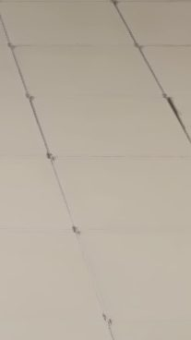 | 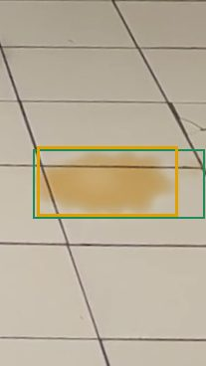 | 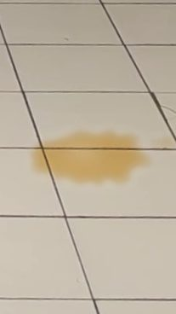
REFERENCE | CURRENT | 2 S LATER
SPILL confidence 0.93 Found
A new amber/orange puddle with an irregular splash outline sits on open tile floor, absent from the reference and unchanged in the later frame. Its colour suggests juice or a soft drink, and no person or object is nearby to cast a shadow.
walkway_vert camera · truth: rendered juice spill, 11% of frame width
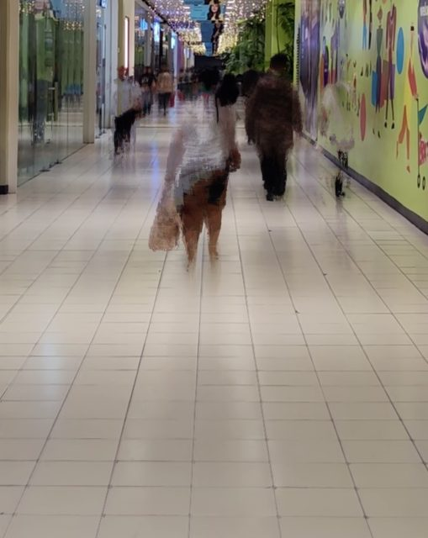 | 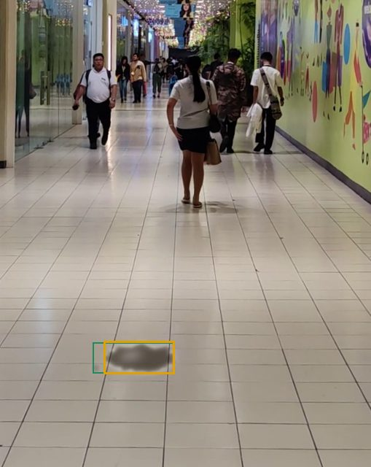 | 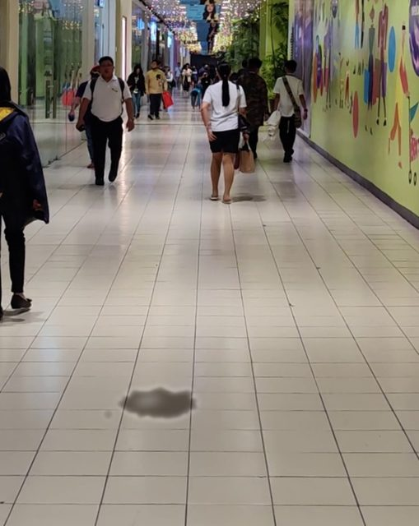
REFERENCE | CURRENT | 2 S LATER
SPILL confidence 0.90 Found
A dark, irregular, wet-looking patch on open floor (lower centre) is absent from the reference and identical in the current and later frames, while the people around it have moved. It has its own outline and touches no person, so it is not a shadow or a wall reflection.
walkway_vert camera · truth: rendered oil spill, 9% of frame width
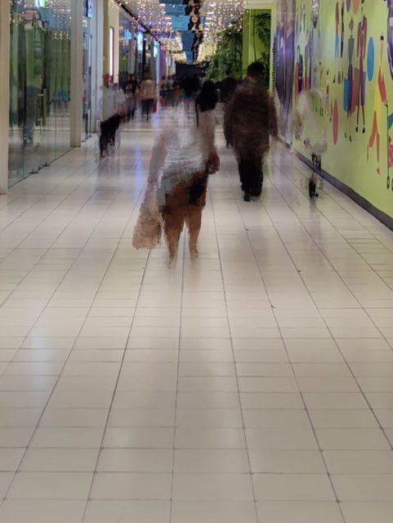 | 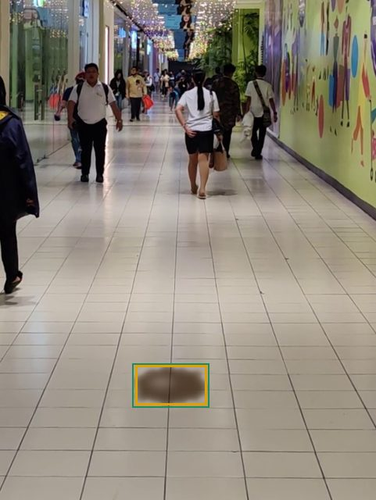 | 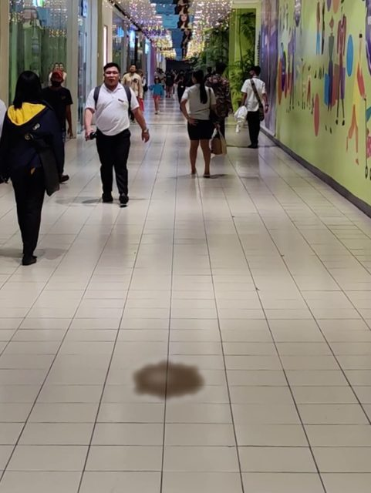
REFERENCE | CURRENT | 2 S LATER
SPILL confidence 0.90 Found
A new brownish puddle with an irregular, darker rim appears on open floor in the current frame, absent from the reference. It is unchanged in the later frame and has no person nearby, so it is not a shadow.
walkway_vert camera · truth: rendered cola spill, 10% of frame width
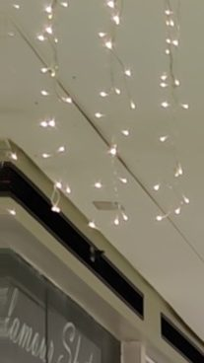 | 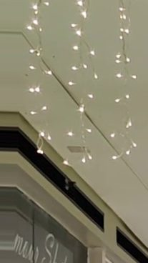 | 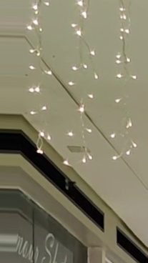
REFERENCE | CURRENT | 2 S LATER
CLEAR confidence 0.96 Missed
All three frames show a ceiling with hanging string lights and an upper shopfront; no floor is visible, so no spill can be assessed. Differences between frames are minor camera shifts only.
walkway_vert camera, a miss · truth: rendered oil spill, 4% of frame width
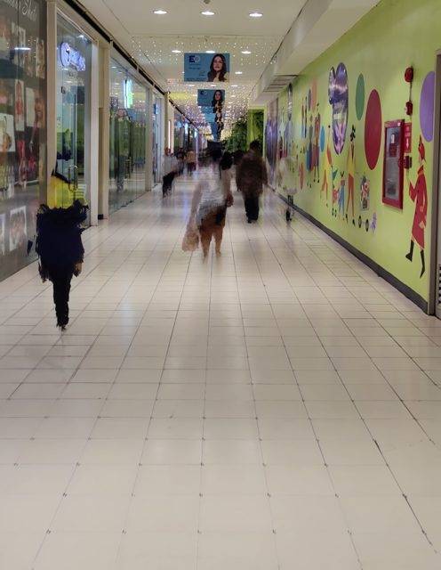 | 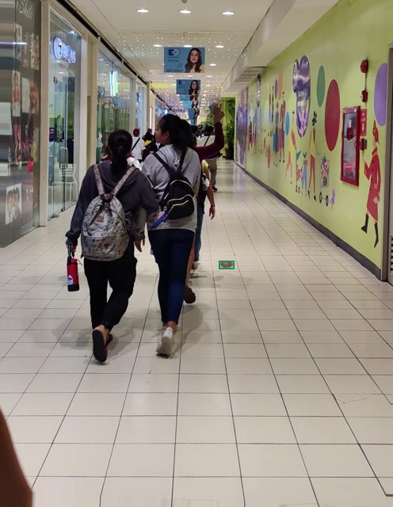 | 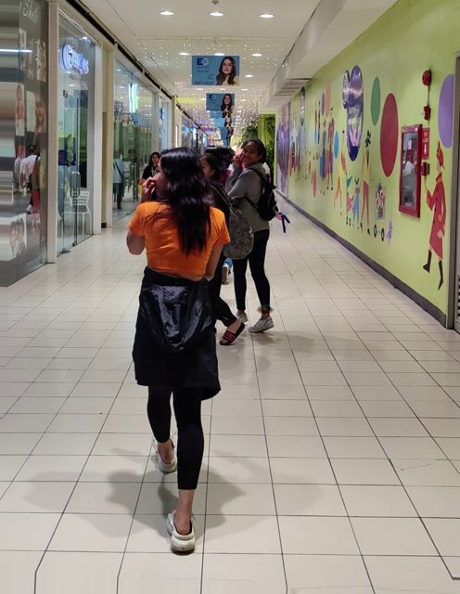
REFERENCE | CURRENT | 2 S LATER
CLEAR confidence 0.70 Missed
The current frame shows a small brownish patch on open floor (around x≈0.57, y≈0.52), but it is absent in the later frame at the same location, so it is not a persistent spill. The other dark patches are shadows of the people walking.
walkway_vert camera, a miss · truth: rendered cola spill, 3% of frame width
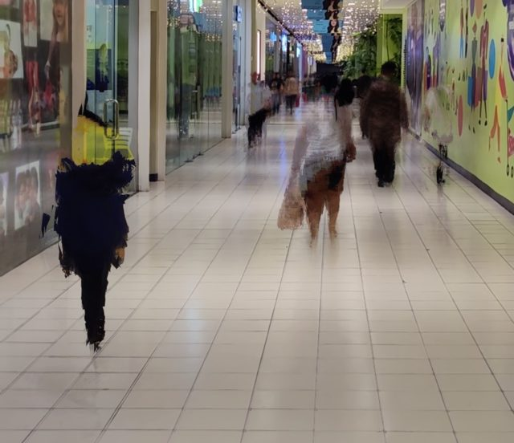 | 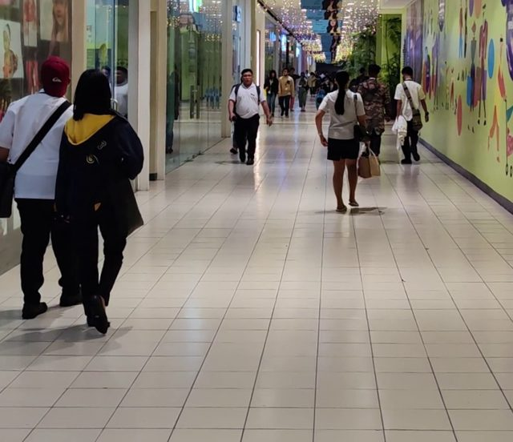 | 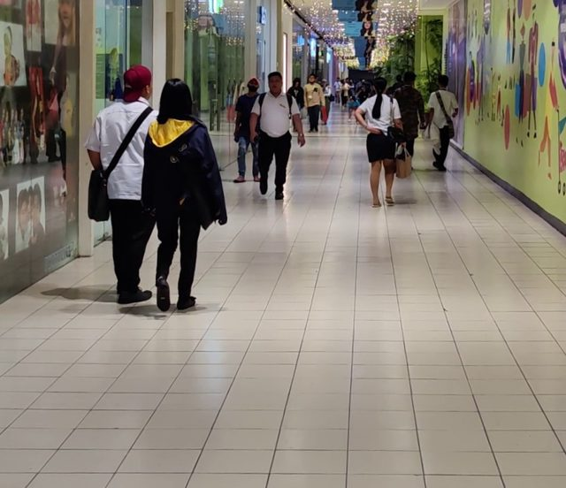
REFERENCE | CURRENT | 2 S LATER
CLEAR confidence 0.93 Correctly clear
The only new dark patches are shadows at the walking people's feet, and they move with them in the later frame. The open tile floor otherwise matches the reference, with only glossy reflections along the shopfronts and wall.
walkway_vert camera, people walking through · truth: no spill, real footage
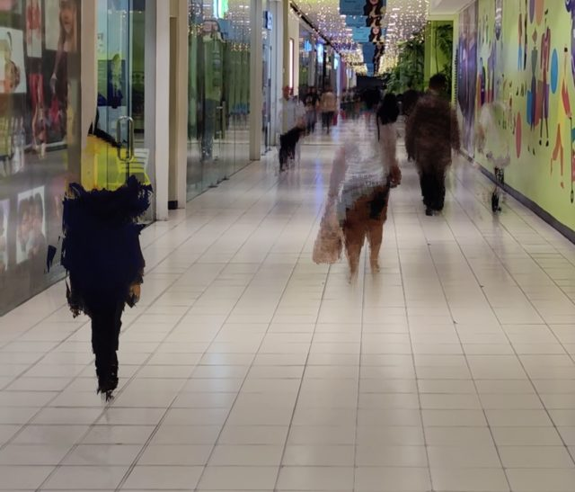 | 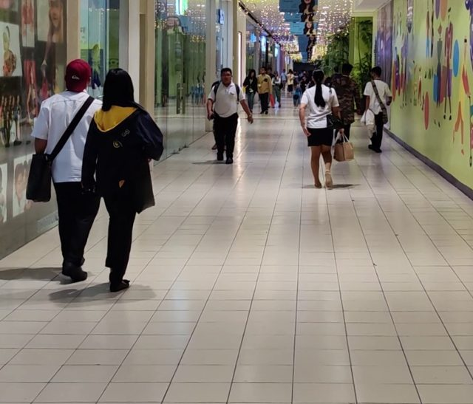 | 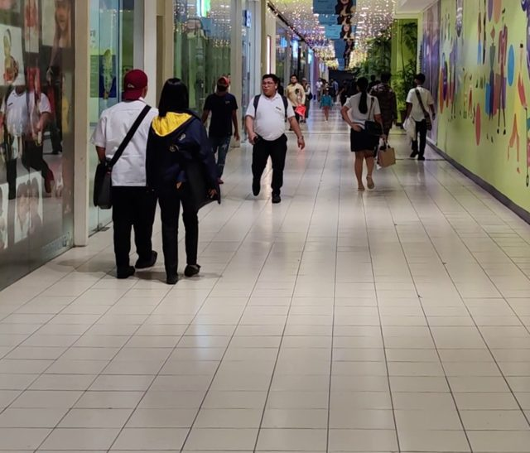
REFERENCE | CURRENT | 2 S LATER
CLEAR confidence 0.93 Correctly clear
The only new dark patches in the current frame are shadows attached to the walking people's feet, and they move with them in the later frame. The remaining changes are normal reflections on the polished tiles, which are also present in the reference, and no independent wet patch appears.
walkway_vert camera, people walking through · truth: no spill, real footage
CLEAR LIQUIDS

Water is the hard case, and it is found
Water has no colour of its own. On a floor it shows only as a darkening of the surface, a soft outline and a slight sheen, which is also how a shadow or a polished patch looks. The model found 50 of 53 water spills across the mall cameras, down to one 3% of the frame wide. Coloured liquids for comparison: coffee 36 of 37, cola 33 of 35, juice 41 of 41, oil 45 of 47.
REFERENCE | CURRENT | 2 S LATER
SPILL confidence 0.88 Found
A grey, irregular, puddle-shaped dark patch has appeared on open floor right of centre. It is absent in the reference, is not attached to any person, and stays unchanged in the later frame, which is consistent with a liquid spill.
atrium_escalators camera, water · truth: rendered water spill, 4% of frame width
REFERENCE | CURRENT | 2 S LATER
SPILL confidence 0.85 Found
A new dark, irregular, wet-looking patch has appeared on open floor near center-bottom that is absent in the reference. It persists unchanged in the later frame and is not attached to any person, so it is not a moving shadow.
corridor_vert camera, water · truth: rendered water spill, 10% of frame width
 | 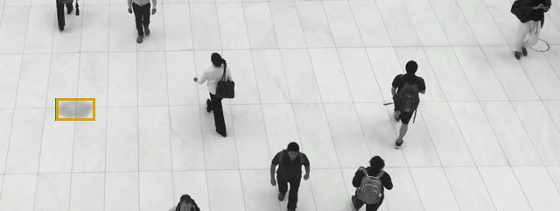 | 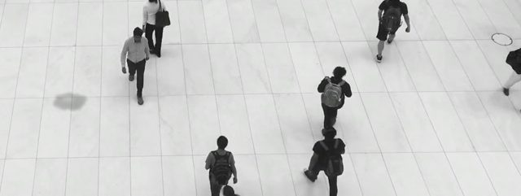
REFERENCE | CURRENT | 2 S LATER
SPILL confidence 0.88 Found
A dark, irregular puddle-shaped patch on open floor at left-centre is absent in the reference and unchanged in both later frames, with no person nearby, consistent with a liquid spill.
plaza_overhead camera, water · truth: rendered water spill, 4% of frame width
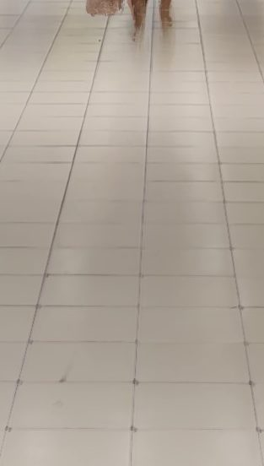 | 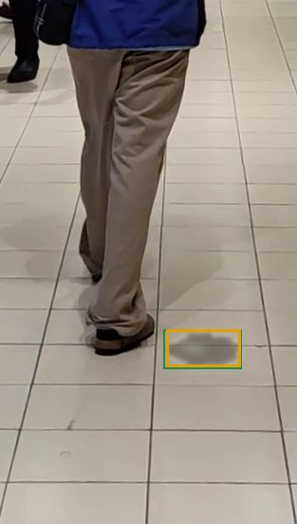 | 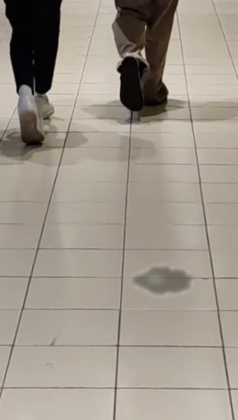
REFERENCE | CURRENT | 2 S LATER
SPILL confidence 0.90 Found
A dark, irregular, wet-looking patch has appeared on open floor to the right of the walker. It is absent in the reference and unchanged in the later frame after the person moved away, so it is not a shadow.
walkway_vert camera, water · truth: rendered water spill, 6% of frame width
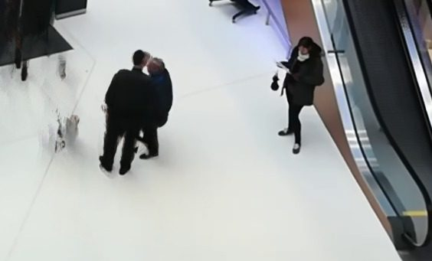 | 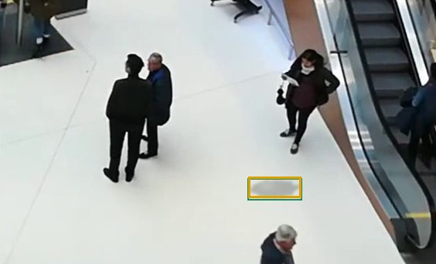 | 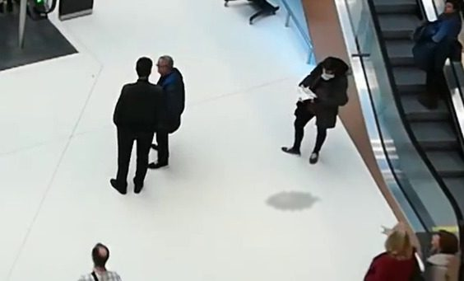
REFERENCE | CURRENT | 2 S LATER
SPILL confidence 0.88 Found
A new grey, irregular-edged patch has appeared on open white floor and is absent from the reference. It is not touching any person and stays in the same place and shape in the later frame, consistent with a liquid puddle.
atrium_escalators camera, the smallest water spill found · truth: rendered water spill, 3% of frame width
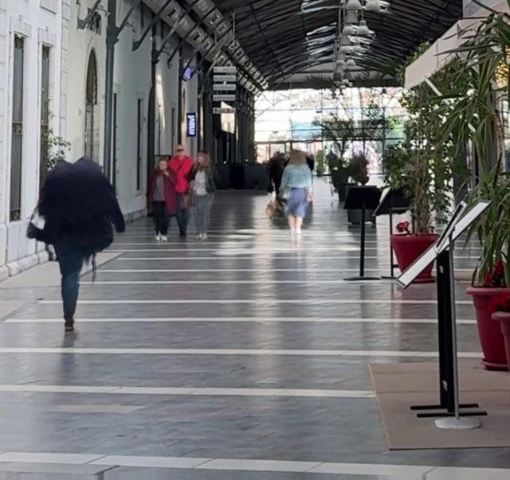 | 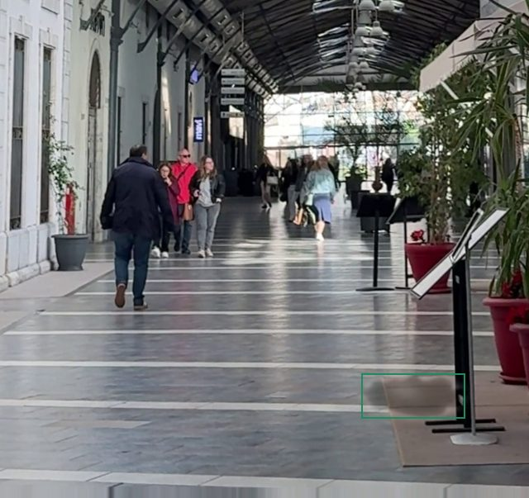 | 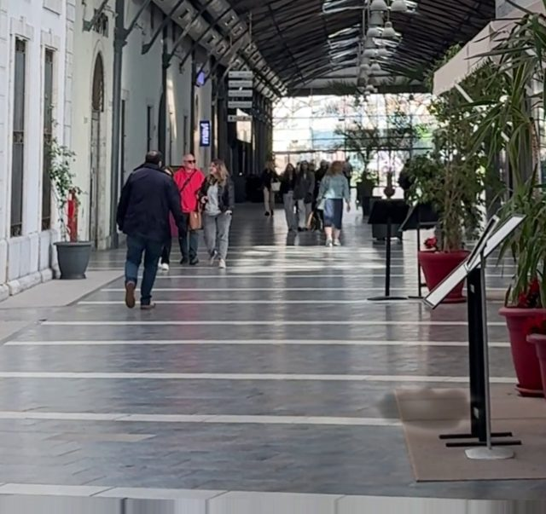
REFERENCE | CURRENT | 2 S LATER
CLEAR confidence 0.90 Missed
Across all three frames the polished floor shows only the same light reflections, white stripes and moving pedestrians with their reflections; no new patch with its own liquid outline appears on open floor. A potted plant near the left wall appears in later frames but is not a spill.
corridor_vert camera, a water spill it missed · truth: rendered water spill, 11% of frame width

The pipeline against a whole-frame check
 | Pipeline: persistent crops, three frames (458 pairs) | Whole frame, two frames (153 pairs, every third)
Spills found | 205 of 213 | 55 of 70
False alarms | 8 of 245 | 0 of 83
Spills smaller than 7% of frame width found | 87 of 90 | 19 of 27
Model calls per frame | 6.1 | 1
Cost per checked frame | $0.051 | $0.016
Latency per frame | 21.5 s | 10.0 s

COST AT SCALE

What this costs across a mall
The camera server does the cheap work for free: it keeps the reference, finds changes and drops the ones that walk away. Only persistent patches reach the model, and each check costs about $0.051 at the 6.1 crops per check seen in the busy test clips. One camera, a 12-hour day:
One camera | Checks per day | Per day | Per month
Quiet floor: one check every 4 minutes | 180 | $9.25 | $277
Busy corridor: one check every minute | 720 | $37.00 | $1,110
The per-check cost was measured on crowded test clips where people standing still add crops; an empty floor costs less per check. Once enough labelled patches have accumulated, a small on-site model takes the easy decisions and the cloud model becomes a second opinion.
NEXT

Roadmap
When | What
Done | Fixed-camera pipeline. Reference, persistent change, before-and-after crops. Tested on five mall cameras with rendered spills: no false alarms on the mounted cameras.
Next | One real mall camera, real spills. A few hours of footage from a single camera in any mall, with water, coffee and oil spilled on the floor in view. This replaces the rendered positives and gives the true recall number and the real check rate.
Then | Hard negatives at scale. Polished stone, reflections, cleaning carts, wet-floor signs, dropped bags. Measure the false-alarm rate per camera per day, which is what decides whether staff trust the alerts.
Later | Camera-server deployment. Reference and persistence run on the camera server at no cost; only persistent patches go to the model. Robot dispatch on confirmed spills. An on-site model trained from the accumulated labels where the cloud call is not wanted.

ALSO TESTED

A close camera on the robot itself
Before the camera question was settled, the same model was tested on single close-range frames, the view a camera on the robot would have. It is kept here because it is the fallback if a mall's cameras cannot be used, and because it shows how the model behaves on a public spill dataset with real liquids.
One or two frames per second are sampled from the camera, near-identical frames are dropped, and each frame is sent to Claude Opus 5.5 with a written brief of what counts as a spill and what does not. The answer is a yes/no, a confidence, a liquid type, a box and a one-line reason, in a fixed JSON shape, and every answer is kept with its frame as a training label.

What the model saw, and what it said
Real close-range frames from the public dataset. The amber box is where the model says the spill is. The text under each frame is the model's own one-line reason, unedited.
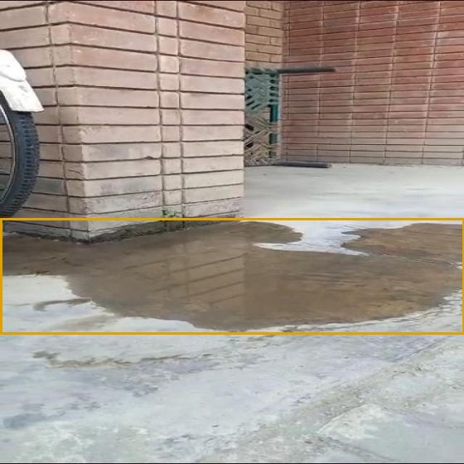 | 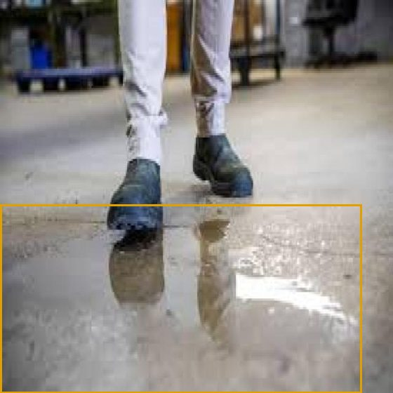
SPILL confidence 0.95  A large, irregularly shaped standing puddle of muddy water covers the concrete floor in front of the brick wall, with the wall clearly reflected in its surface. The distinct edges and reflection indicate real pooled liquid rather than a floor pattern or shadow.  Rain puddle on outdoor pavement, phone video at knee height | SPILL confidence 0.93  A large clear puddle covers the lower half of the concrete floor, with mirror-like reflections of the person's boots and a distinct irregular edge showing standing liquid rather than glossy flooring. The clear colour suggests water.  Person walking through a puddle on a glossy indoor floor

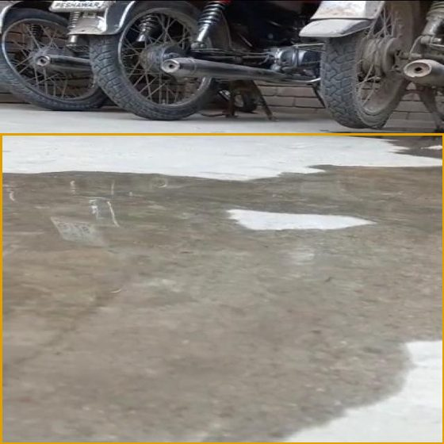 | 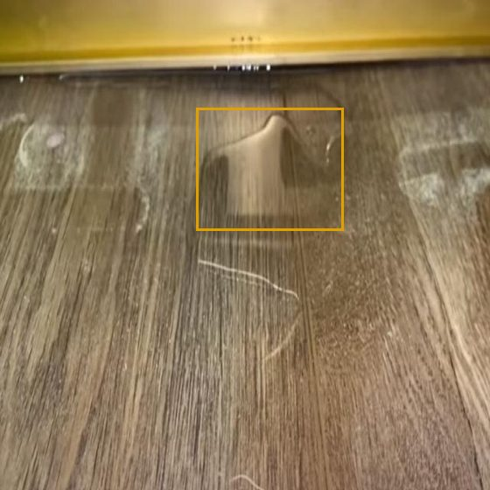
SPILL confidence 0.93  A large dark wet patch covers most of the concrete floor, with irregular puddle edges and visible reflections of the motorcycles and plate, which indicates standing water. Dry lighter concrete is visible at the top and bottom-right edges.  Wet concrete outside a parking area, low-angle video | SPILL confidence 0.85  A clear liquid puddle with a distinct raised meniscus edge and light reflection sits on the wood-look floor near the yellow baseboard. Dried white residue marks and a hair-like strand are also visible.  Small water patch on a wooden floor, screenshot from video

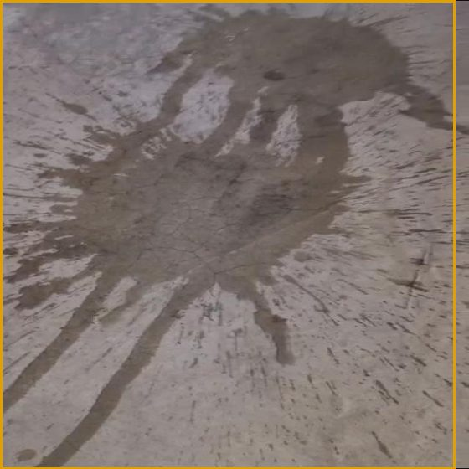 | 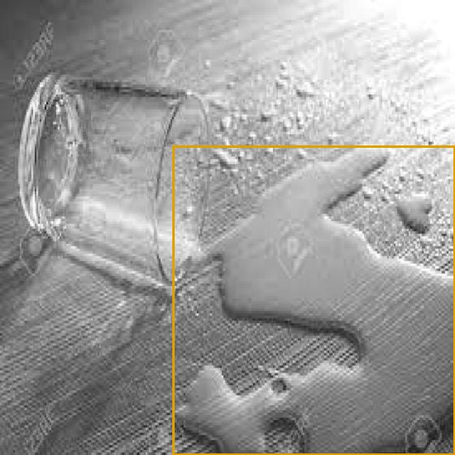
SPILL confidence 0.90  A large dark wet splash pattern with radiating streaks and droplet spatter covers most of the concrete floor, consistent with spilled liquid (likely water) rather than a material stain or shadow.  Muddy splash across a tiled floor, WhatsApp video frame | SPILL confidence 0.90  A tipped-over glass lies on a wood-grain surface with a large clear puddle with defined edges and scattered droplets spreading from its rim, consistent with spilled water. The close-up stock-photo framing makes it slightly uncertain whether the surface is a floor rather than a table.  Tipped glass with water spreading on a grey surface

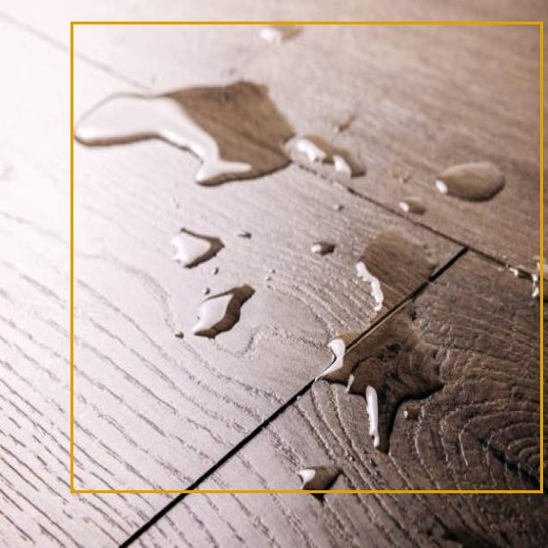 | 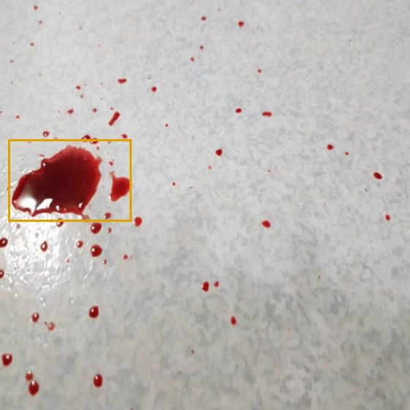
SPILL confidence 0.96  Clear beaded puddles and droplets with raised edges and specular highlights sit on the wood-look plank floor, consistent with spilled water. They are spread across the upper and central frame, with liquid also running along a plank seam.  Water droplets and a wet patch on a dark wooden floor | SPILL confidence 0.96  A glossy red liquid pool with many scattered droplets and splatter is visible on light speckled vinyl flooring, consistent with blood or a red drink spill. This may be a biohazard and should be flagged for staff.  Red liquid splashed on white tiles

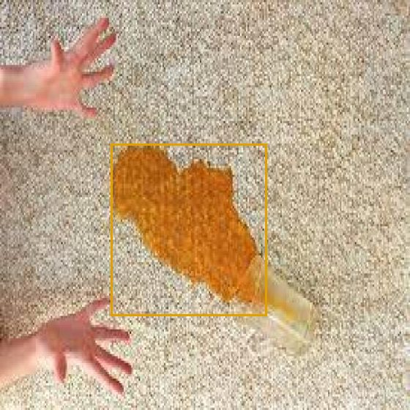 | 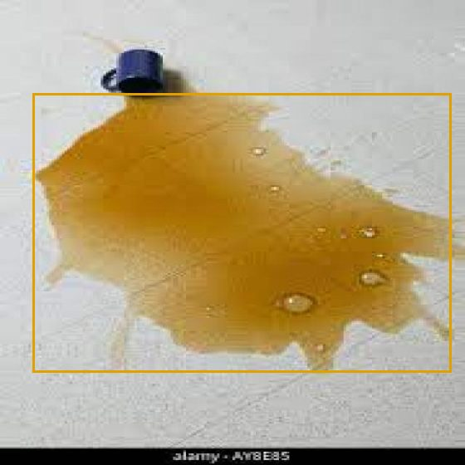
SPILL confidence 0.96  An orange liquid, likely juice, has soaked into the beige carpet in a distinct stain spreading from a tipped-over glass. The outline and saturation clearly indicate a fresh drink spill.  Orange drink soaked into carpet, hands reaching in | SPILL confidence 0.97  A large brown puddle with irregular edges and surface bubbles spreads across a light floor next to a tipped-over blue mug, consistent with spilled coffee or tea. The overturned mug is an object on the floor that also needs picking up.  Juice pooled on a tiled floor

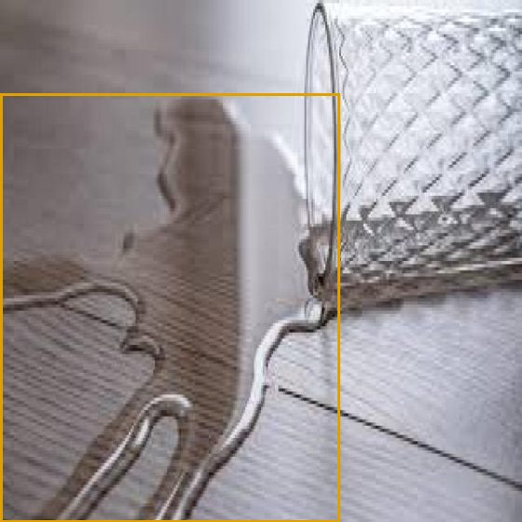 | 
SPILL confidence 0.93  A tipped-over glass sits on a wood-grain floor, with a clear liquid puddle spreading from its rim. The puddle has distinct raised, reflective edges and darkens the wood beneath it.  Clear water from a tipped glass on wood grain. Opus caught it, Haiku called it a reflection | SPILL confidence 0.60  A distinct brown puddle consistent with spilled coffee lies next to a tipped cup on a white surface, with a hand wiping it with a pink cloth. This is a watermarked stock photo, and the plain white surface could be a table rather than the floor, which lowers confidence.  Tea spill next to a cup. Flagged at low confidence (0.60), which the robot should treat as 'go check'

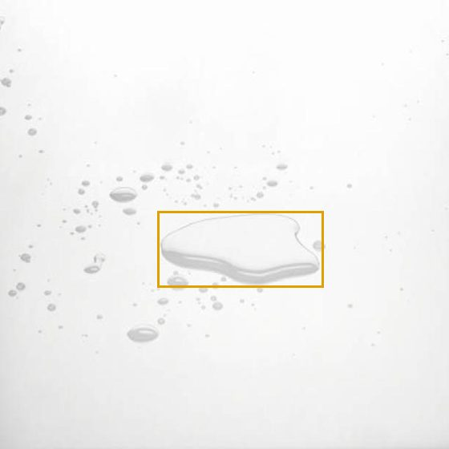 | 
SPILL confidence 0.90  A clear, raised puddle with defined meniscus edges sits on a white glossy surface, surrounded by scattered droplets, consistent with spilled water. The surface looks like a close-up floor, so this is likely a small water spill.  Small clear puddle on a pale floor, almost invisible at a glance | CLEAR confidence 0.88  The supermarket aisle floor is partly visible between the shopping carts and shows a uniform grey surface with only light sheen and cart shadows. No puddles, drips or debris are visible, though much of the floor is occluded by carts and people.  Supermarket CCTV frame, shoppers in an aisle, dry floor

 | 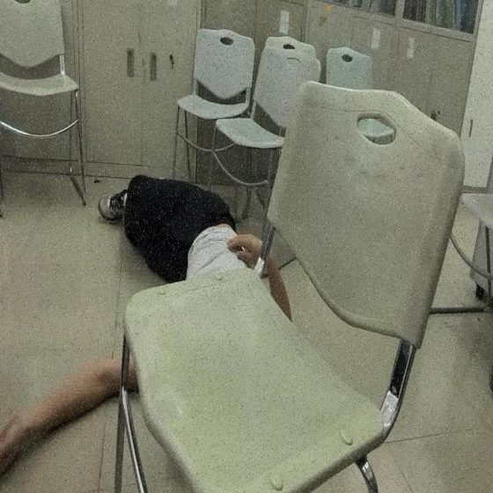
CLEAR confidence 0.90  Motion-blurred supermarket freezer aisle with a shopping cart blocking most of the floor; the small visible floor strips show only bright reflections and no distinct puddle or liquid.  Bright supermarket aisle, polished floor, no spill | CLEAR confidence 0.85  No puddle, smear or wet patch is visible on the beige tile floor; only chairs, cabinets and a few small dark specks are present. IMPORTANT: a person appears to be lying motionless on the floor among the chairs, a possible medical emergency that should be escalated to staff immediately.  Person lying on a tiled floor between chairs, no liquid

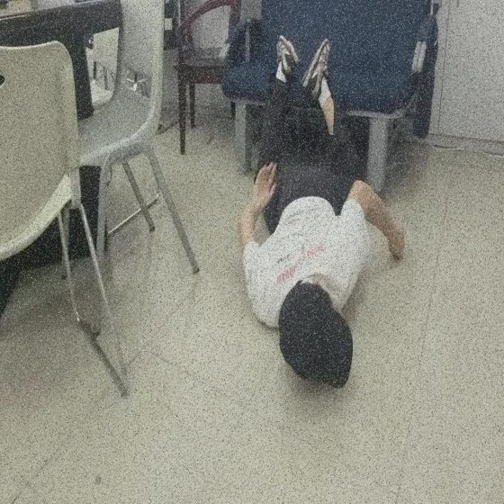 | 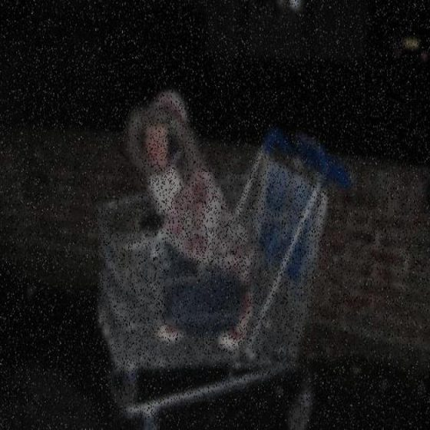
CLEAR confidence 0.85  The light tiled floor shows no puddles, drips or wet outlines, only image noise and soft reflections. A person is lying face-down on the floor with their legs on a sofa, which is not a spill but may be a fall or medical incident and warrants flagging to staff.  Same room, different angle. Scuffed tiles, no spill | CLEAR confidence 0.80  Very dark, heavily noisy frame showing a child sitting in a shopping cart; the visible floor area shows no distinct puddle or wet outline, though low light and noise limit certainty.  Very dark, grainy frame of a shopping trolley

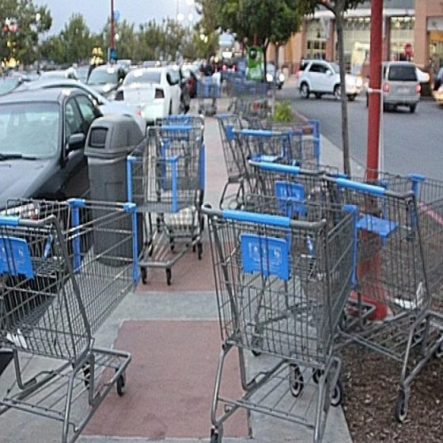 | 
CLEAR confidence 0.90  Outdoor parking-lot sidewalk crowded with shopping carts; the visible concrete and red-brick paving looks dry, with no puddles, drips or wet sheen. Dark patches are cart shadows and mulch, not liquid.  Shopping trolleys on wet-look pavers outdoors | CLEAR confidence 0.90  Coffee is spilled on a laptop keyboard and touchpad resting on a wooden table, not on the floor. No floor surface is visible, so this is not a floor spill for the robot to clean.  Coffee on a laptop keyboard. Dataset says 'water', the model says 'not on a floor'

Why Opus 5.5 and not the cheaper model
Claude Haiku 5.5 costs about a thirtieth as much. On the same 200 frames its headline score is close, but it is less consistent: it ignored the floor-only rule on 4 of the 8 mislabelled frames, gave up on several abstract splash images, and missed the one genuinely hard floor spill in the set.
 | Claude Opus 5.5 | Claude Haiku 5.5
Floor-frame accuracy | 100% | 97%
Floor spills missed | 0 of 95 | 5 of 95
False alarms | 0 of 97 | 0 of 97
Followed the floor-only rule | 8 of 8 | 4 of 8
Cost, 200 frames | $1.16 | $0.032
Mean latency | 3.1 s | 2.0 s
Recommendation: Opus 5.5 for the proof of concept and for labelling anything subtle. Haiku may later take the easy frames in bulk, with Opus re-checking anything it marks below 0.8 confidence.

Model: claude-opus-5-5, effort low, structured JSON output.
Fixed-camera footage: five mall clips from Pixabay and Pexels (Pixabay Content License, Pexels License), real floors with rendered spills; no AI image generation was used anywhere in this work.
Close-camera data: Spill_Detection v4 by slipp on Roboflow Universe, CC BY 4.0. Validation split, 200 frames, random seed 0.
Generated from data/results by scripts/build_docx.py.

