LibriSense
An Adaptive Smart Library
— Project Proposal —
Smart Cities and the Internet of Things · Practical Project 2026
M.Sc. Autonomous Systems · Universität Stuttgart
Domain: Smart Building · Functionality: Monitoring + Automation
Team: Dennis Gunt · [member 2] · [member 3]
Submission date: 1 May 2026

1 · Executive Summary
Libraries are still the silent infrastructure of deep work — but they have not kept pace with what we now know about cognitive performance, indoor-air quality, and sustainable building operation. LibriSense is an IoT-plus-AI system that turns an ordinary reading room into an environment that actively collaborates with its learners.
The system continuously monitors temperature, humidity, illuminance, noise, occupancy, and a simulated CO₂ proxy, and combines those streams with each learner's focus-session state. An AI planner (PDDL, solved with Fast Downward) decides — every few seconds — which of six actuators to move next: it dims or brightens a reading lamp, switches heating/ventilation, or escalates a break reminder from a soft dashboard nudge to a buzzer.
The design directly satisfies all six Smart-Cities course requirements: modular architecture, indirect integration over MQTT, a rich IoT fabric of seven sensors and six actuators spanning physical + simulated, automatic PDDL problem generation with a real planner in the loop, a live dashboard that renders both environment state and the current plan, and a distributed deployment across an edge Raspberry Pi and a core processing node.
This proposal presents the system focus, architecture, module-by-module design, PDDL sketch, IoT device map, timeline, and risk analysis. All deliverables are on track for the 14 July report and 20 July demo.

2 · Proposal-form Content (copy-paste ready)
The three tables below map one-to-one to the fields of the official Project_Proposal_Form.pdf. Their wording is written to fit the form's text boxes.

2.1 Project Information
Project Information
1. Student Name | Dennis Gunt | Student ID | [fill in]
2. Student Name | [team member 2] | Student ID | [fill in]
3. Student Name | [team member 3] | Student ID | [fill in]
Group ID | [assigned by course] | Project Title | LibriSense — Smart Library

2.2 System Focus
System Focus
Domain | ◉ Smart building ○ Autonomous vehicle  Educational / public-learning space — a university or municipal library. | Type | Public educational facility
Functionality | Monitoring: continuous tracking of temperature, humidity, illuminance, noise level, occupancy, indoor-air-quality proxy (CO₂), and per-learner focus-session state.  Automation: closed-loop control of reading-lamp brightness, heating/fan, ventilation relay, and multi-modal break reminders (dashboard → LED → buzzer → TTS) — all decided by an AI planner.
Components | 1. IoT Sensor Hub — Raspberry Pi 3 B+ + Sense HAT (temperature, humidity, pressure, IMU)  2. Ambient Sensing Suite — GrovePi Light + Sound sensors, PIR motion, simulated CO₂  3. Software Sensors — Learner-session state API, Pomodoro timer, weather API  4. Smart Actuators — Plugwise smart switches (lighting, heating), Grove Relay (ventilation)  5. AI Planning Core — PDDL domain + problem generator + Fast Downward planner  6. Visualisation & UX — React/WebSocket dashboard, break-reminder escalation, plan timeline
Objective | Transform a traditional library into an adaptive learning environment that autonomously optimises for four competing objectives: (i) learner focus and cognitive well-being — enforcing evidence-based break rhythms (Pomodoro 25/5, long break every 4 cycles); (ii) physical comfort — regulating illuminance, temperature, and CO₂ within ergonomic ranges; (iii) energy efficiency — switching off actuators in unoccupied zones and re-using passive daylight/heat; and (iv) respect for privacy and user agency — every automated action is overridable, no biometric data leaves the edge.

2.3 Project Requirements
Project Requirements
System Design | Six strongly-decoupled modules — (1) IoT driver layer, (2) processing/state-estimation, (3) problem generator, (4) AI planner, (5) execution engine, (6) visualisation — communicate only via MQTT topics and share no in-process state, so any module can be swapped or re-deployed independently.
System Integration | Indirect communication through a Mosquitto MQTT broker. Topics follow a namespaced convention (library/sensors/<type>, library/state, library/plan, library/actions). JSON payloads with a lightweight schema; each module is both publisher and subscriber and knows nothing about the others' implementation.
IoT | ≥ 7 sensors (physical + software + simulated): Sense-HAT temperature, humidity, pressure; GrovePi light, sound; Grove PIR motion; software sensors for learner-session state, weather API, and a CO₂ proxy derived from occupancy × time.  ≥ 6 actuators: Plugwise smart switch for reading lamp; Plugwise smart switch for space heater / fan; Grove Relay for ventilation; GrovePi LED + buzzer for break reminder; software actuator for TTS audio; software actuator for dashboard alert banner.
AI Planning | PDDL 2.1 domain with numeric fluents (temperature, illuminance, session-minutes, energy-budget) and durative actions (adjust_light, adjust_heating, ventilate, suggest_short_break, suggest_long_break, enable_focus_mode).  Problem instances are auto-generated by a Python/Jinja2 generator from the current processed state. Goals express comfort ∧ break-hygiene ∧ minimum-energy as a weighted metric. Planner: Fast Downward (seq-opt-lmcut) with ENHSP as fallback for numeric planning.
Visualisation | Browser dashboard (React + WebSocket) shows live environment state on a library floor-plan heatmap, sensor-trend charts for the last 24 h, a Pomodoro timer, and — critically — the currently-executing plan as a Gantt-style timeline with predicate diffs (satisfies both "current state" and "latest plan" requirements).
System Distribution | Machine #1 — Raspberry Pi edge node: sensor/actuator drivers + MQTT client. Machine #2 — laptop / second Pi: Mosquitto broker, processing, problem generator, planner, execution, dashboard backend. Optional Machine #3 — wall-mounted kiosk running the dashboard for library users. All nodes join over the same Wi-Fi / LAN.

3 · System Architecture
The diagram below is a logical view — it describes what the system does and how modules communicate, independently of the eventual deployment. The three colour bands indicate physical-machine boundaries; satisfying the "≥ 2 machines" requirement is achieved by running the Edge (blue) and Core (yellow) layers on two separate Raspberry Pis / hosts, with the optional Visualisation kiosk (purple) as a third node.
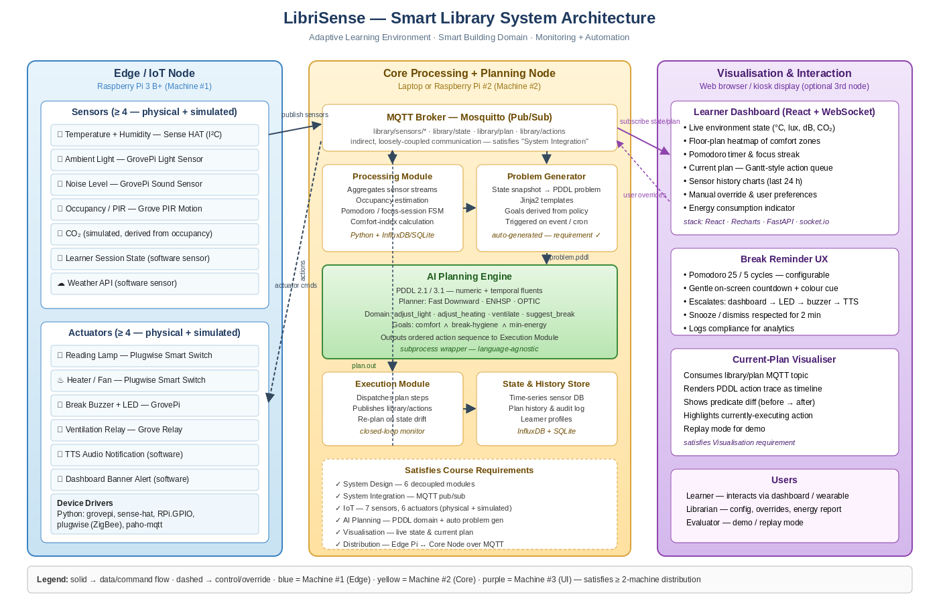
Figure 1 — LibriSense three-layer logical architecture.

3.1 Data-flow walk-through
- Sensors on the edge node are sampled at 1 Hz; drivers normalise readings to SI units and publish to library/sensors/<type>.
- The processing module subscribes to all sensor topics, keeps a sliding-window state, runs a small finite-state machine per learner (idle → focused → break-due → on-break), and publishes a compact world-state snapshot on library/state.
- A problem generator watches library/state and, whenever a significant change is detected (or every 30 s), materialises a PDDL problem file using Jinja2 templates.
- The planner is invoked as a subprocess; its resulting plan is published on library/plan.
- The execution module subscribes to library/plan, dispatches the next action to library/actions, and monitors the world state for drift — triggering a re-plan if reality diverges from the plan's expected effects.
- The edge node subscribes to library/actions, translates each action into a device-specific command, and actuates.
- The dashboard subscribes to library/state and library/plan to render live state + plan Gantt, and publishes user overrides back on library/overrides.

4 · Modular System Design
Modularity is enforced by two rules: (1) every module communicates only through MQTT topics; (2) every module is independently unit-testable with a recorded-message fixture. The table below specifies the six modules.

4.1 Module responsibilities
Module | Responsibility | Tech / language
1 · IoT Layer | Read sensors, command actuators, publish/subscribe MQTT | Python 3, grovepi, sense-hat, paho-mqtt, plugwise
2 · Processing | State aggregation, learner FSM, comfort index, CO₂ proxy | Python 3, numpy, sqlite/influxdb
3 · Problem Generator | State → PDDL problem via Jinja2 templates | Python 3, jinja2
4 · AI Planner | Solve PDDL problem, emit plan JSON on MQTT | Fast Downward (C++) wrapped by Python subprocess
5 · Execution | Plan dispatch, drift detection, re-plan trigger | Python 3, asyncio
6 · Visualisation | Browser dashboard, WebSocket bridge, overrides | React + Recharts, FastAPI, socket.io

5 · IoT Inventory

5.1 Sensors (≥ 4 required — 8 provided)
Sensor | Source / Bus | Measured variable | Role in planning
Temperature | Sense HAT (I²C, physical) | °C, 0.1 K resolution | Drives heating / fan action
Humidity | Sense HAT (I²C, physical) | % RH | Comfort-index calculation
Illuminance | GrovePi light sensor | lux | Lamp dim / turn-on decisions
Sound level | GrovePi sound sensor | dB(A) proxy | Detects disturbance → ventilate / dim
Motion / occupancy | Grove PIR (I²C) | Boolean presence | Gates all actuators per zone
CO₂ (simulated) | Software — derived | ppm proxy | Triggers ventilation action
Learner-session state | Software (REST to UI) | focus-minutes, phase | Primary trigger for break actions
Weather API | Software (OpenWeather) | outdoor °C, cloud cover | Informs heating pre-conditioning

5.2 Actuators (≥ 4 required — 6 provided)
Actuator | Interface | Effect | Planner action
Reading lamp | Plugwise smart switch (ZigBee) | Light on / off, brightness via PWM-dimmable bulb | adjust_light(zone, level)
Space heater / fan | Plugwise smart switch (ZigBee) | Heating on / off | adjust_heating(zone, +/-)
Ventilation relay | Grove Relay (I²C) | Opens/closes simulated window / fan | ventilate(zone)
Break LED + buzzer | GrovePi LED + buzzer | Visual + audible alert | suggest_short_break(user)
TTS audio | Software — pyttsx3 / Piper | Spoken reminder via speaker | suggest_long_break(user)
Dashboard banner | Software — WebSocket to UI | Visual on-screen nudge | nudge(user, message)
Device-preference bid (submit by 1 May): (A) GrovePi set — primary sensor platform, (B) Plugwise set — primary actuator platform, (C) Raspberry Pi Sense HAT — backup sensor platform, (D) Grove Relay — ventilation actuator. If an item is not awarded, the risk table in §8 lists our fallback.

6 · AI Planning Detail
A PDDL 2.1 domain with numeric fluents captures both the physical environment and the learner's cognitive state. The excerpt below is a sketch; the final domain will include energy accounting, hysteresis thresholds, and a metric for multi-objective optimisation.

6.1 Domain sketch
(define (domain librisense)
(:requirements :typing :numeric-fluents :durative-actions)
(:types zone user device)
(:predicates
(occupied ?z - zone)
(lights-on ?z - zone)
(heating-on ?z - zone)
(ventilating ?z - zone)
(session-active ?u - user)
(break-due ?u - user))
(:functions
(temperature ?z - zone)
(illuminance ?z - zone)
(co2 ?z - zone)
(session-minutes ?u - user)
(energy-used))

(:durative-action adjust_light
:parameters (?z - zone)
:duration (= ?duration 2)
:condition (and (at start (occupied ?z))
(at start (< (illuminance ?z) 300)))
:effect (and (at end (lights-on ?z))
(at end (increase (illuminance ?z) 250))
(at end (increase (energy-used) 0.06))))

(:durative-action suggest_short_break
:parameters (?u - user)
:duration (= ?duration 1)
:condition (and (at start (session-active ?u))
(at start (>= (session-minutes ?u) 25)))
:effect (and (at end (break-due ?u))
(at end (assign (session-minutes ?u) 0)))))

6.2 Problem generation
- Input: current library/state snapshot (JSON).
- Process: Jinja2 templates instantiate objects (zones, users), initial-state fluents (numeric values), and a goal clause derived from policy.
- Goal: (and (forall (?u - user) (not (break-due ?u))) (forall (?z - zone) (and (>= (illuminance ?z) 300) (<= (temperature ?z) 24) (>= (temperature ?z) 20)))).
- Metric: (minimize (+ (* 0.4 (energy-used)) (* 0.6 (total-time)))).

6.3 Planner & performance
Primary planner: Fast Downward with seq-opt-lmcut for optimal plans on small problems; fallback: ENHSP for numeric-heavy instances. Plan horizon is capped at 10 min of simulated time; re-planning is triggered on (i) new goal condition violation, (ii) 30 s timer, or (iii) observed divergence > 10 %.

7 · Visualisation & UX

7.1 Dashboard layout
- Floor-plan heatmap — per zone: °C, lux, CO₂, occupancy dots.
- Trend panel — 24 h stacked charts for each sensor stream (Recharts).
- Current plan — Gantt-style action queue with predicate diffs; colour-codes actions by state (pending / executing / done).
- Pomodoro focus ring — per learner, with streak and compliance rate.
- Energy tile — cumulative kWh since midnight vs. a naive always-on baseline.
- Override drawer — slider + toggle controls that publish to library/overrides; any override is respected for ≥ 2 min before the planner is allowed to counter.

7.2 Break-reminder escalation
The system respects user agency: reminders start soft and escalate only if ignored.
- t = 0: dashboard banner + colour cue (subtle).
- t + 60 s: GrovePi LED pulses in the learner's zone.
- t + 2 min: buzzer chirps twice (audible but brief).
- t + 3 min: TTS voice reminder, then snooze for 2 min.
- Compliance (taken / dismissed / snoozed) is logged and visualised for the demo.

8 · Risks & Mitigation
Risk | Likelihood | Impact | Mitigation
Plugwise bid loss | Medium | We lose the hardware lottery for the smart-switch kit | Fall back to a Grove Relay driving a 230 V contactor on a bench bulb; functionally equivalent for the demo.
Physical CO₂ sensor unavailable | High | Course does not offer a CO₂ sensor in the hardware pool | Model CO₂ proxy from occupancy × time using standard ASHRAE formula; label as simulated in report.
PDDL solver timeout under numeric fluents | Medium | Fast Downward may time out on large numeric problems | Restrict planning horizon to 10 min lookahead, coarsen fluents, or fall back to ENHSP.
MQTT broker single point of failure | Medium | If broker crashes, whole system halts | Run Mosquitto with persistent queue + systemd auto-restart; edge node buffers ≤ 60 s of sensor data.
Break-reminder annoyance | Low | Users ignore or disable reminders | Escalation policy with snooze + user preferences; log compliance for report analysis.
Team-member illness near demo | Low | Single point of human failure | Pair-programming during last sprint; every module has a secondary owner.

9 · Timeline & Milestones
Date | Milestone / deliverable | Owner
Apr 24 | Group registration & device bidding | All
May 1 | Proposal submission + device preferences | All
May 5 | IoT kit collection (Raspberry Pi + bid-won sensors) | All
May 6 – May 20 | Sprint 1 · IoT layer: driver code, MQTT skeleton, sensor smoke test | IoT lead
May 21 – Jun 7 | Sprint 2 · Processing + state store + dashboard v1 | Processing lead
Jun 8 – Jun 24 | Sprint 3 · PDDL domain, problem generator, planner integration | Planning lead
Jun 25 – Jul 6 | Sprint 4 · Execution, closed-loop re-planning, full integration | All
Jul 7 – Jul 13 | Hardening · edge-case testing, energy benchmark, demo script | All
Jul 14 | Report submission | All
Jul 15 – Jul 19 | Demo rehearsal, kiosk setup, risk mitigation drill | All
Jul 20 | Project demo | All
We follow two-week sprints with a 15-minute Monday stand-up and a Friday demo to the group. All code lives in a GitHub monorepo with GitHub Actions running module-level tests on every push.

10 · Success Criteria
- Hardware up-time ≥ 95 % over the final 48-hour soak test.
- End-to-end plan latency (sensor event → actuator command) < 3 s for 90 % of events.
- Energy saving ≥ 25 % compared to an always-on baseline in the demo scenario.
- Break-reminder compliance ≥ 60 % over a 2-hour user session.
- Dashboard renders current state + current plan with ≤ 1 s lag.
- Full demo script executes reproducibly, including a simulated sensor-fault recovery.

11 · References & Tools
- Cirillo, F. — The Pomodoro Technique (1988).
- ASHRAE Standard 62.1 — Ventilation for Acceptable Indoor Air Quality.
- Fast Downward Planner — fast-downward.org
- ENHSP — Expressive Numeric Heuristic Search Planner.
- Eclipse Mosquitto — MQTT broker — mosquitto.org
- Plugwise / GrovePi / Sense HAT vendor documentation.
- PDDL 2.1 — Fox & Long (2003), Journal of AI Research.

