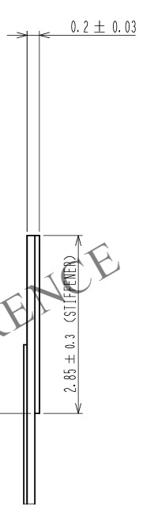45 Pin [官方文件](https://www.hirose.com/en/product/document?clcode=CL0580-2909-6-50&productname=FH35C-45S-0.3SHW(50)&series=FH35C&documenttype=2DDrawing&lang=en&documentid=0001002002)中的厚度圖

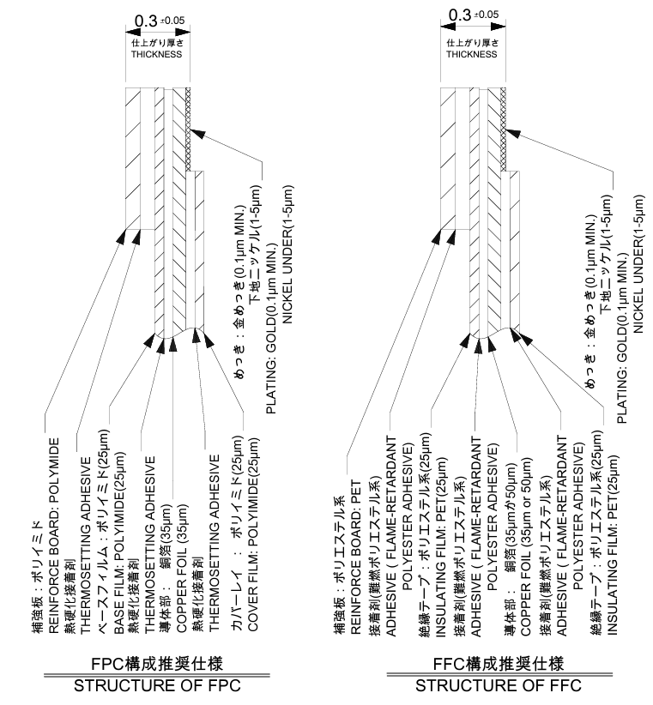24Pin [官方文件](https://www.molex.com/content/dam/molex/molex-dot-com/products/automated/en-us/salesdrawingpdf/522/52207/522072460_sd.pdf?inline)的厚度圖

JLC 計算結果:

(24Pin-0.mm3厚度)

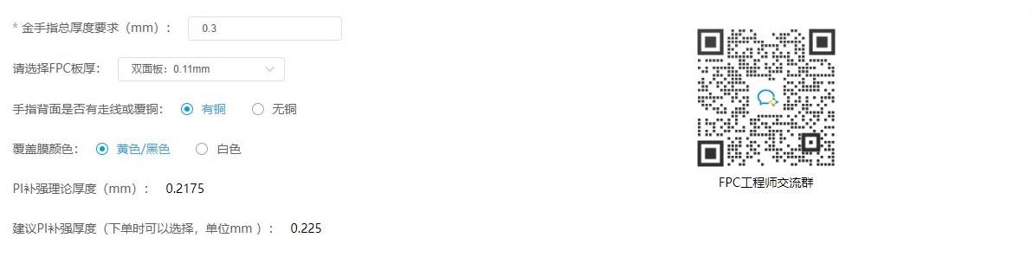

(45Pin-0.2mm 厚度)

