Mansion Escape
Software Requirements Specification
February 29, 2020
Teen Titans

Contents
1 Introduction 1
1.1 Purpose (Taylor Marsh) 1
1.2 Scope (Taylor Marsh) 1
1.3 Definitions, Acronyms, and Abbreviations (Taylor Marsh, Shababa Kamreen, Taisann Kham) 1
1.4 References (Taylor Marsh) 3
1.5 Overview (Taylor Marsh) 3
2 Overall Description 4
2.1 Product Perspective (Taylor Marsh) 4
2.2 Product Functions (Taylor Marsh) 4
2.3 User Characteristics (Taylor Marsh) 4
2.4 Constraints (Taylor Marsh) 4
2.5 Assumptions and Dependencies (Taylor Marsh) 5
2.6 Apportioning of Requirements (Taylor Marsh) 5
3 Specific Requirements 6
3.1 Overall Game Description 6
3.1.1 Table of Rooms (Taylor Marsh, Shababa Kamreen, Taisann Kham) 9
3.1.2 Table of Monsters (Taylor Marsh) 23
3.1.3 Table of Puzzles (Taisann Kham) 25
3.1.4 Table of Items (Taylor Marsh, Taisann Kham) 28
3.1.5 Table of Navigation Command (Taylor Marsh) 30
3.1.6 User Interfaces (Taisann Kham) 30
3.2 Software Product Features (Taylor Marsh, Taisann Kham, Shababa Kamreen) 34
3.2.1 Room Feature 34
Purpose 34
Explains how the player can interact with rooms. 34
Associated Functional Requirements 34
3.2.2 Item Feature 35
Explains how the player can interact with items. 35
Associated Functional Requirements 35
3.2.4 Monster Feature 37
Purpose 37
Explains how the player can interact with monsters. 37
Associated Functional Requirements 37
3.2.5 Puzzle Feature 38
Purpose 38
Explains how the player can interact with puzzles. 38
Associated Functional Requirements 38
3.2.6 Player Feature 40
Purpose 40
Explain how the player can interact with themselves 40
Associated Functional Requirements 40
3.3 Software System Attributes (Shababa Kamreen) 42
3.3.1 Reliability 42
3.3.2 Availability 42
3.3.3 Maintainability 42
3.4 Logical Database Requirements (Shababa Kamreen) 43
3.5 Other Requirements (Taisann Kham) 43

Introduction

Purpose (Taylor Marsh)
The purpose of this document is to provide in detail the requirements for the “Mansion Escape” text-based adventure game software. This document is intended for another development team to allow them to develop the software based on the detailed requirements and explanation of the game below.

Scope (Taylor Marsh)
The “Mansion Escape” is a text-based adventure game software where the player must traverse through multiple rooms while solving puzzles and defeating monsters. The general demographic for this game should be 13+ in age due to mild violence. This game should be available for free to play on any computer.
The game is set in a witch’s mansion, and it starts out by the player waking up in the dungeon of this mansion. The main goal of the game is to escape the mansion, but to do so the player will have to defeat monsters and solve puzzles to be able to escape.
The game must be a Java file, so it will be able to run on Java applications. To be able to play the game, players must have a Java application software to be able to run the game. Players must also have a keyboard to be able to type commands to play the game.
Information and details will be organized into text files that the software will read.
The game is intended for entertainment purposes, and the goal of the game is to defeat the final boss and escape the room.

Definitions, Acronyms, and Abbreviations (Taylor Marsh, Shababa Kamreen, Taisann Kham)
Term | Definition
Player/User | A person who interacts with the gaming application
Game | A text-based adventure
Java | Programming language
USE | A command for using items or certain objects in the background of a room.
DROP | A command for taking the specified item out of the user’s inventory and into the current room the user is in.
ON | A command used in conjunction with other commands like USE when the user wants to use an item on a specific object.
EXAMINE | A command for examining certain objects in closer detail.
SOLVE | A command for initiating a Puzzle when a prompt says, “A puzzle can be solved here.”
HINT | During a puzzle, a command the user types in order to obtain a hint on how to solve a puzzle.
LEAVE | A command for leaving a puzzle.
SAVE | A command for when the user wants to save their progress.
LOAD | A command for when the user wants to load a save.
EXIT | A command for when the user wants to exit to the game’s main menu.
ID | The ID given to an object.
TITLE | The title/name of an object.
DESC | The description.
RAT | The reason why a functional requirement is included.
DEP | Any other functional requirements related to the DEP’s functional requirement.
HP | Health points: Health points are used on the player and monsters
AP | Attack points: How much damage that can be dealt by a player or monster

References (Taylor Marsh)
Amazing Lunch Indicator - Software Requirements Specification
Floor Planner - Online Floor Plan Designer Software https://floorplanner.com/

Overview (Taylor Marsh)
The rest of this document will include an overall description of the software, including the characteristics and functions of the software. It will also go into detail about specific requirements for the software, such as, detailed lists of rooms, monsters, and items required. There will also be a detailed explanation for the software features and attributes. There is also a section dedicated to functional requirements, what the software needs to run properly, and non-functional requirements, what the software needs to perform properly.

Overall Description

Product Perspective (Taylor Marsh)
The product itself will be a Java file, and it should be able to run on Java applications. Java applications can be downloaded on PCs or Macs, and the product, a Java file, must be opened in the Java application to be able to run it. To be able to interact with the product, a keyboard or keyboard software is necessary to be able to input commands to play the game.

Product Functions (Taylor Marsh)
The software will read information and details about the game from text files.
Users will be able to run the game in a Java application. When the user runs the game, they will be able to interact or play the game. Users will type in commands using their keyboard. Some basic commands would be navigating through rooms, interacting with certain items, and interacting with monsters.
The game will include many hints that will help the user play the game. The game will also include a command guide, so the user will know what commands they can use and what they will do.
Users will also be able to save their game and reload it from where they saved. They can also restart the game from the beginning even if they haven’t finished the game yet.

User Characteristics (Taylor Marsh)
There is one kind of user of the software: the player. The player should be 13 years of age or older due to mild violence in the game. They must be able to read and type in English to be able to play the game.
The player can only use the system if they have a device with a Java application software installed, and they are able to run the game software on this application. They also must have a keyboard to be able to type input commands to play the game and a monitor to see and interact with the game.

Constraints (Taylor Marsh)
The text-based adventure game is constrained by Java software on a computer and the game itself. It is important for the computer to have Java software on a computer, or the game will not run at all. The game being on the computer locally is important as well to play the game.
The game is also constrained by text files. Game information is placed into text files and read by the software to allow the game to perform.

Assumptions and Dependencies (Taylor Marsh)
One assumption is that the software will be used on Java applications on personal computers. If the user does not have a Java application software downloaded onto their computer, then they will not be able to run the game.
Another assumption is that the user’s Java application software can run the gaming software. If the software cannot be run on the application, then the user will not be able to play the game.
Another assumption is that the software can read from text files for details about the game and use the information to create the game.

Apportioning of Requirements (Taylor Marsh)
If the project is being delayed, there are some requirements that can wait until an update or future version of the software. A requirement that can be delayed is the “User Interface” requirement

Specific Requirements

Overall Game Description
Map created by Taylor Marsh
1st Floor:
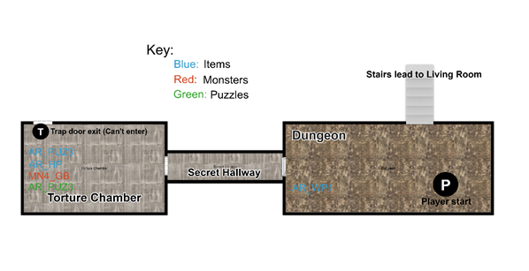

2nd Floor:
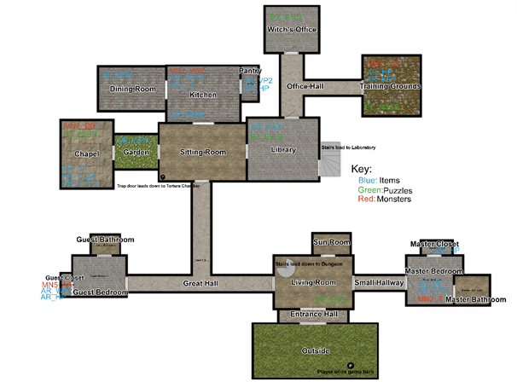

3rd Floor:
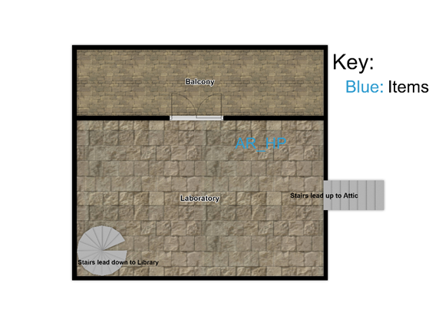

4th Floor:
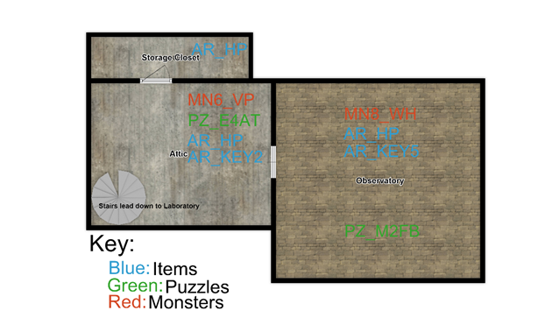

Table of Rooms (Taylor Marsh, Shababa Kamreen, Taisann Kham)
ID | Name | Description | Monster ID | Item ID | Puzzle ID | North ID | South ID | West ID | East ID
RM_1 | Dungeon | [This is the room where the game starts.] You wake up on a cold, hard floor. There is a dead body next to you on the ground. The cell door is open to the north, and there are stairs that lead up. There is a rusty crowbar laying on the ground next to the door. You notice scuff marks on the ground next to the wall to the west. | N/A | AR_WP1 | N/A | N/A | N/A | RM_1  [But you can’t enter from this side] | N/A
RM_2 | Secret Hallway | A small, dusty hallway where the only light is coming from 1 candle. There is a door to the east and a door to the west. | N/A | N/A | N/A | N/A | N/A | RM_2 | RM_1
RM_3 | Torture Chamber | This room is dark and has a  wretched odor. There is a cage with a skeleton in it, and a table with straps and blood stains. There is a small, green goblin down here too. They heard you when you fell down and lunged at you. It attacks you first. [Player takes damage] The only door in here is to the east. | MN4_GB | AR_PUZ3, AR_HP | AR_PUZ3 | N/A | N/A | N/A | RM_2
RM_4 | Living Room | The room has a bench and a small table along with a fireplace roaring in the background. There also is a grandfather clock that looks like it isn’t working. There is a stairway leading down. To the south you see a giant, gold door. There are small doors to the east and west of the room. There is another door to the north where you can see a beam of light peering from the bottom. | N/A | N/A | PZ_E1CL | RM_5 | RM_6 | RM_8 | RM_12
RM_5 | Sunroom | Rays of sunshine are pouring through wide windows into the room, shining on a sofa and a long, glass table. The only way out is the door you came through. | N/A | N/A | N/A | N/A | RM_4 | N/A | N/A
RM_6 | Entrance Hall | The small room is lit with candles. There is a huge, dark brown door to the south and a giant, gold door to the north. | N/A | N/A | N/A | RM_4 | RM_7 | N/A | N/A
RM_7 | Outside | Luscious, green grass is spread out before you. You can see the sun peeking over the trees. You are finally free. [This is where the game ends] | N/A | N/A | N/A | RM_6 | N/A | N/A | N/A
RM_8 | Small Hallway | The hallway is dimly lit with only a few candles. There are doors on both sides of the hallway to the east and to the west. | N/A | N/A | N/A | N/A | N/A | RM_9 | RM_4
RM_9 | Master Bedroom | This is a big room with a king-sized bed with red linen. A giant troll with a club towers above you. He is beating the club against his hand watching you. There is a door to the east of the room, a door to the north of the room near the bed, and a door to the west. | MN2_T | AR_WP3, AR_HP | N/A | RM_11 | N/A | RM_10 | RM_8
RM_10 | Master Bathroom | You see a sink with the faucet running. There is also a giant bathtub and a toilet. The only way out is through the door you came through | N/A | N/A | N/A | N/A | N/A | N/A | RM_9
RM_11 | Master Closet | The closet has an assortment of clothing and shoes. You look closely and see a bottle lying on the ground. There is a door to the south that you came in. | N/A | AR_HP | N/A | N/A | RM_9 | N/A | N/A
RM_12 | Great Hall | You see velvet carpet spread over the hall. The windows are covered by draperies, and bright candles line the walls. The hallway is so big it breaks into three sections. There is a door to the west end, a door toward the north end, and a door to the east. | N/A | N/A | N/A | RM_16 | N/A | RM_4 | RM_13
RM_13 | Guest Bedroom | In front of you, there is a twin bed, a nightstand, and a dresser. Everything is covered in dust, like it hasn’t been cleaned in a very long time. You can see three doors in this room; one to the north, one to the west. and one to the east. | N/A | N/A | N/A | RM_14 | N/A | RM_12 | RM_15
RM_14 | Guest Bathroom | This room is small with only a toilet and a sink. It looks like this room hasn’t been touched in a long time. There is a door to the south that will allow you to leave. | N/A | N/A | N/A | N/A | RM_13 | N/A | N/A
RM_15 | Guest Closet | This closet is quite spacious and has a few clothes in it. You notice a figure hiding between the clothes. They are completely covered in black clothes that assassins wear. The door is to the east if you want to leave. | MN5_AA | AR_WP2,  AR_HP | N/A | N/A | N/A | RM_13 | N/A
RM_16 | Sitting Room | There is a small sofa and a few love seats. Crackling from the fire in the fireplace can be heard. There are doors on all sides of the room. To the east there is a brown door. To the west there is a glass door where you can see grass and plants on the other side. There is also a door to the north and south. You notice weird markings on the ground in the corner of the room. [Note: examining this corner will allow the player to go to the torture chamber room] | N/A | N/A | N/A | RM_17 | RM_12 | RM_22 | RM_20
RM_17 | Kitchen | There appears to be a stove, and a cutting board was left on the counter with no knife. A bag of salt lays next to the cutting board. A tall, hairy man-like creature is growling at you. Is that a werewolf? You can see a small door to the east slightly open. There appears to be food inside. There is another door to the west and the south. | MN1_WW | AR_KEY3,  AR_HP,  AR_PUZ6 | N/A | N/A | RM_16 | RM_19 | RM_18
RM_18 | Dining Room | There is a long dinner table that is broken and covered in dust and cobwebs. There is a piece of wood that was part of the table laying on the floor. The door to the east is the door you came through. | N/A | AR_WP4 | N/A | N/A | N/A | RM_17 | N/A
RM_19 | Pantry | This is a small, but spacious room filled with shelves of spices and food in jars. There is a garlic clove lying on the floor. There is also a glass bottle with red liquid on the top shelf in the back. To leave, you must go back through the door to the west. | N/A | AR_VP2, AR_HP | N/A | N/A | N/A | N/A | RM_17
RM_20 | Garden | Flowers, tomatoes, and small trees are all growing in this area. There is a small, garden hoe laying on top of a dirt mound. It looks like someone was working on planting something. There is a tall fence that lines the garden, but you see a building to the west that you are able to get to with a big, white door. There is a door to the east to go back inside the house. | N/A | AR_WP5 | N/A | N/A | N/A | RM_16 | RM_21
RM_21 | Chapel | Rubble covers the room. There is some debris over at the corner. There is, what looks to be, a crusader praying at the altar. They stand up and look at you as you walk in. They point their sword at you, warning you that they are about to strike you. The only door is to the east. | MN7_CD | AR_PUZ5, AR_PUZ4, AR_HP | PZ_E2PB | N/A | N/A | RM_20 | N/A
RM_22 | Library | You come to a room that appears to have an unimaginable number of shelves of books. There is a silver door to the east, a door to the north, and a brown door to the west. [Note: unlocking the silver door with the silver key will tell the player that there are stairs leading up.] | N/A | AR_PUZ1 | PZ_E3LB | RM_23 | N/A | RM_26 | RM_16
RM_23 | Office Hall | This looks much like the other halls. It divides into three pathways. There is a door to the north, a door to the east, and a brown door to the south. | N/A | N/A | N/A | RM_24 | RM_22 | RM_25 | N/A
RM_24 | Witch’s Office | A giant mahogany desk is located in the middle of the room with a chair. There is a clock in the room with the time ***INSERT TIME. See the Clock Puzzle (PZ_E1CL) or Functional Requirement FR8 for more context*** There is a door to the south to exit the room. | N/A | N/A | PZ_E1CL | N/A | RM_23 | N/A | N/A
RM_25 | Training Grounds | You enter a room made of stone. There are giant curtains attached to the mechanized heading, concealing the front of the room. There is a lone lever installed in the middle of the room. Lurking in the corner looks like a walking corpse, a ghoul. It looks like it didn’t hear you, yet.  [If you interact with anything in the room, other than exiting] The ghoul-like creature hears movement, turns around and attacks you first. [Player is dealt damage] There is a door to the west to leave. | MN3_GH | AR_HP, AR_KEY1 | PZ_M1SB | N/A | N/A | N/A | RM_23
RM_26 | Laboratory | You see a table with test tubes, liquid in bottles, and a coat drenched in blood on the floor. You see a glass bottle with red liquid on the table as well. There are stairs leading down to the west and another set of stairs leading up to the east. There is a big, glass door to the north where you can see the sky through it. | N/A | AR_HP | N/A | RM_27 | N/A | RM_28 | RM_22
RM_27 | Balcony | You see the blue sky and feel the wind. You look down over the fence to see how high up you are. There is a cliff of rocks below. A big, glass door is to the south that leads back inside. | N/A | N/A | N/A | N/A | RM_26 | N/A | N/A
RM_28 | Attic | The room is dusty and is filled with ancient objects. There is a red door to the east. It’s covered in a malevolent energy, but the keyhole appears unaffected. There is another door to the north behind a dark coffin. There is a figure that seems to be a vampire sleeping in the coffin.  [The Vampire will wake up if you interact with anything in the room except leaving the room] You hear a noise and turn to look at the coffin and it is empty. The Vampire suddenly appears in front of you and attacks you first. [The player is dealt damage] | MN6_VP | AR_KEY2, AR_HP | PZ_E4AT | RM_30 | N/A | RM_29 | RM_26
RM_29 | Observatory | A chill and feeling of dread fills the room you are in. There is a woman, who looks as if she is thousands of years old. She is dressed in a black dress and purple cloak. She is just looking at you, cackling. There a cursed salt circle around the with, empowering her. The only exit is the red door to the west. | MN8_WH | AR_HP,  AR_KEY5 | PZ_M2FB | N/A | N/A | N/A | RM_28
RM_30 | Storage Closet | There is dust in the air, and you see boxes sprawled around. There is a glass bottle with red liquid on the shelf. The door to exit is to the south. | N/A | AR_HP | N/A | N/A | N/A | RM_28 | N/A

Table of Monsters (Taylor Marsh)
ID | Name | Description | HP | AP | Location | Monster Defeated Message | Item reward (after defeated)
MN1_WW | Werewolf | A tall, hairy man-like creature is growling at you. | 70 | 10 | RM_17 | The werewolf whimpers and falls to the ground. | 1. AR_HP  2. AR_KEY3
MN2_T | Troll | A giant troll with a club towers above you. He is beating the club against his hand watching you. | 70 | 10 | RM_9 | The troll falls to the ground with a big thud. The whole house feels like it shook. | 1. AR_HP  2. AR_WP3
MN3_GH | Ghoul | Lurking in the corner looks like a walking corpse. It looks like it didn’t hear you come in, yet.  [If you interact with anything in the room] The ghoul-like creature hears movement, turns around and attacks you first. | 90 | 20 | RM_25 | The ghoul collapses to the ground, now a skeleton. | 1. AR_HP  2. AR_KEY1
MN4_GB | Goblin | There is a small, green down here too. They heard you when you fell down and lunged at you. It attacks you first. | 70 | 10 | RM_3 | The goblin lets out a final grunt, but now it lays on the ground no longer moving. | 1. AR_HP  2. AR_KEY4
MN5_AA | Assassin | As you enter the closet, you notice a figure hiding between the clothes. They are completely covered in black clothes that assassins wear. | 70 | 20 | RM_15 | It was a tight squeeze to fight in the closet, but the assassin crumples down amongst all the clothes now on the floor. | 1. AR_HP  2. AR_WP2
MN6_VP | Vampire | There is a figure sleeping in the coffin.  [The Vampire will wake up if you interact with anything in the room] You hear a noise and turn to look at the coffin and it is empty. The Vampire suddenly appears in front of you and attacks you first.  [Regular weapons don’t lower his HP. The only way to defeat him is with a stake or garlic] | 115 | 25 | RM_28 | After stabbing the vampire with a stake, their body turns to ash and falls on the floor. | 1. AR_HP  2. AR_KEY2
MN7_CD | Crusader | There is, what looks to be, a crusader praying at the altar. They stand up and look at you as you walk in. They point their sword at you, warning you that they are about to strike you. | 115 | 25 | RM_21 | The crusader collapses after the final blow and lays on the ground unmoving. | 1. AR_HP  2. AR_PUZ5
MN8_WH | Witch | There is a woman, who looks as if she is thousands of years old. She is dressed in a black dress and purple cloak. She is just looking at you, cackling. | 250 | 35 | RM_29 | The witch, no longer laughing, fades to dust. | 1. AR_HP  2. AR_KEY5

Table of Puzzles (Taisann Kham)
Puzzle ID | Description | Solution | Rewards | Punishment | Room Puzzle is in
PZ_E1CL | EXAMINE’ing unset clock: It looks like the clock can be set.  The grandfather clock is unset. What do you want to set the time as? (Any time between 1:00 and 12:59)  Hint: There must be another clock somewhere in this mansion.  Completion: The clock door opened, revealing a note.  (User can PICKUP note) | The unset clock’s time must be set to the already set clock’s time (Set clock’s time is randomly determined for each save).  Slots 12:34  Slot 1 can be empty, 1, or 2.  Slot 2 can be 0, 1, or 2.  A semicolon must be between slots 2 and 3.  Slot 3 can be any number from 0 – 5.  Slot 4 can be any number from 0 – 9. | Obtain Autobiography Memo in order to gain relevant information for completing Library Puzzle (Puzzle ID: PZ_E3LB). | N/A | Set Clock: RM_24  Unset Clock: RM_4
PZ_E2PB | EXAMINE’ing debris Chapel: You remove the debris, revealing a hidden cabinet. It requires a password to unlock. What word will you say?  Correct Password: The cabinet opened, revealing an alter decorated with a book and religious artifacts. | A password must be found by EXAMINE’ing the cage or skeleton in the Torture Room. Password is variable between saves. It can be: “Hope”, “Guardian”, “Knowledge”, “Faith”, or “Spirit” | Obtain Prayer Book | N/A | RM_21
PZ_E3LB | EXAMINE’ing Library Bookshelf: There are four books. “Might of Magic”, “Kingdom of Wonder”, “Of Sorcery and Souls”, and Might of Magic”.  User chooses to SOLVE puzzle:  Which book should be first?  Which book should be second?  Which book should be third?  Which book should be the last?  Completion: The books lock in place and the bookshelf rises | 1st Book:  Kingdom of Wonder  2nd Book:  Fairytales of the Old World  3rd Book:  Might of Magic  4th Book:  Of Sorcery and Souls | Obtain Spellbook | N/A | RM_22
PZ_E4AT | EXAMINE’ing Door to Final Boss: The door speaks, “What is the password?”  Completion: The door opens, “You may pass.” | Obtain password from the Training Grounds Puzzle (PZ_M1SB) | Unlock door to Final Boss | N/A | RM_28
PZ_M1SB | EXAMINE’ing or USE’ing lever: You get ready to pull the lever.  SOLVE puzzle/Step1: There is a gap between you and the other side of the room. On the other side is a conduit hole with a thunder sign. Strangely, it has rubber inside it. Leading to the conduit hole is a toy canal filled with water. At the opposite end of the canal is a sailboat with a clear cup of cubed ice.  Hint: The sailboat needs to move somehow.  USE/CAST THUNDER at wrong time (Fail, triggers when the user USEs Thunder ON the Conduit at the wrong time aka not on Step 3): Thunder was cast into the conduit, but the rubber inside caused the electricity to disperse. Something else must be done first.  Step2: The boat has made it to the end of the canal and dropped its ice into the conduit. What to do now?  Hint: The electricity needs to be conducted better.  Step3: The ice melts, turning into water inside the conduit insulated by rubber.  Completion: The water crackles with electricity. You hear gears inside the wall move, a hidden panel in it moving to reveal a plaque with a strange phrase:  ***Insert Reward’s phrase. A reward phrase is variable between saves. See Rewards section for more context***. | “CAST Gust”  “CAST Fire ON Ice”  “CAST Thunder ON water” or “CAST Thunder ON conduit”. Both phrases must work. | Obtain password for entering Final Boss room through another puzzle. Password is variable between saves.  The sequence contains the following words in any order: la loo lue lei lo | N/A | RM_25
PZ_M2FB | SOLVE puzzle/Step1: You must get rid of the Witch’s cursed salt circle. But how?  Hint: When you entered the room, the wind blew away a small part of the salt circle.  Step2: The cursed circle is gone. Now you need something to channel your own magic to banish the Witch.  Hint: What are magic circles made out of?  Step3: You create your own salt circle. Now it needs something to give it energy.  Hint: Witches are weak to faith.  Step4: The salt circle is now empowered by holy magic. What can you use to banish this evil creature?  Hint: Only holy objects can interact with one another. | “CAST/USE Gust”.  “Use Salt”  “Use Holy Sigil”  “Use Prayer Book” | Automatically defeat the Witch without having to FIGHT it | Must defeat the Witch in a FIGHT to progress the game | RM_29

Table of Items (Taylor Marsh, Taisann Kham)
ID | Item Name | Description | Acquired | Item Use
AR_WP1 | Crowbar | A black, rusty crowbar | RM_1 | Equipped:  1. Attack Monsters  2. Add +10 to AP
AR_VP1 | Stake | A sharp, wooden stake | AR_WP2 + AR_WP4 | Kill Vampire
AR_WP2 | Dagger | A dagger with a silver blade and black handle. | MN5_AA | Craft:  1. Broken Table Leg  Equipped:  1. Attack Monsters  2. Add +15 to AP
AR_WP3 | Club | A heavy, wooden club | MN2_T | Equipped:  1. Attack Monsters  2. Add +15 to AP
AR_WP4 | Broken table leg | A broken piece of wood that was the leg to the dining room table | RM_18 | Craft:  1. Dagger  Equipped:  1. Attack Monsters  2. Add +5 to AP
AR_VP2 | Garlic | A bundle of white garlic cloves. | RM_19 | Kill Vampire (in case player doesn’t have stake)
AR_HP | Health potion | A small glass container filled with red liquid. | Dropped by monsters and found around house | Get back +75hp to current health, but can’t exceed max health.
AR_WP5 | Garden Hoe | A garden hoe covered in dirt. | RM_20 | Equipped:  1. Attack Monsters  2. Add +10 to AP
AR_KEY1 | Silver Key | A small, silver key | MN3_GH | Unlocks Lab
AR_KEY2 | Red Key | A big, red key | MN6_VP | Unlocks Observatory
AR_KEY3 | Brown Key | A small, brown key | MN1_WW | Unlocks Library
AR_KEY4 | White Key | A shiny, white key | MN4_GB | Unlocks Chapel
AR_KEY5 | Gold Key | A big, gold key | MN8_WH | Unlocks Entrance Room
AR_PUZ1 | Spellbook | A magical tome for casting spells. | PZ_E3LB | Used to solve puzzles
AR_PUZ2 | Autobiography Memo | A memo on the resident’s favorite books. | PZ_E1CL | Used to remind the user the solution to the Library Puzzle
AR_PUZ3 | Captive Memo | A single word from a captive in the Torture Chamber that passed away. | Gained by EXAMINE’ing the skeleton or cage in the Torture Chamber | Used to remind the user the solution to the Chapel Altar Puzzle
AR_PUZ4 | Prayer Book | A holy book revered by those faithful to its teachings. Is used in rituals to banish evil. | PZ_E2PB | Used to defeat Crusader and or solve the Final Boss/Witch Puzzle
AR_PUZ5 | Holy Sigil | A religious symbol that radiates a warm and comforting light. | MN7_CD | Used to solve the Final Boss/Witch Puzzle
AR_PUZ6 | Bag of Salt | A generous bag of multipurpose salts. | RM_17 | Used to solve the Final Boss/Witch Puzzle

Table of Navigation Command (Taylor Marsh)
ID | Name | Description
NAV_1 | North | Player will navigate to the room that is to the north of the room they are currently in. (If there is a room there)
NAV_2 | N | Player will navigate to the room that is to the north of the room they are currently in. (If there is a room there)
NAV_3 | East | Player will navigate to the room that is to the east of the room they are currently in. (If there is a room there)
NAV_4 | E | Player will navigate to the room that is to the east of the room they are currently in. (If there is a room there)
NAV_5 | South | Player will navigate to the room that is to the south of the room they are currently in. (If there is a room there)
NAV_6 | S | Player will navigate to the room that is to the south of the room they are currently in. (If there is a room there)
NAV_7 | West | Player will navigate to the room that is to the south of the room they are currently in. (If there is a room there)
NAV_8 | W | Player will navigate to the room that is to the north of the room they are currently in. (If there is a room there)
NAV_9 | Up | If there are stairs in the room the player is currently in, the player will travel up the stairs to the room it is connected to. (If the stairs go up)
NAV_10 | U | If there are stairs in the room the player is currently in, the player will travel up the stairs to the room it is connected to. (If the stairs go up)
NAV_11 | Down | If there are stairs in the room the player is currently in, the player will travel down the stairs to the room it is connected to. (If the stairs go down)
NAV_12 | D | If there are stairs in the room the player is currently in, the player will travel down the stairs to the room it is connected to. (If the stairs go down)

User Interfaces (Taisann Kham)

The Main Menu
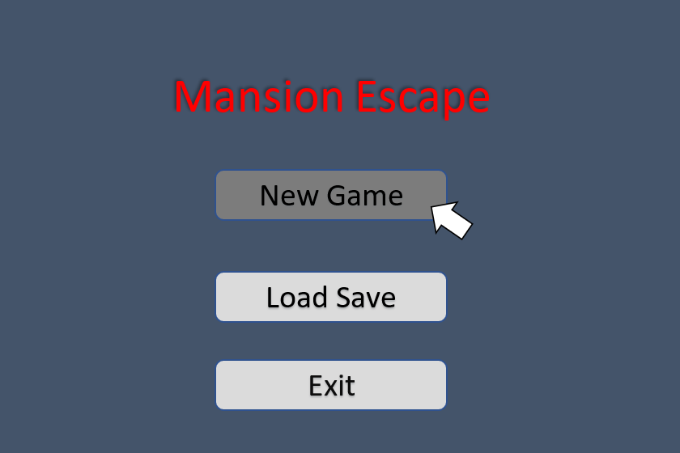
The first interface the user should see when they open the game is the main menu. The main menu should at least have the title of the game displayed, a “New Game” button that starts a new game from the beginning, a “Load Game” button that loads an already saved game from the point that specific file was saved at, and an “Exit” button that exits the user from the game.
The Load Save Menu
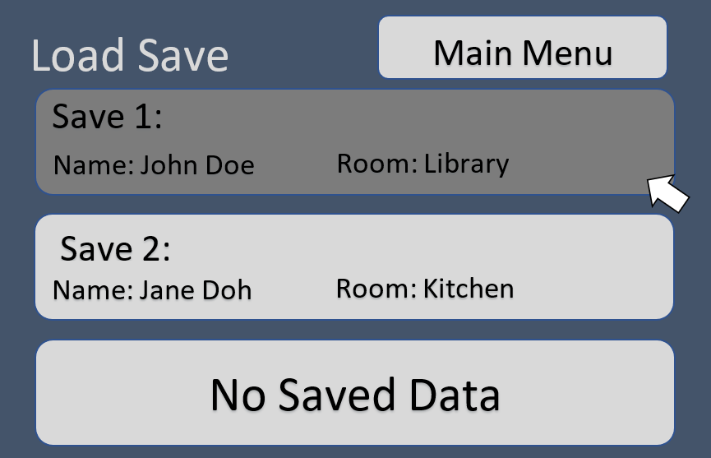
When the “Load Save” button is pressed, it should lead to another menu where the user can load saved games and continue off where they last saved in the file they chose. They must also have a “Main Menu” button to allow them to return to the main menu.

The Name Menu
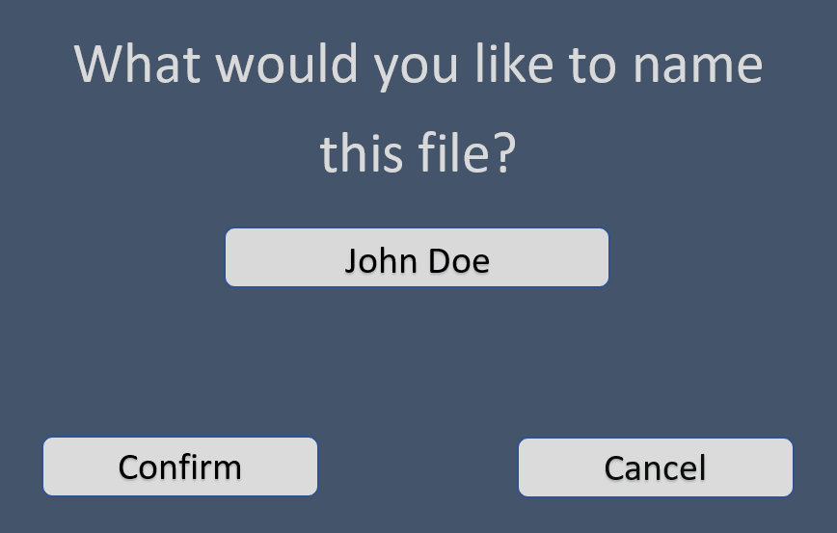
When the “New Game” button is pressed, it should lead to the Name Menu where the user inputs the name for their save and can press “Confirm” to confirm the name selection and start at the beginning of the game. Or the user can press the “Cancel” button which returns them to the main menu.

The Game Interface
The game interface is where the actual game is played. It has a console that gives the output of the game. At the bottom of the output’s side is the User Input area where the user can input commands in order to interact with the game. Commands like “SAVE”, “LOAD”, and “EXIT” will be implemented, so buttons for those functions will not be necessary. Above the User Input area will be the User’s HP, Player Attack, and Monster’s HP (If the monster is already defeated, the Monster’s HP can be zero or any other value signifying the monster has been defeated). This allows the user to see stats relevant to combat so they will not have to call redundant commands in order to see their stats for combat.
A map must be provided in order to give the user visual context as to where they are, and their current location should be marked on the room they’re at. The inventory must be shown in some way so the user knows what items they have (Either through the game interface in the Inventory slot, or as a command to be input in the console which will show the user’s inventory through the console).
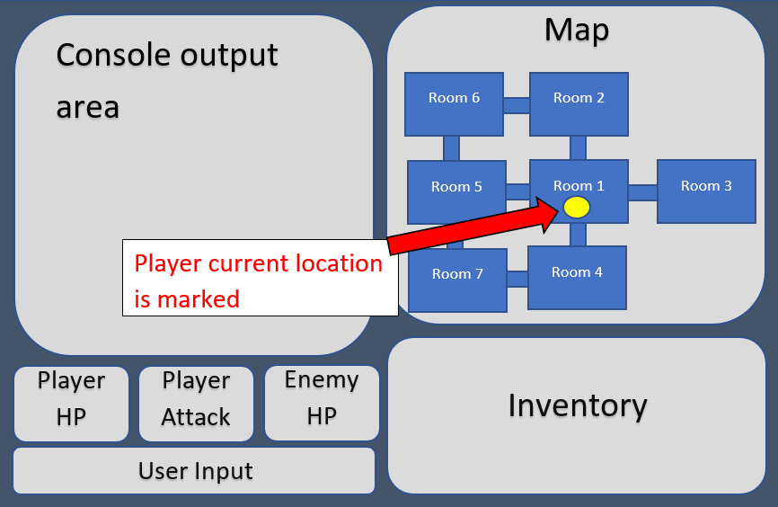

Software Product Features (Taylor Marsh, Taisann Kham, Shababa Kamreen)

Room Feature

Purpose

Explains how the player can interact with rooms.

Associated Functional Requirements

3.2.1.1 Functional Requirement 1.1

ID: FR1.1

TITLE: Enter Room

DESC: Given that the user is in the game and currently in a room, the user can move to a different room by typing in one of the navigation commands in the navigation command table into the console. If there is a room that is in that direction, the user will move to that new room and the description of the room will be displayed. If there isn’t a room in that direction, the user will not move to a different room, and will be prompted that there isn’t a room in that direction.

RAT: Allows the user to explore new rooms to find new items, defeat monsters, and solve puzzles.

DEP: N/A

3.2.1.2 Functional Requirement 1.2

ID: FR1.2

TITLE: Examine Room

DESC: Given that the player is in the game and currently in a room, the player can get the room description by typing “Look” or “L” into the console. After typing the command, the description of the room will be displayed on the console.

RAT: Allows the player to acquire information about the room and to know where the user is.

DEP: FR1.1

Item Feature
    - Purpose

Explains how the player can interact with items.

Associated Functional Requirements

3.2.2.1 Functional Requirement 2.1

ID: FR2.1

TITLE: Examine Item

DESC: Assuming the player is in the same room as the item, or the item is in the player’s inventory, the player must be able to type “Examine” followed by the item name. This will display the description of the item to the player. If the item cannot be examined, the player will be told that they cannot examine that item.

RAT: Allows the player to get the description of items.

DEP: FR5.6

3.2.2.2 Functional Requirement 2.2

ID: FR2.2

TITLE: Pickup Item

DESC: Given that the player is in the same room as the item, does not have this item in their inventory, and the item is an item that can be picked up, the player must be able to type “Pickup” followed by the name of the item into the console. This will remove the item from the room and add it to the player’s inventory. The player will also be told that the item was added to their inventory.

RAT: Lets the player add items to their inventory.

DEP: N/A

3.2.2.3 Functional Requirement 2.3

ID: FR2.3

TITLE: Drop item

DESC: Assuming the player has the item in their inventory, the player can type “Drop” followed by the item name. The item will be removed from the player’s inventory and added to the room that the player was in when they dropped the item. The player will be told that the item has been dropped.

RAT: Allows the player to drop items into the current room the player is in.

DEP: FR5.6

3.2.2.4 Functional Requirement 2.4

ID: FR2.4

TITLE: Use Item

DESC: Given that the item is in the player’s inventory and that the item can be used to do a certain task, the player can type “Use” followed by the item name into the console. If the item needs to be used on a specific object, the player must type the command in the following format “Use” item name “on” object name. Both of these commands will apply the items ability, and the player will be notified that the item was used, a description of what happened after the item was used, and if it is applicable the item will be removed from inventory. If the player can’t use the item at all or in the way they want to, the player will be prompted that they can’t do that. If the player is trying to use the item on an object, but that isn’t the correct object to use the item on, the player will be told that that isn’t correct. If the player is trying to use an item that needs to be used on an object, but they don’t type what object in the console, the player will be asked what they would like to use it on.

RAT: Allows the player to use items on objects or player

DEP: FR5.1

3.2.2.5 Functional Requirement 2.5

ID: FR2.5

TITLE: Equip Item

DESC: Assuming the player has the item in their inventory, is an item that can be equipped, and isn’t already equipped, the player can type “Equip” followed by item name. This will add to the player’s AP based on the item’s ability. The player will also be told that they have equipped the item. If the item cannot be equipped, the player will be told that they cannot equip that item. If the player already has an item equipped, equipping the new item will replace that item.

RAT: Allows the user to equip items and add to their AP

DEP: FR5.6, FR5.1

3.2.2.6 Functional Requirement 2.6

ID: FR2.6

TITLE: Unequip Item

DESC: Assuming the player has the item equipped, the player can type “Unequip” followed by the item name into the console. This will subtract the item’s AP ability from the player’s AP. The player will also be told that the item has been unequipped.

RAT: Allows the user to unequip items and the player’s AP will go back to their default number

DEP: FR5.1

Monster Feature

Purpose

Explains how the player can interact with monsters.

Associated Functional Requirements

3.2.3.1 Functional Requirement 3.1

ID: FR3.1

TITLE: Examine Monster

DESC: Assuming the player is in the same room as the monster is, the player must be able get the monster’s HP and AP stats with the command “Examine” followed by the monster name. This will display the stats of the monster to the player. If there is no monster in the room, the player will be told that there is no monster in the room. If the monster has been defeated, the player will be told that the monster has already been defeated.

RAT: Allows the player to see the stats of the monster in the room the player is in.

DEP: N/A

3.2.3.2 Functional Requirement 3.2

ID: FR3.2

TITLE: Attack Monster

DESC: Assuming the player is in the same room as a monster, and the monster hasn’t been defeated yet, the player must be able to type “Attack” or “Hit” followed by monster name. After each attack command, the monster’s HP will be subtracted by the player’s AP and the monster will counter-attack. If the monster can counter-attack, the player’s HP will be subtracted from the monster’s AP. When the monster’s HP reaches 0, the monster will be defeated and will not spawn in that room anymore. After the monster is defeated, the player will be told that the monster is defeated and the items that the monster had will be removed from their inventory and added to the player’s inventory.

RAT: Allows the player to fight monsters.

DEP: FR5.1, FR2.5

Puzzle Feature

Purpose

Explains how the player can interact with puzzles.

Associated Functional Requirements

3.2.4.1 Functional Requirement 4.1

ID: FR4.1

TITLE: Solve Puzzle

DESC: Assuming the player is in the same room as a puzzle, and the puzzle hasn’t been solved yet, the player can type “Solve” into the console. This will display the puzzle description of the puzzle in the room that needs to be solved.

RAT: Allows the player to examine the description of and solve puzzles.

DEP: N/A

3.2.4.2 Functional Requirement 4.2

ID: FR4.2

TITLE: Cast Spells

DESC: Given that the player has the Spellbook in their inventory, they must be able to use a type “Cast” followed by one of the following spells: “fire”, “gust”, and “thunder.” This will tell the user that the spell was used and will let the user solve certain puzzles that need spells.

RAT: Allows the user to cast spells once they have the Spellbook.

DEP: FR4.1

3.2.4.3 Functional Requirement 4.3

ID: FR4.3

TITLE: Solve Clock Time Puzzle

DESC: Assuming the player is in the same room as this puzzle, the player must be able to solve the Clock Puzzle (PuzzleID: PZ_E1CL) by providing a time/12:34 format command when prompted in that puzzle. A clock in the Witch’s Office will have a set clock, while the Living Room will have an unset clock the user must EXAMINE then SOLVE then provide the same time/12:34 format as the set clock in the Witch’s Office. The number in slot 1 must be a random number from 0 - 1. The number in slot 2 must be a random number from 1 - 2, but if the number in slot 1 is 1, then the number in slot 2 can be a number from 0 - 2. A colon (:) must be between slot 2 and 3. The number in slot 3 must be a number from 0 - 5. The number in slot 4 must be a number from 0 - 9.

Example1: 12:59

Example2: 01:00

Cannot be: 20:00 (Slot 1 cannot be above 1)

Cannot be: 13:00 (Slot 2 cannot be above 2)

Cannot be: 00:11 (Slot 2 cannot be 0 if slot 1 is also 0)

Cannot be: 01:80 (Slot 3 cannot be above 5)

RAT: Allows the Clock Time Puzzle to be implemented.

DEP: FR4.1

3.2.4.4 Functional Requirement 4.4

ID: FR4.4

TITLE: Solve Captive and Chapel Puzzle

DESC: Assuming the player is in the same room as this puzzle, the player must be able to solve the Chapel Puzzle by providing the correct word. The word is chosen between a random pool of 5 words: “Hope”, “Guardian”, “Knowledge”, “Faith”, or “Spirit”. The password is determined upon the creation of a new game, so different saves may either have different passwords or the same passwords. The password for the save file must be in the Captive’s Memo item/artifact.

Example1: Guardian

Example2: Knowledge

Example3: Spirit

RAT: Allows the Chapel Puzzle to be solved.

DEP: FR4.1

3.2.4.5 Functional Requirement 4.5

ID: FR4.5

TITLE: Solve Attic Door Password

DESC: Assuming the player is in the same room as this puzzle, the player must be able to input a password to SOLVE the puzzle in the Attic to allow the user to enter the Observatory and fight the Witch. The password is a five-word phrase containing the words: “la”, “loo”, “lue”, “lei”, “lo”. These words will be mixed up so that they may create a different phrase for every save. However, there may be some rare cases where the password will be the same for different saves.

Example1: la loo lue lei lo

Example2: loo la lei lo lue

Example3: lo la lue loo lei

RAT: Allows the Attic Door Puzzle to be solved.

DEP: FR4.1

3.2.4.6 Functional Requirement 4.6

ID: FR4.6

TITLE: Retrieve Hint

DESC: Assuming the player is in the same room as a puzzle, they can type in “hint” into the console. The software calls the hint from the puzzle’s hint and displays it to the player.

RAT: Allows the player to have an easier time with puzzles if they are stuck on it.

DEP: FR4.1

Player Feature

Purpose

Explain how the player can interact with themselves

Associated Functional Requirements

3.2.5.1 Functional Requirement 5.1

ID: FR5.1

TITLE: Examine Player

DESC: Assuming the player is in the game, the player can type “Stats” into the console. This will display the HP, AP, and current equipped item if they have on equipped.

RAT: Allows the user to get stats of the player.

DEP: N/A

3.2.5.2 Functional Requirement 5.2

ID: FR5.2

TITLE: Save Game

DESC: Given that the player is currently in the game, the player must be able to save the game by typing “Save” into the console. After the game is saved, the program will print out SAVED to the user for confirmation, and the player’s game information will be written to a text file.

RAT: Lets the player save the game, so they can play in the future.

DEP: N/A

3.2.5.3 Functional Requirement 5.3

ID: FR5.3

TITLE: Load Save

DESC: The player must be able to access the Load Save Menu by using a LOAD command.

If there is no saved game in the selected file, then nothing happens, and the player will be notified that there is no saved game.

If there is a saved game, then the player’s game information will be read, and the player will start where the save last left off (In the last room they were at, with the same inventory they last saved with in that save file, the monsters they defeated stay defeated, the last score that was saved along with the HP and AP, and the puzzles they completed stay completed).

RAT: Allows the user to return to previously saved games.

DEP: FR5.2

3.2.5.4 Functional Requirement 5.4

ID: FR5.4

TITLE: Exit Command to Return to Main Menu

DESC: Assuming the player is currently playing a game, the player must be able to type an EXIT command, which puts them back into the main menu.

RAT: Allows the player to exit the game menu and go to the main menu which allows them to either start a new game, load a saved game, or exit the game entirely.

DEP: N/A

3.2.5.5 Functional Requirement 5.5

ID: FR5.5

TITLE: Start a new game

DESC: Assuming the user is currently on the main menu, the user must be able to go to a new game by clicking on the New Game button on the screen. When the “New Game” button is clicked on, the user must see the Name Menu where the user must be able to input the name for their save and be able to click “Confirm” to confirm the name selection. After the user clicks on “Confirm”, the user must be taken to the beginning of the game.

RAT: Gives the user a new game with a new name and starts the game in the Dungeon with score and health reset

DEP: N/A

3.2.5.6 Functional Requirement 5.6

ID: FR5.6

TITLE: Check Inventory

DESC: Assuming the player in the game, the player can type in “inventory” or “i”. This will display the item the player has in their inventory. If the player does not have anything in their inventory, the player will be told that their inventory is empty.

RAT: Allows the user to check their inventory.

DEP: N/A

Software System Attributes (Shababa Kamreen)

Reliability
The system should not lose any saved games. The system should perform the output of user commands as expected.

Availability
The system cannot be down for more than 5 hours a day.

Maintainability
There should be comments for the code, so future developers can understand the code. The code should be simple enough, so it would be easier to extend in the future.

Logical Database Requirements (Shababa Kamreen)
Text files should serve as databases for this program. One text file should represent one entity. These are the entities for the files: Player, Room, Puzzle, Items, Monsters, and Navigation Commands.

Entity | Attribute | Attribute | Attribute | Attribute | Attribute | Attribute | Attribute | Attribute | Attribute | Attribute
Player | Player ID | Inventory | Score | HP | Current Room | Monsters Defeated | N/A | N/A | N/A | N/A
Room | Room ID | Room Name | Room Description | Monster ID | Puzzle ID | Item ID | Room to the North ID | Room to the South ID | Room to the West ID | Room to the West ID
Puzzle | Puzzle ID | Puzzle Description | Room ID | N/A | N/A | N/A | N/A | N/A | N/A | N/A
Item | Item ID | Item Name | Item Description | Room Acquired | Item Use | N/A | N/A | N/A | N/A | N/A
Monster | Monster ID | Monster Name | HP | AP | Room ID | Monster Defeated Message | Item ID (for Reward) | N/A | N/A | N/A
Navigation Commands | Navigation ID | Navigation Name | Navigation Description | N/A | N/A | N/A | N/A | N/A | N/A | N/A

Other Requirements (Taisann Kham)
The game must not take more than 1 minute to output a response. The New Game button should not take more than one click for it to function according to FR5.5.
Given the user inputs an invalid input, the game must tell the player that the input they provided is incorrect.

