CHPD Daily Replication

Useful source for understanding RMarkdown: <https://bookdown.org/yihui/markdown-cookbook>

To knit the daily without any code chunks, you can set the parameters in code chunks options. Note that figure captions is a parameter in the code chunk. The full list of code chunk options can be found here: <https://yihui.org/knitr/options/>

Use echo=FALSE when coding to see the outputs in the RMarkdown. Once everything is ready to be knit, change it to include=FALSE.

Assume that the daily will be written for the current year.

# Canadian Cancer Statistics: A 2021 special report on Lung and bronchus Cancer

## Lung and bronchus cancer most commonly diagnosed cancer and leading cause of cancer death

Lung and bronchus cancer is the most commonly diagnosed cancer and the leading cause of cancer death in Canada. More Canadians die of Lung and bronchus cancer than colorectal, pancreatic and breast cancers combined. In 2021 alone, it is estimated that more than 21,000 Canadians are expected to die of lung and bronchus cancer. The high rate of death (mortality rate) from lung and bronchus cancer reflects both its high rate of diagnosis (incidence rate) and its low survival.

The Canadian Cancer Statistics: A 2021 special report on Lung and bronchus cancer, developed by the Canadian Cancer Statistics Advisory Committee in collaboration with the Canadian Cancer Society, Statistics Canada and the Public Health Agency of Canada, provides new insight into lung and bronchus cancer patterns in Canada. The report also provides information on important and emerging issues related to lung and bronchus cancer, such as risk factors, screening and treatment. While the results predate the COVID–19 pandemic, they provide a baseline with which to eventually gauge the impact of the pandemic on rates of lung and bronchus cancer incidence, mortality and survival.

# Lung and bronchus cancer rates increase dramatically with age and are higher among males than females

Lung and bronchus cancer incidence and mortality rates increase dramatically with age. Incidence rates peak among Canadians aged 75 to 79 years (387 per 100,000 people), while mortality rates peak among Canadians aged 85 years and older (352 per 100,000 people). Overall, the incidence rate of lung and bronchus cancer is about 22% higher among males than females and the mortality rate is about 31% higher among males than females. However, among Canadians younger than 55 years of age, rates are higher among females than males.

# Rates of diagnosis of lung and bronchus converging over time between males and females

While lung and bronchus cancer incidence rates are higher among males than females, these rates have been getting closer over time. In 1992, the lung and bronchus cancer incidence rate among males (75.1 per 100,000 males) was almost over twice that recorded among females (42.5 per 100,000 females). However, by 2012 the gap had narrowed considerably (72 per 100,000 males versus 66.1 per 100,000 females) due to decreasing rates among males and increasing rates among females. Rates have subsequently been increasing in females and decreasing in males, but more quickly among males.

The difference in lung and bronchus cancer rates in males and females over time largely reflects past differences in tobacco smoking. Among males, a decrease in the prevalence of daily smoking began in the mid-1960s, preceding the decrease in lung and bronchus cancer incidence by about 20 years. Among females, the decrease in daily smoking did not start until the 1980s. Trends in lung and bronchus cancer mortality rates largely follow trends in lung and bronchus cancer incidence.

# Chart 1

# Age-standardized incidence rate trend of lung cancer, by sex, Canada excluding Quebec, 1992 to 2016

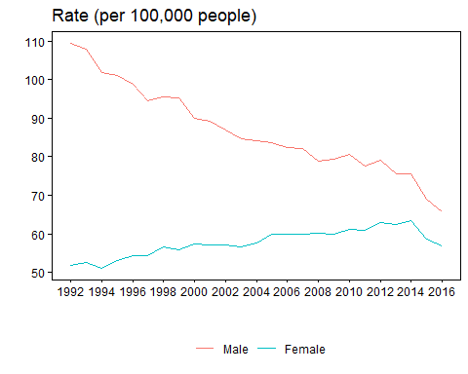

Source(s): Canadian Cancer Registry (3207).

# Lung and bronchus cancer survival higher among females than males

Lung and bronchus cancer survival is typically higher among females than males, regardless of age or province at diagnosis. For example, five-year net survival among females was 22%, compared with 15% among males. While survival tends to be higher among females for many cancers, the strength of this advantage among str_to_lower(mcCancer) cancer patients is particularly notable.

# About half of lung and bronchus cancer cases are diagnosed at the latest stage when survival is extremely low

Staging is a way of classifying a cancer based on the extent of disease in the body at the time of diagnosis. Staging levels typically run from I to IV, with the higher number indicating greater spread of disease in the body from the origin of the cancer. About half of all str_to_lower(mcCancer) cancers are diagnosed at stage IV, at which point survival is extremely low—three-year net survival of 5%. In contrast, slightly less than 1 in 10 str_to_lower(mcCancer) cancers are diagnosed at stage I where the cancer is relatively small and contained within the lung and the three-year prognosis is much better (71%).

# Chart 2

# Lung cancer three-year predicted net survival estimates by stage at diagnosis, Canada excluding Quebec, 2012–2014

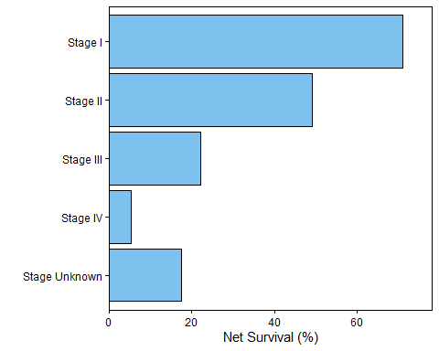

Source(s): Canadian Cancer Registry (3207) linked to mortality data from the Canadian Vital Stats Death Database (3233) and death information from the T1 Personal Master File (CCR-CVSD-T1PMF).