**LABS 4-7**

**Objectives**

1. Implement Full Search Based Variable Block Size Motion Estimation using MIPS ISA with the spiral search pattern shown below.

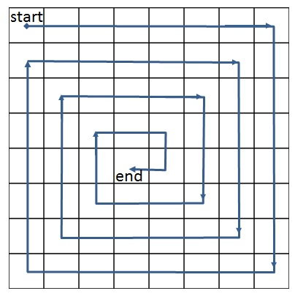

**Logistics**

* Due: September 25 at 2pm
* The template file **“vbsme.s”** includes an overview of the algorithm and public test cases.
* Demonstration due during your designated lab section.
* Demonstration will include running your program using public test cases and private test cases that will be given to you at the beginning of the lab.
* A signup sheet will be available to choose your demonstration time slot at the beginning of the lab.
* Submit only the “vbsme.s” on D2L to the designated dropbox. Include the overall percent effort of each team member in the file.

**Rules and Grading Requirements**

* you must follow the spiral access pattern
* you are not allowed to use special registers in your implementation
* "s" and "t" registers are the only registers to store values during the execution of the program
* avoid the following commands: division, mod

**Scoring** (250 points)

* Public test cases (70 points)
* Private test cases (180 points)

**Penalty Conditions**

* Percent effort not reported (20% penalty)
* Late submission or late demonstration (10% per day)
* Submitting files in a folder or in compressed form (zip/tar). (20% penalty)
* Changing the file name or extension. (20% penalty)
* Failing to demonstrate (80% penalty)
* Illegal register usage: max score 100pts,
* Illegal scan pattern usage: max score 60pts

**Assumptions**

* Frame size : 16x16 to 64x64, where x and y dimensions can be any integer between 16 and 64 (can be square or rectangle)
* Window size : One of 7 specified dimensions in the “vbsme.s”.