**19-APR-2021**

**Capstone Project — The Battle of Neighborhoods**

**Introduction**[**¶**](https://eu-gb.dataplatform.cloud.ibm.com/data/jupyter2/runtimeenv2/v1/wdpx/service/notebook/conda2py377593f3f69f704940975443e6e28dcc50/dsxjpy/brl-_4V8P75shRh4nmbJJQ:U53ayhTMqwewyEtcELHeE66phzRhZtCepe5QFdCFFWQQFkCDYppiWtnjKGc1J3wVtuLu760/container/notebooks/a234cb3e-6313-427e-9aeb-5039f72ca6ee?api=v2&project=7593f3f6-9f70-4940-9754-43e6e28dcc50#Introduction)

New Delhi is the capital city of India. It is a part of the city of Delhi’s 11 districts. It has a population that exceeds 30 million.

New Delhi are used interchangeably to refer to the National Capital Territory of Delhi (NCT), these are two distinct entities, with New Delhi forming a small part of Delhi. The National Capital Region is a much larger entity comprising the entire NCT along with adjoining districts in neighboring states.

With it’s diverse culture , comes diverse food items. There are many restaurants in New Delhi City, each belonging to different categories like Chinese , Italian , French etc.

So as part of this project , we will list and visualize all major parts of New Delhi City .

### Questions that can be asked using the above mentioned datasets

* What is best location in New Delhi City for Italian Cuisine ?
* Which areas have large number of Italian Restaurant?
* Which all areas have less number of restaurant ?
* What places are having best restaurant in New Delhi?

**Data**

For this project we need the following data :

* New Delhi Restaurants data that contains list Locality, Restaurant name, Rating along with their latitude and longitude.
  + Data source : [Zomato kaggel dataset](https://www.kaggle.com/shrutimehta/zomato-restaurants-data)
  + Description : This data set contains the required information. And we will use this data set to explore various locality of New Delhi city.
* Nearby places in each locality of New Delhi city.
  + Data source : [Fousquare API](https://developer.foursquare.com/" \t "_blank)
  + Description : By using this api we will get all the venues in each neighborhood.

**Approach**[**¶**](https://eu-gb.dataplatform.cloud.ibm.com/data/jupyter2/runtimeenv2/v1/wdpx/service/notebook/conda2py377593f3f69f704940975443e6e28dcc50/dsxjpy/brl-_4V8P75shRh4nmbJJQ:U53ayhTMqwewyEtcELHeE66phzRhZtCepe5QFdCFFWQQFkCDYppiWtnjKGc1J3wVtuLu760/container/notebooks/a234cb3e-6313-427e-9aeb-5039f72ca6ee?api=v2&project=7593f3f6-9f70-4940-9754-43e6e28dcc50#Approach)

* Collect the New Delhi city data from [Zomato kaggel dataset](https://www.kaggle.com/shrutimehta/zomato-restaurants-data)
* Using FourSquare API we will find all venues for each neighborhood.
* Filter out all venues that are nearby by locality.
* Using aggregative rating for each restaurant to find the best places.
* Visualize the Ranking of neighborhoods using folium library(python)

**Results**

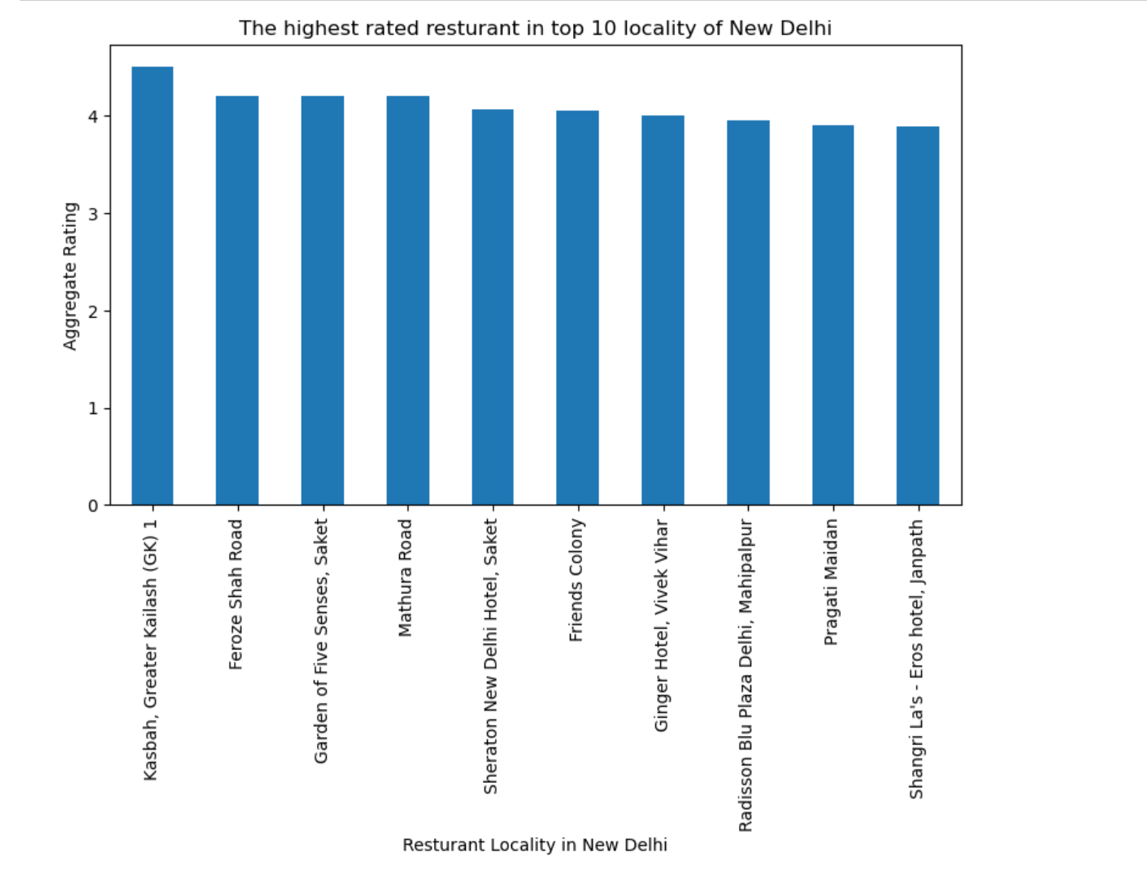

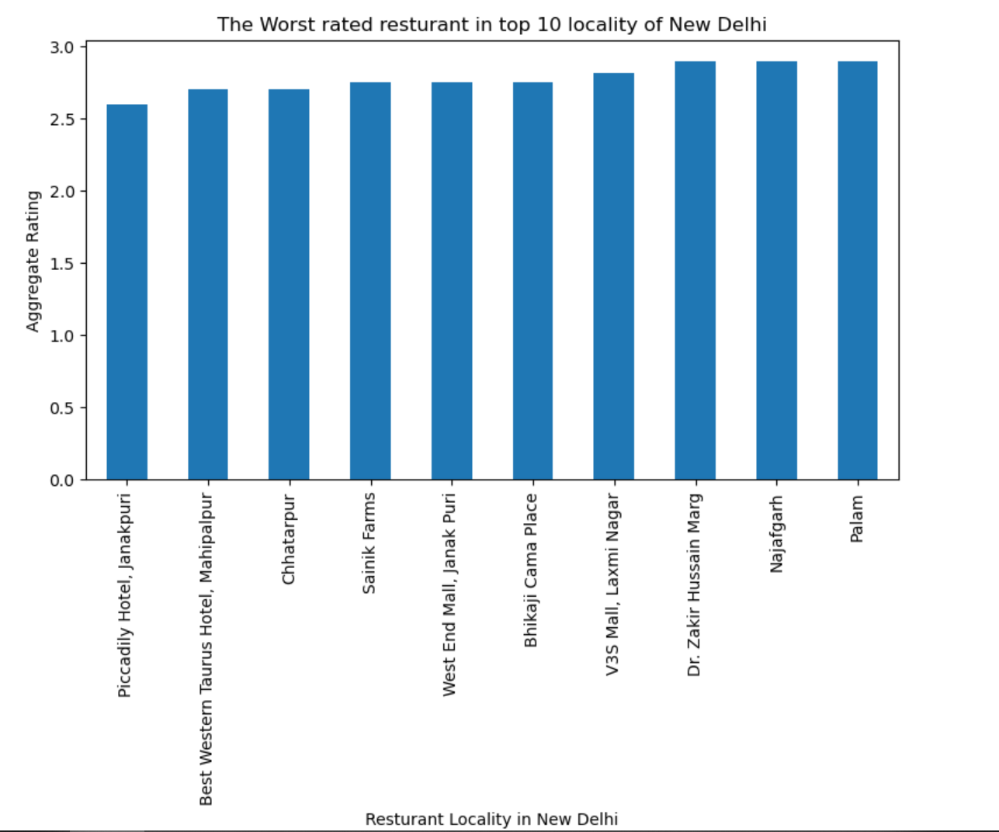

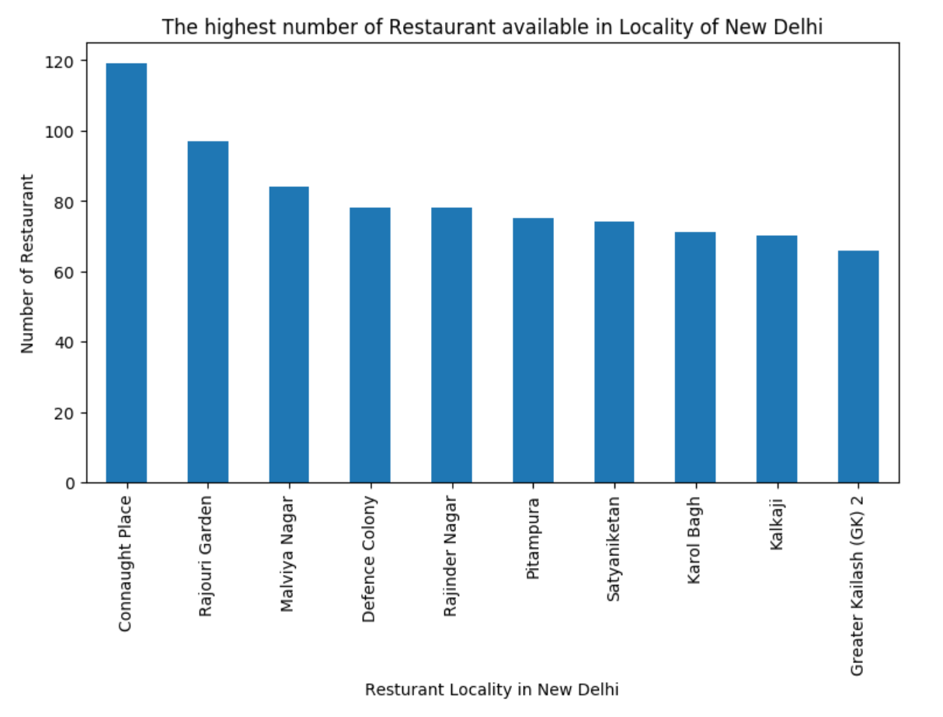

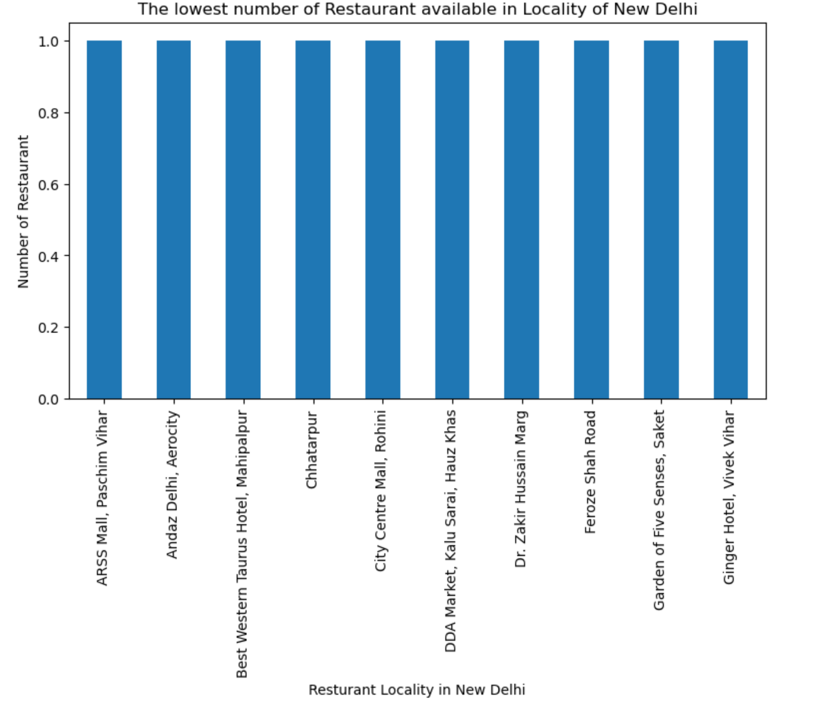

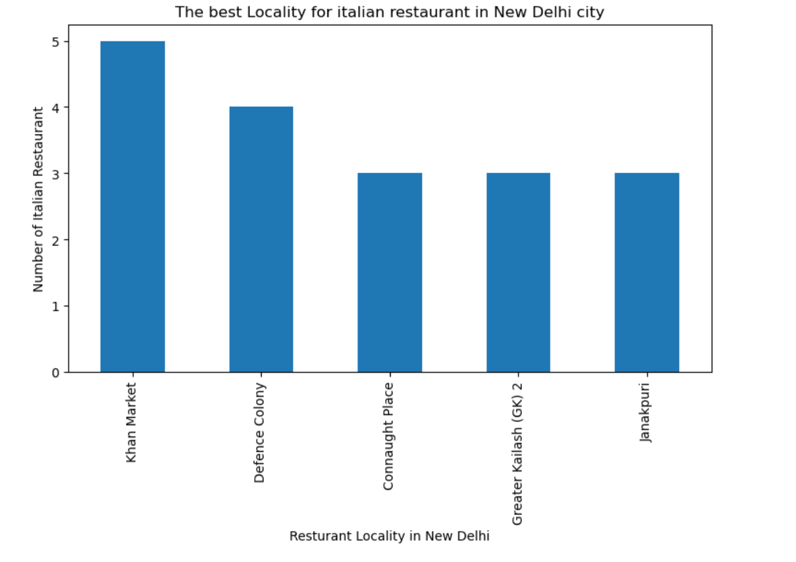

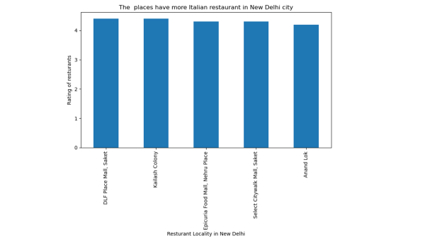

**Conclusion**

* DLF palace Mall, Kailash Colony are some of the best neighborhoods for Italian cuisine.
* -Khan Market, Defense Colony have the best Italian Restaurant.
* -Connaught place, Rajouri garden, Malviyanagar are the best places for foodie person.
* -Greater Kailash, Froze shah road, Saket have best restaurants in New Delhi.