Exposed on: <35.197.177.156:8088>

<https://github.com/DennisPYu/SIT323-2024-t1-prac10p>

create new deployment and sure the pod its running



Exposes the deployment as a service and listen on port 8088 and forward the traffic to port to 4000



Successful result

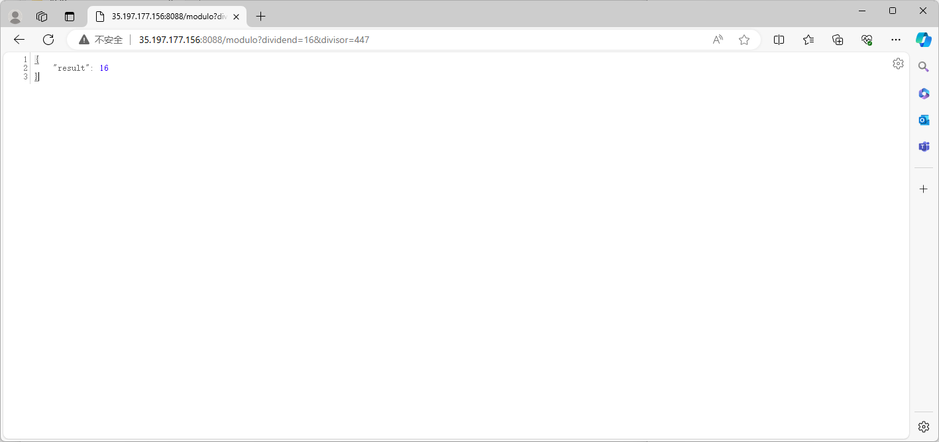

Monitoring usage

