https://github.com/DennisPYu/SIT323-2024-t1-prac6.2c

Verify that the application is running by running kubectl get pods and kubectl get services

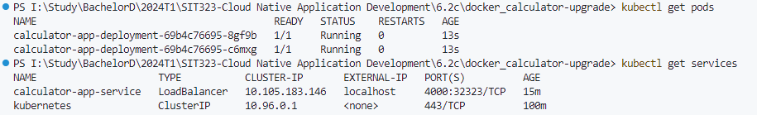

Port-forward command to forward traffic from a local port to the Kubernetes service

Kubernetes port  


port-forward

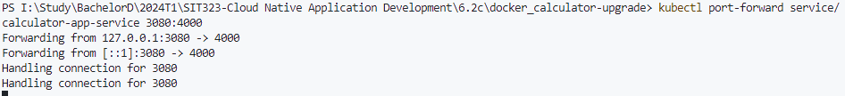

Localhost

