Deployment.yaml file that deploy app on kubernetes

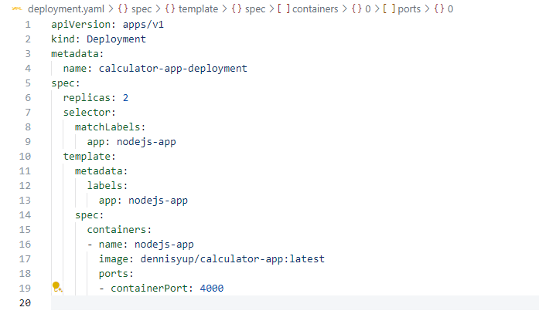

Command that created the deployment



Expose app to the outside

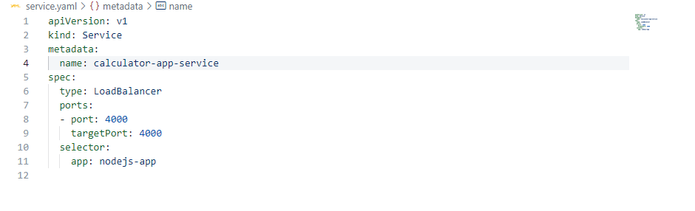

Command that apply the services to Kubernetes cluster



Docker image

