GitHub link: <https://github.com/DennisPYu/sit323-2024-t1-prac4c>

Note: this task is the extend version of task 4.1p. It contains some of the code that I used in task 4.1p.

* Code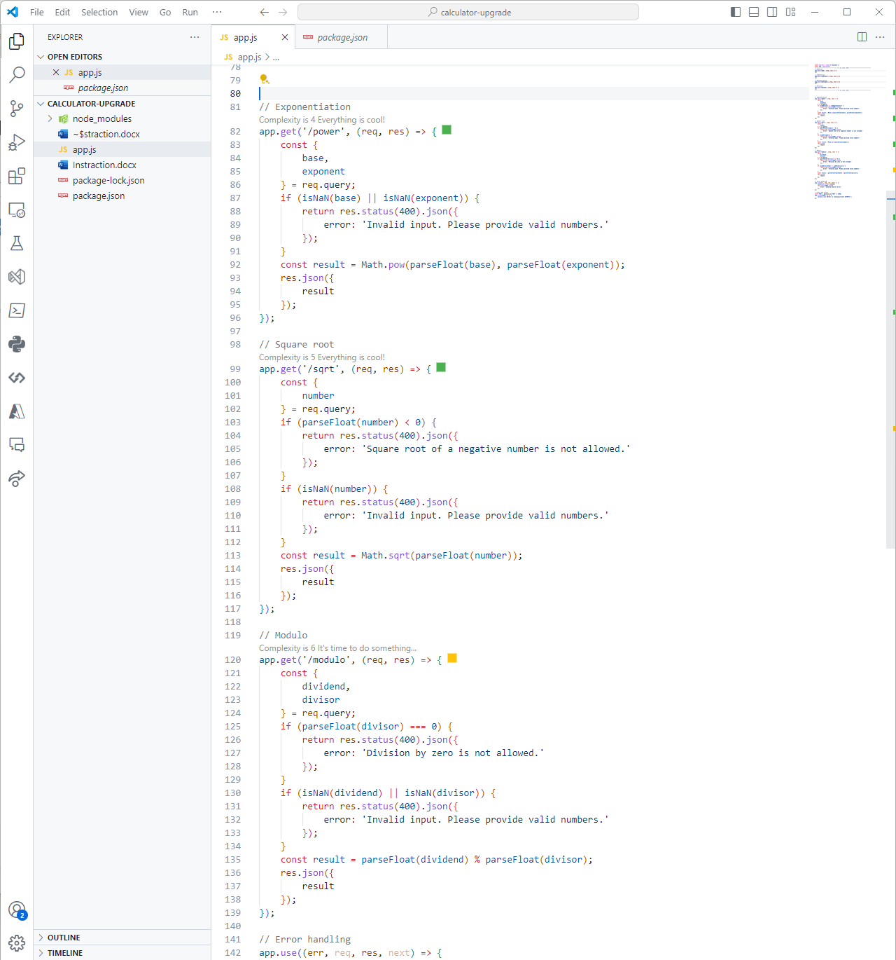
* Exponentiation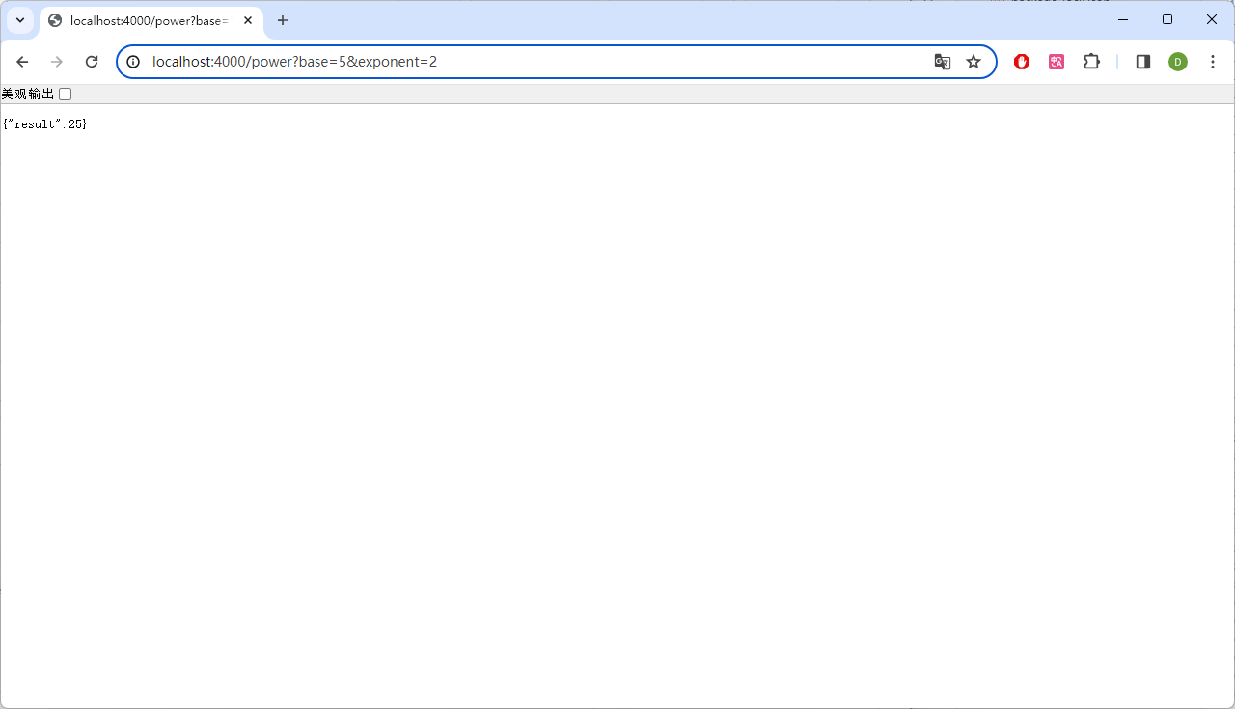
* Square root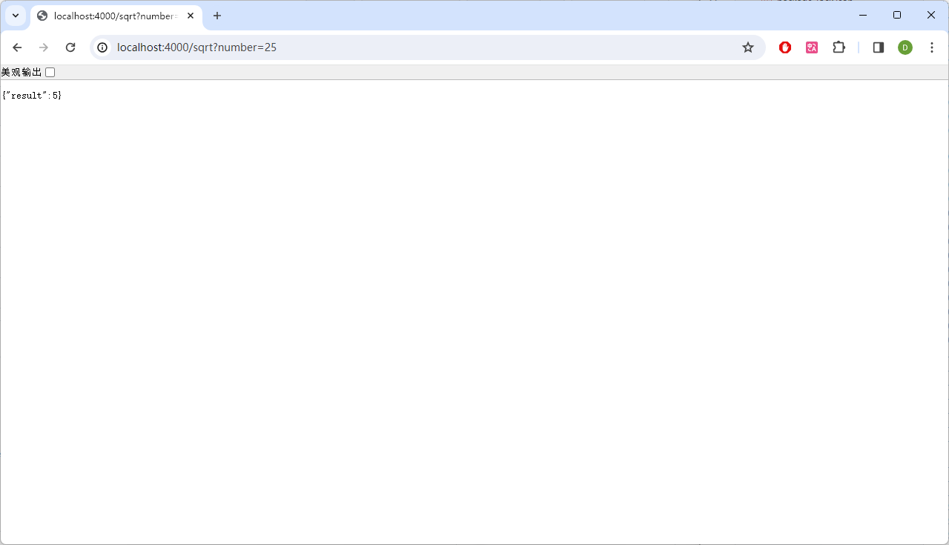
* Square root error handling 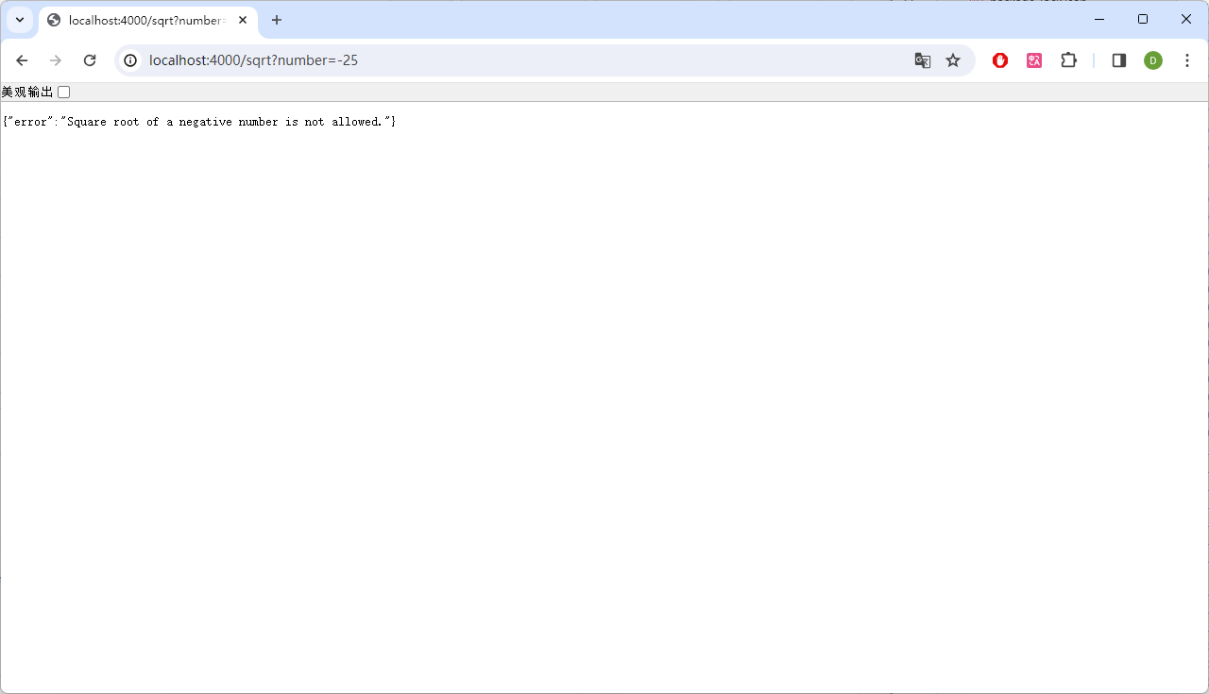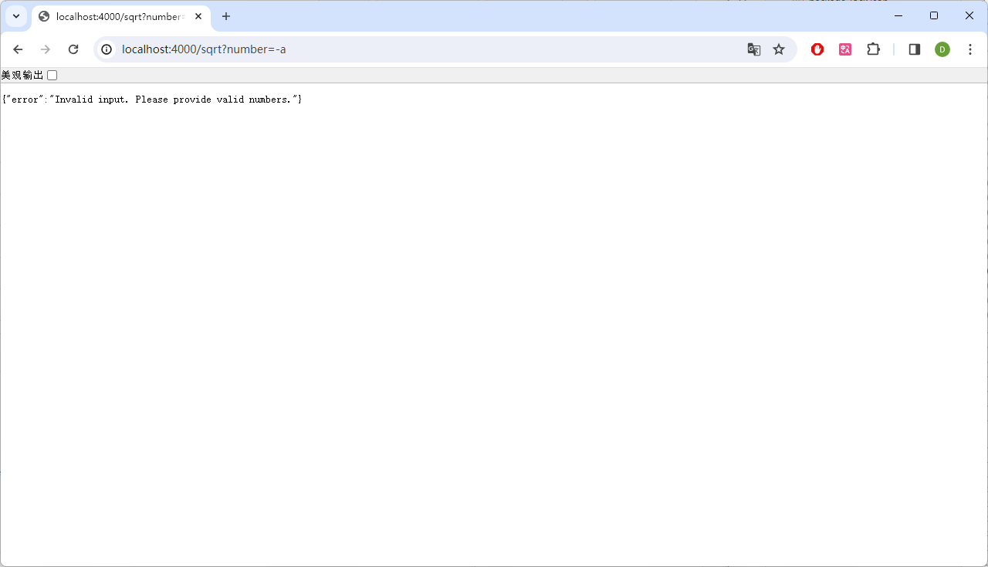
* Modulo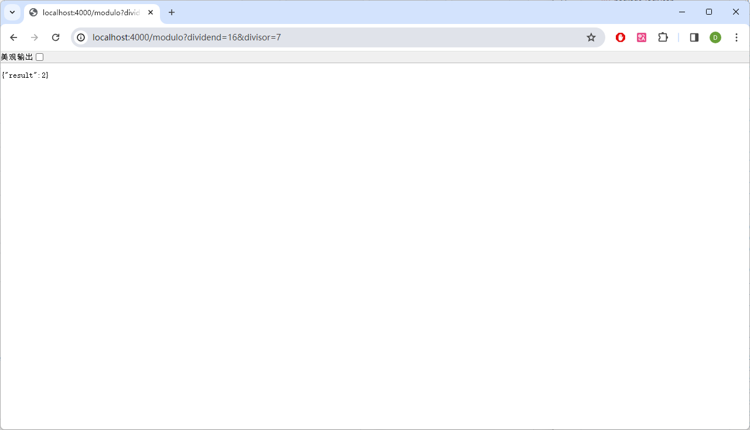
* Modulo error handling