GitHub: <https://github.com/DennisPYu/sit323-2024-t1-prac5p>

DockerHub: https://hub.docker.com/repository/docker/dennisyup/calculator-app/general

File that created the docker image

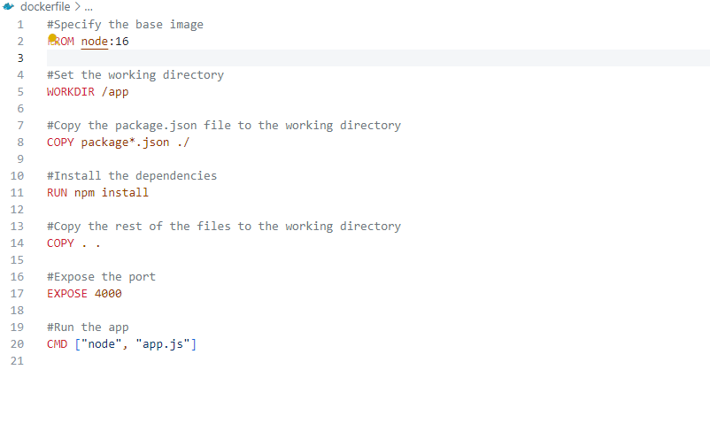

File that defines a service base on docker image

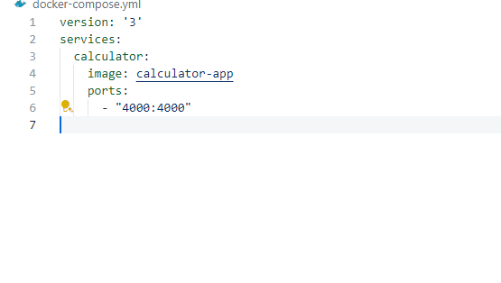

Command that build image base on dockerfile

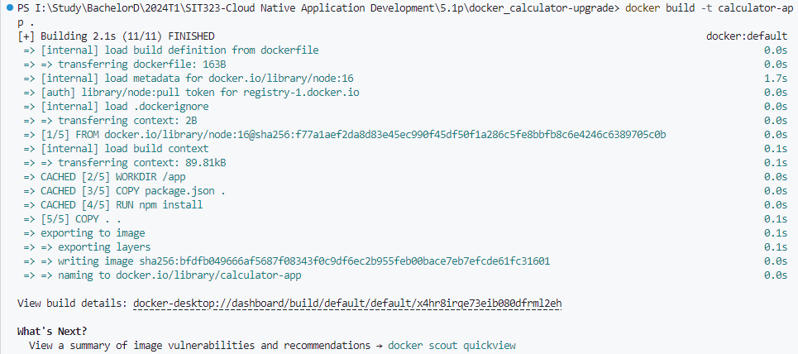

Command that starts the docker compose environment



Working example

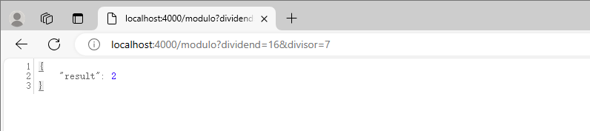

Command that pushes all to Docker Hub

