<https://github.com/DennisPYu/sit323-2024-t1-prac9p>

Install MongoDB into Kubernetes cluster

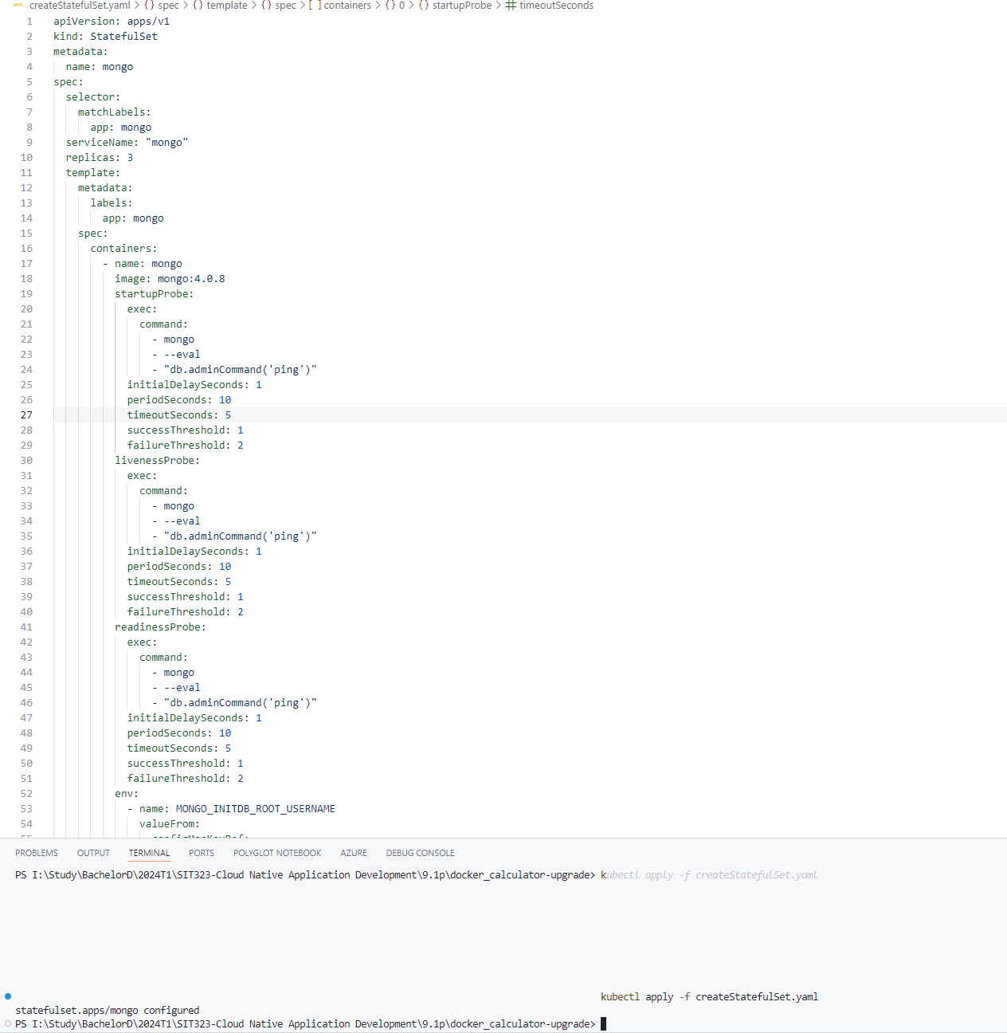

Create a MongoDB user

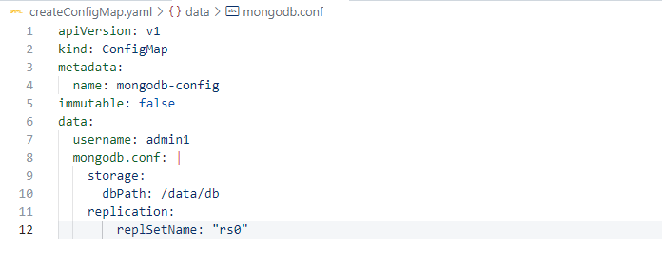

Create a Persistent Volume

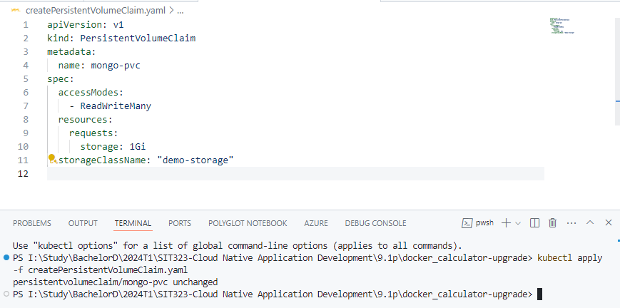

Create a Kubernetes Secret

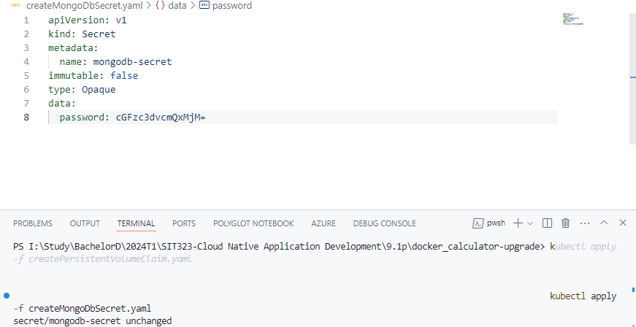

Setting up

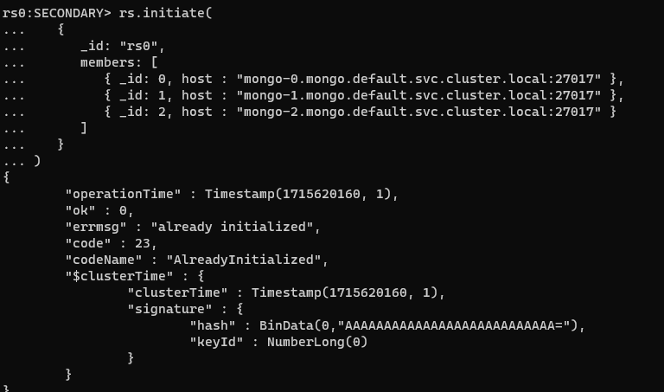

Creating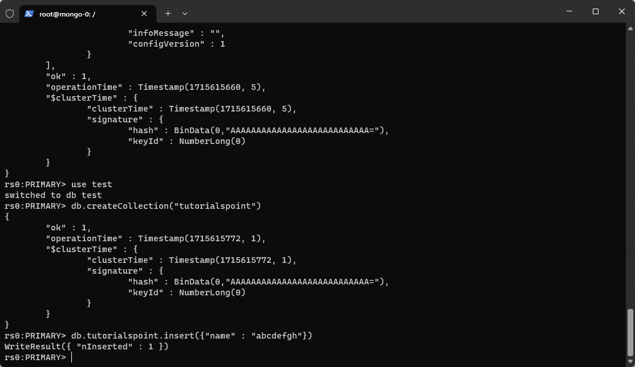

Reading

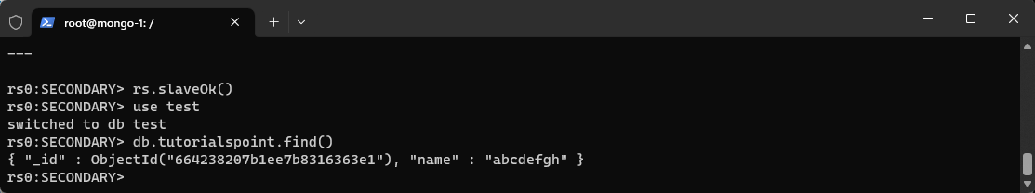

Updating

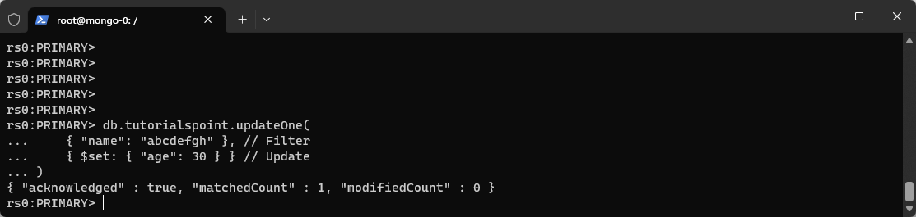

Deleting

