Dennis Persaud

CS-410-J5821 Software Reverse Engineering

Southern New Hampshire University

20EW5

Final Project: Code File

**File Name:** ProjectCode.o

**Functions:** main(), DisplayStudentInformation(), CheckUserPermissionAccess(), ReadUserInfo()

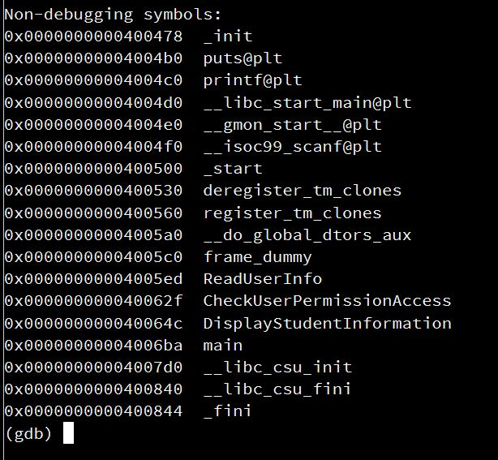

**Assembly Code:**

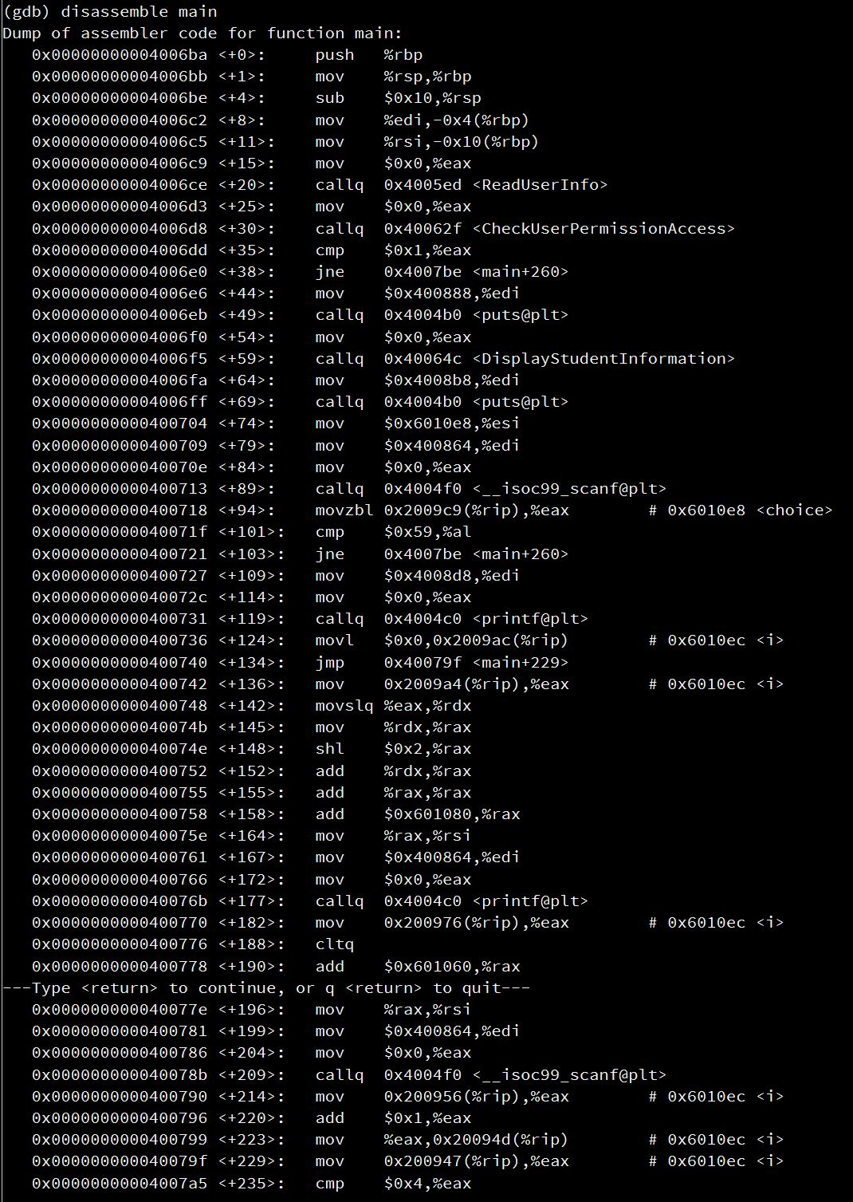

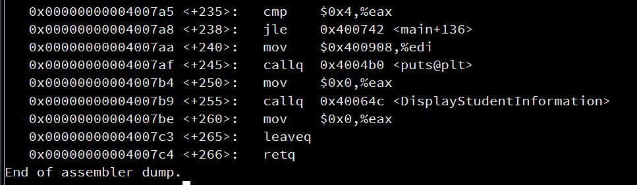

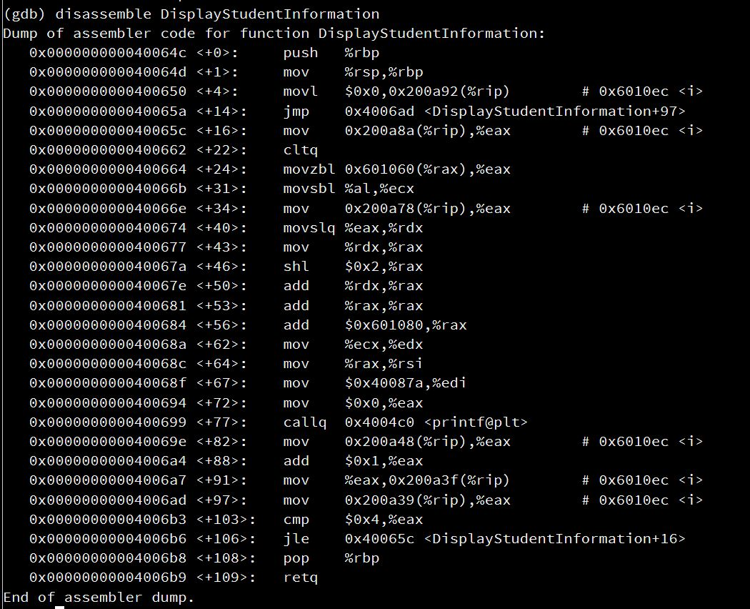

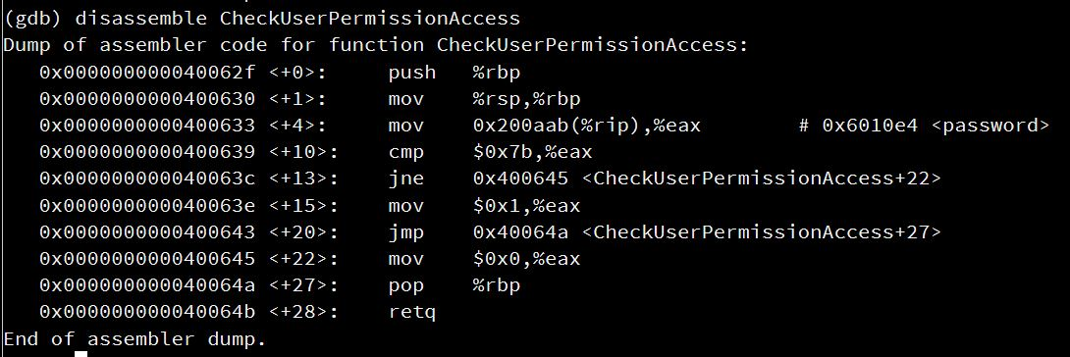

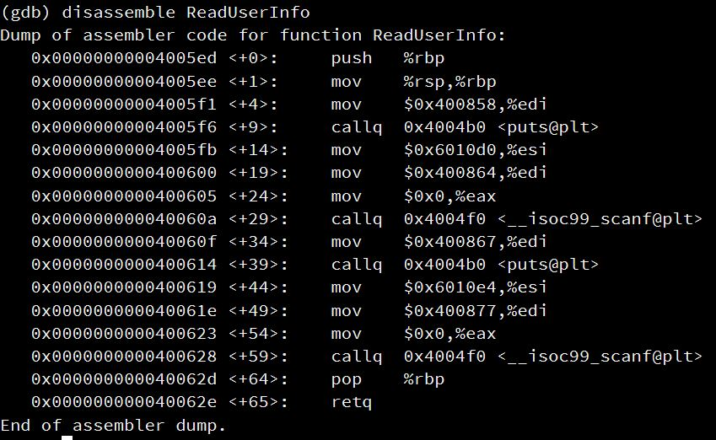

**Explanation:**

|  |  |
| --- | --- |
| **main()** | |
| **Assembly Code** | **C Code** |
| push %rbp  mov %rsp, %rbp  sub $0x10, %rsp  mov %edi, -0x4(%rbp)  mov %rsi, -0x10(%rbp) | Function Prologue. |
| mov $0x0, %eax  callq 0x4005ed <ReadUserInfo> | ReadUserInfo(); |
| mov $0x0, %eax  callq 0x40062f <CheckUserPermissionAccess> | CheckUserPermissionAccess(); |
| cmp $0x1, %eax  jne 0x4007be <main+260> | if (password == 1) |
| mov $0x400888, %edi  callq 0x4004b0 <puts@plt> | printf(“Welcome Professor. Below are all student grades.”); |
| mov $0x0, %eax  callq 0x40064c <DisplayStudentInformation> | DisplayStudentInformation(); |
| mov $0x4008b8, %edi  callq 0x4004b0 <puts@plt> | printf(“Adjust grades for students?”); |
| mov $0x6010e8, %esi  mov $0x400864, %edi  mov $0x0, %eax  callq 0x4004f0 <__isoc99_scanf@plt> | scanf(“%s”, choice); |
| movzbl 0x2009c9(%rip), %eax # 0x6010e8 <choice>  cmp $0x59, %al  jne 0x4007be <main+260> | if(choice == value) |
| mov $0x4008d8, %edi  mov $0x0, %eax  callq 0x4004c0 <printf@plt> | printf(“Enter the GPA for students one at a time ”); |
| movl $0x0,0x2009ac(%rip) # 0x6010ec <i>  jmp 0x40079f <main+229>  mov 0x2009a4(%rip), %eax # 0x6010ec <i>  movslq %eax, %rdx  mov %rdx, %rax  shl $0x2, %rax  add %rdx, %rax  add %rax, %rax  add $0x601080, %rax  mov %rax, %rsi  mov $0x400864, %edi  mov $0x0, %eax  callq 0x4004c0 <printf@plt>  mov 0x200976(%rip), %eax # 0x6010ec <i>  cltq  add $0x601060, %rax  mov %rax, %rsi  mov $0x400864, %edi  mov $0x0, %eax  callq 0x4004f0 <__isoc99_scanf@plt>  mov 0x200956(%rip), %eax # 0x6010ec <i>  add $0x1, %eax  mov %eax,0x20094d(%rip) # 0x6010ec <i>  mov 0x200947(%rip), %eax # 0x6010ec <i>  cmp $0x4, %eax  jle 0x400742 <main+136> | int i;  for(i=0;i<=4;i++){  printf(“%s”, students[i]);  scanf(“%s”, &grades[i]);  } |
| mov $0x400908, %edi  callq 0x4004b0 <puts@plt> | printf(“You have successfully updated class grades. The grades are now as follows: ”); |
| mov $0x0, %eax  callq 0x40064c <DisplayStudentInformation> | DisplayStudentInformation(); |
| mov $0x0, %eax  leaveq  retq | return 0; |

|  |  |
| --- | --- |
| **ReadUserInfo()** | |
| **Assembly Code** | **C Code** |
| push %rbp  mov %rsp, %rbp | Function Prologue. |
| mov $0x400858, %edi  callq 0x4004b0 <puts@plt> | printf(“Enter name: ”); |
| mov $0x400864, %edi  mov $0x0, %eax  callq 0x4004f0 <__isoc99_scanf@plt> | scanf(“%s”, name); |
| mov $0x400867, %edi  callq 0x4004b0 <puts@plt> | printf(“Enter password: ”); |
| mov $0x6010e4, %esi  mov $0x400877, %edi  mov $0x0, %eax  callq 0x4004f0 <__isoc99_scanf@plt> | scanf(“%d”, password); |
| pop %rbp  retq | return; |

|  |  |
| --- | --- |
| **CheckUserPermissionAccess()** | |
| **Assembly Code** | **C Code** |
| push %rbp  mov %rsp, %rbp | Function prologue. |
| mov 0x200aab(%rip), %eax # 0x6010e4 <password>  cmp $0x7b, %eax  jne 0x400645 <CheckUserPermissionAccess+22>  mov $0x1, %eax  jmp 0x40064a <CheckUserPermissionAccess+27>  mov $0x0, %eax | if (password == “123”) {  password = 1;  } else {  password = 0;  } |
| pop %rbp  retq | return; |

|  |  |
| --- | --- |
| **DisplayStudentInformation()** | |
| **Assembly Code** | **C Code** |
| push %rbp  mov %rsp, %rbp | Function prologue. |
| movl $0x0, 0x200a92(%rip) # 0x6010ec <i>  jmp 0x4006ad <DisplayStudentInformation+97>  mov 0x200a8a(%rip), %eax # 0x6010ec <i>  cltq  movzbl 0x601060(%rax), %eax  movsbl %al, %ecx  mov 0x200a78(%rip), %eax # 0x6010ec <i>  movslq %eax, %rdx  mov %rdx, %rax  shl $0x2, %rax  add %rdx, %rax  add %rax, %rax  add $0x601080, %rax  mov %ecx, %edx  mov %rax, %rsi  mov $0x40087a, %edi  mov $0x0, %eax  callq 0x4004c0 <printf@plt>  mov 0x200a48(%rip), %eax # 0x6010ec <i>  add $0x1, %eax  mov %eax,0x200a3f(%rip) # 0x6010ec <i>  mov 0x200a39(%rip), %eax # 0x6010ec <i>  cmp $0x4, %eax  jle 0x40065c <DisplayStudentInformation+16> | for(i=0; i<=4; i++){  printf(“%s %c \n), students[i], grades[i];  } |
| pop %rbp  retq | return; |

**Converted C Code**

#include <stdio.h>

#include <stdlib.h>

#include <string.h>

//Initialize global variables

char name[] = "";

char password[] = "";

char *students[] = {"Jim","Tom","Ben","Alice","Ruby"};

char grades[] = "ACCDF";

// Display Student Information Function

void DisplayStudentInformation(){

//Loop 5 times to display student name and grade

for(int i =0; i <=4; i++){

printf("%s %c \n",students[i],grades[i]);

}

}

// Check User Permission Access Function

int CheckUserPermissionAccess(){

char pass[] = "123"; //Initialize variable

char nam[] = ""; //Initialize nam with “

//compare strings, 0 means the strings are equal

if(strcmp(password, pass) == 0){

return 1; //Return 1 if values are equal

}else{

return 0; //Return 0 if values are not equal

}

}

// Read User Info Function

void ReadUserInfo(){

printf("Enter Name:\n"); //Print string on the screen

scanf(" %s",&name); //Pause for user to enter value

printf("Enter Password:\n"); //Print value on the screen

scanf(" %s",&password); //Take in value through standard input stream

}

// Main Function

int main(int argc, char** argv) {

ReadUserInfo(); //Call method ReadUserInfo

int value = CheckUserPermissionAccess(); //Call function and store its value

if(value == 1){ //Check if value is equal to 1

DisplayStudentInformation(); //Call function to display student data

printf("Adjust grades for students?"); //Print string on screen

char choice;

char value = 'Y';

scanf(" %c",&choice); //Take user choice through the standard input stream

if(choice == value){

printf("Enter the GPA for students one at a time \n");

int x;

//loop to enter new grade for each student

for(i = 0; i <=4; i++){

printf("%s",students[i]);

scanf(" %c",&grades[i]);

}

}

printf("You have successfully updated class grades. The grades are now as follows:\n");

DisplayStudentInformation(); //Display updated grades for students

}else{

return (0);

}

return (EXIT_SUCCESS);

}