|  |  |
| --- | --- |
| *Demo code can be downloaded from Fronter:* [PROGRAMMING](https://fronter.com/cphbusiness/links/top_frame.phtml) > [Web](https://fronter.com/cphbusiness/links/top_frame.phtml) | * Servlets and JSp - exercises.zip |

**Exercise 1 (form > Servlet)**

Create a project with an HTML page containing a simple form.   
Create a Servlet that reads the parameter from the form and output "an echo" of the input.

**Exercise 2 (how the Container handles a request)**

Fill in some of the major ingredients that are interacting in the container.  
Show with arrows and numbering how they interact.  
Hints: HTTP request, HTTP response, request, response, thread, service(), doGet(),



**Exercise 3 (Forward to JSP)**

Create a project similar to the "Demo_ForwardToJSP" project from scratch.

**Exercise 4**

Create a project similar to the "Demo_Attributes" project from scratch.

**Exercise 5**

Create a project, where you insert several pieces of Java code into an JSP.  
Hint: Look in the "Demo_JSP_Elements" and "Demo_ShowList" projects for inspiration.

**Exercise 6 (Architecture, MVC) - in pairs**

1. Look carefully at the sketches below and read the text explaining each step.
2. If (you don’t remember most of the text) go to a)
3. 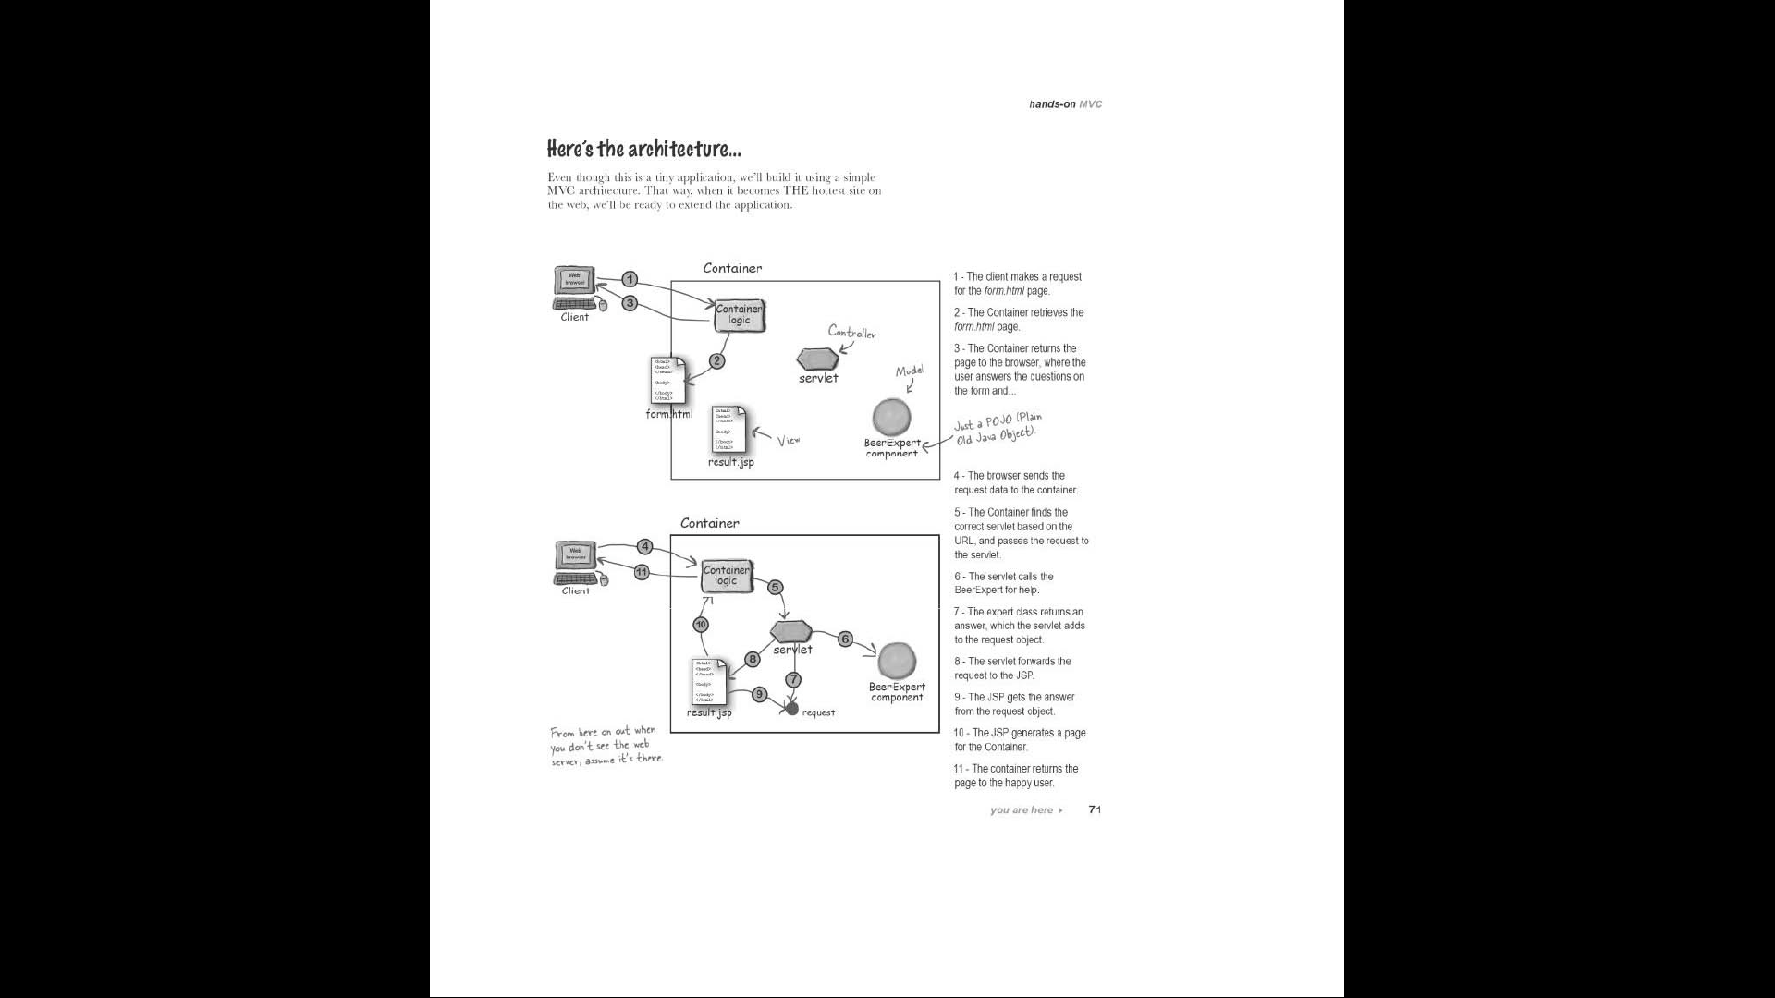Turn the right part of the page (so you can't see the text) and try to explain each step  
    - take turns

**Exercise 7**

Create a project with the following:

* An HTML page with a form that has:
  + two input fields (first and last name)
  + Drop down list for which semester (1-4) you are attending
  + Check boxes for which topics you like
    - HTML
    - CSS
    - DB
    - Java
  + Text field where you can write 3 lines about yourself
* A JSP page that show all input