HW3：
part1，讀取影像做二值化後，再依使用者輸入選項做形態運算(erosion、dilation、opening、closing)。
part2，實現optical character recognition(ORC)，從輸入的文字圖檔識別特定字元，並在中間點上一點黑點。
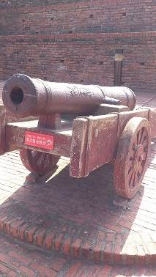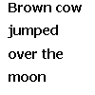
程式碼：
3-1
clc;clear;
%讀取圖檔
[FN] = uigetfile({'*.jpg','JPEG (*.jpg;*.jpeg;*)';...
'*.png','PNG (*.png)';...
'*.bmp','BMP (*.bmp)'},'開啟圖檔');
RGB = imread(FN);
%Binary
threshold = 150; %閾值
threshold2 = threshold / 255;
Binary = im2bw(RGB,threshold2); %二值化轉換
subplot(1,2,1); imshow(Binary); title('Binary');
%將輸入的訊息轉成字串
work = input(...
'請輸入以下代號對二值化影像作形態處理:\n(E)erosion、(D)dilation、(O)opening、(C)closing '...
,'s');
se = strel('disk',2);
if work == 'e' | work == 'E'
w1 = imerode(Binary,se);
subplot(1,2,2); imshow(w1); title('erosion');
elseif work == 'd' | work == 'D'
w1 = imdilate(Binary,se);
subplot(1,2,2); imshow(w1); title('erosion');
elseif work == 'o' | work == 'O'
w1 = imopen(Binary,se);
subplot(1,2,2); imshow(w1); title('erosion');
elseif work == 'c' | work == 'C'
w1 = imclose(Binary,se);
subplot(1,2,2); imshow(w1); title('erosion');
end
saveas(figure(1),'CV_HW3_1_M1035502','jpg');

3-2
clc;clear;
%讀取圖檔
[FN1] = uigetfile({'*.jpg','JPEG (*.jpg;*.jpeg;*)';...
'*.png','PNG (*.png)';...
'*.bmp','BMP (*.bmp)'},'開啟文字圖檔');
original= imread(FN1);

[FN2] = uigetfile({'*.jpg','JPEG (*.jpg;*.jpeg;*)';...
'*.png','PNG (*.png)';...
'*.bmp','BMP (*.bmp)'},'開啟辨識字元圖檔');
o = imread(FN2);

subplot(1,2,1); imshow(original); title('original');

size1 = size(original);
size2 = size(o);
%取得辨識字元中心點
if mod(size2(1),2) == 0
h =(size2(1)/2);
w =(size2(2)/2);
else
h =(size2(1)+1)/2;
w =(size2(2)+1)/2;
end

t1=sum(sum(o));
total1 = sum(sum(o(1,1:size2(2))));
total2 = sum(sum(o(1:size2(1),1)));
Recognition_results = original;
%辨識字元
for i=1:size1(1)-size2(1)+1
for j=1:size1(2)-size2(2)+1

t2=sum(sum(original(i:i+size2(2)-1,j:j+size2(1)-1)));
total3 = sum(sum(original(i,j:j+size2(1)-1)));
total4 = sum(sum(original(i:i+size2(2)-1,j)));

if total1==total3 && t1==t2 && total2==total4
Recognition_results(i+h-1,j+w-1)=0;
end
end
end

subplot(1,2,2); imshow(Recognition_results); title('Recognition results');
saveas(figure(1),'CV_HW3_2_M1035502','png');

結果：
3-1
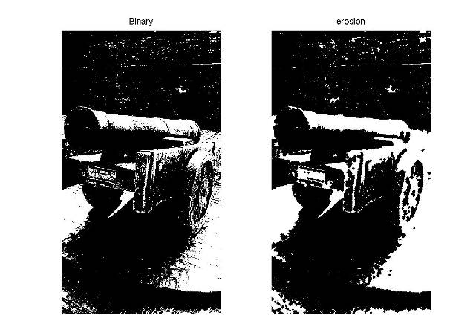
3-2


