**Assignment 3 – Web App, MySQL Integration, and Selenium Testing**

**Name: Denish Akbari (8901001)**

**Github Link:-** [**https://github.com/Denny0404/DBA-Assignment-3.git**](https://github.com/Denny0404/DBA-Assignment-3.git)

**Part 1: Web Application UI**

This screenshot shows the login form interface developed using Flask and HTML/CSS. Users can enter a username and password and submit the form to store data in the database.

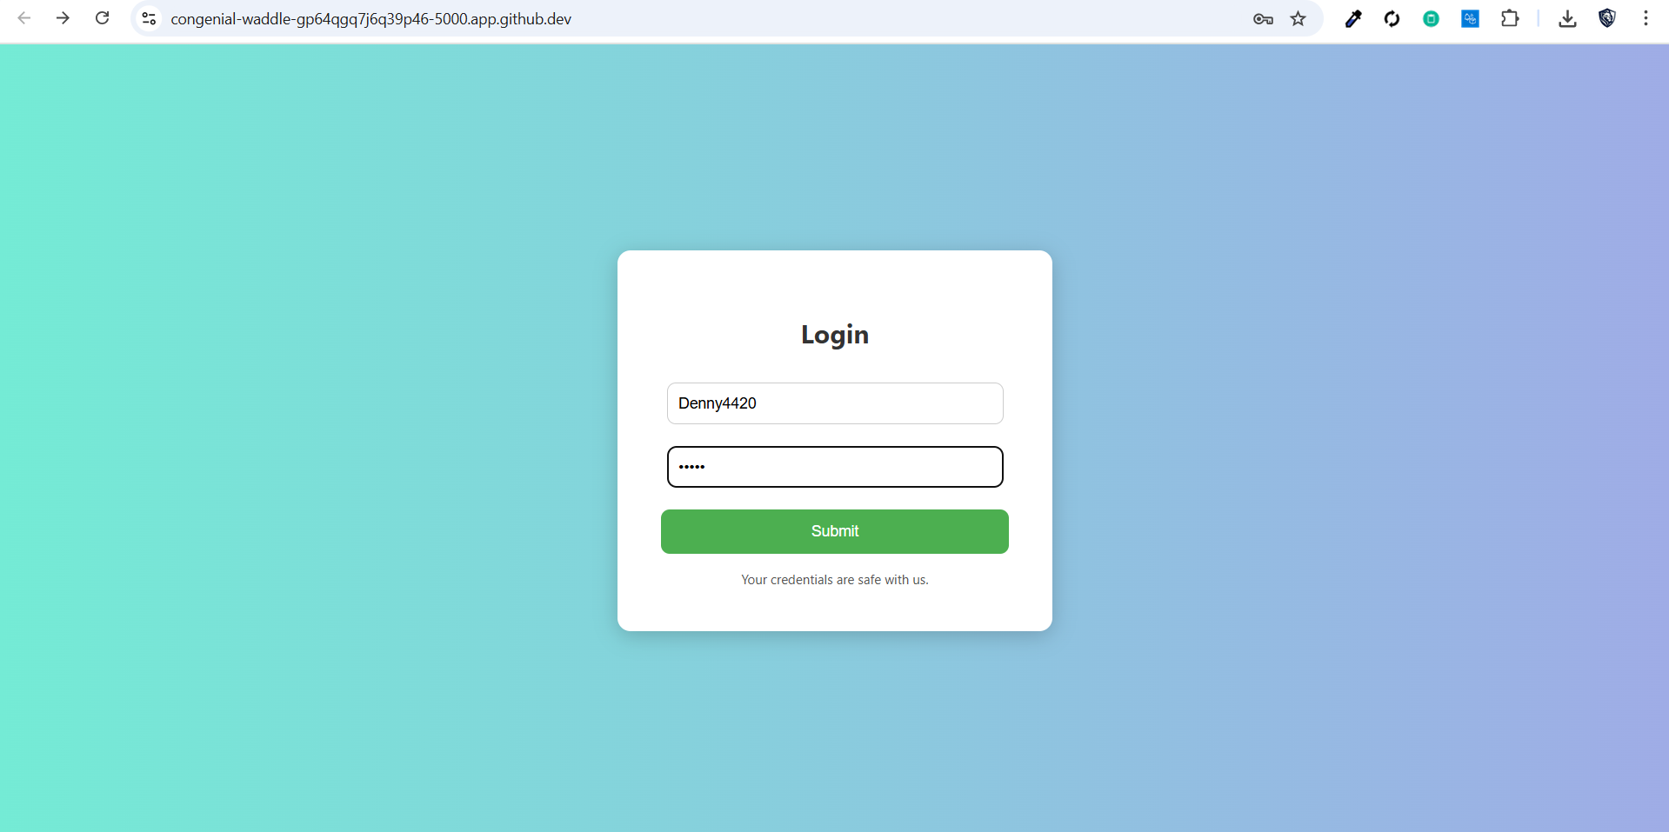

**Part 1b: Login Success Page**

This screenshot shows the success message after a valid form submission. It confirms data was inserted and shows a user-friendly UI.

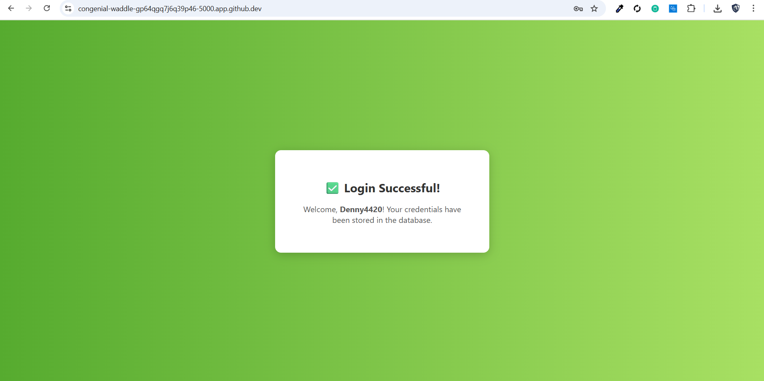

**Part 2: Database Setup**

These screenshots confirm that the MySQL database and 'users' table were created successfully, and new users are being inserted into the table.

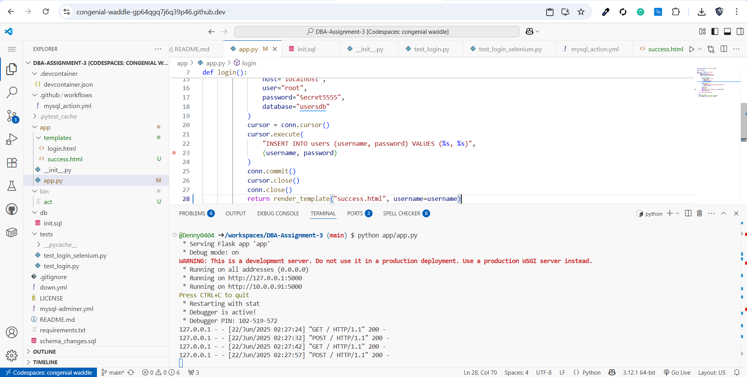

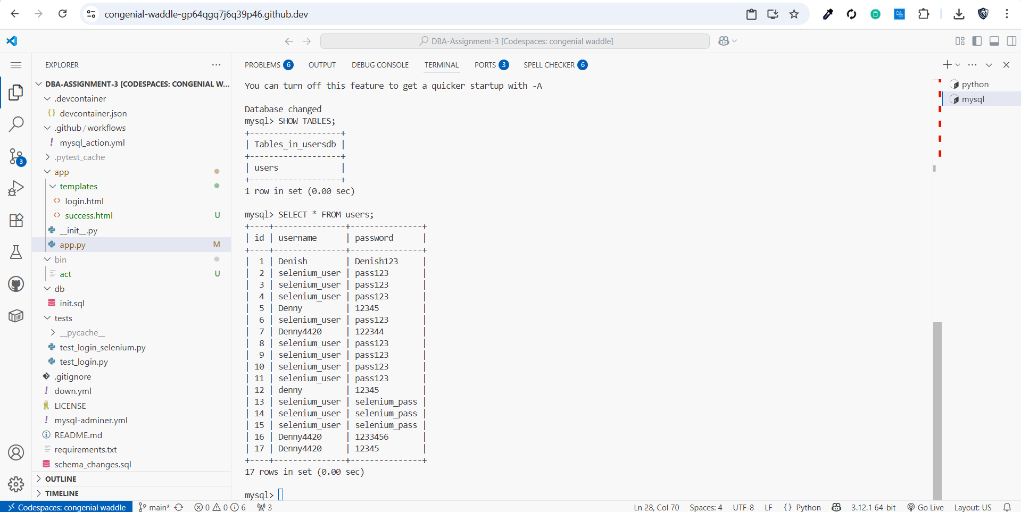

**Part 3: Selenium Test Result**

This screenshot shows the terminal result of a Selenium test script that programmatically submits the login form and verifies that the user was inserted into the database.

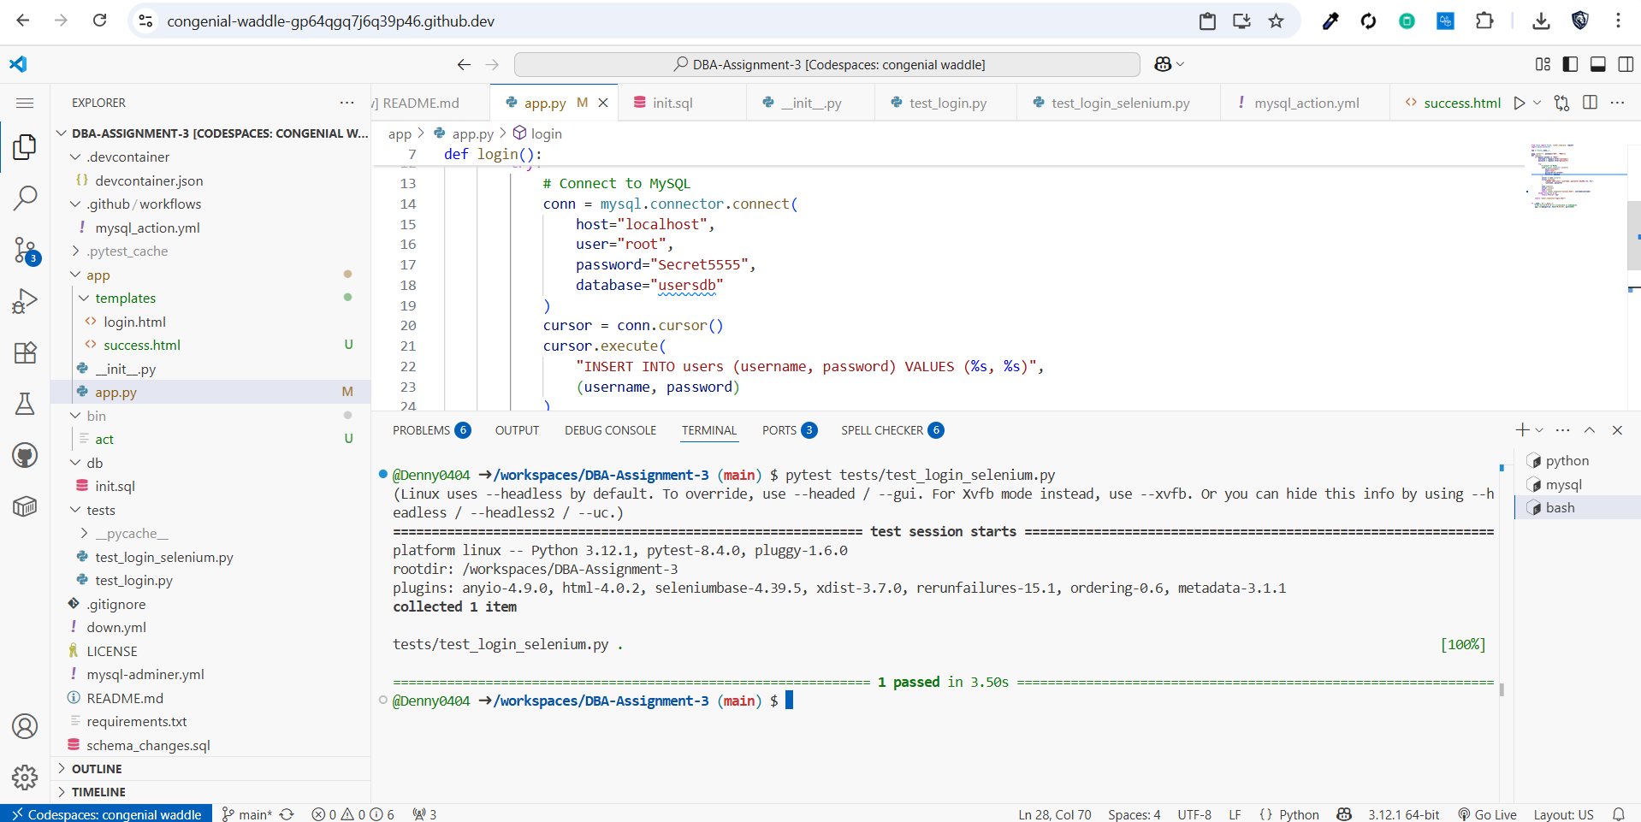

**Part 4: GitHub Actions**

This screenshot shows the GitHub Actions workflow running successfully. It starts MySQL, installs the client, and runs schema updates automatically on push.

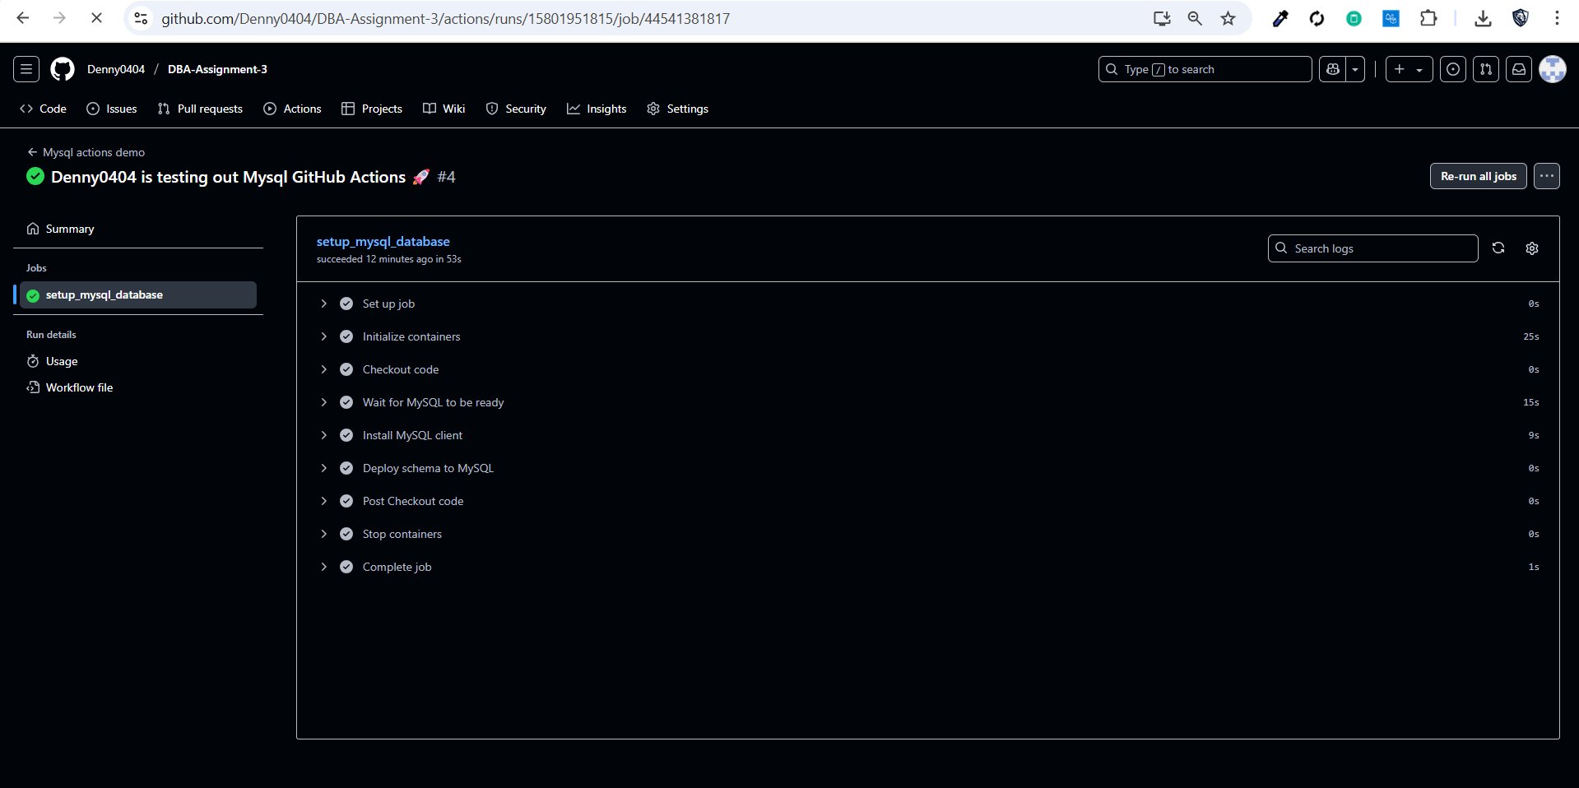

**Bonus: Flask Terminal Logs**

This shows the terminal running the Flask app and receiving requests from the login form.

