Design and analysis of a soft continuum robot prototype for endoscopic interventions

Author 1, Author 2

\begin{abstract}
%\boldmath
The abstract goes here.
\end{abstract}
\begin{IEEEkeywords}
IEEEtran, journal, \LaTeX, paper, template.
\end{IEEEkeywords}

Introduction
- 1st paragraph: To introduce the advantages of using soft robots in endoscopy
  - Clinical data of endoscopy, showing the increasing need of robotic endoscope
  - Review of some state-of-the-art robot-assisted endoscopy with rigid structure
    - tendon-driven
  - Current applications of soft robots in medical applications
  - Advantages of using soft robots in endoscopy
    - low-cost
      - disposable
    - easy to fabricate
    - particularly fluidically-driven soft continuum robots
- 2nd paragraph: To introduce the technical challenges of using soft robots in endoscopy
  - State-of-the-art soft robotic technologies
    - achievements in literature
  - requirements for endoscopy
    - safe
    - fast response
    - small size
    - with working channel *
    - (with embedded camera)
  - the technical challenges in design:
    - choice of material
    - structural and geometrical design
    - how stiff should be enough?
    - simulation of hyper-elastic materials and interaction with internal instrument
- 3rd paragraph: How do we solve these challenges
  - state-of-the-art FEA for hyperelastic material
    - achievement in literature
  - what are the contributions of our FEA?
    - any literature have done simulation of interaction with internal instrument?
  - what are our approach/tricks that can approximate the hyperelastic behaviour?
    - new FEM formulations?
    - new combination of element?
    - optimized for fast computation?
    - etc…
  - how the FEA results be incorporate in the design optimization
    - description of role of FEA in the design optimization cycle
  - Fig. 1.1. The endoscope prototype.
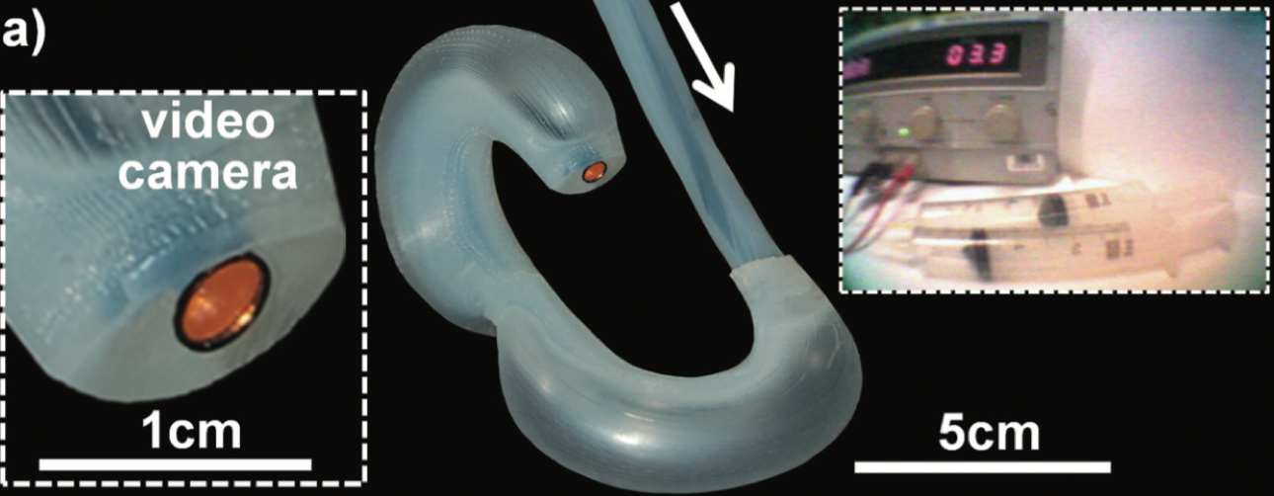 Figure 1.1: The endoscope prototype.
  - 4rd paragraph: Clearly list out the contributions using the proposed FEM-based design
    - how small the soft endoscope with working channel can we achieve?
    - how much force does our prototype can it give?
    - how accurate the FEA simulations were?

Materials and methods

Design and performance requirements
- do we need to specify the target application, e.g. to colonoscopy?
- a working channel is preserved
  - for biopsy, suction, irrigation, and other instruments
  - give common dimension of clinically-used instruments (e.g. biopsy forceps)
    - dimensions in specific applications: e.g. colonoscopy
  - requirement for the diameter: the larger the better
    - specify a dimension for the prototype in this paper
- target dimension: Outer diameter and length
  - why such dimension?
    - it is easier to give reason if the target application is specific. e.g. colonoscope
  - what is(are) the potential endoscopic applications
- How stiff should the scope be?
  - sufficient to withstand instrument insertion
  - sufficient to withstand high input pressure
- constrained elongation
  - i.e. only bending without much elongation
  - why?
    - camera is mount at the tip. bending with large elongation will cause loss of tracked vision target in the endoscopic view
- Durability
  - long life cycle
- actuation method - fluidic actuation
- advantages of fluidically driven - can be only Hydraulic/pneumatic
  - safe without internal electric component or some toxic component
  - hydraulic: incompressible transmission media gives fast response, …
  - pneumatic: ease of assembly, …
  - MRI-compatible
  - a sentence about the control method
  - why not tendon-driven?
    - here we may need to mention also the advantages of tendon-driven soft continuum robot
- discuss difficulties of miniaturization
  - mention the state-of-the-art soft robot dimension
  - difficulties of including a central working channel
    - weaken structure
    - reduced volume of material –> less elongation and thus smaller bending curvature
  - are we the first soft robot with working channel of that small dimension?

Structural design
- the actuation response depends on the structural design
  - the geometric design of the actuation chambers
  - material
- we use FEA to simulate the kinematic and dynamics behaviour in the design optimization process
- we can first give the design using fan-shaped actuation chambers
- then use FEM to demonstrate the weak points at the chamber corners
- then provide the dump bell shaped design
- Fig. 2.2.1. 2D FEM model
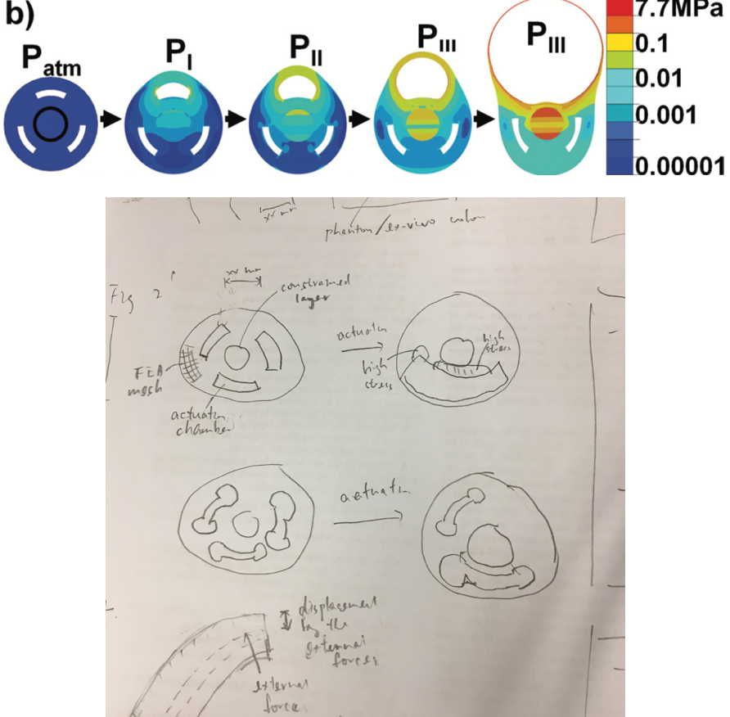 Figure 2.2.1: Internal stress during actuation. (a) Fan-shaped actuation chamber design has higher stress. (b) Dump-bell shaped chamber design has lower stress.
- actuation chamber design - 1st version: the fan-shaped
  - number of chambers
    - 3-chamber are commonly used in the literature
  - chamber geometry
    - why do we use the fan-shaped chamber?
  - chamber arrangement/location
    - mention about
- constraint layers
  - material
  - where are the constraint layers
  - what are the benefits of the constraint layers?
  - why they are necessary?
- dimension of the working channel
- actuation chamber design - 2nd version: the dump-bell shaped
  - thicker walls between the chambers and the central channel
  - no-corner chambers
  - why?
    - during actuation, high stress are found in the fan-shaped chambers
      - in the walls between the chambers and the central channel
      - at the corners
- the choice of material
- Fig. 2.2.2. Stress-strain curves of the materials in used
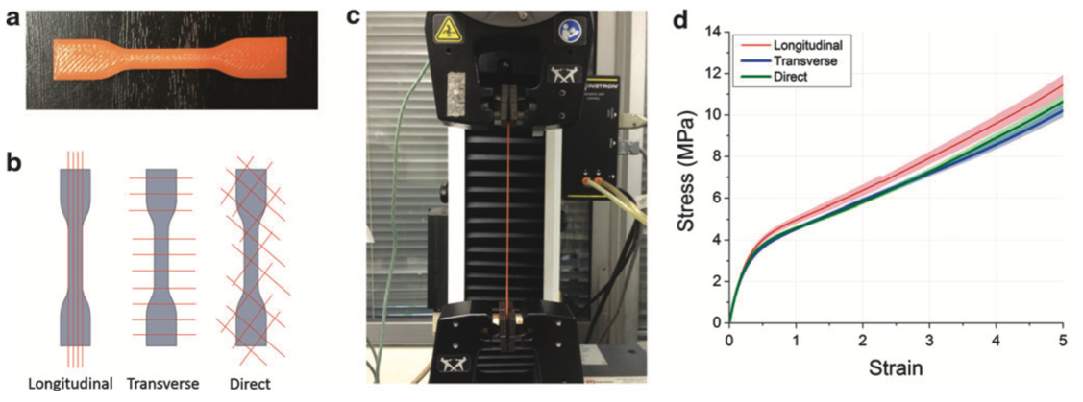 Figure 2.2.2: Stress-strain curves of the materials in used. These measurement data are used to identify the correct hyperelastic models in Table 2.3.1.

FEM optimization
- Table 2.3.1. Table of hyperelastic models
Table 2.3.1: Hyperelastic model candidates for FEM simulation.
\includegraphics[width=.45\linewidth]{./fig/tab1.png}
- Table 2.3.2. FEM simulation parameters
Table 2.3.2: FEM simulation parameters.
\includegraphics[width=.45\linewidth]{./fig/tab2.png}
- the advanced formulations for simulating hyperelastic materials
  - how to choose the strain energy functions?
    - list several candidates, and then discuss how to choose among them.
  - what software you are using?
  - how to choose the finite element? and why?
    - hexahedral element for the hyperelastic material, truss for the constraint layer?
      - with the element number in that software (e.g. Abaqus element type C3D10H)
    - what is the number of element
    - simulation time
- Fig. 2.3.1. 3D FEM model for stiffness simulation
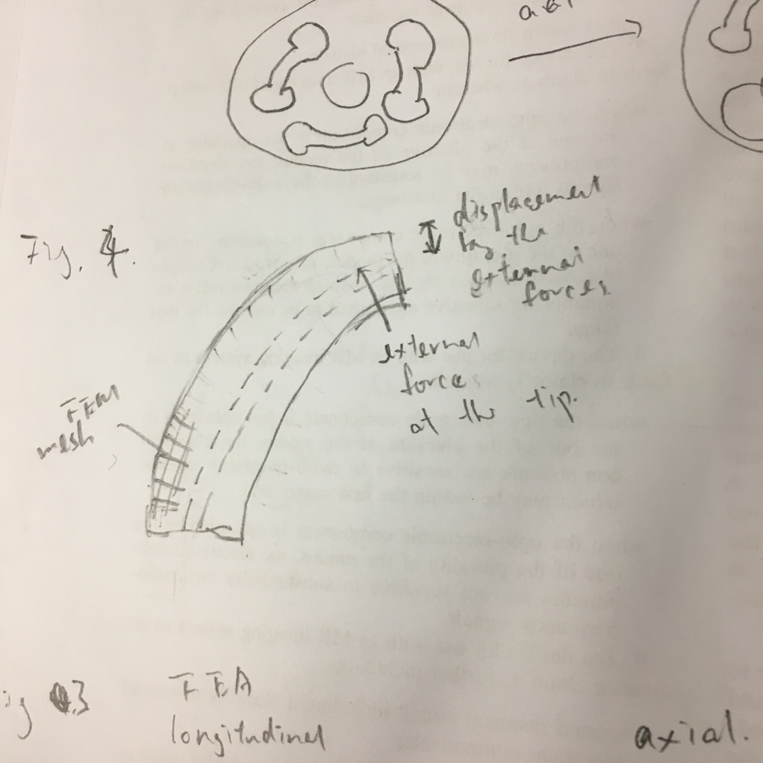 Figure 2.3.1: FEM simulation to estimate the robot stiffness. An external force is exerted at the tip perpendicular to the pointing direction. Stiffer robot requires larger force to move the tip.
- how to estimate stiffness?
  - simulating the reaction force from the instrument
  - applying a force to the inner wall of the working channel
    - stiffness = force / displacement
- measuring bending performance: ratio = curvature/length
- bending force
  - what is bending force? the force at the tip ?

Fabrication - optional
- Fig. 2.4.1. Fabrication procedure – optional
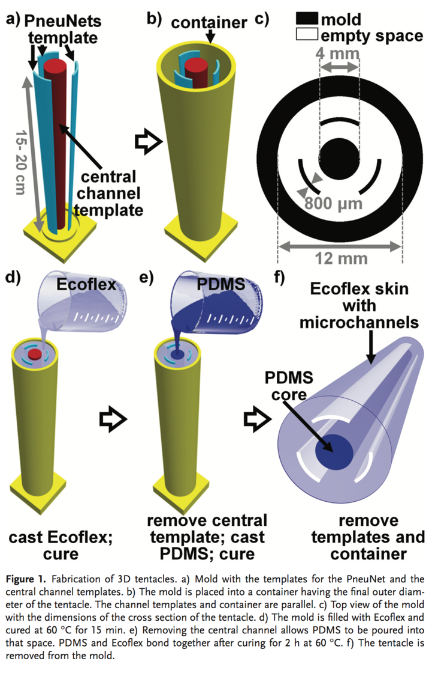 Figure 2.4.1: Fabrication procedure of the endoscope prototype. - optional
- Fabrication process
  - low-cost
  - basic procedure (of course some basic tricks that can be disclosed)
    - e.g. sequence of molding and filling material, temperature
    - reference: e.g. Fig.1 in martinez2012robotic \cite{martinez2012robotic}.
  - what should be paid attention to? why?
    - e.g. temperature control, material filling speed, assembly cautions
    - …

Results and discussion
- Comparison of the results between FEA and the real robot
- workspace analysis
  - using random pressure inputs
- how to measure the bending force
- how to measure the internal force
  - fatigue test
    - no. of cycle until failure
  - can take reference from yap2016highforce \cite{yap2016highforce}

Bending behavior
- Fig 3.1.1. Bending behaviour
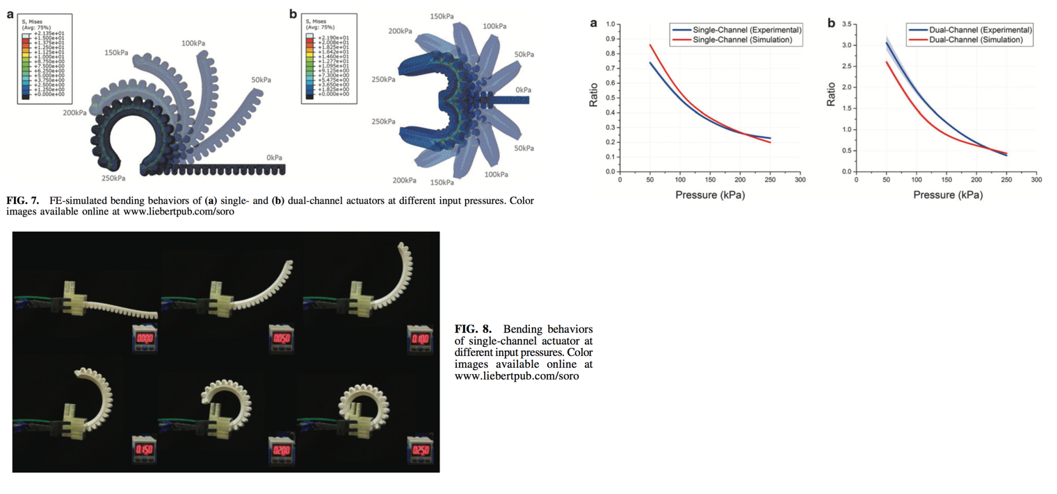 Figure 3.1.1: Bending behavior of the endoscope. (a) FEA results with different chamber pressure. (b) Snapshots of the real robot. (c) The relationship between chamber pressure and the bending curvature, for different preloaded pressure (and designs). (d) Bending coplanarity of the prototype. (e) Workspace of the prototype.
To evaluate the bending behavior

Stiffness analysis
- Fig. 3.2.1. Stiffness measurement setting.
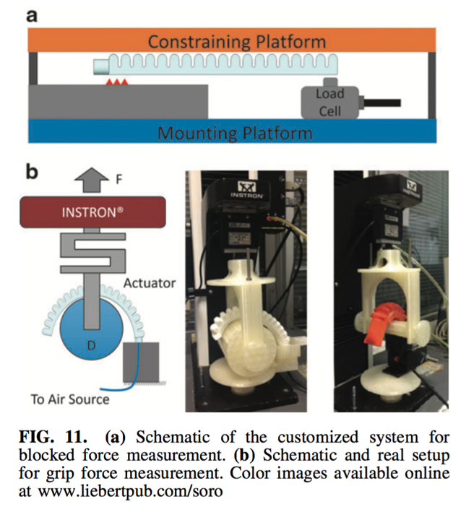 Figure 3.2.1: Stiffness measurement setting. The tip of the robot is connected to a pulling device with a force sensor. The robot is fixed to a platform. The platform is tilted to ensure the force is exerted perpendicular to the pointing direction.
- Fig. 3.2.2. Stiffness results
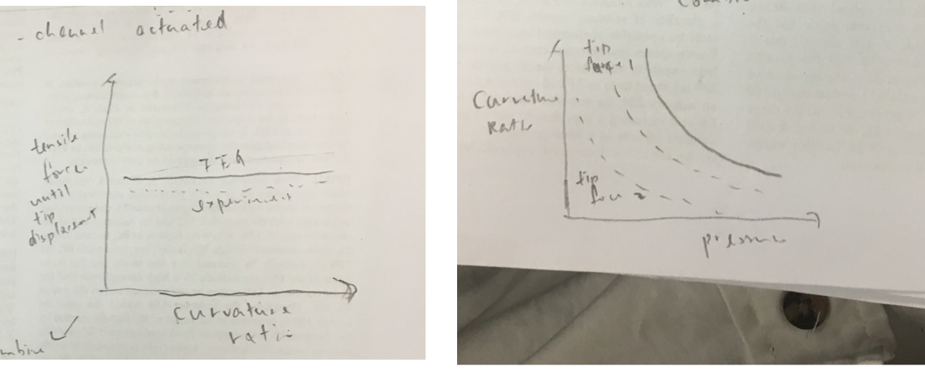 Figure 3.2.2: Stiffness of the protoype. (a) The min. force required to move the tip for Xmm vs curvature ratio, for different preloaded pressure (and design). This force indicates the stiffness of the prototype. (b) The maximum displacement of the tip when accelerating a biopsy forceps inserted in the central channel.

Dynamic response
- Fig. 3.3.1. Dynamic responses
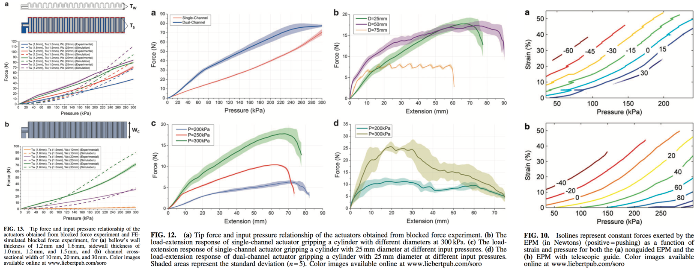 Figure 3.3.1: Dynamic response analysis. (a) The relationship of the tip force output and chamber pressure, for different preloaded pressure (and designs). (The tip force is measured while constraining the robot at 0 bending angle) Kinematics histories of the (b) step responses and (c) frequency responses of the robot.

Limits
- Fig. 3.4.1. Prototype limits
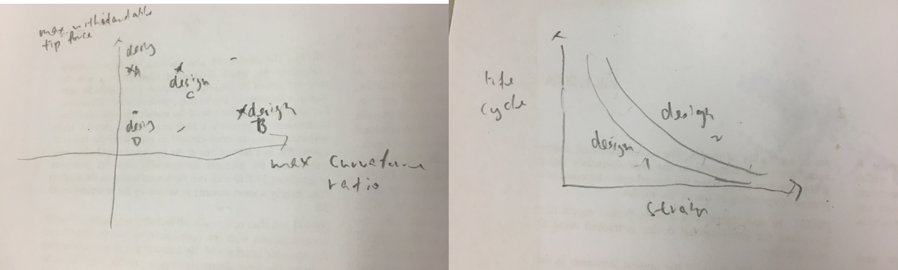 Figure 3.4.1: Performance limits of the prototype for different preloaded pressure (and designs). (a) Stiffness vs max. curvature ratio. (b) Life cycle.

Discussion
- Fig. 3.5.1. Demonstration of basic endoscopic procedure
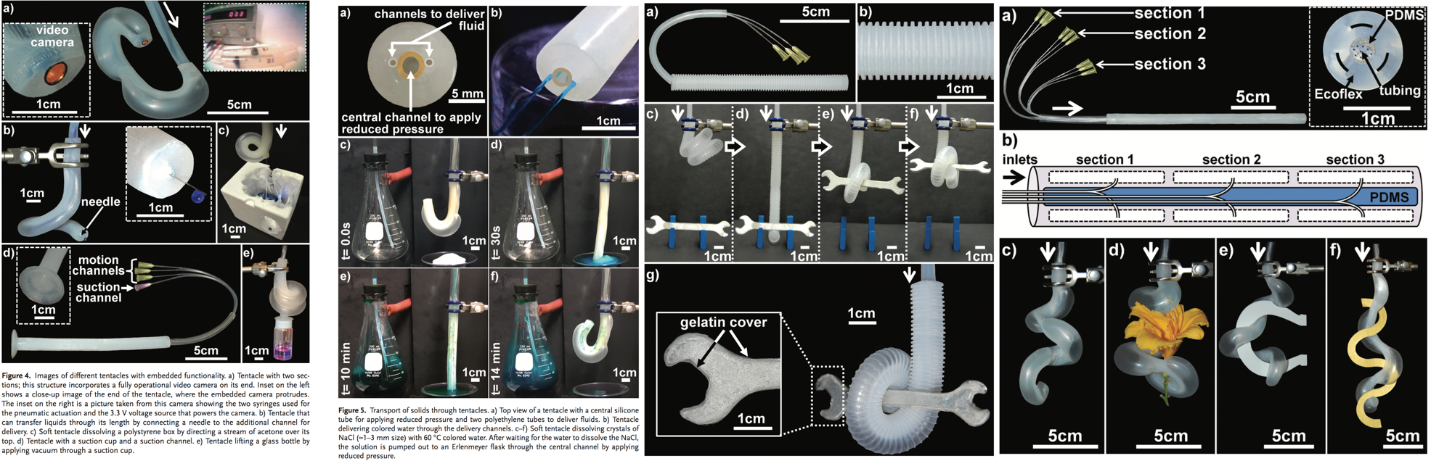 Figure 3.5.1: Basic functions of the prototype. (a) Endoscopic view when performing a biopsy task inside a phantom model. (b) Suction and (c) Irrigation of colored liquid. The demonstrations can also be found in the provided videos.
- comparison to results in literature
- discuss some advantages in the endoscopy procedure

Conclusion
- summary
- future work

