Project Title: Website for a Studio and Gift Shop

Client Shop: Lucky Digital Studio and Gift Shops

1. **Contents**
2. Certificate of the organization
3. Introduction
4. Objectives
5. Proposed / Existing system
6. System Requirements
7. How modules are divided by the team
8. ER / DFD diagram of the project.

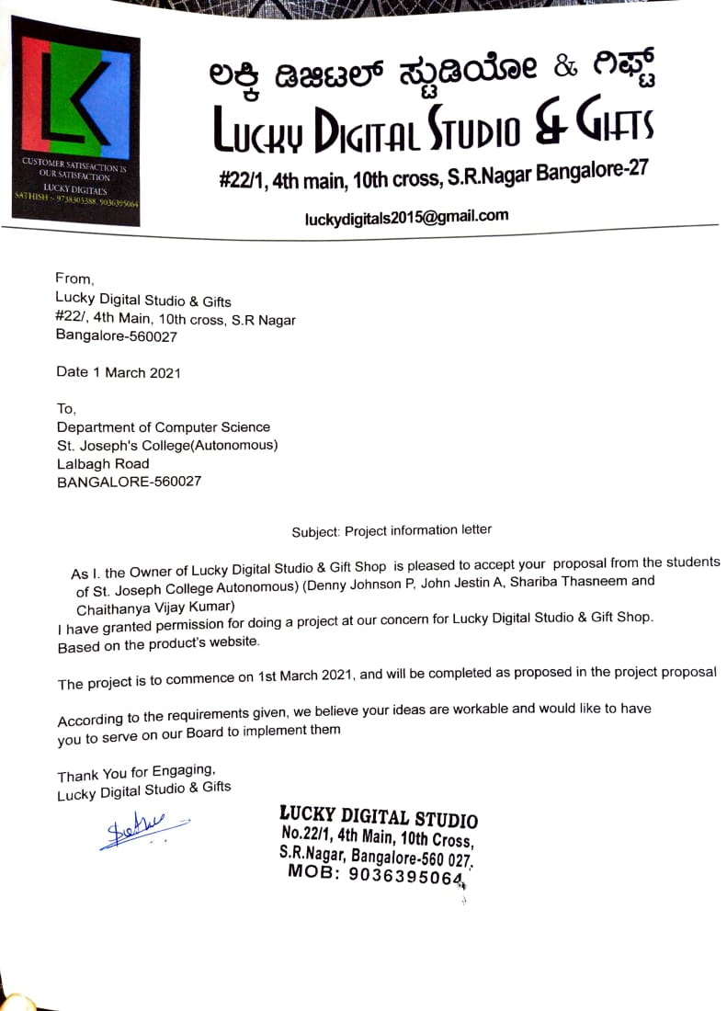

1. **Introduction**

If anyone looking forward to making beautiful movements towards best photograph framework then you are at the right spot.

This website is to visualize how making your beautiful movements into perfect memories into a high-quality HD image. This website helps people to choose what kind of shoots they want what kind of gift they want to gift their loved ones.

This website is mainly focused on placing an order through the site by signing in. It can be a Shoot or any products in the shop. Customers Information are saved in backend and used for placing order.

1. **Objectives**

1. A person Should be able to view all the products available in the Store with or without signing in.

2. To able to place order by Signing In

3. The main objective of this website is to view products or place order where ever they are in Bangalore so that they get the product at their door step.

1. **Proposed System**

This website doesn’t have any existing System. In Proposed System the admin will maintain a wide range of products at affordable prices for customers and it makes easier for those who buy in the products.

1. **System Requirements**

**Software Requirements**

Front end: HTML, CSS, Django

User Interface:

Back end: SQL

**Hardware Requirements:**

Processor: Minimum 1 GHz; Recommended 2GHz or more

Ethernet connection (LAN) OR a wireless adapter (Wi-Fi)

Hard Drive: Minimum 32 GB; Recommended 64 GB or more

Memory (RAM): Minimum 1 GB; Recommended 4 GB or above

**6.How modules are divided by the team**

Front end:

Home Page- Denny Johnson P

Portfolio – John Jestin A

Contact us – Shariba Thasneem

About Us – Chaithanya Vijay Kumar

Back End:

Contact us - Shariba Thasneem

Shopping Page – Denny Johnson P & John Jestin A

Login Page - Shariba Thasneem & Chaithanya Vijay Kumar

**7. ER / DFD diagram of the project.**

