**Fall Training Conference 2017: Sergeant-At-Arms Handbook**

# Introduction

Hello to all my lovely SAA volunteers!

My name is Josephine Molina, your Sergeant-At-Arms Chair for this year’s Fall Training Conference, and I am so excited to welcome you to the SAA Committee! As an SAA, you will play a very important role by ensuring that FTC is a smooth, safe, and spectacular experience for all attendees. On behalf of myself and the entire CNH District, we would like to thank you for volunteering to make sure that this year’s Fall Training Conference is successful.

In this handbook, you will find lots of information about your responsibilities as an SAA, specific duties regarding various shifts, important rules to keep in mind, and much more! This handbook will be your go-to resource during your time as an SAA, so I would strongly encourage you to read through the information thoroughly and completely so that you are familiar with the expectations of your role. Of course, if there is anything that you have questions about or need clarification on, you can always reach out to me, and I will be glad to help you.

Again, thank you so much for offering your service and leadership to the district!

~ **S-U-P-E-R**, a superstar is what you are! ~

Talk to you all very soon!

Sincerely,

Josephine Molina

Fall Training Conference 2017 Sergeant-At-Arms Chair

E-mail: [ftc.saachair@gmail.com](mailto:ftc.saachair@gmail.com)

# General Overview of SAA Duties

As an SAA volunteer, you will all be responsible for carrying out the same general tasks during your shift:

* Knowing and enforcing the **Code of Conduct** and the **Old Oak Ranch Camp Guidelines**, making sure that all attendees abide by the rules at all times
* Answering questions and guiding attendees to where they need to be
* Offering assistance to members in any way you can and know how
* Fostering a safe environment for everyone
* Remaining positive and friendly to everyone you meet!

## **Circle K Code of Conduct**

The following Code of Conduct has been established to make Fall Training Conference as safe and enjoyable for all attendees and will be in effect during the entire event. The following is an excerpt of the Circle K International Policy Code and adopted by the District Board of Officers:

1. No drugs of any nature (with the exception of prescribed medication) will be permitted in the possession of anyone in attendance.
2. The International Alcohol Policy will be enforced at all times during this event, and throughout the travel to and from the event.
3. There is no curfew hour. However, in consideration of other attendees, Circle K members must be in their cabins, with closed doors by the Retirement Hour indicated on the event program. After Quiet Hours as designated on the event program, gatherings must be contained inside. Loud noises and disruptive behavior will not be tolerated. In deference to camp rules, men are not allowed in women’s cabins and women are not allowed in men’s cabins at any time.
4. Circle K District Staff members or their associates must make room or cabin assignment changes.
5. Smoking is prohibited at all general sessions, contests, workshops, and caucuses. Individuals who wish to smoke must do so in the designated areas of the camp.
6. Do not deface or destroy any property. Any damages will be paid for by the individuals responsible.
7. All Circle K members and guests are expected to conduct themselves as responsible, professional men and women and are required to attend all sessions and activities.
8. The appropriate dress code for men and women must be followed at all times as prescribed in the event program.
9. Every attendee will respect the authority of the Circle K District Administrator and the Sergeant-At-Arms Committee.
10. Infractions of the Code of Conduct will be reported to the District Board of Officers and the District Administrator. Appropriate actions will be taken for any infraction, including but not limited to the dismissal of any attendees from the event at the expense of the individual.
11. The Code of Conduct is in effect from the moment an attendee leaves home and until the moment he or she arrives home.

## **Old Oak Ranch Camp Guidelines**

1. Be where you are supposed to be when you are supposed to be there.
   1. All meals, meetings, and activities are mandatory.
   2. Stay in the camp boundaries at all times.
2. Respect other people and their belongings.
   1. No fighting or foul language.
   2. No stealing.
   3. No raiding of any kind.
      1. E.g. damaging, rearranging
3. No illegal items.
   1. Drugs, alcohol, cigarettes, weapons of any kind.
4. You break it, you buy it!
   1. All damage to camp property must be paid for prior to leaving the campsite.
   2. A fine of $500 will be imposed for graffiti.
5. No pillow fights.
6. Due to liability, skateboarding on campgrounds is allowed only in a designated skate area with proper safety equipment.
7. Respect the staff of the Old Oak Ranch. They do a fantastic job of accommodating us!
8. Men are not allowed in women’s cabins, and women are not allowed in men’s cabins, at any time.

# SAA Shifts

SAAs will be expected to work during...

* Registration & Sign-Ins
* Opening Session
* General Sessions
* Workshops
* Lunch / Dinner
* Campfire Skits
* Night Activities

## **SAA Shift Assignments**

Depending on what shift you have, you may be given additional duties:

* SAA Table
* Main Hall
* Cabin Patrol
* Independent Patrol
* Amphitheater

Please note: Your duties may be subject to change once assigned, so please make sure that you read through all the shift descriptions so that you are prepared for your job in case any changes are made.

### SAA Table

* Note: The SAA Chair will be stationed at the SAA Table with you
* There will be a total of 2 volunteers assigned to this duty each shift (except during lunch/dinner and campfire skits).
* At the SAA Table, you will:
  + Assist Main Hall SAAs in their duties
  + Assist the SAA Chair with checking SAAs in and out of their shifts
  + Answer questions/direct attendees
  + Distribute/collect medical notes from attendees
  + Help with Lost & Found
  + Take over the SAA Table if the SAA Chair is not present
  + Serve as a back-up SAA to fill in for any SAAs that do not show up for their shift, if needed

### Main Hall

* Main Hall SAAs will be stationed outside the main hall
* There will be a total of 2 volunteers assigned to this duty each shift.
* While on duty, you will:
  + Assist the SAA Chair when needed
  + Answer questions/direct attendees
  + Ensure attendees attend workshops and all other scheduled activities (unless excused by the SAA Chair and/or accompanied by a medical note)
  + Help to direct traffic if needed

### Cabin Patrol

* SAAs assigned to cabin patrol will be doing exactly that – patrolling the cabins! You will be told where to go before your shift.
* There will be a total of 4 volunteers assigned to this duty each shift. For shifts during lunch/dinner or night activities, there will be a total of 6 volunteers.
* While patrolling, you will:
  + Check cabins, making sure that members are only in there at appropriate times
  + Ensure guys and girls are not intermixing in cabins
  + Make sure attendees are following the schedule and are going to all programmed activities (unless excused by the SAA Chair and/or accompanied by a medical note)

### Independent Patrol

* SAAs assigned to independent patrol will be patrolling areas that are not covered by cabin patrol. This includes restrooms, amphitheater, around dining hall, basketball courts, etc.
* There will be a total of 2 volunteers assigned to this duty each shift (except during lunch/dinner).
* While patrolling, you will:
  + Assist Cabin Patrol SAAs when needed
  + Direct attendees (no one should be loitering)
  + Make sure attendees are following the schedule and are going to all programmed activities (unless excused by the SAA Chair and/or accompanied by a medical note)

### Amphitheater

* SAAs assigned to amphitheater will be overlooking attendees during campfire skits.
* There will be a total of 4 volunteers assigned to this duty during Campfire Skits.
* While on duty, you will:
  + Ensure that everyone arrives to the amphitheater safely
  + Direct traffic if needed
  + Guide members to where they need to go if they need to leave (restroom, main hall, etc.)
  + Make sure that campfire skits run smoothly and that attendees aren’t doing anything dangerous

## **Map**

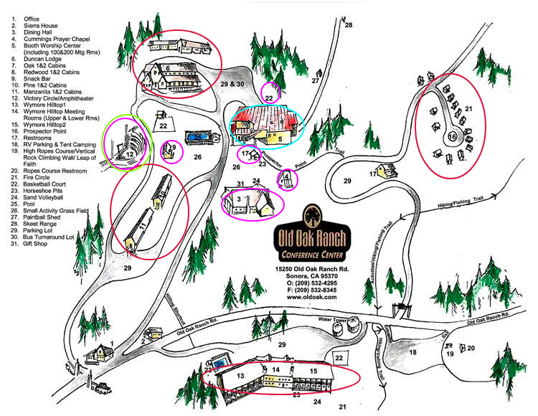

### Locations/Facilities

Depending on the shift, each SAA pair will be assigned to a specific location and will be responsible for monitoring that area for the duration of their shift.

SAA Table + Main Hall: Located in Booth Worship Center (5)

Cabin Patrol: Duncan Lodge (6), Oak 1&2 Cabins (7), Redwood 1&2 Cabins (8), Pine 1&2 Cabins (10), Manzanita 1&2 Cabins (11), Hilltop (13, 14, 15), Prospector Point (16)

Independent Patrol: Dining Hall (3), Cummings Prayer Chapel (4), Snack Bar (9), Amphitheater (12), Restrooms (17), Basketball Court (22), and nearby cabins

Amphitheater: Amphitheater (12)

# Violations

What should you do during a violation?

If the violation is **minor**, let the attendee(s) know and have them correct it. If there is no cooperation and the violation persists, take note of the name(s) of the those at fault as well as the club they belong to and notify the SAA Chair.

* Examples of minor violations: men and women intermixing in cabins, loud noises and disruptive behavior (especially after Quiet Hours)

If the violation is **major**, notify the SAA Chair *immediately*. If you are not near the SAA Chair at the moment, notify the closest District Board Officer or FTC Committee Member. If possible, take note of the name and school of those at fault.

* Examples of major violations: possession or consumption of alcohol or illegal substances, defacing of property, physical altercations

# Emergencies

What should you do if you encounter a medical emergency or incident?

Immediately notify the SAA Chair, or the closest District Board member or FTC Committee Member.

What should you do if there is a natural disaster?

Wait for instructions from the SAA Chair, FTC Committee, or District Board, and help direct and instruct attendees with proper precautions.

# Additional Notes

## **Do’s and Don’ts of SAAing**

Do’s:

1. Be prepared. Make sure you know all rules, responsibilities, and duties before your shift.
2. Wear your proper uniform (SAA Vest).
3. Be punctual and arrive 5 minutes before the start of your shift. If you miss your shift, show up at the SAA Table and you will be added into another shift.
4. Be polite, courteous, and respectful to all attendees. If someone is rude to you, remain calm and notify the SAA Chair.
5. Bring campsite map and be aware of the campsite locations.
6. Always make an effort to lend a helping hand to people. Intentionally look for people that seem lost or need help and ask them if they need any assistance.
7. Stay with your SAA Buddy at all times!!!
8. Be alert and focused.
9. Have fun!!

Don’ts:

1. Do not leave your post unless permitted by the SAA Chair. Always stay within the general area you were assigned.
2. Do not walk in the dark without a flashlight.
3. Do not get distracted in unnecessary conversation while on duty.
4. Do not listen to music while on duty.
5. Do not sleep on duty.
6. Do not loiter.
7. In case of emergency, don’t panic. Remember to stay calm and notify someone (SAA Chair/FTC Committee Member/District Board Member) immediately!

## **Important Reminders**

Prior to your shift, you are required to attend a training session. This is to ensure that you are prepared to fulfill your duties and any questions you have. There will be two on-site trainings. You must choose between one of the two to attend. For those with SAA shifts on Friday, you must attend the Friday session.

Friday, November 3 // 8:00 - 8:30 PM // Location: FC 200

Saturday, November 4 // 8:45 - 9:00 AM // Location: FC 200

How to check in:

* Please check in at the SAA Table 5 minutes prior to the start of your shift.
* Once you check in, I will give you and your partner a quick debrief about where you will be assigned and what you will be doing.
* What you will get at check in:
  + SAA Vest
  + Flashlight (if volunteering at night)
  + Campsite Map (in case you don’t have your program with you, but make sure to bring it with you upon checking in!)

How to check out:

* After your shift is over, please check out at the SAA Table.
* Receive your SAA Appreciation Gift!

**CONGRATS!**

You have reached the end of this handbook.

If you have any questions about anything, please don’t hesitate to contact me.

Thank you so much for your commitment to making Fall Training Conference an amazing experience for all <3