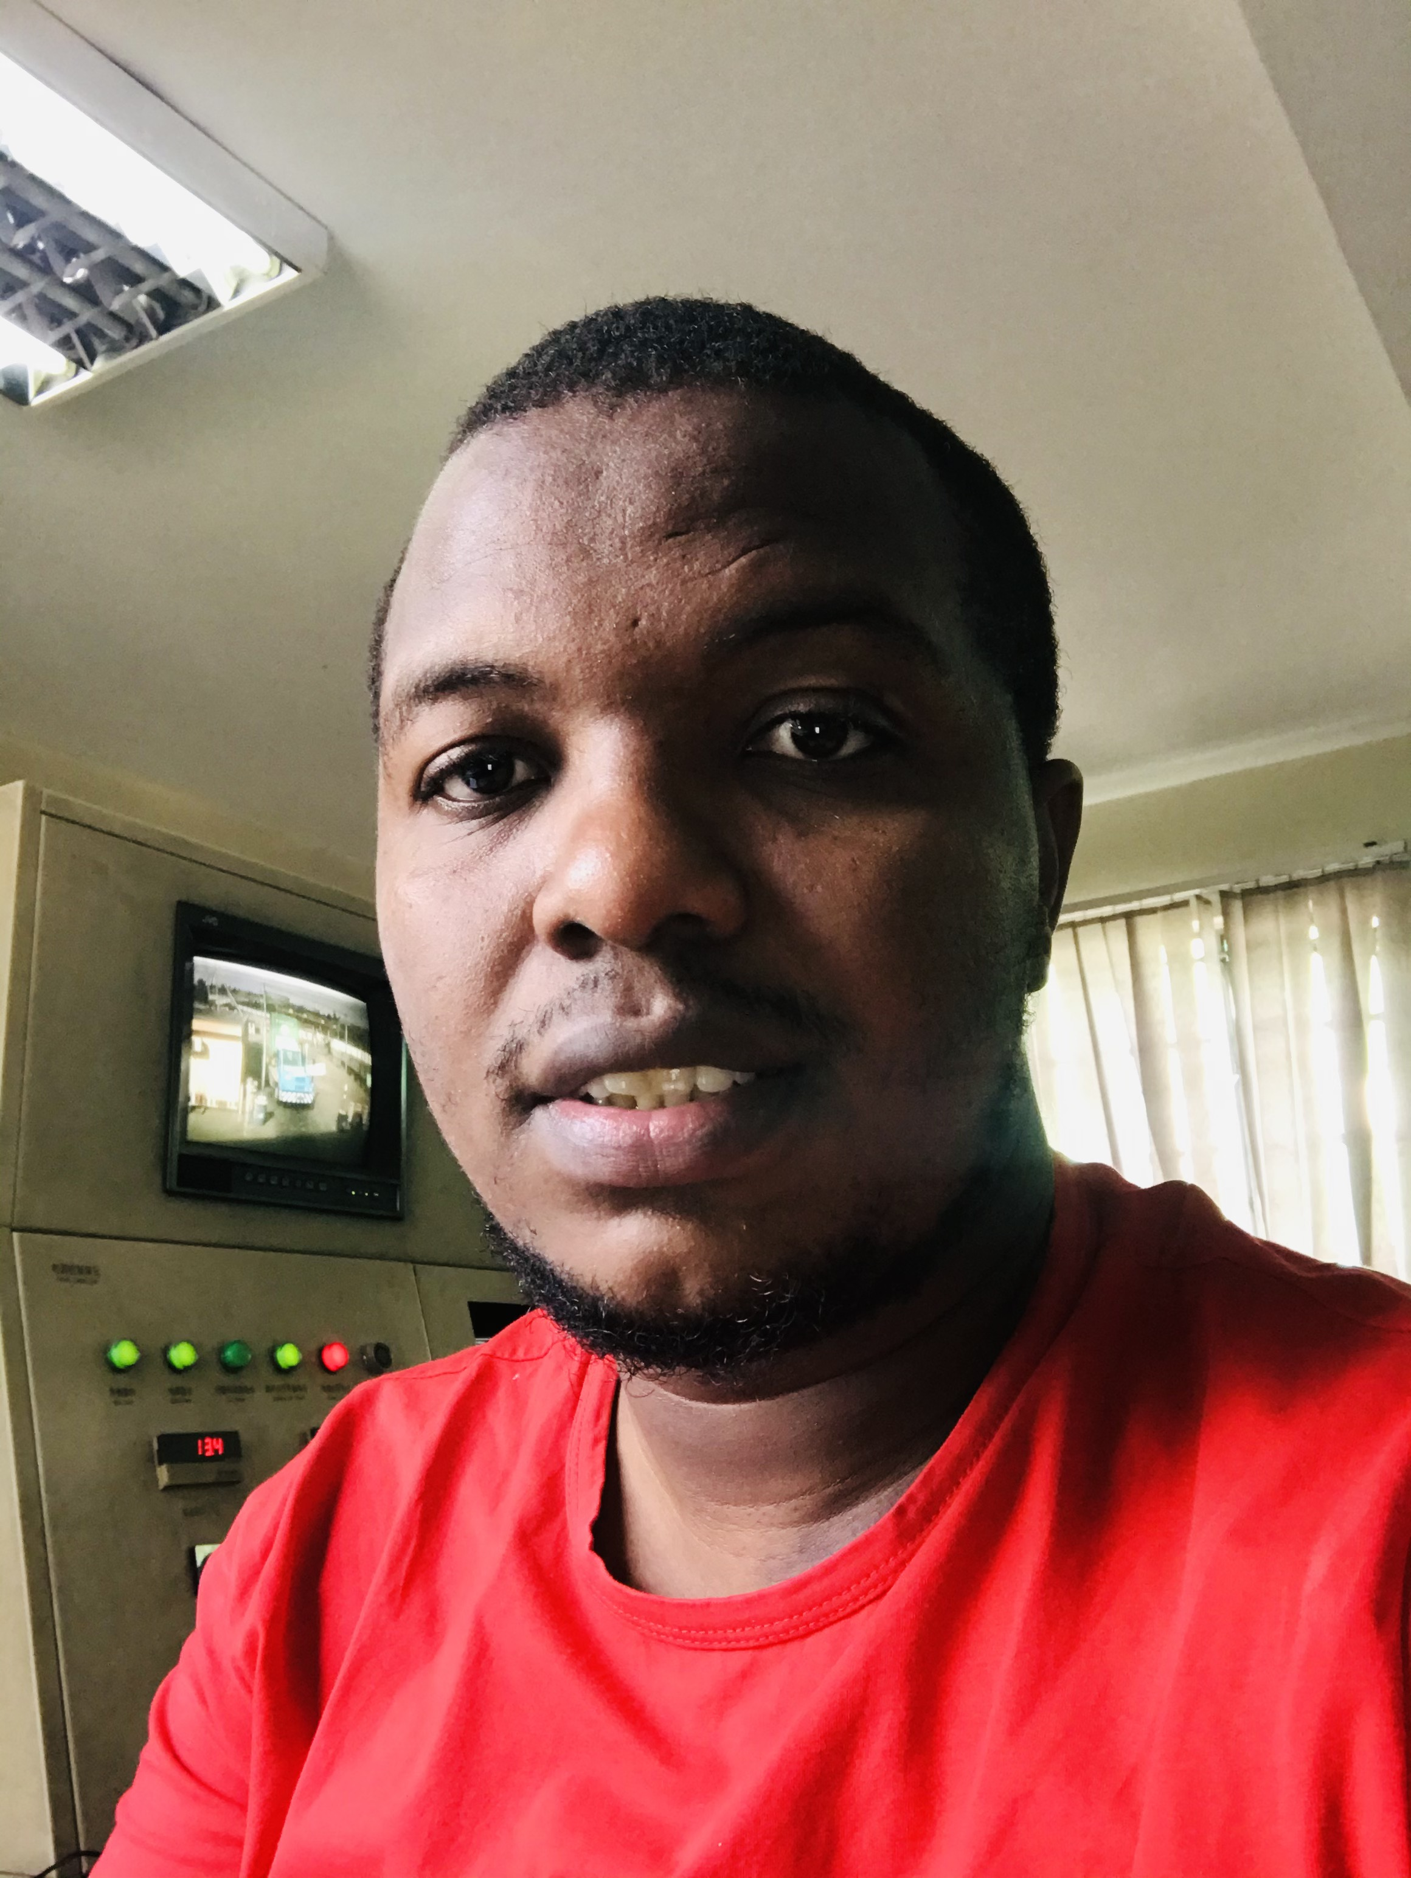

Dennis | /Library/Frameworks/Python.framework/Versions/3.9/bin/python3 /Users/denogwaro/Desktop/learning-python/my_app.py | /Library/Frameworks/Python.framework/Versions/3.9/bin/python3 /Users/denogwaro/Desktop/learning-python/my_app.py

# About me

/Library/Frameworks/Python.framework/Versions/3.9/bin/python3 /Users/denogwaro/Desktop/learning-python/my_app.py

# Work Experience

**/Library/Frameworks/Python.framework/Versions/3.9/bin/python3 /Users/denogwaro/Desktop/learning-python/my_app.py** */Library/Frameworks/Python.framework/Versions/3.9/bin/python3 /Users/denogwaro/Desktop/learning-python/my_app.py - /Library/Frameworks/Python.framework/Versions/3.9/bin/python3 /Users/denogwaro/Desktop/learning-python/my_app.py*/Library/Frameworks/Python.framework/Versions/3.9/bin/python3 /Users/denogwaro/Desktop/learning-python/my_app.py