jQuery

**DEADLINE:** 14/07/2021

## FOLDER STRUCTURE

|  |  |
| --- | --- |
| FL16_HW8/ *  ├─ task  ├─ homework/ *  ├─ js/ *  ├─ index.js *  ├─ jquery-3.6.0.min.js *  ├─ css/ *  ├─ style.css *  ├─ index.html * | *  - required |

## TASK

1. Create simple calculator and logs block.
2. Calculator should contain:

* Screen block (default value equals 0)
* Numbers and operators block

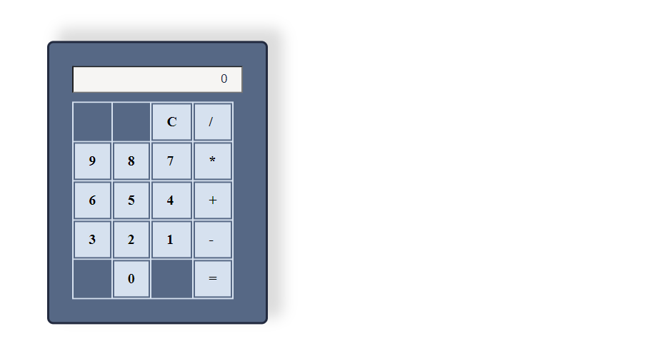

1. Main calculator features:

* Numbers should be displayed on screen when you click on number button.

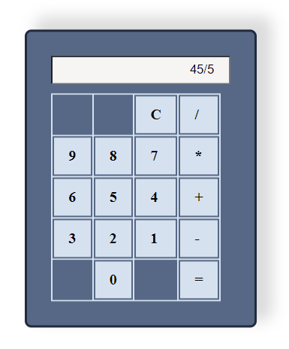

* When you select one operator, then another, the second one should replace first one on the screen.
* When you try to divide on 0, the ‘ERROR’ should be displayed on screen.

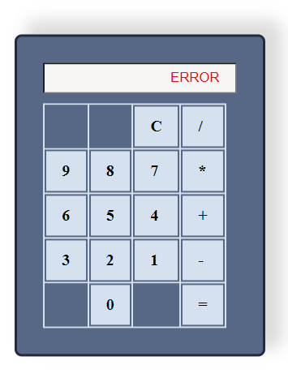

* When you click on ‘C’ – you need to clear screen to default value.
* When you click on ‘=’ – you need to display result on screen and show equation in logs block.

1. Main logs block features:

* Logs line contains empty circle, equation and close sign.

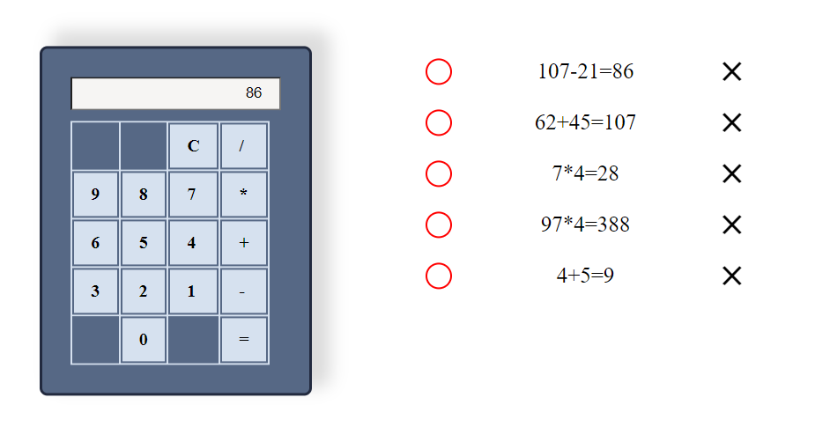

* When you hover on circle or close icon they should be red color.
* When there are too many logs you should show scroll. 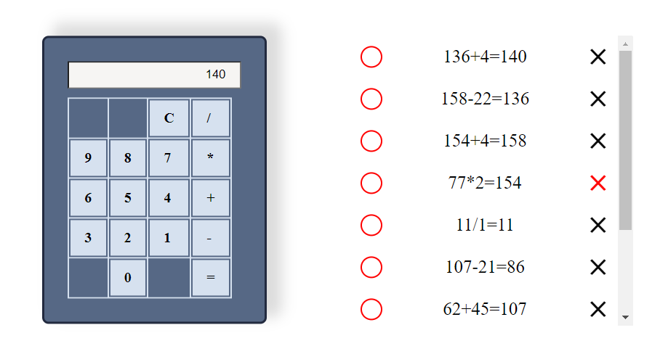
* You should show Scroll Top value in the console only while scrolling logs block.

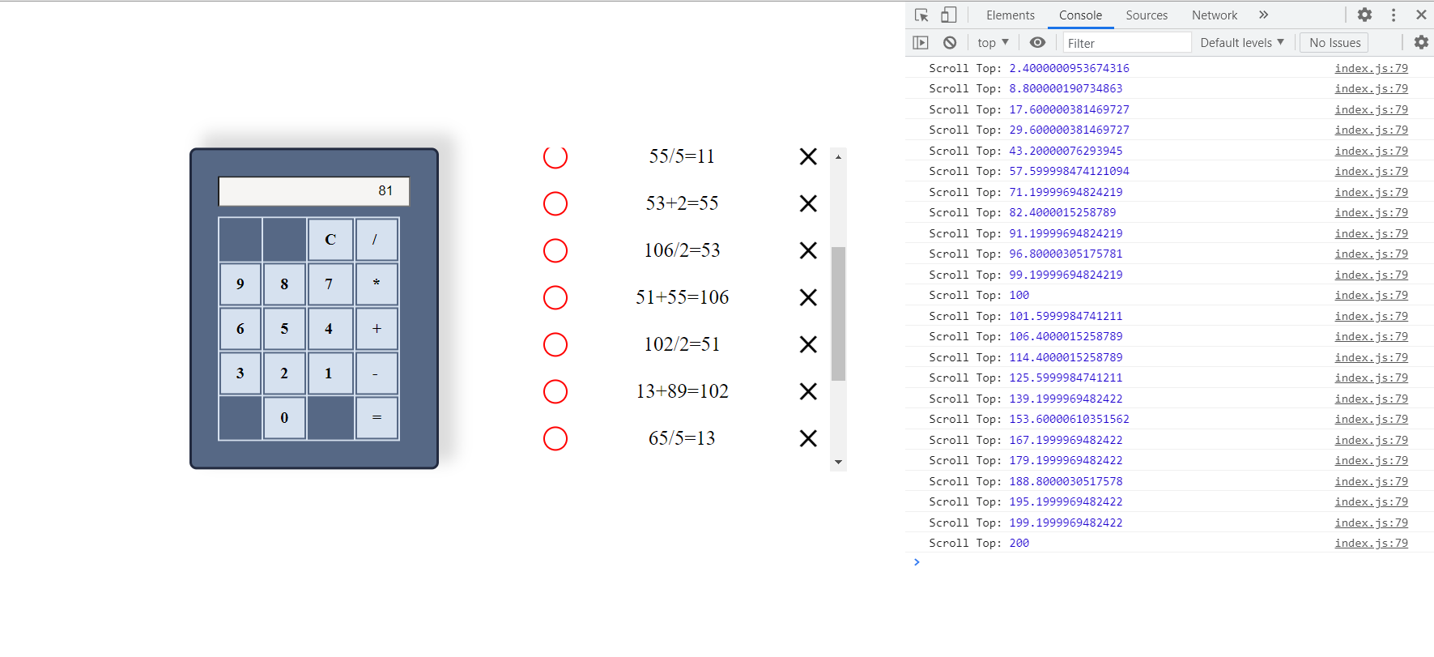

* When clicking on circle you should toggle its color

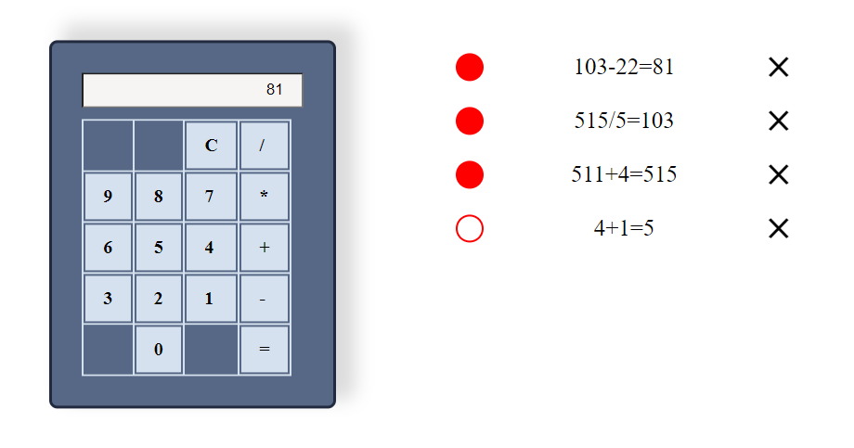

* Add filter in logs: when equation contains ‘48’ – underline it.

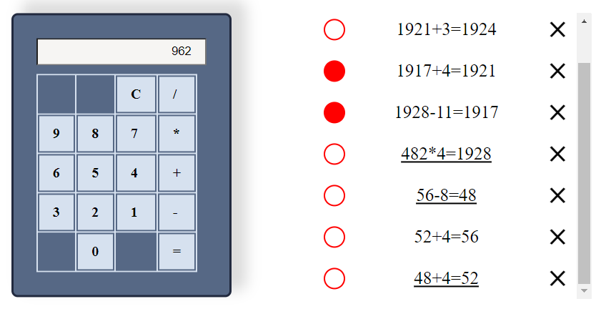

* When you receive ‘ERROR’ on screen, you should not display the equation in logs block.
* When you click on close icon you should remove log

1. You have to use at least once such methods:

* toggleClass
* css
* prepand

**RESTRICTIONS**

* Adding **task/** folder is forbidden. Do not push it to repository. (Only **homework/** folder should be pushed)
* Do not use any external libraries

## BEFORE SUBMIT

* Code should be clean, without comments, readable, and tested
* Make sure your GitLab folder structure meets folder structure from this document (without **task** folder)

## SUBMIT

* The **FL16_HW8** folder without **task** folder should be uploaded to GitLab repository “**FL-16**” into **master** branch.