EMAIL ATTACK DEFENCE
Staff Training Booklet for Dental Practices
How to recognise and survive the “shared folder” phishing attack currently spreading between Australian dental clinics
Practice: ______________________________ Date: ______________
Review with all staff — including reception and casual staff — and keep a copy at the front desk.

1. The attack, in plain English
Since mid-2026, a criminal group has been working through the Australian dental industry using a simple trick: they hack one clinic's email account, then send phishing emails from that real account to every clinic it has ever corresponded with.
That means the dangerous email comes from a real colleague's real email address. It is not “spoofed” — it passes every technical check, and your spam filter will usually let it straight through. The only reliable defence is a human who recognises the pattern.

What the email looks like
- It appears to come from a dentist, practice or lab you genuinely know.
- It says they have “shared a folder” or “shared files/documents” with you.
- There is no attachment — just a link to click.
- The link uses a made-up but pronounceable name on an odd web address ending such as .vu — e.g. avernix.vu/access, uvanv.vu, xornavo.vu/file (a NEW domain is used for every wave, so never rely on recognising an old one).
- It often asks you to open the link on a desktop or laptop, not your phone. That instruction is there because the malware only runs on Windows PCs — it is one of the strongest red flags.
- It often arrives at a strange hour — very early in the morning (3–6am) is common, because the attackers operate from overseas. No legitimate clinic shares referral documents with you at 3am.

What it looks like — real example (link disabled)
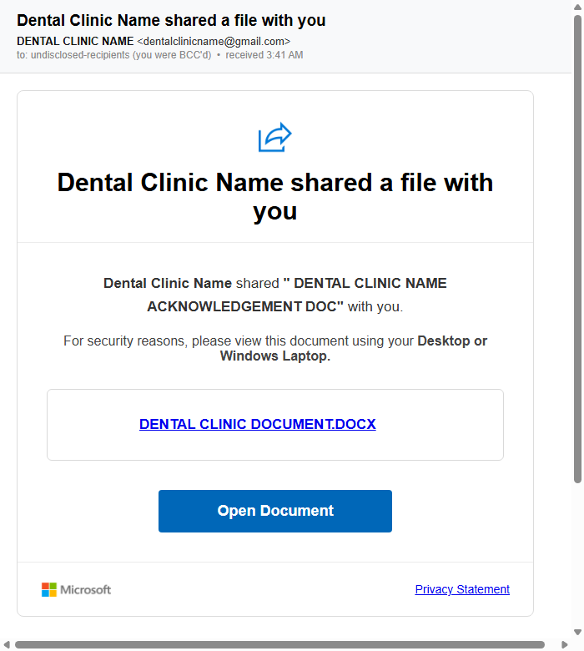
An actual email from this campaign (July 2026), sent from a real dental practice's hacked account. Every wave looks almost identical to this — same fake Microsoft card, same “Open Document” button, same “Desktop or Windows Laptop” instruction. Only the practice name and the link change.

What happens if someone clicks
The link downloads remote-control software. While it installs, the screen shows a fake “Windows Update” so the user waits patiently instead of getting suspicious. After that, a real human attacker can operate the computer remotely — reading email, stealing saved passwords and banking details, and sending the same phishing email to every practice in the address book. They typically return for further access over the following weeks.
Important: Link-scanning tools can say these links are “clean”. The attackers deliberately show scanners a harmless decoy page. A clean scan result means nothing for this campaign.

2. Red flags — quick reference
If an email ticks ANY of these boxes, stop and verify before clicking:
☐ “Shared a folder / shared files with you” from a colleague — especially unexpected.
☐ A link whose address you don't recognise, or ends in something unusual like .vu
☐ Instructions to open it on a computer / desktop / laptop, or “not on mobile”.
☐ A link only, no attachment, and vague wording (“please review the documents”).
☐ You were not addressed by name, or other recipients seem hidden (BCC / “undisclosed recipients”).
☐ It arrived at an odd hour — e.g. 3am–6am. Real clinics don't share documents in the middle of the night; overseas attackers do.
☐ Any pressure or urgency (“before end of day”, “access expires”).

The golden rule
VERIFY BY PHONE. Before opening any shared-file link — even from someone you trust — ring the sender on their known number and ask “did you send me this?”. If their account is hacked, they usually have no idea. A 30-second phone call is the entire defence. Do not reply by email to check: the attacker controls that mailbox and will happily answer “yes it's safe”.

Never do these
- Never click a share link “just to see what it is”. Looking is how it starts.
- Never enter your email password on a page a link took you to.
- Never assume “it's fine, I know this person”. Knowing the person is exactly what the attack exploits.

Monthly sweep: find these emails before anyone clicks
Once a month (and any time a colleague warns you), have one person search the practice mailbox — All Mail, not just the inbox — for:
“shared a file with you” OR “shared a folder with you” OR “shared a file for you”
The same phrase search works in Gmail and Outlook. If anything matches the pattern in this booklet, do NOT click it. Ask every staff member out loud, no blame: Did anyone open this link on any computer? Has any PC shown a strange “Windows Update” screen, a mouse moving by itself, or run hot while idle? Has a colleague asked about an email we don’t remember sending? Nobody opened it → save the email as evidence (Gmail: ⋮ → Download message), report it, delete it. Opened but nothing ran → change the email password and enable 2FA from a different device, and audit mail rules. Something ran or symptoms → treat the machine as infected and follow section 3. A printable one-page flowchart of this sweep is on the Phish Watch site under Resources.

A note for referrers, labs and specialists
When sending documents between practices, attach the file to the email (or use a secure clinical messaging platform such as Medical-Objects or HealthLink) rather than a “click here to download” link to an outside website. Attachments from a known sender that you can see and open directly are much harder to fake convincingly than a link, and if everyone in your referral network follows this convention, any “download my document from this site” email instantly stands out as suspicious. (Attachments aren't risk-free either — an unexpected attachment that asks you to “enable editing” or “enable macros” is its own red flag — but a plain PDF attached to a referral is the normal, expected pattern.)

3. If you clicked — do this immediately
No blame, no cover-ups: the practice can only defend itself if you speak up straight away. Minutes matter.

First five minutes
- Unplug the network cable / turn off Wi-Fi on that computer immediately. Do not keep using it.
- Tell the practice owner or manager right now — even if nothing seemed to happen. A fake “Windows Update” screen, a brief flash, or “the page didn't load” all still count.
- Do not type any passwords on that machine, and do not just restart it and carry on.

For the owner / manager — the recovery checklist
☐ Treat the PC as compromised: it must be wiped and Windows reinstalled. Antivirus “cleaning” is not sufficient against hands-on remote access.
☐ From a DIFFERENT clean device: change the email account password, enable two-factor authentication, and sign out all sessions.
☐ Audit the mailbox: look for forwarding rules, filters and auto-replies you didn't create; confirm recovery email/phone are unchanged; review connected third-party apps.
☐ Assume every password saved in that PC's browser is stolen. Change them all — banking first, then Medicare/PRODA, HICAPS, practice management, supplier portals.
☐ If bank/card details were saved or used on that machine, phone the bank and watch statements.
☐ Warn your contacts that emails from your address may be malicious — they are the next targets.
☐ Patient data: if patient records may have been accessed, contact your indemnity provider — the Notifiable Data Breaches scheme (OAIC) may require notifying patients.
☐ Report to the ACSC at cyber.gov.au/report, and tell your IT provider you require: reimaging, mailbox-rule audit, MFA enforcement, and a sign-in log review — in writing.

4. For practice owners — harden the practice
Staff awareness is the front line, but these one-time technical settings make a click far less catastrophic. Ask your IT provider for each item BY NAME and get written confirmation it's done. None of this is exotic — it is standard, mostly free, and a competent provider can do the lot in an afternoon.

The two that matter most
- 1. Two-factor authentication (2FA/MFA) on every email account, enforced. This is the single control that stops your mailbox being taken over and used to attack every clinic you know. Non-negotiable.
- 2. Staff log in as Standard users, never Administrator. A standard Windows account cannot install software — which blocks most of these payloads outright. Keep one separate admin account for IT use only. This is the practical answer to “disable installation of files”.

Locking down the computers
- Application control: on Windows 11, enable Smart App Control (requires a clean install); on Windows Pro, ask IT for AppLocker or WDAC policies that only allow approved programs to run. This is the strong version of blocking installs — unknown programs simply won't start.
- Ask IT to enable Microsoft Defender Attack Surface Reduction (ASR) rules — free, built into Windows, and specifically designed to block this style of attack (e.g. blocking downloaded scripts and untrusted executables).
- Restricting cmd/PowerShell for staff accounts (via Group Policy on Windows Pro) is worth doing, but know its limits: this malware installs via a downloaded program, not by staff opening a command prompt. Standard-user accounts + application control give far more protection than hiding cmd.
- Block risky web addresses at the practice router/DNS: point DNS to a filtering service (e.g. Quad9 9.9.9.9, or Cloudflare 1.1.1.2) so known-malicious domains fail to load on every device, on every browser, with nothing to install.

Email and accounts
- Ask IT to add a mail rule that quarantines or tags emails containing links to high-risk domain endings such as .vu (Microsoft 365 mail-flow rule or Google Workspace content compliance rule).
- Turn on the “external sender” banner so staff instantly see when mail is from outside the practice.
- Don't run the whole practice through one shared mailbox if you can avoid it — one account compromised should not mean everything compromised.
- Ban saving banking passwords in the browser on practice machines; use a proper password manager.

Resilience
- Backups: automatic, tested, with at least one copy offline or in cloud storage the practice PCs can't overwrite. Assume ransomware is the attacker's endgame.
- Check whether your practice insurance / indemnity includes cyber incident response — know who you'd call before you need them.
- Run this booklet as a 15-minute team meeting twice a year, and every time a new staff member starts.

5. Pin this up: the one-page version
THE PATTERN: Real colleague's address + “shared a file/folder” + strange link (e.g. ending .vu) + “open on a computer” + often sent at 3am = ATTACK. New web address every wave; the pattern stays the same.

Three rules for everyone
- Unexpected share link? PHONE the sender before clicking. Always.
- Never open share links on a practice PC because the email told you to use a computer.
- Clicked something? Unplug from the network and tell the manager IMMEDIATELY. No blame.

Owner's minimum standard
- 2FA enforced on all email accounts.
- Staff use standard (non-admin) Windows accounts — installs blocked.
- Application control (Smart App Control / AppLocker) + Defender ASR rules on.
- DNS filtering on the router; mail rule tagging risky links.
- Tested backups the PCs can't overwrite.
Report incidents: cyber.gov.au/report (ACSC) | Scams: scamwatch.gov.au | Patient data breaches: oaic.gov.au

