Contents
Parts 2
Parts List 2
Wiring 2
Notes 3
Circuits 6
Basics 6
Buzzer Circuit 6
DHT11 Sensor Circuit 7
LED Circuit 7
Setup 9
Install Raspbian 9
Connect to WiFi 9
Update Software 10
Set Up Secure Shell (Optional) 11
Command Line Cheat Sheet 12
Directory navigation 12
File and directory commands 12
Networking 13
Python commands 13
General 13
Git commands 13
Examples 14
Learning More 15
Computer Science 15
Electronics 15
HTML and CSS 16
Javascript 16
Linux 17
Python 18
Raspberry Pi 18

Parts

Parts List
- Raspberry Pi Zero W
- DHT11 analog temperature & humidity sensor
- Red LED
- 200Ω resistor
- 1KΩ resistor
- 5V passive piezo buzzer
- NPN Transistor
- Breadboard
- Wiring

Wiring
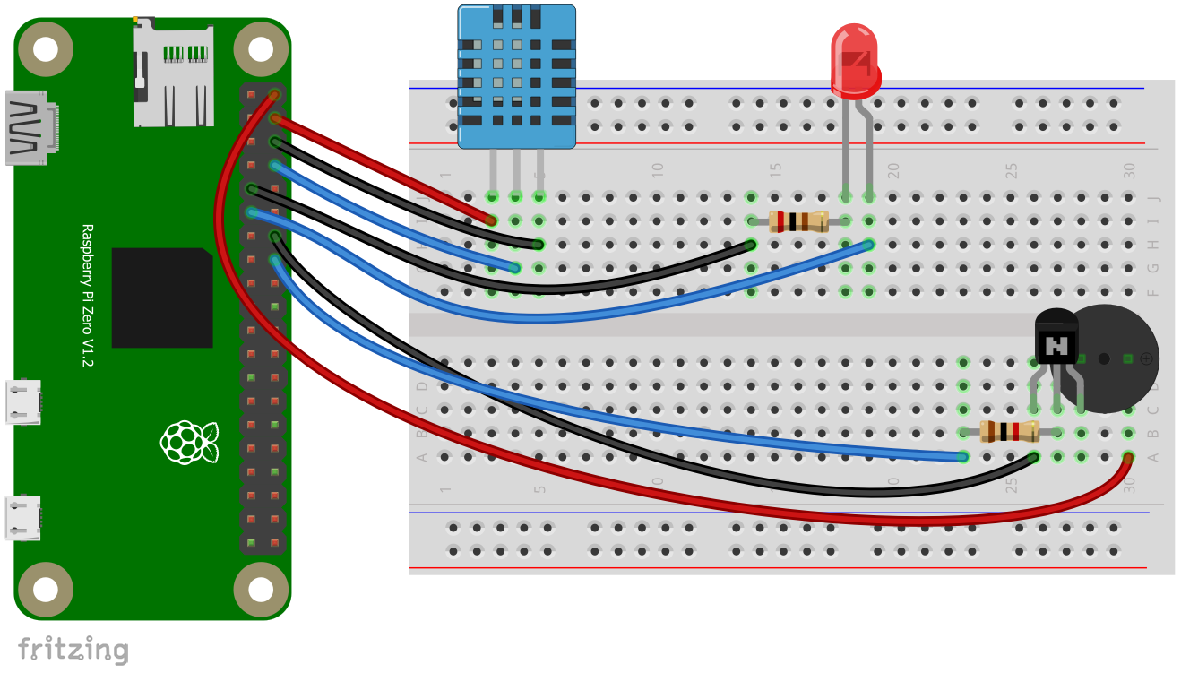

Notes
- LEDs are polarity-sensitive, electricity can only flow through them in one direction. The current flows from the negative (cathode) side to the positive (anode) side. If you wire the LED backwards it will simply not light up. The negative, cathode, pin will be the shorter pin on the LED and also the pin nearest the flat edge of the outer casing.
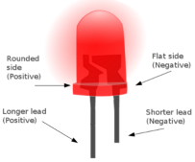
- The piezo buzzer is also polarity-sensitive. A small plus (+) symbol is engraved in the plastic over the positive pin.
- The NPN Transistor has three pins, known as the base, collector, and emitter pins. The pins can be determined by noticing the flat end of the outer casing and referencing the datasheet for the component:
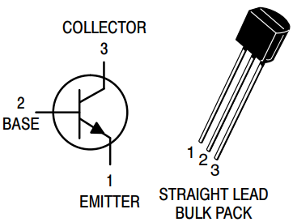
- Resistors are color coded to identify their value. Each color represents a digit, multiplier, and tolerance. The resistors used use the colors red, black, brown, and gold.
Color | Digit | Multiplier | Tolerance (%)
Black | 0 | 10^0 (1)
Brown | 1 | 10^1 (10) | 1
Red | 2 | 10^2 (100) | 2
Gold |  | 10^-1 (0.1) | 5
The first two colors indicate the value, multiplied by the third color multiplier, and the resistor has a tolerance indicated by the fourth color. The two resistors used are:

Red | Black | Brown | Gold
2 | 0 | 10 | 5
20 * 10 (200) with a 5% tolerance

Brown | Black | Red | Gold
1 | 0 | 100 | 5
10 * 100 (1000) with a 5% tolerance

Circuits

Basics
Electricity is the flow of electrons through a conductor, free electrons flow from one atom to the next. There are three primary parameters to keep in mind with electricity: pressure, current, and resistance. Electricity flowing through wires is similar to a closed system of water pipes with a pump pushing the water. If the pump creates a difference in pressure between two points in the pipes, then water will flow from one point to the other. This flowing water is able to do work (such as turning a waterwheel).
Electric pressure, or electric potential difference, is measured in volts. The actual flow of electric charge is known as electric current and is measured in amps. Anything that resists the flow of the electric current provides resistance, which is measured in ohms.
The relationship between the potential difference (volts), current (amps), and resistance (ohms) is a well known mathematical equation knows as Ohm's law.
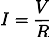
Where I is current (amps), V is potential difference (volts), and R is resistance (ohms). This means that if you increase the resistance in a circuit, while keeping the same voltage, it will lower the current. If you increase only the voltage, it will increase the current. Etc.
Each of the major functions of the weather station consists of a separate circuit, connected to different pins of the Raspberry Pi.

Buzzer Circuit
The buzzer circuit is a simple one-transistor audio amplifier. The Raspberry Pi provides 5 volts of electricity and 1.5 amps of current to the buzzer. Sound volume is controlled primarily by current. The 1.5 amps from the Pi directly is not enough to make the buzzer very loud. Because of this, we add a transistor. A transistor consists of a collector and emitter. The flow of electricity through these is controlled by the base. When electric current is applied to the base (at a higher voltage then the emitter), it allows current to flow through the collector and emitter. The actual current through the transistor is a ratio of the currents between the collector and emitter, and to the base.
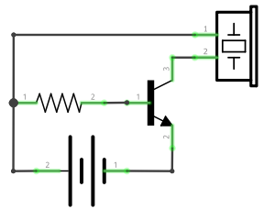
To ensure that the voltage (or specifically the electric potential difference) to the base of the transistor is higher, we put a resistor there. The transistor amplifies the signal passing through the collector to the emitter (in our case per the transistor's data sheet by a factor of at least 60) and makes the buzzer louder.

DHT11 Sensor Circuit
The DHT11 sensor circuit is very simple, as most of the components are packaged together into a small module. The power, ground, and data pins merely need to be connected to the appropriate pins on the Raspberry Pi. Note that it is important to connect the pins properly, as the sensor circuit could overheat and possibly melt if wired incorrectly.

LED Circuit
The LED circuit consists of a light-emitting diode and a resistor. A diode is a component that only allows electric current in one direction. LEDs also emit light when current flows through the diode. LEDs can only handle a small number of amps, so a resistor is used to limit the current.
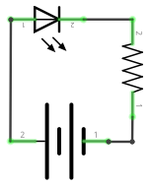

Setup

Install Raspbian
Note: We use NOOBS to install the operating system onto the Pi. The kit we are using came with NOOBS preinstalled on an SD card, but if needed it can be downloaded and copied to an SD card (see instructions here if you need help).
- To install Raspbian, we simply need to boot the Pi to NOOBS and select Raspbian in the list of options. Select the language and keyboard as desired. Then hit the 'i' key or click Install. (Note: to reset the Pi to you can hit the shift key during boot to launch NOOBS again and reinstall Raspbian.)
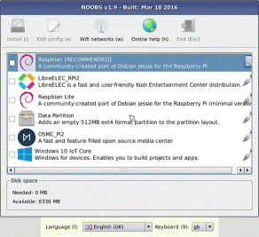

Connect to WiFi
In most cases you can use the instructions here to connect to wifi.
If connecting to a network with a setup more complicated than a shared key (such as a corporate network), follow these instructions:
- Open a terminal and type:
sudo nano /etc/wpa_supplicant/wpa_supplicant.conf
- Edit that file, add something like (example for MSCHAP):
network={
ssid="[ssid]"
key_mgmt=WPA-EAP
eap=PEAP
identity="[domain]\[username]"
password="[password]"
phase2="auth=MSCHAPV2"
}
- CTRL-O, enter to save, CTRL-X to exit
- Reboot (sudo reboot)

Update Software
We use the Debian Advanced Package Tool (APT) to update the software on the Pi.
- Open a terminal. This can be done via the Raspberry Pi menu or using the shortcut.
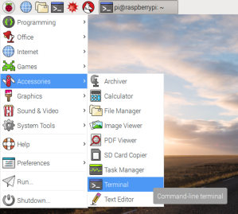
- In the terminal type sudo apt-get update. Note: sudo is a special command that runs the subsequent command as superuser. For more information on sudo (and on any command) you can type "man [command]", such as man sudo.
- Then type sudo apt-get upgrade. Note: this step may take quite some time, up to an hour or more depending on your Internet connection speed, wifi network, and the number of updates needed.

Set Up Secure Shell (Optional)
It is possible to set up SSH to allow the Raspberry Pi to be accessed remotely from another computer.
- Click the Raspberry Pi menu, then Preferences, and then Raspberry Pi Configuration.
- Select the Interfaces tab.
- Click the Enabled radio button next to SSH.
- Open a terminal and type ifconfig. The output will contain the IP address of the Pi (next to inet). Then use an SSH program (such as PuTTY) to connect. The default Raspberry Pi user name is "pi" and the password is "raspberry". Note: to change the default password type sudo passwd pi in the terminal and follow the prompts.

Command Line Cheat Sheet

Directory navigation
To go up one level of the directory tree (change into the parent directory):
cd ..

Go to the $HOME directory:
cd

Change to the /etc directory:
cd /etc

File and directory commands
List all files in a long listing (detailed) format:
ls -al

Display the present working directory:
pwd

Create a directory:
mkdir directory

Remove (delete) file:
rm file

Remove the directory and its contents recursively:
rm -r directory

Force removal of file without prompting for confirmation:
rm -f file

Forcefully remove directory recursively:
rm -rf directory

Copy file1 to file2:
cp file1 file2

Copy source_directory recursively to destination. If destination exists, copy source_directory into destination, otherwise create destination with the contents of source_directory:
cp -r source_directory destination

Rename or move file1 to file2. If file2 is an existing directory, move file1 into directory file2:
mv file1 file2

Networking
Display all network interfaces and IP address:
ifconfig -a

Python commands
Run a python program:
python file.python

Kill all background python processes:
pkill -9 python

General
To break out of a current running processes:
press ctrl-C on keyboard

Git commands
Add all changes to repository:
git add –all

Commit changes:
git commit -m "enter description of changes here"

Push changes to git server, replace branch with branch name:
git push origin branch

Changes branches, replace [branch] with branch name:
git checkout [branch]

Pull down latest changes from current branch:
git pull

Pull down latest changes from specified branch, replace [branch] with branch name:
git pull origin [branch]

Examples
Change to repository folder:
$ cd src/starfish2018/

Pull latest changes:
$ git pull origin working

Run hardware test:
$ python tests/testHardware.py

Learning More

Computer Science

Books
Title | Author | ISBN
Code: The Hidden Language of Computer Hardware and Software | Charles Petzold | 978-0735611313
Head First Learn to Code: A Learner's Guide to Coding and Computational Thinking | Eric Freeman | 978-1491958865

Websites
- https://www.codecademy.com/catalog/subject/all
- https://www.khanacademy.org/computing
- https://mva.microsoft.com
- https://stackoverflow.com
- https://teachyourselfcs.com

Electronics

Books
Title | Author | ISBN
Getting Started in Electronics | Forrest M. Mims III | 978-0945053286
Make: Electronics: Learning Through Discovery | Charles Platt | 978-1680450262
Understanding Basic Electronics | Walter Banzhaf | 978-0872590823

Websites
- https://www.allaboutcircuits.com/textbook
- https://www.circuitlab.com
- https://www.electronics-tutorials.ws
- http://fritzing.org
- http://www.instructables.com/technology/electronics

HTML and CSS

Books
Title | Author | ISBN
Head First HTML5 Programming: Building Web Apps with JavaScript | Eric Freeman and Elisabeth Robson | 978-1449390549

Websites
- https://mva.microsoft.com/en-us/training-courses/html5-css3-fundamentals-development-for-absolute-beginners-14207
- https://www.w3schools.com/html/html5_intro.asp

Javascript

Books
Title | Author | ISBN
Head First JavaScript Programming: A Brain-Friendly Guide | Eric Freeman and Elisabeth Robson | 978-1449340131
JavaScript: The Definitive Guide | David Flanagan | 978-0596805524
JavaScript: The Good Parts, 1st Edition | Douglas Crockford | 978-0596517748
JavaScript and jQuery: Interactive Front-End Web Development, 1st Edition | Jon Duckett | 978-1118871652

Websites
- https://www.codecademy.com/learn/learn-javascript
- https://javascript.info
- https://mva.microsoft.com/en-US/training-courses/javascript-fundamentals-for-absolute-beginners-14194
- https://www.w3schools.com/jS/default.asp

Linux

Books
Title | Author | ISBN
Learning Raspbian | William Harrington | 978-1784392192
Raspberry Pi Assembly Language RASPBIAN Beginners: Hands On Guide, 3rd Edition | Bruce Smith | 978-1492135289

Websites
- https://www.debian.org/doc/manuals/debian-handbook
- https://www.debian.org/doc/manuals/debian-reference
- https://www.raspbian.org

Python

Books
Title | Author | ISBN
Head First Python: A Brain-Friendly Guide, 2nd Edition | Paul Barry | 978-1491919538
Learning Python, 5th Edition | Mark Lutz | 978-1449355739
Python Programming for the Absolute Beginner, 3rd Edition | Michael Dawson | 978-1435455009

Websites
- https://www.learnpython.org
- https://mva.microsoft.com/en-US/training-courses/introduction-to-programming-with-python-8360
- https://www.python.org

Raspberry Pi

Books
Title | Author | ISBN
Getting Started with Raspberry Pi (Make: Projects) | Matt Richardson and Shawn Wallace | 978-1449344214

Websites
- https://leanpub.com/pi
- https://www.raspberrypi.org/help
- https://www.raspberrypi.org/magpi
- https://www.raspberrypi.org/resources/learn

