ILLUSTRATIVE SAMPLE · ALL NAMES AND FIGURES ARE INVENTED
ANNUAL
REPORT
2025
Reliable water for a growing region
Harbourline Water
Published April 2026
For customers, regulators and the public

CONTENTS
Foreword from the chair | 03
2025 at a glance | 04
01 Service and finance | 05
How we performed | 06
Revenue and investment | 07
Where the money goes | 08
Key figures by service area | 09
Customers and complaints | 10
02 Organisation and outlook | 11
How we are organised | 12
Risk and governance | 13
Priorities for 2026 | 14
Method and glossary | 15

FOREWORD
A YEAR OF
STEADY
DELIVERY
Twelve months ago we promised to cut leakage, keep bills affordable and prepare the network for the next twenty years of growth. This report shows how far we have come.
Leakage fell for the third year running, and our teams repaired more mains in a single year than ever before. Water quality stayed at the level our customers expect, and complaints dropped by a fifth.
None of this happened by accident. It came from a steady programme of investment, better data from the network and, above all, the people who work in it every day.
The year ahead asks more of us. Demand is rising, summers are drier and our oldest assets are reaching the end of their life. Our plan for 2026 sets out how we will respond, and how you can hold us to it.
Miriam Okafor
Chair of the Board
“
Every litre we stop losing is a litre we do not have to take from a river.
MIRIAM OKAFOR, CHAIR
KEY NUMBER
18%
less water lost to leaks than in 2022, our baseline year.

2025 AT A GLANCE
The network is in better shape than at any point in the last decade, and it now needs to be ready for a hotter, busier region.
Water quality held at record levels while leakage, complaints and carbon all fell. Investment rose for the fourth year, funded without a real-terms rise in bills.
  312 M  litres of drinking water supplied per day |   1.4 M  customers served across 38 towns |   99.96%  of samples met drinking-water standards |   −11%  operational carbon emissions vs 2024

Leakage is down 18% since 2022  Active pressure management in 61 zones and faster repairs cut losses to 84 litres per property per day. |  | Bills stayed flat in real terms  The average household bill was 412 a year, 0.4% below inflation, while the social tariff reached 31,000 homes.
Complaints fell by a fifth  Written complaints dropped to 2,960. Most of the fall came from billing, after the new account system went live. |  | Investment reached a new high  We invested 214 million in mains, treatment and storage, 9% more than in 2024 and ahead of plan.

IN THIS SECTION
01
SERVICE
AND
FINANCE
How the network performed, what it cost to run and where the money went in 2025.
How we performed 06
Quality, leakage, supply interruptions and the work behind them.
Revenue and investment 07
Five years of income and capital spending.
Where the money goes 08
How each pound of a customer bill is spent.
Key figures by service area 09
The year's numbers for each of our four regions.
Customers and complaints 10
What customers told us, and what we changed.

214 M
invested in pipes, treatment works and storage in 2025, the highest in our history.

HOW WE PERFORMED
Quality  99.96%  of 48,200 samples met the drinking-water standard. |  | Water quality is the measure our customers care about most, and it held at the level of the last three years. Of 48,200 samples taken at treatment works, reservoirs and customer taps, 19 failed a standard, none of them for a substance that affects health.  Each failure was traced and closed within 48 hours. Twelve were linked to old iron mains in two towns, which are now first in line for replacement in the 2026 programme.
Leakage  84 l  lost per property per day, down from 102 in 2022. |  | Leakage fell for the third year in a row. Pressure management now covers 61 of our 74 supply zones, which reduces the stress on old pipes at night when demand is low.  Repair crews fixed 9,840 leaks, 14% more than in 2024, and the average time from report to repair dropped from 4.1 to 2.9 days. Acoustic loggers on 1,100 km of main now find leaks before they reach the surface.
Supply  6 min  average interruption per property, against a target of 8. |  | Planned and unplanned interruptions together averaged six minutes per property. Two large bursts in February accounted for a third of the total; both areas were back in supply within five hours.  We now carry bottled water stocks for 40,000 people at three depots, and every vulnerable customer on our register is contacted within two hours of an outage.
Carbon  −11%  operational emissions against 2024, to 61,400 tonnes. |  | Pumping and treatment use most of our energy. New high-efficiency pumps at nine stations and solar arrays at four treatment works cut electricity use by 7%, and 38% of the power we use is now generated on our own sites.  Process emissions from sludge treatment fell after the anaerobic digester at Eastbrook returned to full operation in May. Our target is net zero operational emissions by 2035.

REVENUE AND
INVESTMENT
Income grew in line with the customer base and the price limits set by the regulator. Capital investment rose faster, funded by efficiency savings and long-term green bonds.
 | Revenue  548 M |  | Capital investment  214 M
 | Operating costs  291 M |  | Efficiency savings  19 M
FIGURE 1 — REVENUE, 2021–2025 (MILLIONS)
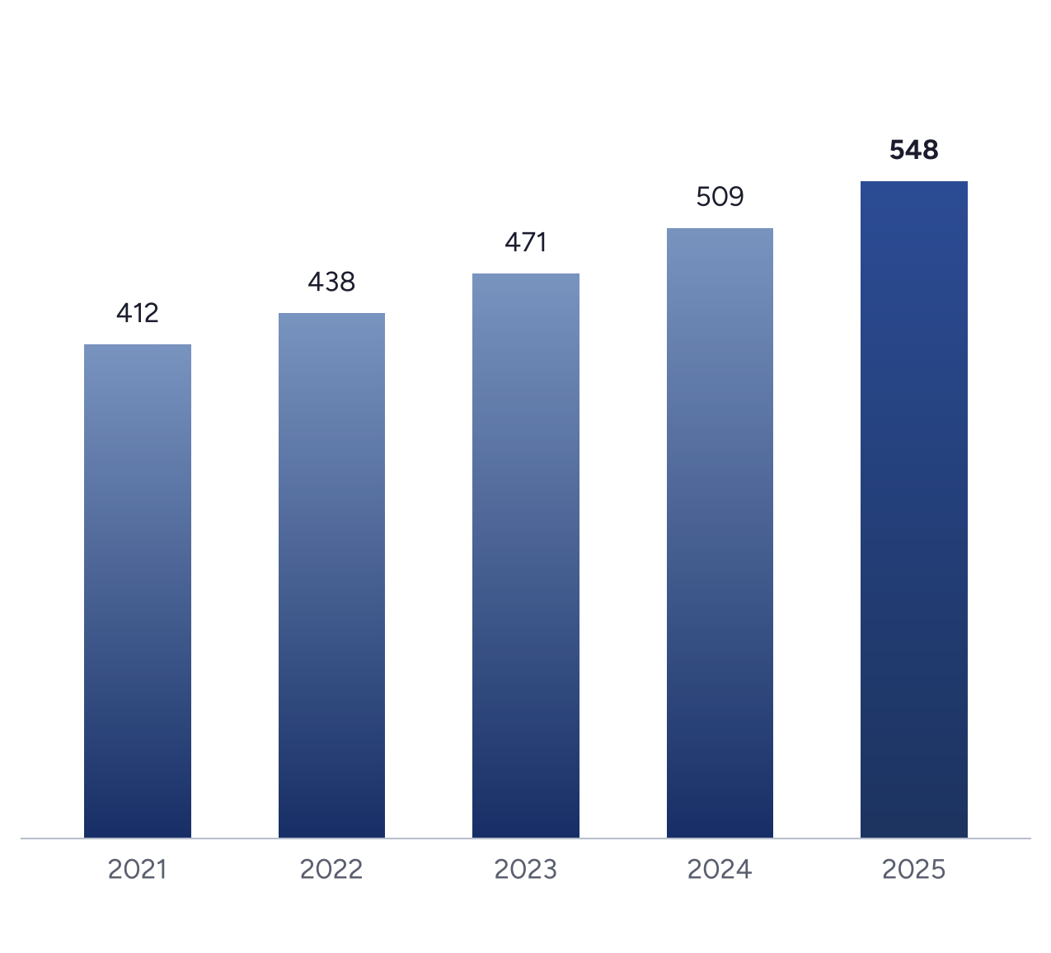
Source: Harbourline Water audited accounts (illustrative). 2025 is the deepest bar.

WHERE THE
MONEY GOES
How each pound of an average household bill was spent in 2025.
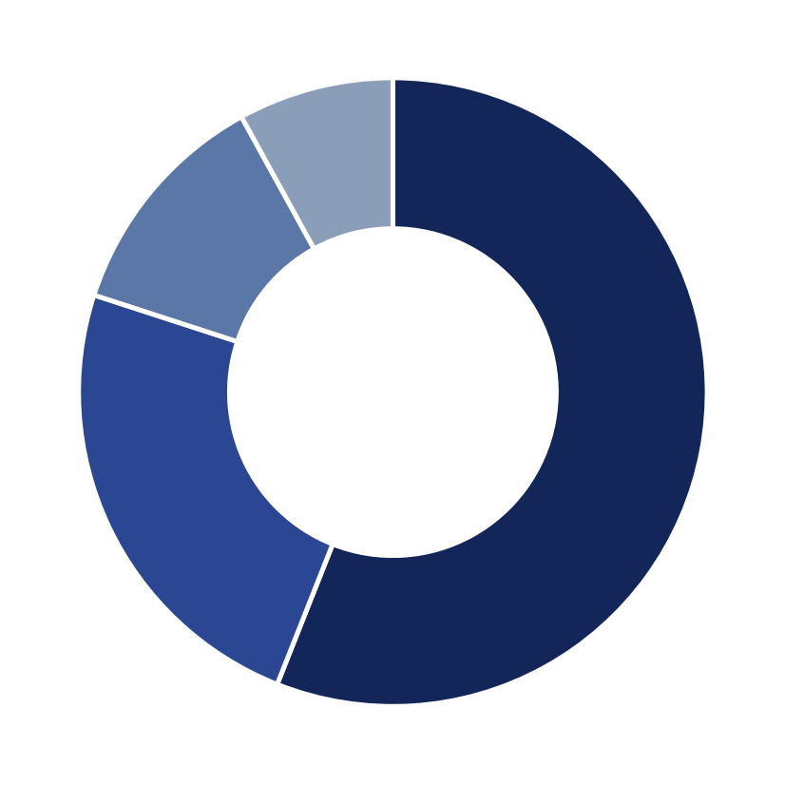
   | 56%  Running the network: treatment, pumping, repairs
   | 24%  Paying for investment in pipes and works
   | 12%  Customer service and billing
   | 8%  Environmental schemes and catchment work

Why the running share is falling  Five years ago, running the network took 63 pence of every pound. Lower energy use at the two largest treatment works and fewer emergency repairs have brought that down to 56 pence, freeing money for investment without raising bills.  The shift matters because investment today avoids larger repair bills later. Every kilometre of main we replace now removes, on average, four bursts over the next decade. |  | 63p  running share in 2020  56p  running share in 2025  4  bursts avoided per km replaced

KEY FIGURES BY
SERVICE AREA
Our four regions in 2025. North and Coast carry most of the older iron mains, which is where leakage and interruptions remain highest.
TABLE 1 — PERFORMANCE BY REGION, 2025
REGION | CUSTOMERS | SUPPLY (ML/D) | LEAKAGE (L/PROP/D) | INTERRUPTIONS (MIN) | COMPLAINTS
North | 382,000 | 84.1 | 97 | 8.2 | 1,040
Coast | 296,000 | 66.4 | 92 | 7.1 | 760
Central | 448,000 | 98.7 | 74 | 4.6 | 690
Valley | 274,000 | 62.8 | 71 | 4.9 | 470
All regions | 1,400,000 | 312.0 | 84 | 6.0 | 2,960
Ml/d = million litres per day. Leakage per property per day, three-year average. Figures are illustrative.
Reading the table  Central and Valley sit below the company leakage figure because most of their mains were replaced in the 1990s. North is 13 litres above average, and two of its largest towns are in the 2026 replacement programme. |  | What changes next year  From 2026 we will report each region against its own target, set from the age and material of its pipes, rather than one company-wide figure that hides the gap between them.
FIGURE 2 — LEAKAGE BY REGION, LITRES PER PROPERTY PER DAY
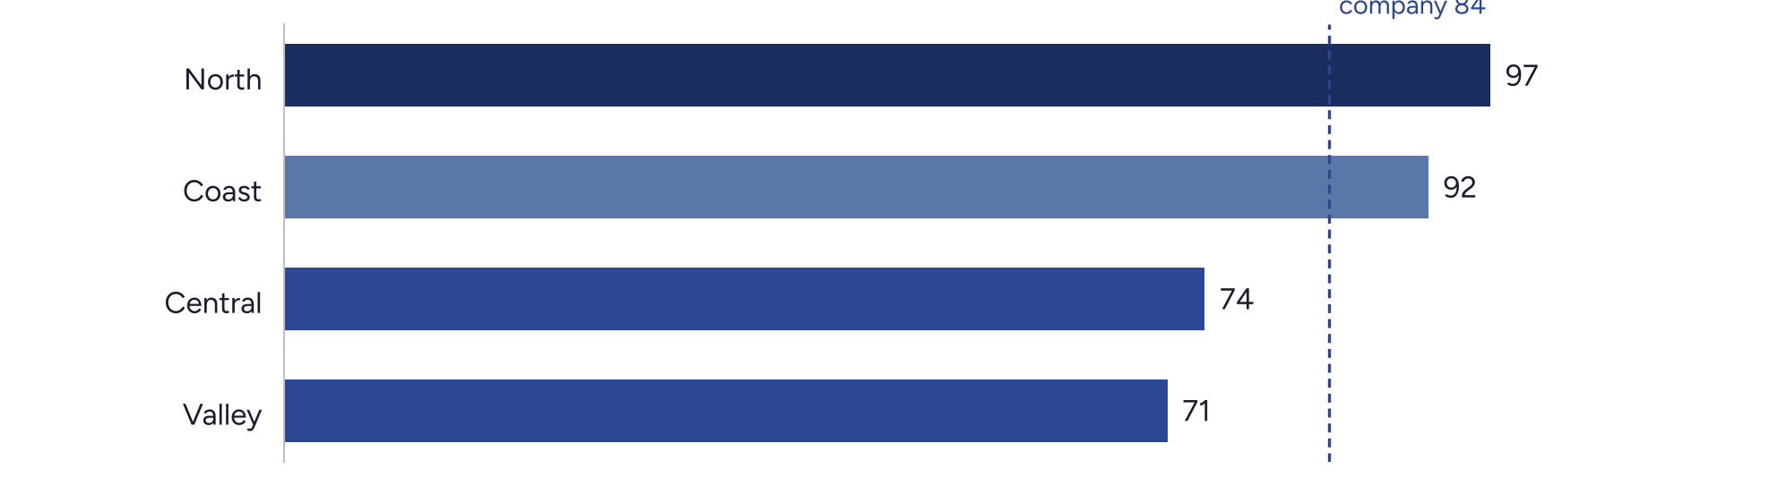
Source: Harbourline Water leakage returns (illustrative). The dashed line is the company figure.

CUSTOMERS AND
COMPLAINTS
Written complaints fell to 2,960, a fifth fewer than in 2024. Billing complaints fell fastest, by 38%, after the new account system went live in March and customers could see their usage online for the first time.  Complaints about water pressure rose slightly, mostly in the north, where pressure management lowered night-time pressure in older streets. We reviewed every one of the 410 cases and raised pressure again in 37 roads where upstairs taps were affected.  We now answer 92% of calls within a minute and resolve 81% of contacts first time. Customers on our priority services register, now 52,000 households, get a named contact and a call before any planned work.  Satisfaction in our independent survey rose from 7.6 to 8.1 out of 10. The largest gain was on trust: 74% of customers said they believe we will do what we say, up from 66%. |  | “  The engineer phoned before the work started and again when it was done. That is all I wanted.  CUSTOMER, VALLEY REGION  8.1  out of 10 overall satisfaction, up from 7.6.
SERVICE IN NUMBERS
92%  of calls answered within a minute | 81%  of contacts resolved first time | 52,000  households on the priority services register | −38%  billing complaints after the new account system

IN THIS SECTION
02
ORGANI-
SATION
AND
OUTLOOK
Who runs the company, how risk is managed, and what we will deliver in 2026.
How we are organised 12
The board, the executive team and the four directorates.
Risk and governance 13
The risks that matter most and how the board oversees them.
Priorities for 2026 14
Four commitments and how we will measure them.

4
commitments for 2026, each with a published target and a quarterly progress report.

HOW WE ARE
ORGANISED
CHIEF EXECUTIVE
OFFICER
OPERATIONS
ASSETS
CUSTOMERS
FINANCE
· Treatment works
· Network and repairs
· Incident response
· Laboratories
· Capital programme
· Mains replacement
· Asset data
· Engineering
· Billing
· Contact centre
· Priority services
· Developer services
· Planning and treasury
· Regulation
· Procurement
· Risk and audit
THE BOARD
Nine directors: the chair, five independent non-executives and three executives. Four committees report to the board: audit, risk, remuneration and a customer and environment committee chaired by an independent director.
In 2025 the board met nine times, with full attendance at seven meetings. Two new independent directors joined in June, bringing experience in climate adaptation and in consumer protection.
The board sets strategy and holds the executive to account. Four directorates run the business day to day.

RISK AND GOVERNANCE
Drought and demand  Two dry summers in three years have lowered reservoir levels at the start of autumn. We have brought forward a new transfer main between Central and North, and our drought plan now triggers earlier, more gradual restrictions.  Ageing assets  A quarter of our mains are more than 80 years old. The replacement rate rose to 0.9% a year in 2025 and will reach 1.2% by 2028, prioritised by burst history and material.  Cyber security  Treatment works are run by control systems that must stay safe from attack. We completed an independent review in 2025 and separated the operational network from the office network at all sites. |  | Affordability  Rising costs put pressure on bills. The social tariff now supports 31,000 homes, and we fund debt advice through two local charities.  People and skills  Thirty percent of our engineers can retire within ten years. We doubled apprentice intake to 48 and launched a graduate scheme with the regional university.  How the board oversees risk  The risk committee reviews the full register every quarter and one principal risk in depth at each meeting. Internal audit reports directly to the audit committee chair.
TABLE 2 — PRINCIPAL RISKS AT A GLANCE
RISK | TREND | OWNER | RATING
Drought and demand | Rising | Director of Operations | High
Ageing assets | Stable | Director of Assets | High
Cyber security | Rising | Chief Information Officer | Medium
Affordability | Rising | Director of Customers | Medium
People and skills | Stable | Chief People Officer | Medium

HOW WE WILL TRACK PROGRESS
PRIORITIES FOR 2026
Four commitments, each with a target we will publish and report on every quarter.
Cut leakage to
78 litres
per property per day, by replacing 95 km of main.
01
Keep bills flat
in real terms
with the social tariff extended to 36,000 homes.
02
Finish the north
transfer main
to move water between regions in a drought.
03
Halve the time
to fix leaks
from 2.9 to 1.5 days, using network sensors.
04
MEASURE | 2025 | 2026 TARGET
Leakage, litres per property per day | 84 | 78
Customers on the social tariff | 31,000 | 36,000
North transfer main complete | 40% | 100%
Average days to repair a leak | 2.9 | 1.5

METHOD AND
GLOSSARY
Leakage  Water lost between treatment works and customers' property boundaries, as a three-year average per property per day.  Supply interruption  Average minutes per property without supply for three hours or more, planned or unplanned.  Ml/d  Million litres per day, the unit for water put into supply.  Social tariff  A reduced bill for households whose water costs exceed 5% of their income after housing costs. |  | Priority services register  Customers who need extra help during an incident, such as bottled water delivery.  Capital investment  Spending on new or replacement assets, excluding routine maintenance.  Efficiency savings  Reductions in operating cost against the 2020 baseline, after inflation.  About this report  This is an illustrative sample built to test the Navy Annual design. Harbourline Water, its people and every figure are invented.
DATA SOURCES AND ASSURANCE
Performance figures come from the regulatory returns submitted in March 2026. Water quality results are taken from the laboratory information system and checked by the drinking-water inspectorate. Financial figures are from the audited accounts for the year to 31 December 2025.
An independent technical auditor reviewed leakage, supply interruptions and customer contact data. Where a measure changed method during the year, the previous year is restated on the same basis.

Water you can trust,
today and for the
next generation.
Harbourline Water
1 Quay Street, Harbourline
harbourline-water.example
ILLUSTRATIVE SAMPLE · ALL NAMES AND FIGURES ARE INVENTED

