LUMEN FOUNDATION · ILLUSTRATIVE SAMPLE
IMPACT
REPORT
2025
Five programmes, one city, 214,000 people reached
EDUCATION
HEALTH
ENVIRONMENT
COMMUNITIES
FINANCE

CONTENTS
 | Foreword  A letter from the director | 03
 | 2025 at a glance  The year in numbers | 04
 | Education  Reading, tutoring and school meals | 05
 | Health  Community clinics and mental health | 07
 | Environment  Trees, retrofits and clean air | 09
 | Communities  Grants, housing and local groups | 11
 | Finance  Where the money came from and went | 13

HOW TO READ THIS REPORT
Each programme has its own colour. The strip at the top of every page shows where you are: the current programme's colour drops down as a tab.

FOREWORD
“
We measure a good year by the number of people who no longer need us.
Lumen Foundation was set up eleven years ago with one idea: that a city's problems are connected, so the answers should be too. A child who reads well, a family in a warm home and a street with clean air are parts of the same story.  In 2025 we reached 214,000 people through five programmes, more than in any previous year. We opened two new community clinics, planted our 50,000th tree and gave 640 grants to local groups, most of them under 5,000. |  | This report is organised by programme. Each has its own colour, so you can follow one thread or read the whole picture. Every figure is checked by our independent evaluation partner.  None of this would be possible without 3,400 volunteers, 61 partner organisations and the donors who trusted us with their money. Thank you. The work is not finished, and next year we will ask even more of ourselves.
Dr Amara Lindqvist
Director, Lumen Foundation
2025 IN FIVE MOMENTS
FEB  Maths tutoring pilot starts in six schools |  | MAR  Eastfield clinic opens its doors |  | JUN  The 50,000th street tree is planted |  | SEP  Harbour hub opens for local groups |  | DEC  Running costs stay below 8%

OVERVIEW
2025 AT A GLANCE
  
  EDUCATION
  38,600
  children in reading and tutoring programmes
  
  HEALTH
  92,400
  clinic visits across six community clinics
  
  ENVIRONMENT
  13,600 t
  of CO₂ avoided through trees and retrofits
  
  COMMUNITIES
  640
  grants to local groups, worth 6.8 million

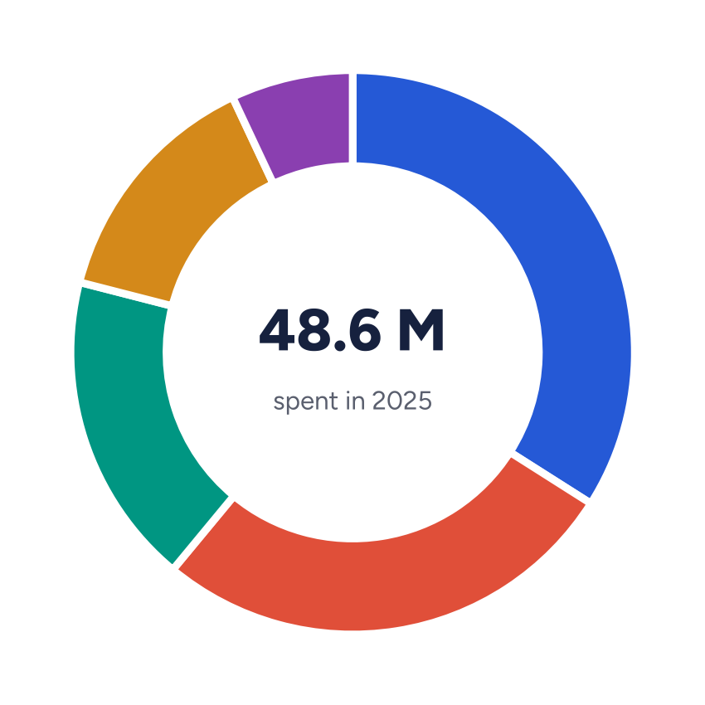 |  | WHERE THE MONEY WENT
   | Education | 34%
   | Health | 27%
   | Environment | 18%
   | Communities | 14%
   | Running the foundation | 7%


01
PROGRAMME 01 · EDUCATION
Every child reading
by age eleven
Tutoring, libraries and breakfast clubs in 84 schools, focused on the neighbourhoods where reading scores lag.
38,600  children reached, up 24% on 2024 | 84  partner schools, 19 of them new | +9 pts  rise in age-11 reading scores at partner schools

Reading by eleven is the single best predictor we have of how a child does at sixteen. That is why most of the education budget goes to one-to-one tutoring in the last two years of primary school.  In 2025, 2,100 trained volunteers gave 146,000 hours of tutoring. Schools choose the children, and every child is tested at the start and end of the year so we can see what works. |  | Breakfast clubs now run in 52 schools and serve 9,800 children a day. Teachers tell us that attendance and concentration in the first lesson have both improved.  Next year we will add maths tutoring in 20 schools, using the same model and the same measurement.

PROGRAMME 01 · EDUCATION
MORE CHILDREN, EVERY YEAR
FIGURE 1 — CHILDREN REACHED, 2021–2025  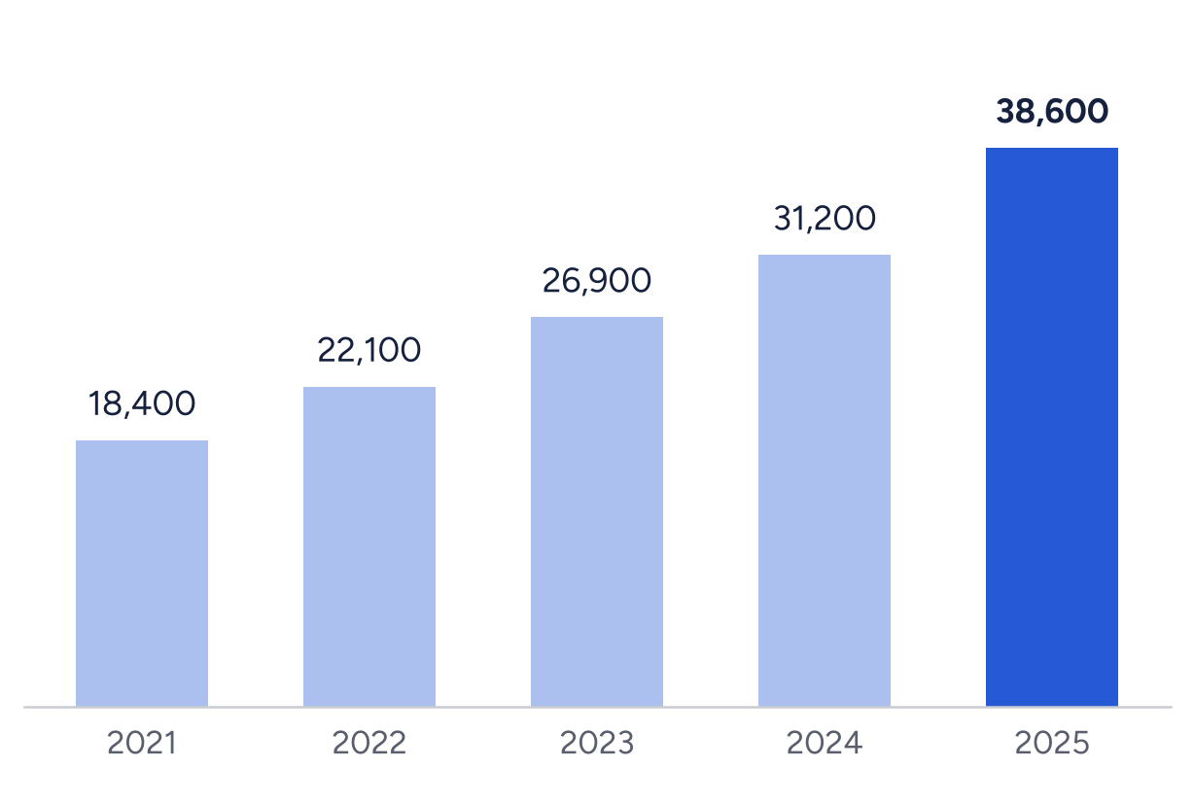  Source: Lumen programme records (illustrative). |  | Growth came from new schools, not bigger classes.  Each school keeps the same tutor-to-child ratio of one to three, so quality holds as numbers rise.

CASE STUDY · RIVERSIDE PRIMARY
From the bottom ten to the city average in two years
Riverside joined the programme in 2023 with one of the lowest reading scores in the city. Two years and 3,800 tutoring hours later, 71% of its eleven-year-olds read at the expected level, against 74% across the city. The school now trains other schools' volunteers.

“
My tutor never got bored of the same book. Now I pick my own.
PUPIL, AGE TEN, RIVERSIDE PRIMARY


02
PROGRAMME 02 · HEALTH
Care close to home
Six community clinics, a mental-health line and home visits for people who find it hard to get to a doctor.
92,400  clinic visits, 18% more than in 2024 | 6  community clinics, two opened in 2025 | 4 days  average wait for a first appointment

Our clinics sit in community centres, not hospitals. They are open in the evening and on Saturdays, and most visits are booked by phone or simply by walking in.  The two new clinics in Eastfield and Harbour opened in March and September. Together they saw 21,000 visits in their first months, mostly for long-term conditions such as diabetes and asthma. |  | The mental-health line took 14,200 calls. Two thirds of callers were offered a follow-up session within a week, and 83% said the call helped.  Home visits reached 1,900 older or disabled residents, many of whom had not seen a health professional in more than a year.

PROGRAMME 02 · HEALTH
CLINICS IN 2025
TABLE 1 — VISITS AND WAITING TIMES BY CLINIC
CLINIC | OPENED | VISITS | CHANGE | WAIT (DAYS) | SATISFIED
Northside | 2016 | 21,300 | +6% | 3 | 94%
Riverside | 2018 | 18,900 | +4% | 4 | 92%
Old Town | 2019 | 16,700 | +9% | 5 | 91%
Westgate | 2021 | 14,500 | +12% | 4 | 93%
Eastfield | 2025 | 12,800 | new | 3 | 95%
Harbour | 2025 | 8,200 | new | 6 | 90%
All clinics |  | 92,400 | +18% | 4 | 93%
Wait = average days from first contact to first appointment. Satisfaction from exit surveys. Illustrative.
 |  | “  I came in on my way home from work. Nobody made me feel I was wasting their time.  PATIENT, EASTFIELD CLINIC
  WHAT CHANGED
  Evening sessions halved missed appointments
  Clinics that opened until 8 pm saw missed appointments fall from 14% to 7%, mostly among working parents.

2  more clinics planned for 2026, in Westgate North and Millbrook | 24/7  mental-health line from April, with trained volunteers overnight | 3 days  target wait for a first appointment by the end of 2026


03
PROGRAMME 03 · ENVIRONMENT
Cleaner air, warmer homes
Street trees, home retrofits and school-run clean-air zones in the neighbourhoods with the worst air.
50,000  trees planted since 2019, 9,400 of them this year | 1,240  homes insulated, saving 310 a year each | −22%  nitrogen dioxide outside 30 schools

The environment programme works where pollution and fuel poverty overlap. In those streets, a tree, an insulated loft or a car-free school gate makes the biggest difference to health and household bills.  Volunteers planted 9,400 street trees this year, chosen with residents. Survival after two years is 91%, well above the city's own planting. |  | The retrofit scheme insulated 1,240 homes, all of them for households on low incomes, at no cost to the occupants. Average heating bills fell by 310 a year.  Clean-air zones now cover the school run at 30 primary schools, with traffic closed for 45 minutes at each end of the day.

PROGRAMME 03 · ENVIRONMENT
CARBON AVOIDED IS GROWING FAST
FIGURE 2 — TONNES OF CO₂ AVOIDED EACH YEAR
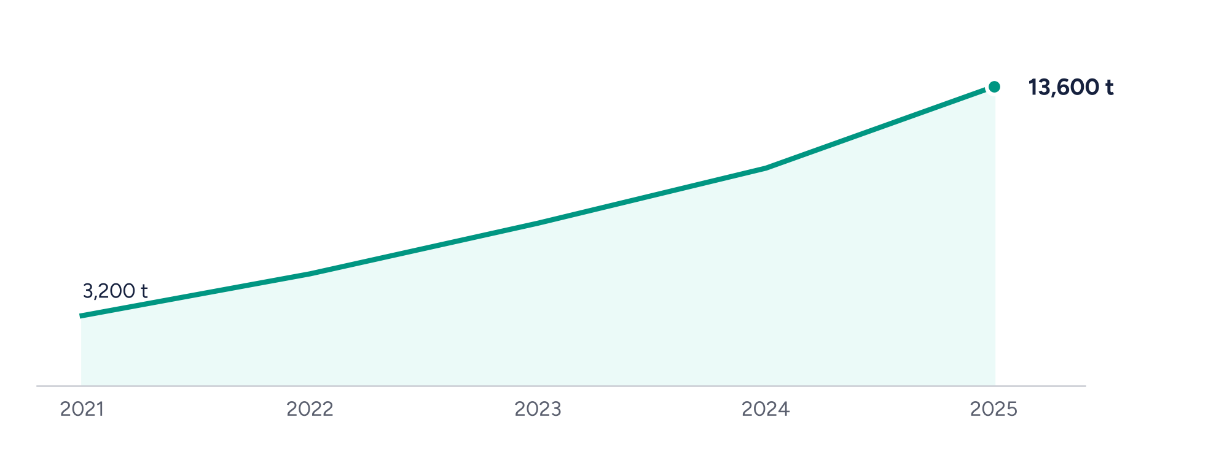
Source: Lumen environment programme, independently verified (illustrative).
HOW A RETROFIT WORKS
01  Referral  From a GP, school or neighbour, or by calling us. |  | 02  Survey  A free home survey within two weeks. |  | 03  Install  Loft, wall and draught-proofing in one visit. |  | 04  Follow-up  We check bills and comfort after one winter.

CASE STUDY · ALDER STREET
Forty homes, one street, one winter
Alder Street was insulated house by house over six weeks in the autumn. Residents' heating bills fell by an average of 34%, and damp complaints to the housing association dropped from 17 to two.


04
PROGRAMME 04 · COMMUNITIES
Small grants,
big difference
Grants, advice and space for the local groups that know their neighbourhoods best.
640  grants awarded, 71% of them under 5,000 | 6.8 M  granted to local groups and projects | 3,400  volunteers active in the year

Most of our community grants are small, quick and simple to apply for. A group can apply in one page and hear back within three weeks.  In 2025 we gave 640 grants. The most common uses were youth activities, food projects and help with energy bills, and two thirds went to groups run entirely by volunteers. |  | We also gave 38 larger grants of up to 60,000 to organisations that run services all year, such as advice centres and lunch clubs for older people.  Every grant holder can use our three community hubs free of charge, and 120 groups now meet there each month.

PROGRAMME 04 · COMMUNITIES
WHERE THE GRANTS WENT
FIGURE 3 — GRANTS BY NEIGHBOURHOOD, MILLIONS  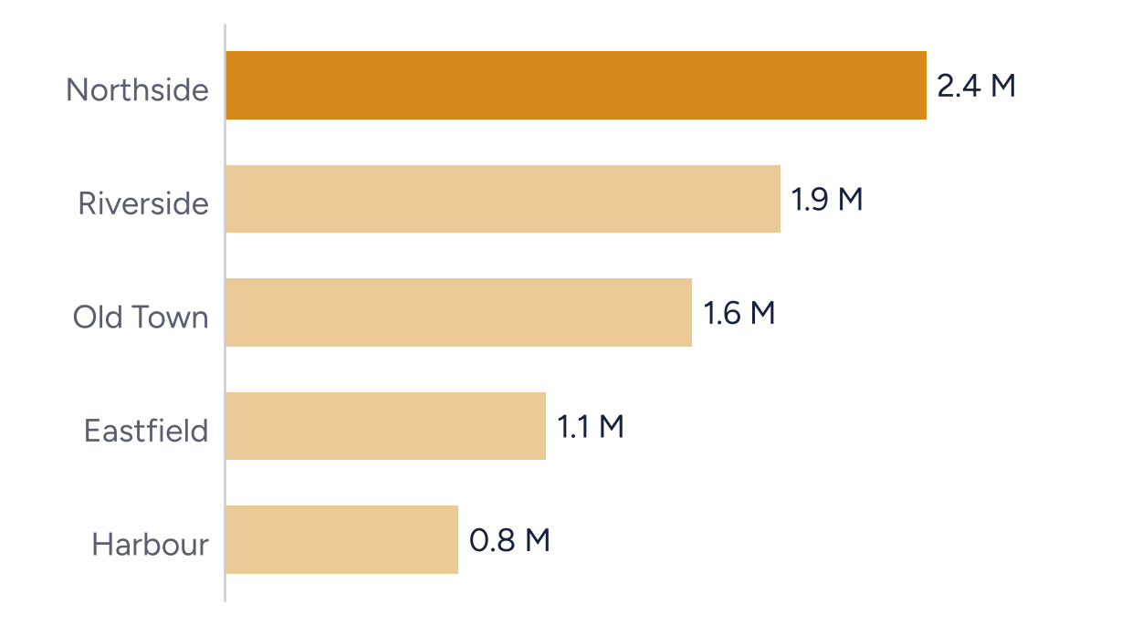  Source: Lumen grants database (illustrative). Darkest bar = largest share. |  | Northside receives most because it has the most groups, not the largest grants.  The average grant is similar everywhere, around 9,000.

 |  | “  The grant was small. What it said to us was: we trust you to get on with it.  VOLUNTEER, HARBOUR LARDER
  CASE STUDY · HARBOUR LARDER
  A food bank that became a café
  A 3,000 grant in 2023 bought a fridge. Today the Harbour Larder runs a pay-what-you-can café five days a week and employs four local people.

HOW A SMALL GRANT WORKS
01  Apply  One page, online or on paper, in any language. |  | 02  Decide  A panel of residents decides within three weeks. |  | 03  Report  Tell us what happened in a short call or a photo.

FINANCE
WHERE THE MONEY
CAME FROM AND WENT
FIGURE 4 — SPENDING BY PROGRAMME, MILLIONS  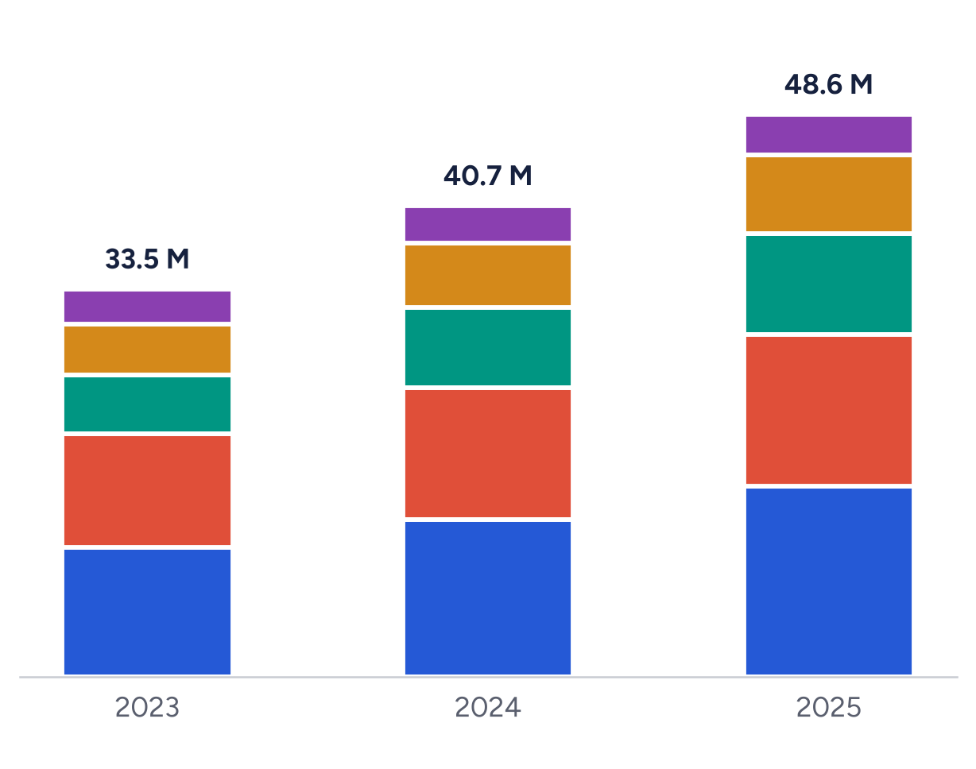 |  | LEGEND  Running costs stayed below 8% of spending for the fifth year.
  Education
  Health
  Environment
  Communities
  Running the foundation

TABLE 2 — INCOME AND SPENDING, MILLIONS
INCOME |  |  | SPENDING
Donations and legacies | 21.4 |  | Education | 16.5
Trusts and foundations | 14.9 |  | Health | 13.1
Government contracts | 8.3 |  | Environment | 8.7
Investment income | 4.6 |  | Communities | 6.8
 |  |  | Running the foundation | 3.5
Total income | 49.2 |  | Total spending | 48.6

Connected problems
need connected answers.
Lumen Foundation · 12 Mill Lane, Harbourline · lumen-foundation.example
ILLUSTRATIVE SAMPLE · ALL NAMES AND FIGURES ARE INVENTED

