PDMT
Birth Certificate & Death Certificate

- CREATE AN ACCOUNT.
If you don’t have an account click the create account button.
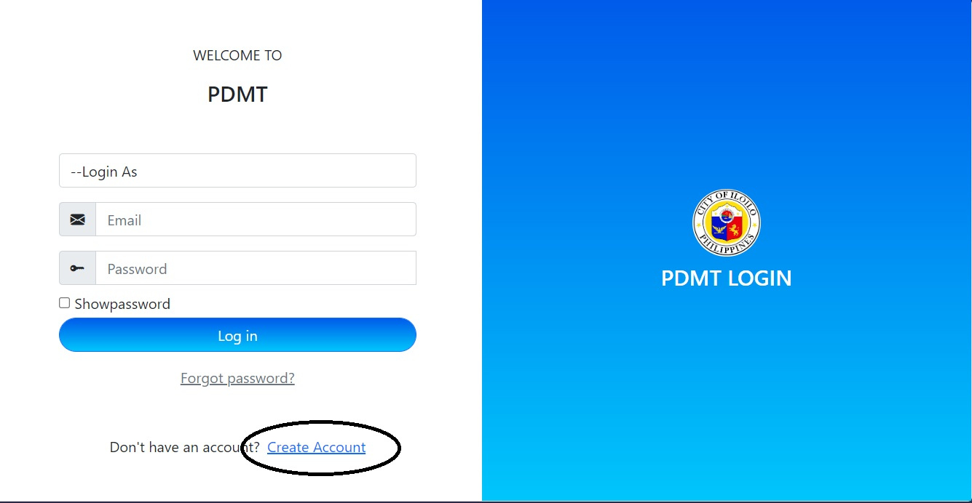

2.FILL UP THE FORM.
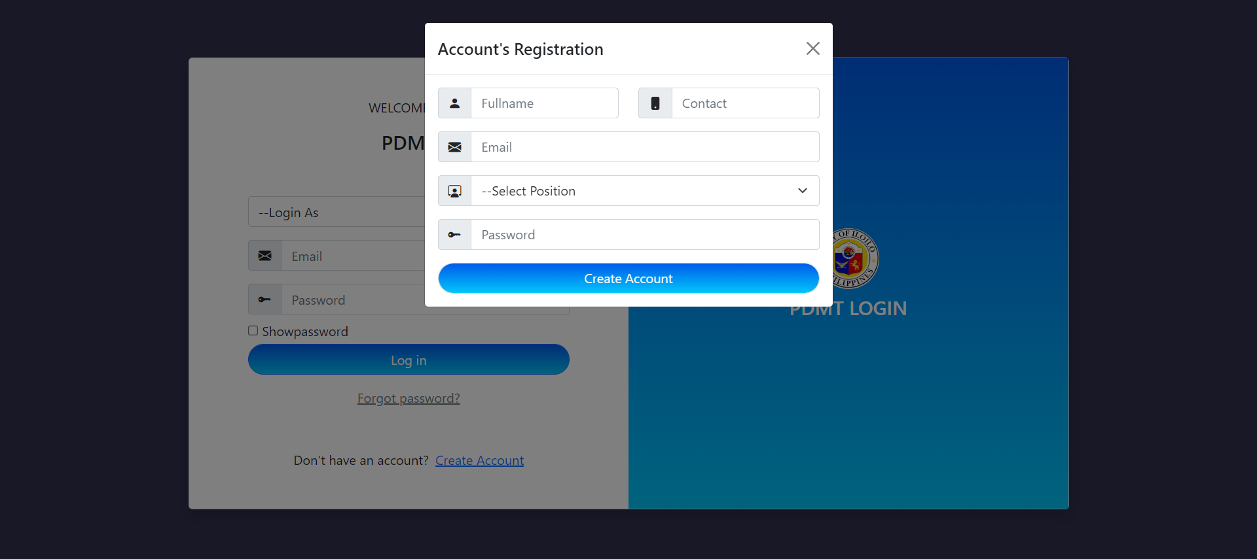

3. LOGIN YOUR ACCOUNT.
After you register your account you can now login your account.
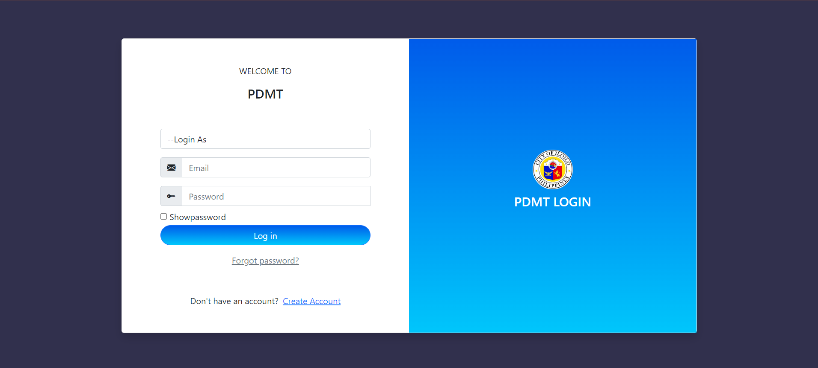

FORGOT PASSWORD.
Click the forgot password button.

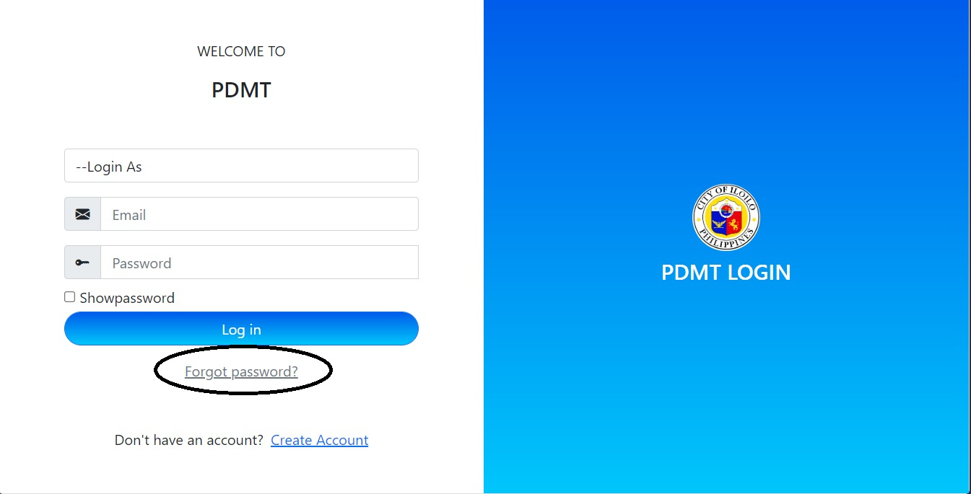

I.RESET YOUR PASSOWRD.
Enter your valid email account to reset your password. After you enter your valid email account click the reset button.

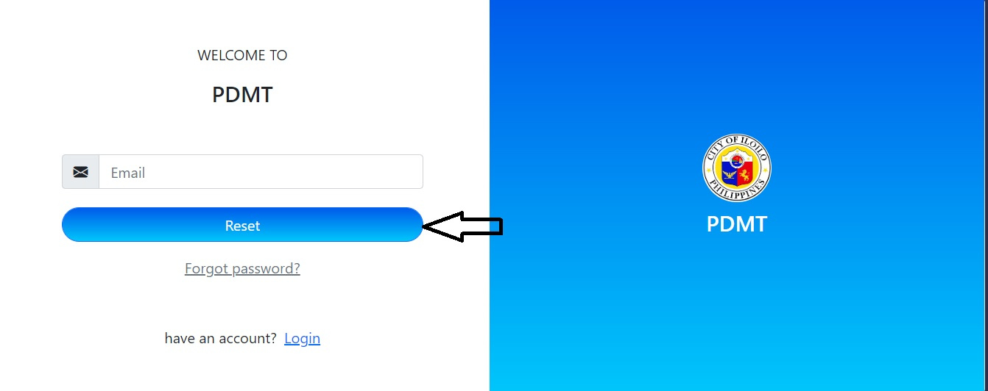

II.CHECK YOUR EMAIL .
Enter your valid email account to reset your password. After you enter your valid email account click the reset button.
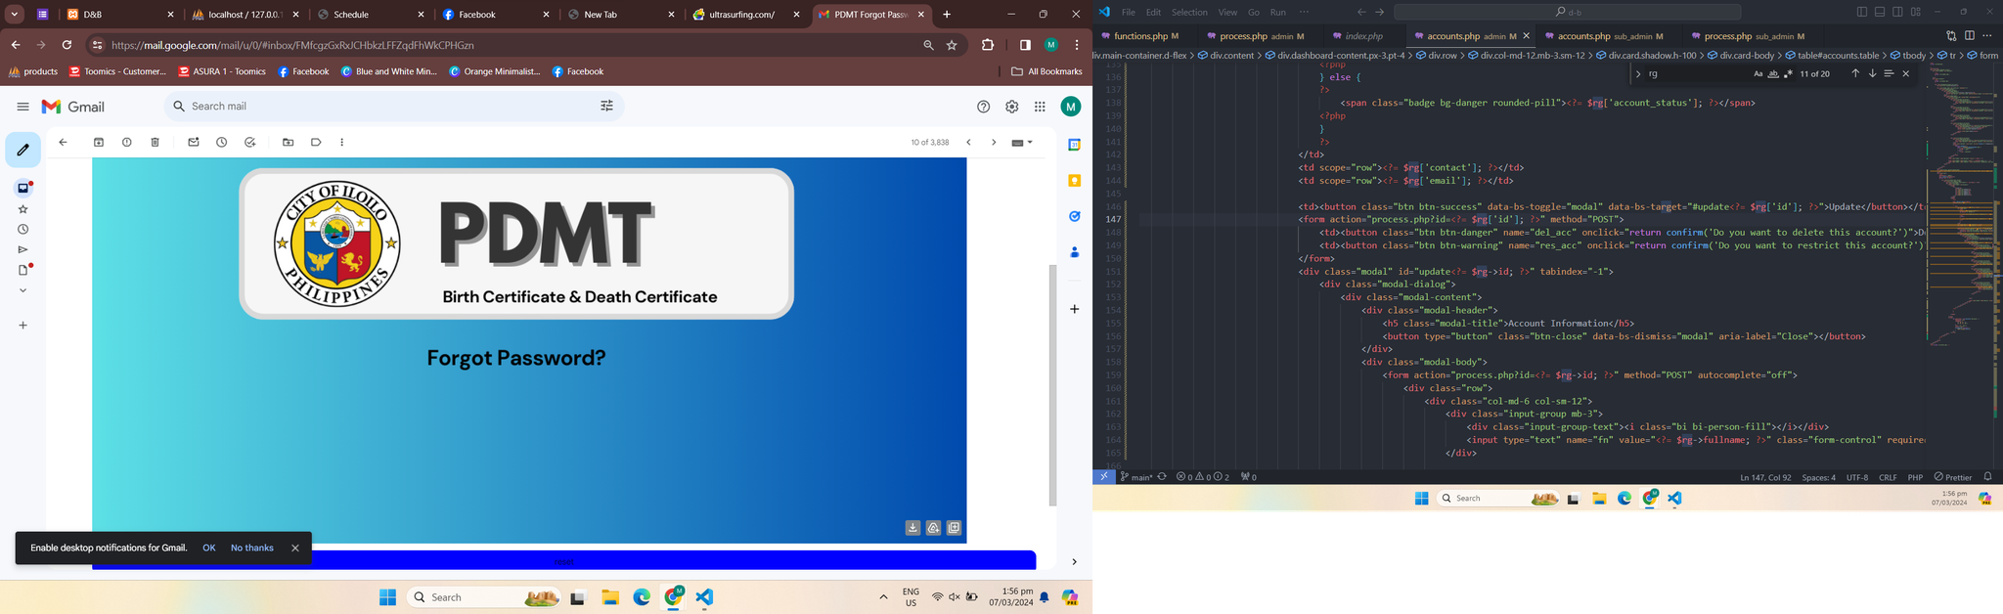

III.ENTER YOUR NEW PASSWORD.
After you enter your new password you can now login your account.
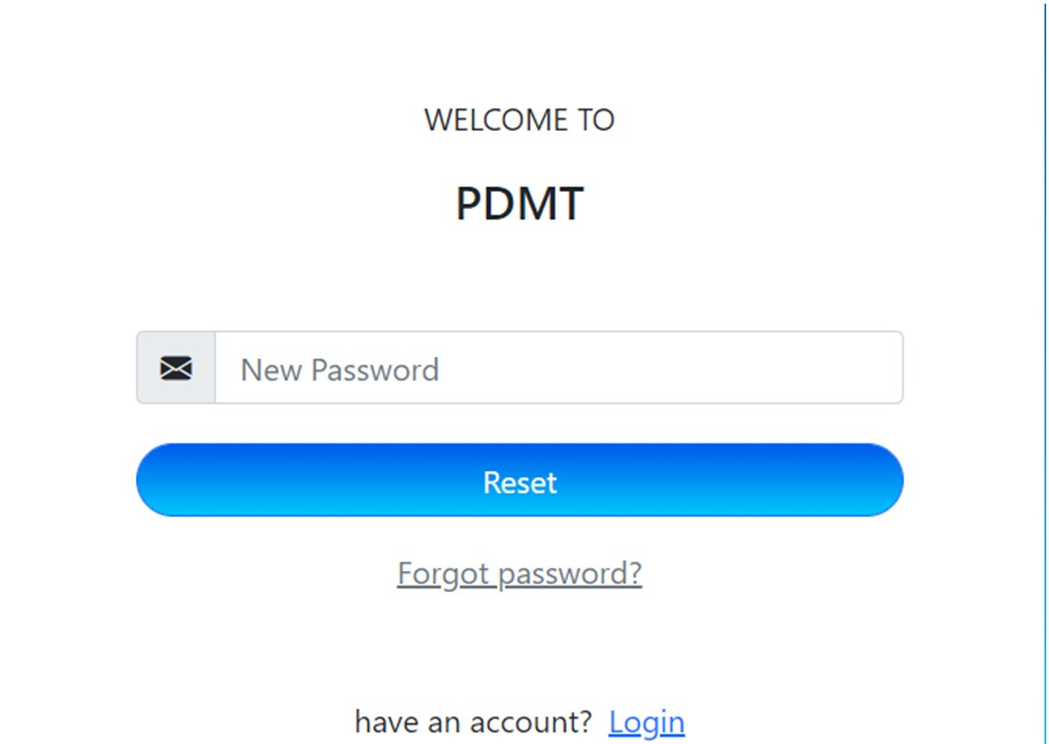

IV.LOGN YOUR ACCOUNT.

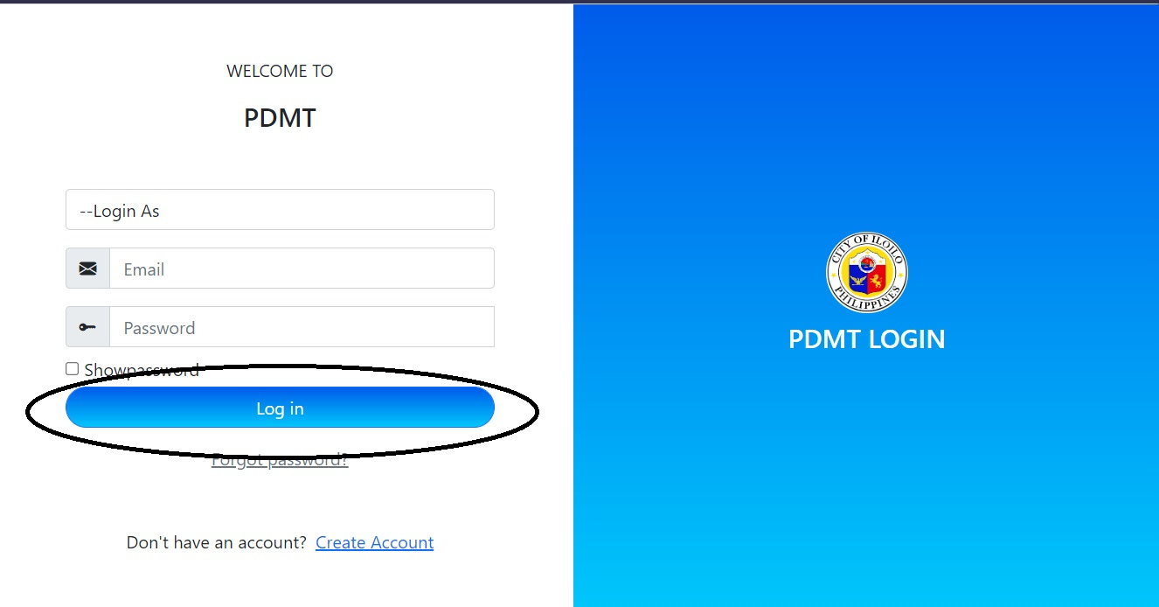

EMPLOYEE’S LANDING PAGE.
Employee’s home page or encoder home page.
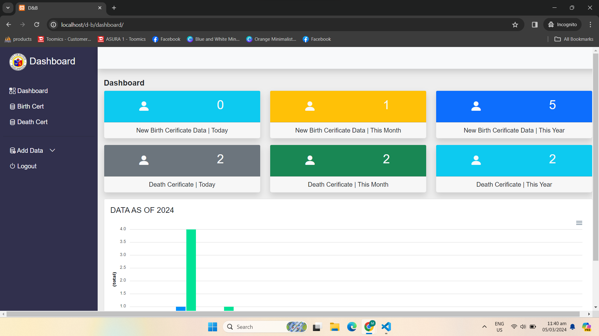

BIRTH CERT NAVIGATION OR BUTTON.
In the birth cert button you can see here the personal details of the person and the child.
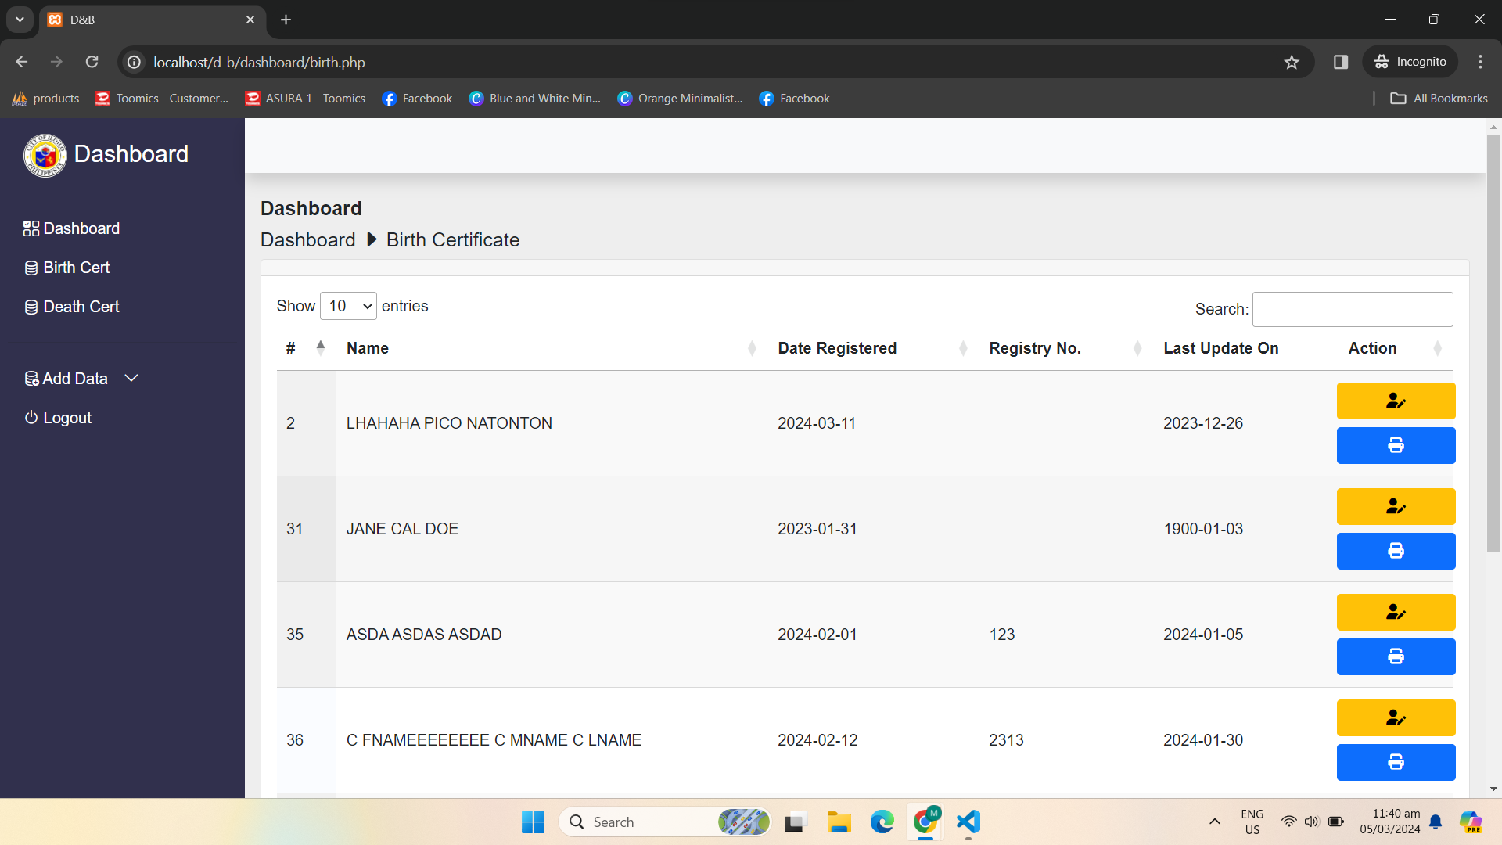

I.BIRTH CERT BUTTON.
In this page you can see the Names, Date Registered, Registry No., Last update, and the action where you can Print and Scanned the file or the data of the person and child.
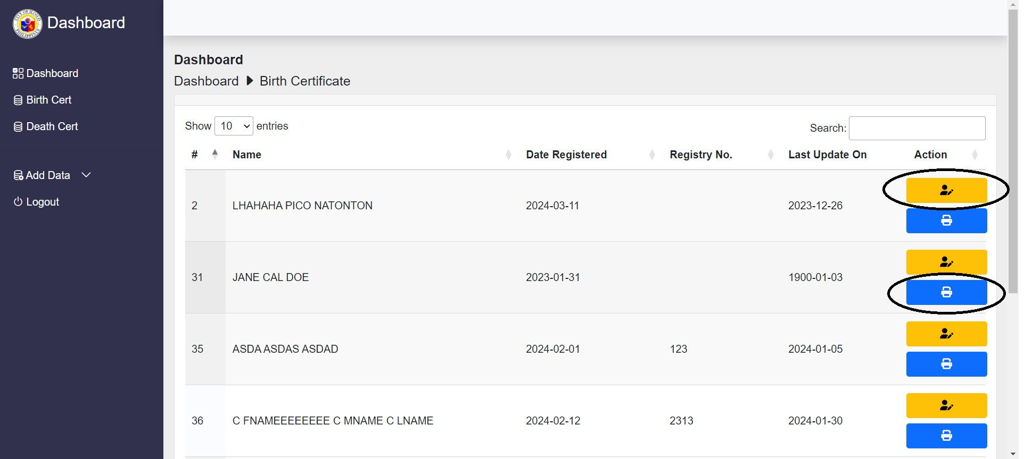

ADD DATA BUTTON.
Add birth info button is where you can add the child’s and person information.
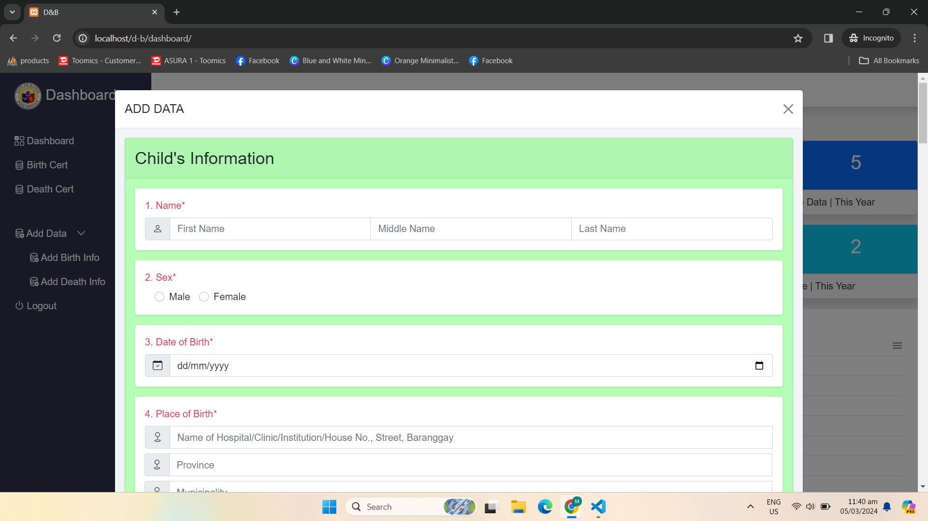

II.DEATH CERT BUTTON.
Death Cert button is where you can see the death chart that can track the number of deceased per day, month, and year. Additionally, you can see the names of the person who had died and the VIEW MORE button is where you can PRINT and VIEW SCANNED FILES.

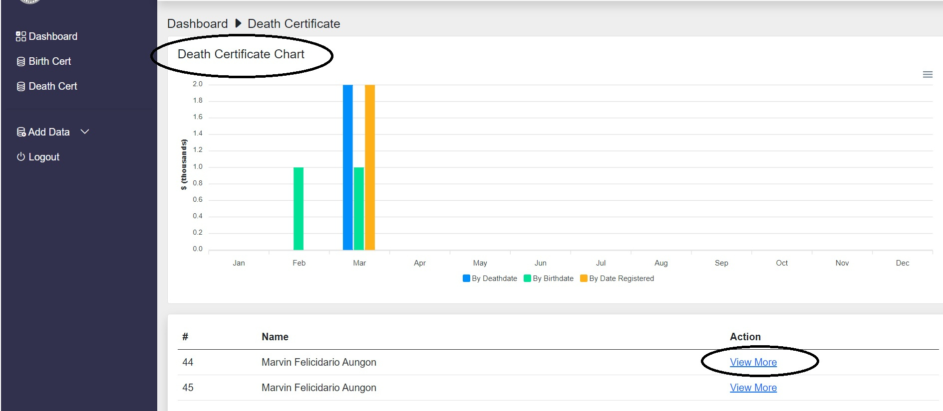

ADD DATA BUTTON.
Add death info button is where you can add person’s or deceased information.

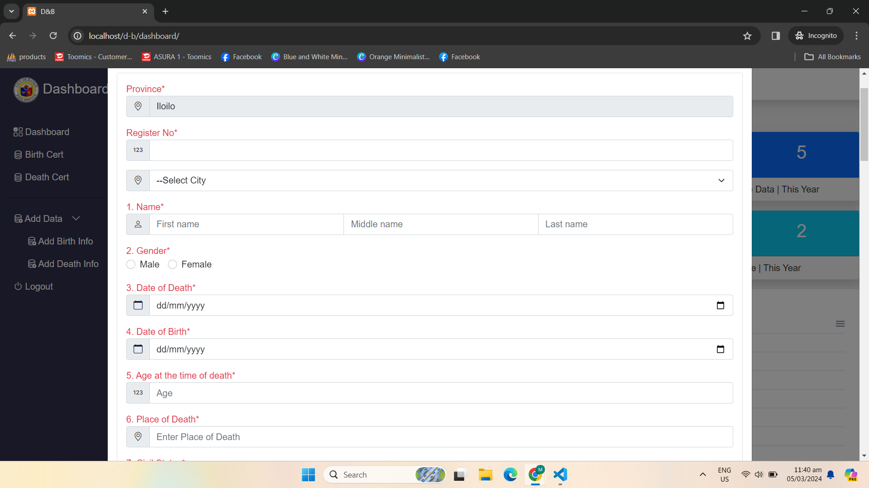

SUPER ADMIN LANDING PAGE.
Super Admin is the one who create an account for the admin of the company also Super Admin can update, delete, and restrict the user’s account.

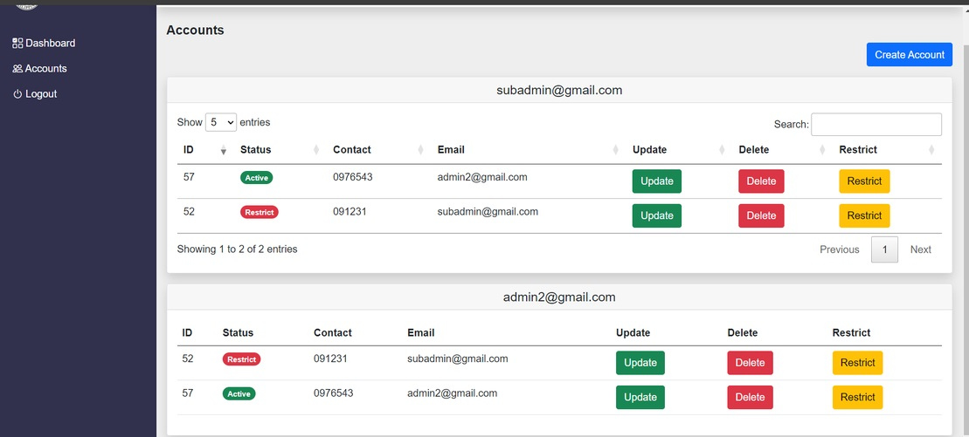

SUPER ADMIN CREATE ACCOUNT BUTTON.
Create account button is where the super admin can add admin of the company.
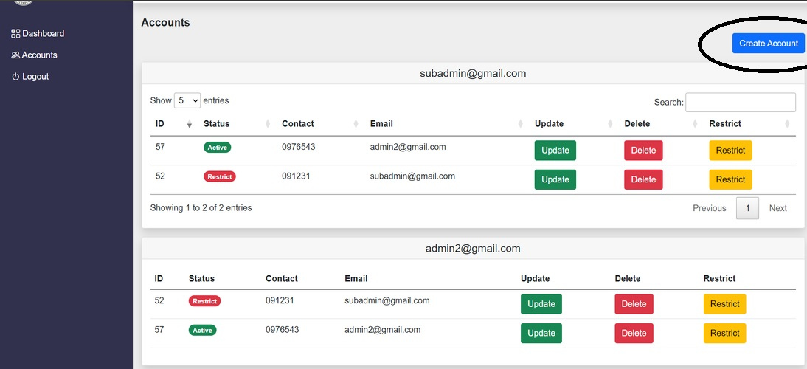

SUPER ADMIN ACCOUNT’S UPDATE BUTTON.
The Update button is where the admin can activate the account or restrict the account.

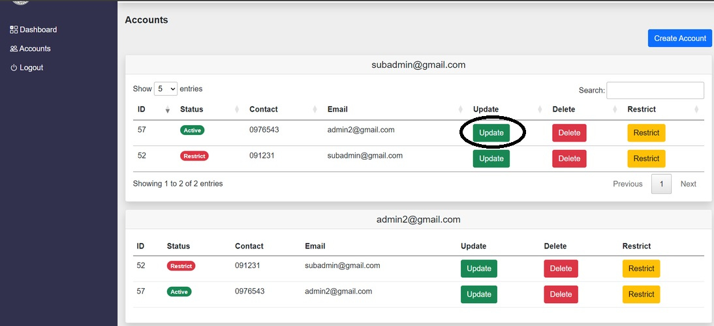

SUPER ADMIN ACCOUNT’S DELETE BUTTON.
Super Admin can delete the account.
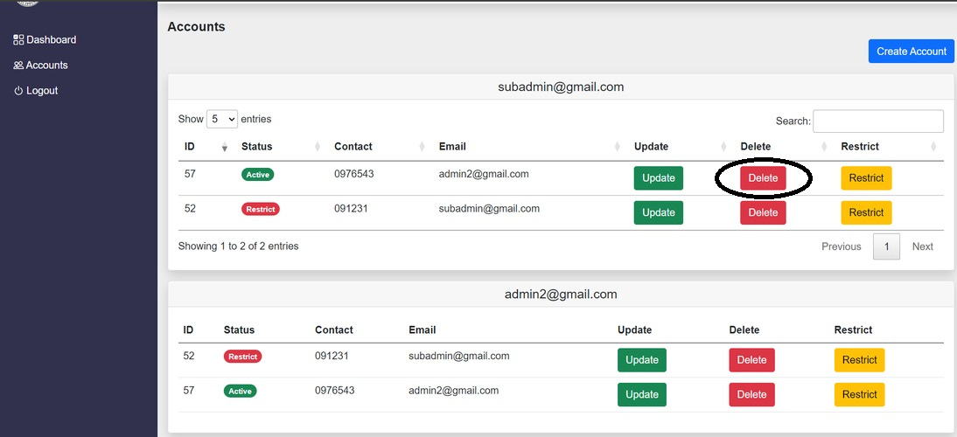

SUPER ADMIN ACCOUNT’S RESTRICT BUTTON.
Super Admin can restrict the account of the user wherein the user can’t login his/her account.
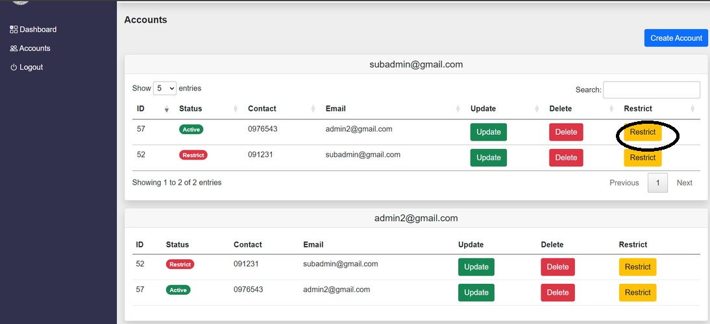

ADMIN ACCOUNT LANDING PAGE.
Admin’s account button where he/she can see the account’s that registered. Also admin can register account of the employee.
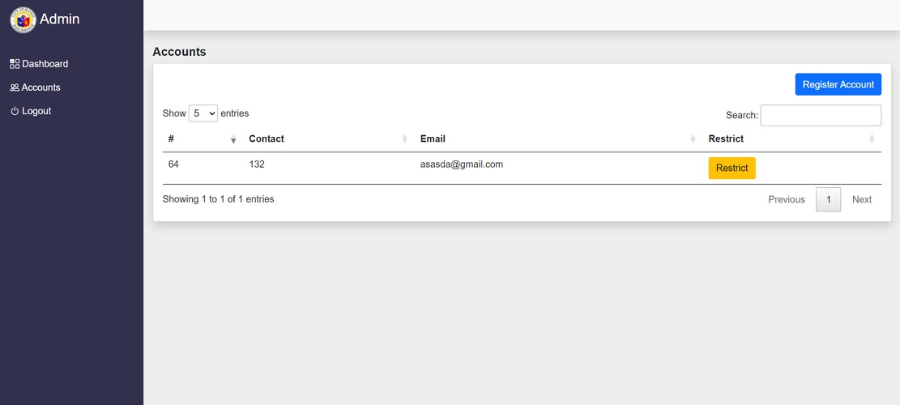

ADMIN REGISTER ACCOUNT BUTTON.
Admin also can register account of their employee.

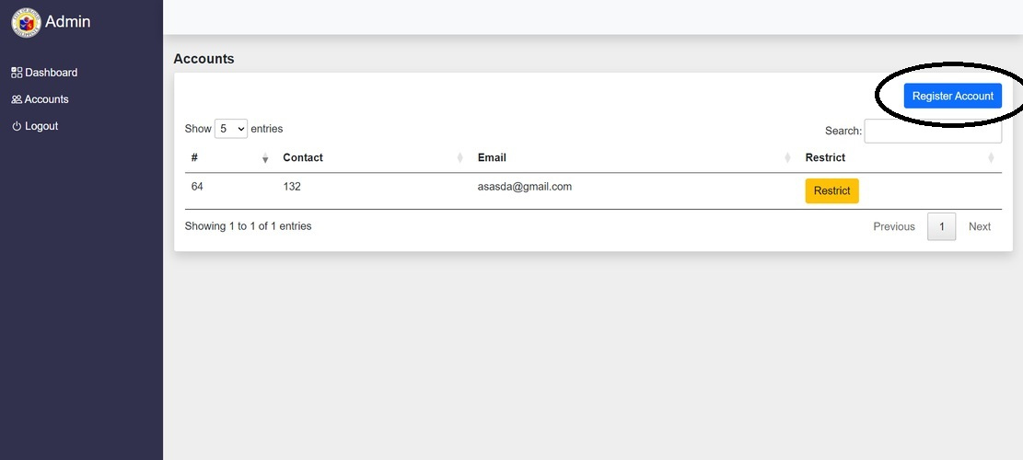

ADMIN ACCOUNTS RESTRICT BUTTON.
Admin also can restrict the account of the employee who registered. Restriction is for if ever the employee is no longer part of the team.
