🩺 dataDoctor — Data Quality Report
Dataset: dataDoctor_big_dataset | 2026-04-26 12:43 | Score: 89.6/100 — Grade B

1. Executive Summary
This report evaluates dataDoctor_big_dataset across 7 quality dimensions. The dataset (10,300 rows × 8 cols) received an overall score of 89.6/100 (Good 🟡). 4 total issues were identified.
⚠ PII DETECTED in 1 column(s). See Section 8.

Overall Quality Score
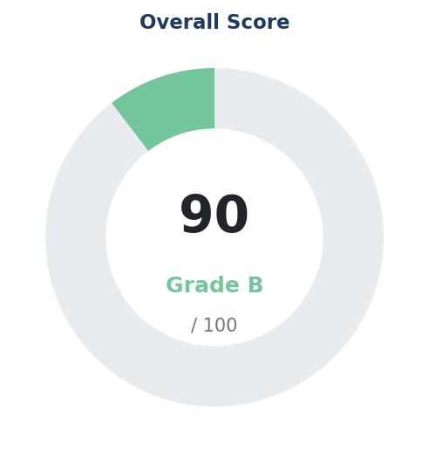

2. Dimension Scores
Dimension | Score | Weight | Status | Issues
Completeness | 74.2/100 | 22% | 🟡 Good | 1
Uniqueness | 77.1/100 | 15% | 🟡 Good | 2
Validity | 100.0/100 | 18% | ✅ Excellent | 0
Consistency | 100.0/100 | 15% | ✅ Excellent | 0
Integrity | 95.0/100 | 10% | ✅ Excellent | 1
Distribution | 98.1/100 | 10% | ✅ Excellent | 0
ML Readiness | 94.0/100 | 10% | ✅ Excellent | 0

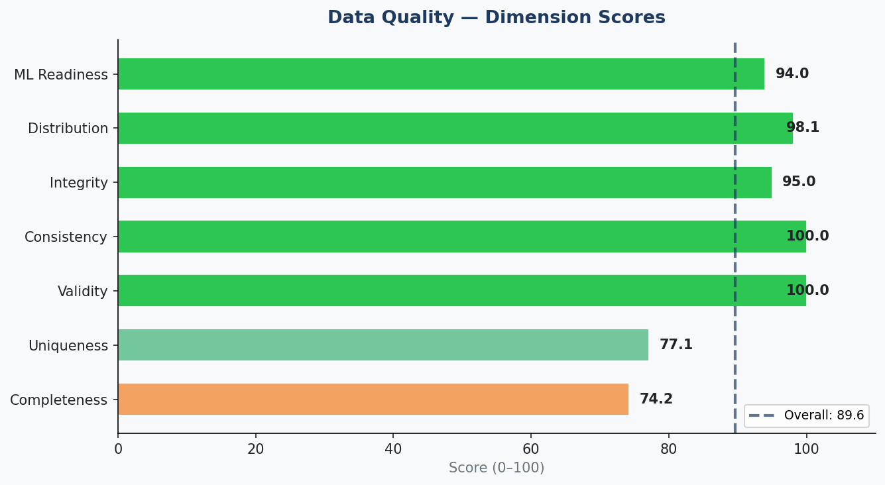

3. Dimension Details

Completeness — 74.2/100
- Positives:
- No column has >50% missing values ✅
- Issues:
- ⚠ 4 column(s) missing 10-50%: quantity, region, sales_rep, total

Uniqueness — 77.1/100
- Positives:
- No constant (zero-variance) columns ✅
- Issues:
- ⚠ 300 duplicate rows (2.9% of dataset)
- ⚠ ID column(s) with duplicates: id

Validity — 100.0/100
- Positives:
- All named numeric columns within expected ranges ✅
- No impossible negative values found ✅
- String column formatting appears consistent ✅

Consistency — 100.0/100
- Positives:
- Date columns appear logically ordered ✅
- Min/Max column pairs are consistent ✅
- No dtype mismatches detected ✅

Integrity — 95.0/100
- Positives:
- All column names are clean and well-formatted ✅
- Index integrity is clean ✅
- Issues:
- ⚠ ⚠️ PII detected in 1 column(s): total

Distribution — 98.1/100
- Positives:
- All numeric distributions have acceptable skewness ✅
- Outlier rates within acceptable bounds ✅
- Categorical columns have good value diversity ✅

ML Readiness — 94.0/100
- Positives:
- 10,300 rows — sufficient for ML ✅
- 4 numeric features available ✅
- Numeric features are well-populated ✅

4. Recommendations
- 1. 🟡 Dataset quality is good. Minor fixes recommended.
- 2. 🟠 Impute moderate-missing columns using mean/median/KNN: quantity, region, sales_rep
- 3. 🟡 Remove 300 duplicate rows → df.drop_duplicates()

5. Dataset Statistics
Metric | Value
Total Rows | 10300
Total Columns | 8
Numeric Columns | 4
Categorical Columns | 4
Null Cells | 7217
Null Rate | 8.76%
Duplicate Rows | 300
Memory (MB) | 0.882

6. Missing Values
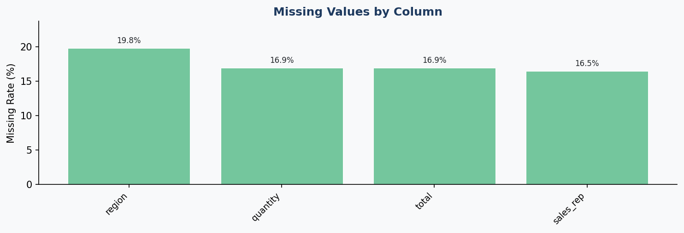

7. Numeric Distributions
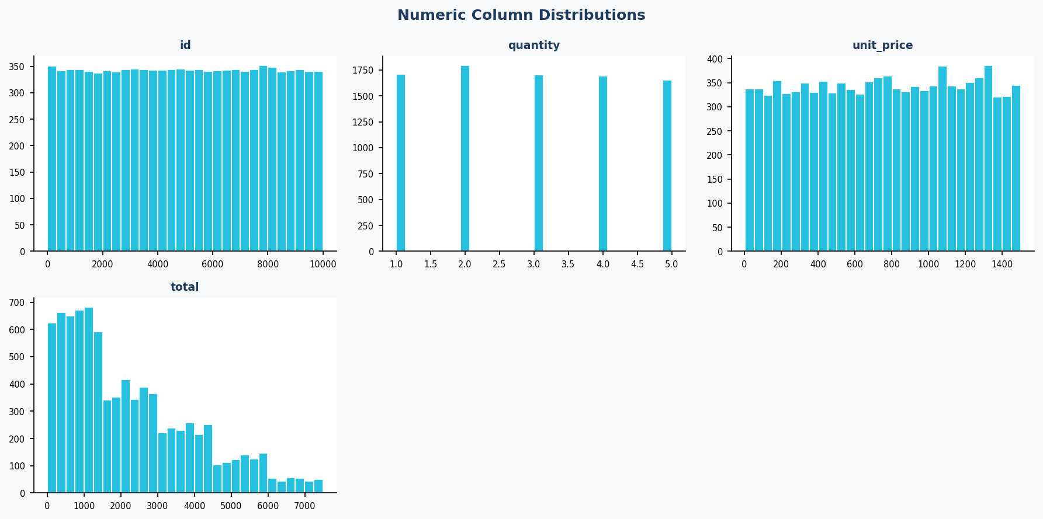

8. ⚠ PII Risk Alert
The following columns contain possible PII. Apply anonymization before sharing.
Column | Signals
total | pattern:phone, pattern:credit_card

