🩺 dataDoctor — Data Quality Report
Dataset: sample_sales | 2026-04-26 16:07 | Score: 90.6/100 — Grade A

1. Executive Summary
This report evaluates sample_sales across 7 quality dimensions. The dataset (15 rows × 8 cols) received an overall score of 90.6/100 (Excellent 🟢). 6 total issues were identified.

Overall Quality Score
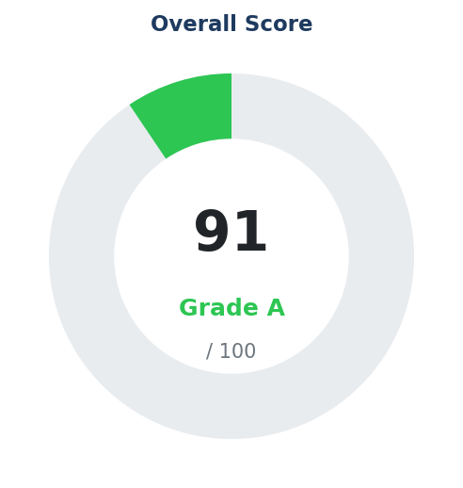

2. Dimension Scores
Dimension | Score | Weight | Status | Issues
Completeness | 81.5/100 | 22% | 🟡 Good | 1
Uniqueness | 100.0/100 | 15% | ✅ Excellent | 0
Validity | 100.0/100 | 18% | ✅ Excellent | 0
Consistency | 100.0/100 | 15% | ✅ Excellent | 0
Integrity | 100.0/100 | 10% | ✅ Excellent | 0
Distribution | 79.8/100 | 10% | 🟡 Good | 4
ML Readiness | 66.5/100 | 10% | 🟠 Fair | 1

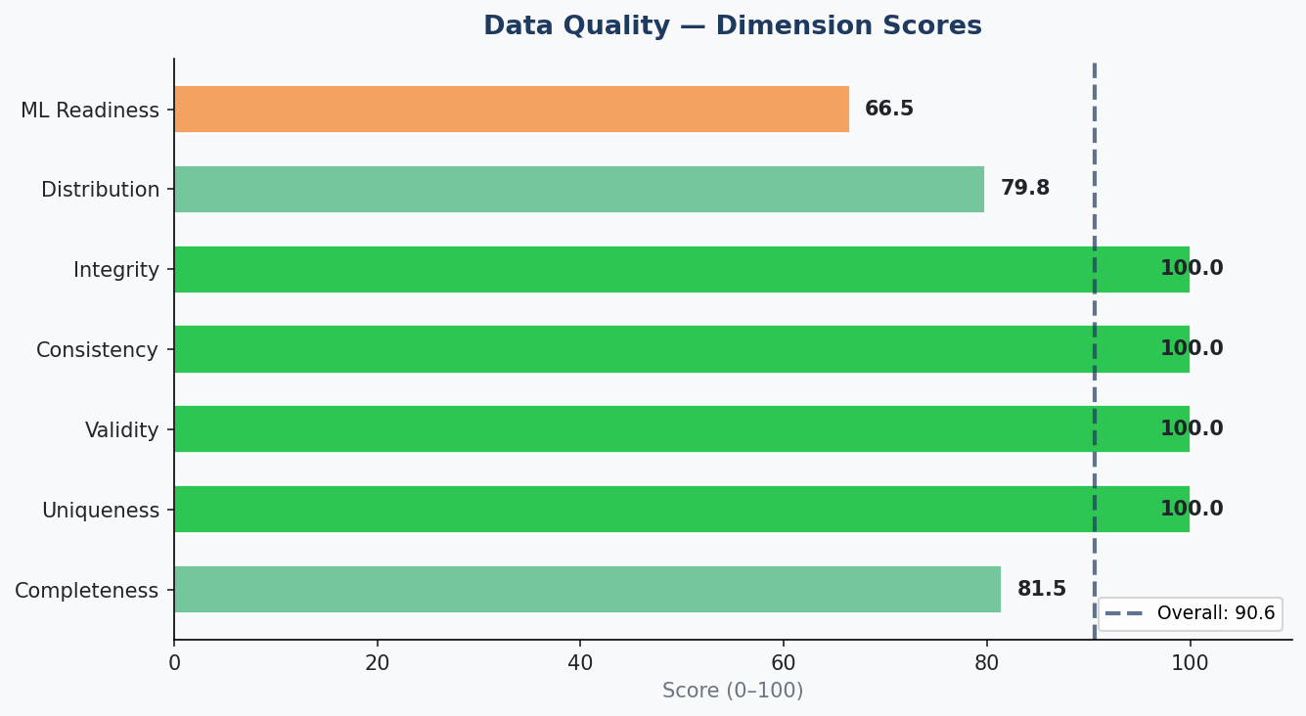

3. Dimension Details

Completeness — 81.5/100
- Positives:
- Dataset is 96.7% complete at cell level ✅
- No column has >50% missing values ✅
- Issues:
- ⚠ 4 column(s) with minor missing values (<10%)

Uniqueness — 100.0/100
- Positives:
- No duplicate rows found ✅
- No constant (zero-variance) columns ✅
- All ID columns are 100% unique ✅

Validity — 100.0/100
- Positives:
- All named numeric columns within expected ranges ✅
- No impossible negative values found ✅
- String column formatting appears consistent ✅

Consistency — 100.0/100
- Positives:
- Date columns appear logically ordered ✅
- Min/Max column pairs are consistent ✅
- No dtype mismatches detected ✅

Integrity — 100.0/100
- Positives:
- No PII detected in column names or values ✅
- All column names are clean and well-formatted ✅
- Index integrity is clean ✅

Distribution — 79.8/100
- Positives:
- Categorical columns have good value diversity ✅
- Issues:
- ⚠ 'quantity': moderate skewness (2.61)
- ⚠ 'total': moderate skewness (1.51)
- ⚠ 'quantity': 14.3% outlier rate (IQR)
- ⚠ 'total': 20.0% outlier rate (IQR)

ML Readiness — 66.5/100
- Positives:
- 4 numeric features available ✅
- Numeric features are well-populated ✅
- Target 'category' is slightly imbalanced ✅
- Issues:
- ⚠ Only 15 rows — ML models need ≥100

4. Recommendations
- 1. ✅ Dataset quality is excellent. Ready for analysis and ML.
- 2. 🤖 ML: Only 15 rows — ML models need ≥100
- 3. 🟡 Apply log/sqrt transform: 'quantity': moderate skewness (2.61)
- 4. 🟡 Apply log/sqrt transform: 'total': moderate skewness (1.51)
- 5. 🟡 Handle outliers: 'quantity': 14.3% outlier rate (IQR)
- 6. 🟡 Handle outliers: 'total': 20.0% outlier rate (IQR)

5. Dataset Statistics
Metric | Value
Total Rows | 15
Total Columns | 8
Numeric Columns | 4
Categorical Columns | 4
Null Cells | 4
Null Rate | 3.33%
Duplicate Rows | 0
Memory (MB) | 0.002

6. Missing Values
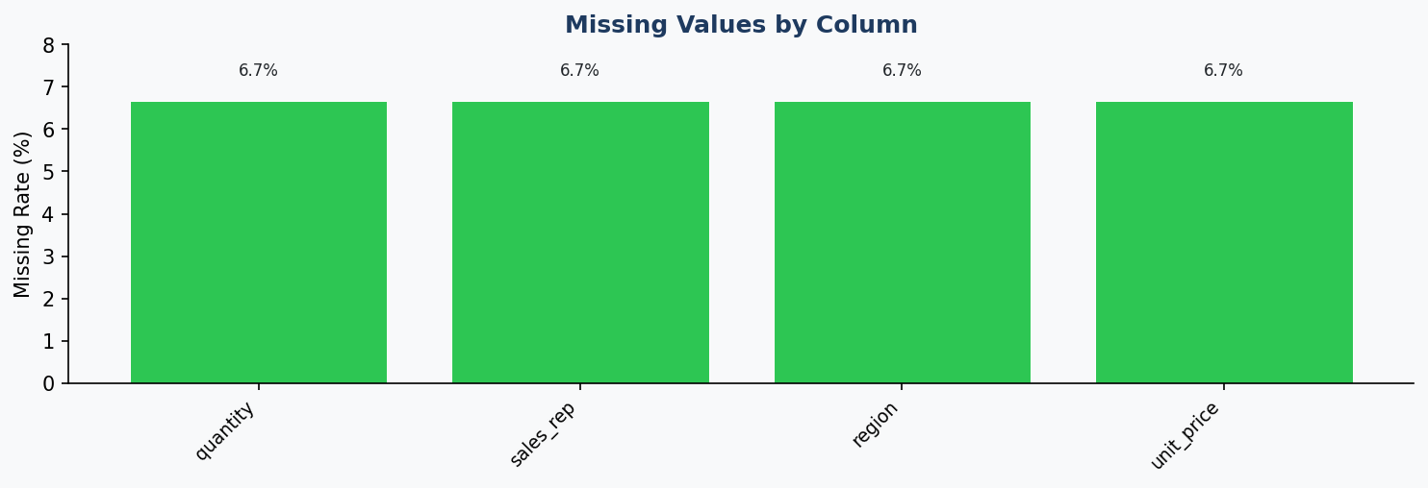

7. Numeric Distributions
