CSA1411-COMPILER DESIGN

LAB EXPERIMENTS

NAME:- DENVAR JOE H

REG NO:- 192511438

EXPERIMENT – 18:
AIM:-
Write a C program to compute TRAILING( ) – operator precedence parser for the given grammar
E → E + T | T
T → T * F | F
F → ( E ) | id
CODE:-
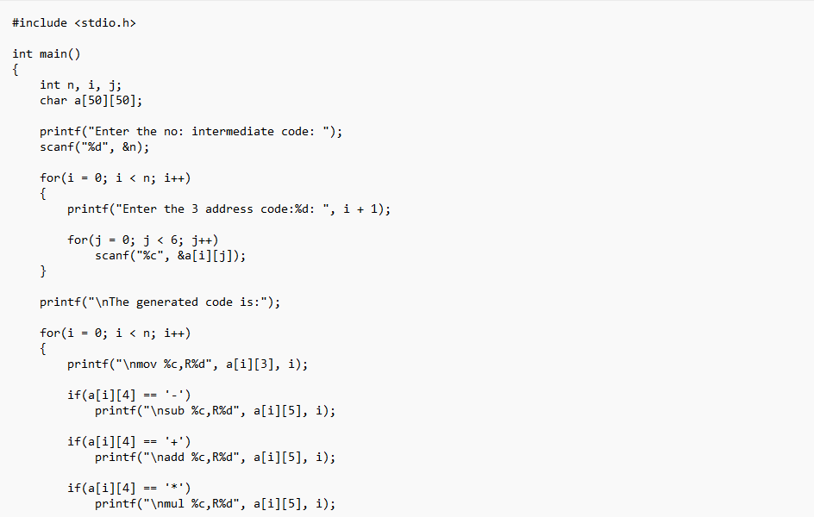
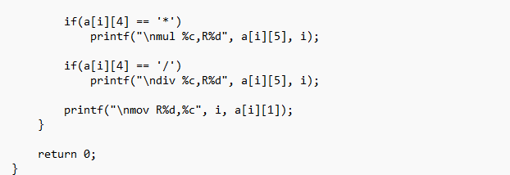
OUTPUT:
