CSA1411-COMPILER DESIGN

LAB EXPERIMENTS

NAME:- Denvar Joe H

REG NO:- 192511438

EXPERIMENT – 22:
AIM:-
Write a LEX program to print all the constants in the given C source program file.
CODE:-
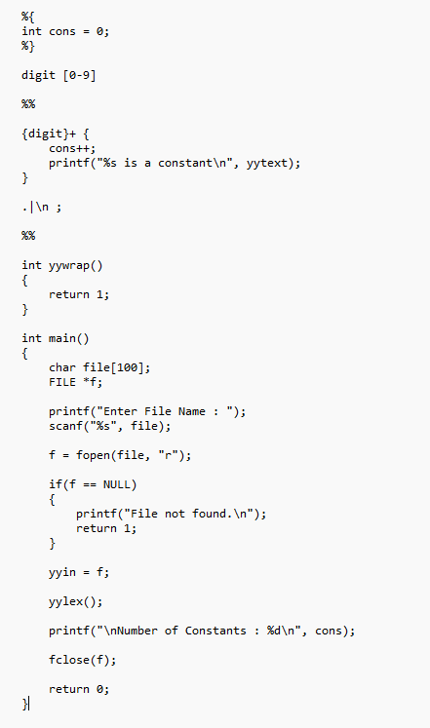
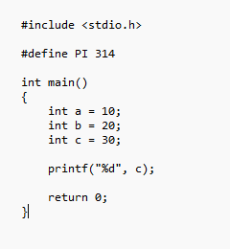
OUTPUT:-
