CSA1411-COMPILER DESIGN

LAB EXPERIMENTS

NAME:- DENVAR JOE H

REG NO:- 192511438

EXPERIMENT – 7:
AIM:-
Write a C program to find FIRST( ) - predictive parser for the given grammar
S → AaAb / BbBa
A → ∈
B → ∈
CODE:-
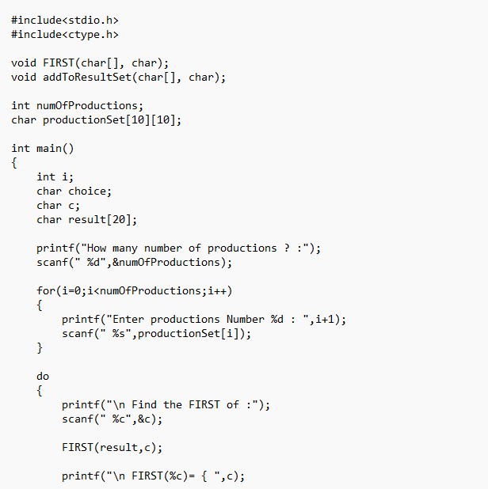
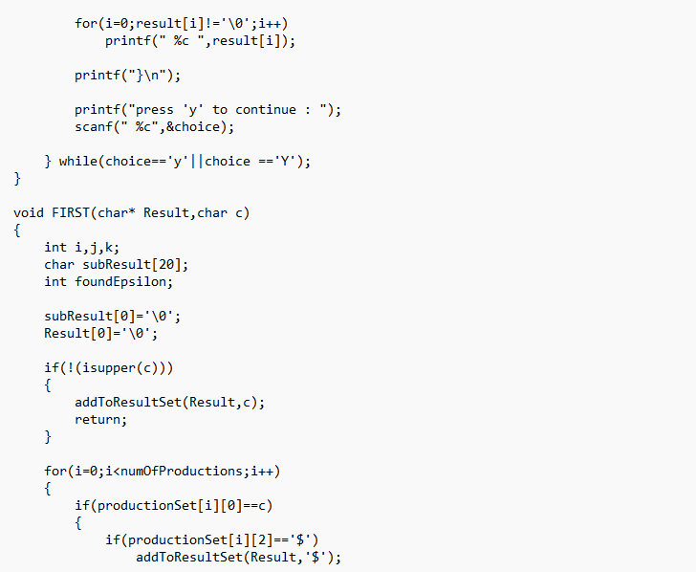
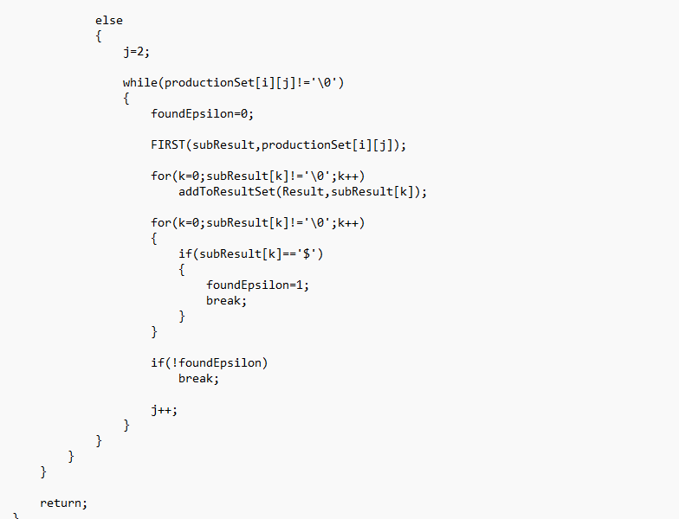
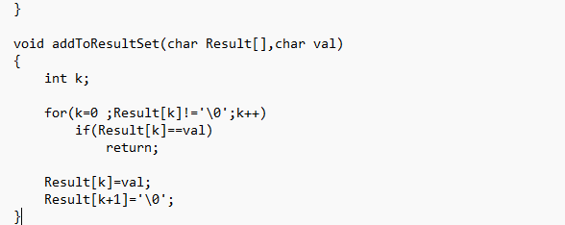
OUTPUT:
