CSA1411-COMPILER DESIGN

LAB EXPERIMENTS

NAME:- DENVAR JOE H

REG NO:- 192511438

EXPERIMENT – 21:
AIM:-
In a class, an English teacher was teaching the vowels and consonants to the students. She says “Vowel sounds allow the air to flow freely, causing the chin to drop noticeably, whilst consonant sounds are produced by restricting the air flow”. As a class activity the students are asked to identify the vowels and consonants in the given word/sentence and count the number of elements in each. Write an algorithm to help the student to count the number of vowels in the given sentence.
CODE:
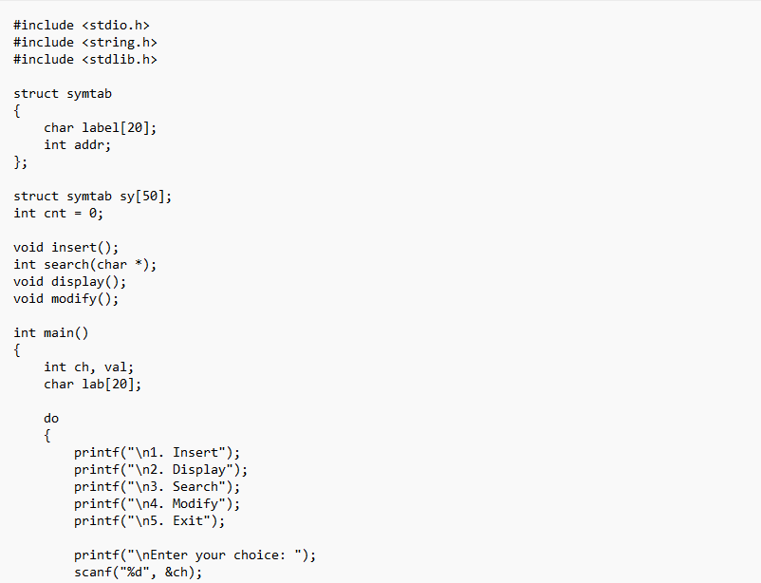
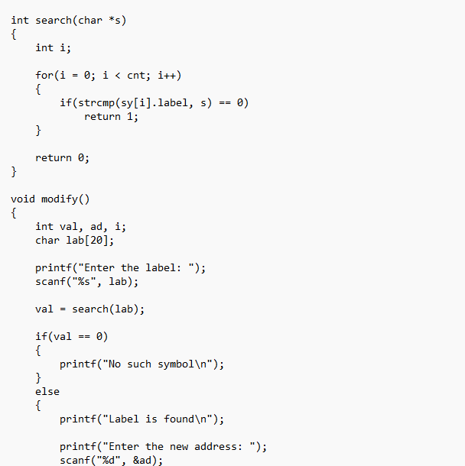
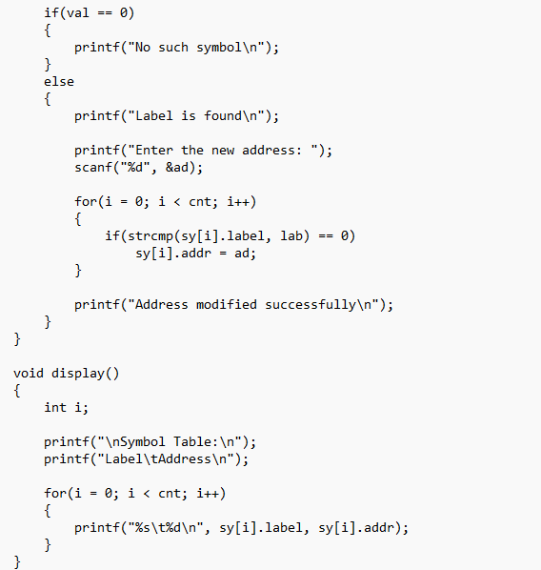
OUTPUT:
