CSA1411-COMPILER DESIGN

LAB EXPERIMENTS

NAME:- DENVAR JOE H

REG NO:- 192511438

EXPERIMENT – 6:
AIM:-
Develop a lexical Analyzer to test whether a given identifier is valid or not.
CODE:-
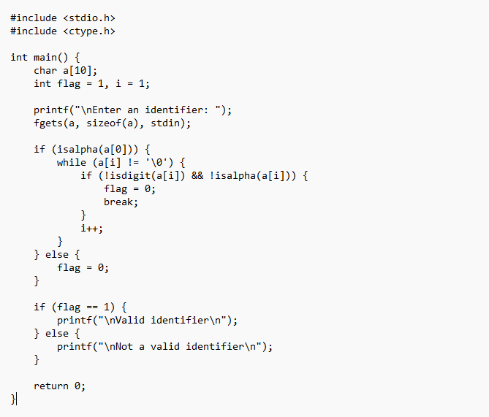

OUTPUT:
